Aviator Game System
Project Progress Report
Prepared from project screenshots and verified implementation files
Date: 10 July 2026
This editable report summarizes the implemented features, explains the submitted screenshots, and organizes the user journey page by page.

Executive Summary
- The Aviator System is now a working Django web application with core gameplay, wallet, profile, compliance, chat, reward, and admin features implemented.
- The screenshots show the application progressing from the live play screen through account management, financial operations, player statistics, social chat, rewards, and user guidance.
- The current build demonstrates both the player-facing experience and the supporting backend workflows needed for deposits, withdrawals, game verification, responsible gaming, and reporting.

Technical Foundation
- Backend: Django application with models for Profile, GameRound, GameSession, Transaction, PaymentRequest, KYCSubmission, SelfExclusion, RiskAlert, RewardEvent, RewardWallet, ChatRain, Room, and AuditLog.
- Frontend: HTML templates, CSS, and JavaScript power the live game interface, drawers, modal views, wallet forms, chat tools, and responsive layouts.
- Data: SQLite is used locally during development, with Django migrations defining persistent tables for users, payments, gameplay, rewards, rooms, and audits.

Implemented Feature Coverage
Feature Area | Status | Progress Explanation
Authentication | Implemented | Register, login, logout, account profile, and automatic redirects into gameplay.
Aviator game loop | Implemented | Two bet panels, animated multiplier, crash/cash-out settlement, recent multipliers, and live table.
Provably fair rounds | Implemented | Server seed hash, client seed, crash point, reveal flow, and audit logging for round verification.
Wallet | Implemented | UGX balance, deposits, withdrawals, payment requests, transaction records, and balance updates.
Payments | Implemented | MTN Mobile Money, Airtel Money, card, bank transfer, and Pesapal provider options in form logic.
Transactions | Implemented | Bet debit, win credit, deposit, withdrawal, refund, and bonus transaction types with status tracking.
Profile and statistics | Implemented | Player ID, VIP level display, XP progress, win rate, games played, winnings, and activity panels.
Compliance | Implemented | Phone verification, KYC submission, deposit/loss limits, risk alerts, and self-exclusion controls.
Free bets and rewards | Implemented | Free-bet management UI, reward events, reward wallet, claims, reward transactions, and chat rain.
Chat | Implemented | Live chat UI, emoji picker, reactions, flagged-message checks, and online player display.
Multiplayer rooms | Implemented | Room creation, room joining, room status, host start flow, participants, and room cash-out logic.
Admin analytics | Implemented | Staff analytics route, financial report generation, payment review data, KYC/risk counts, and admin model controls.
Audit logging | Implemented | System activity logging for registration, deposits, withdrawals, game starts, cash-outs, rooms, rewards, and admin actions.
Responsive UI | Implemented | Dark themed dashboard layout with side navigation, modals, mobile chat panels, and compact game controls.

Screenshot Walkthrough In Page Order
The following pages arrange the screenshots in the order a reviewer would naturally encounter the system while testing the application.

01. Live Aviator Play Screen
Main play interface showing the multiplier flight, live betting table, wallet balance, dual bet controls, recent multipliers, and live chat.
- Shows the completed live game layout with betting list, recent crash multipliers, balance, chat, and dual bet panels.
- The screen proves the application supports real-time style interaction and clear separation between game, betting, and communication areas.
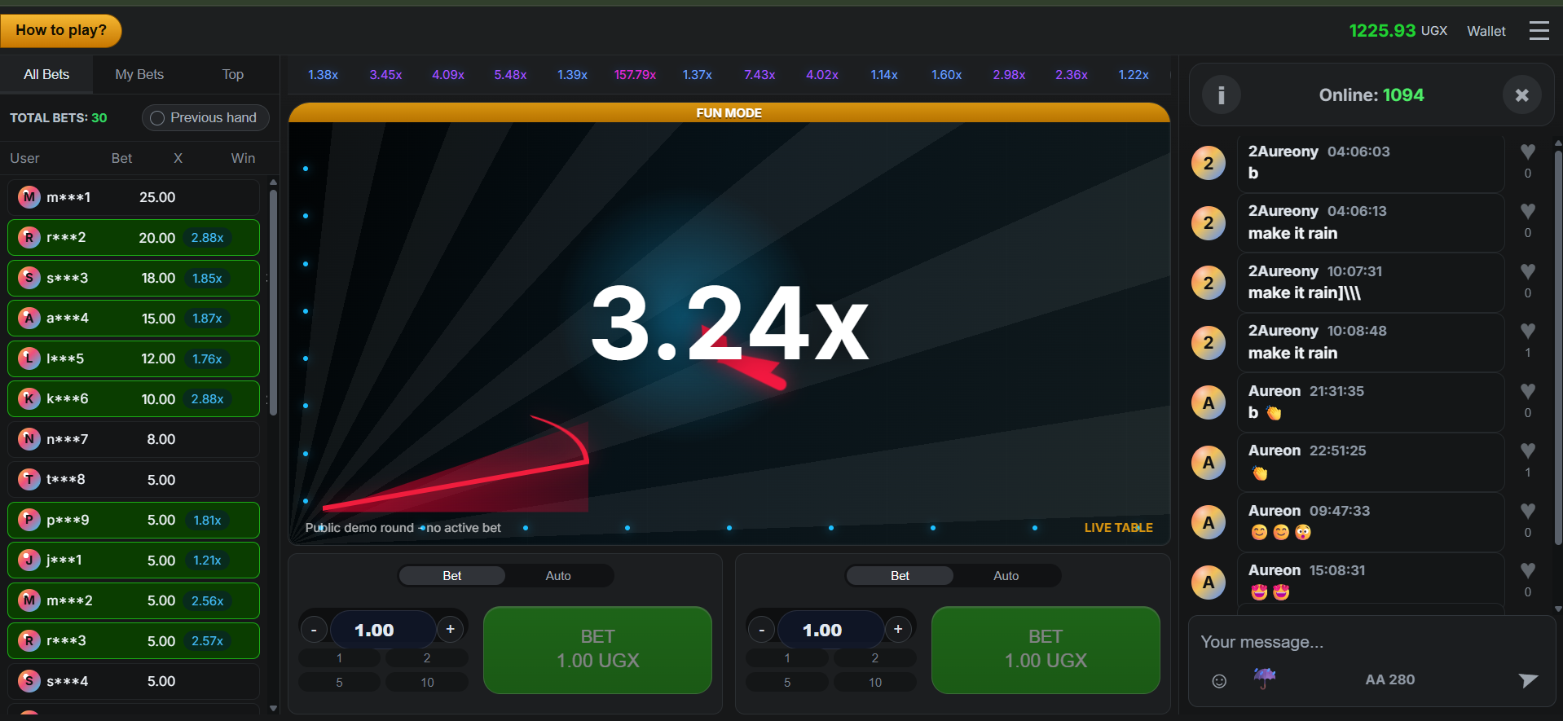

02. Expanded Game Flight View
Wider play view focused on the multiplier graph and betting controls, demonstrating responsive game layout and real-time flight animation.
- This screen completes an important part of the user flow and supports the overall usability of the project.
- It demonstrates that navigation and feature access have been implemented beyond the basic game screen.
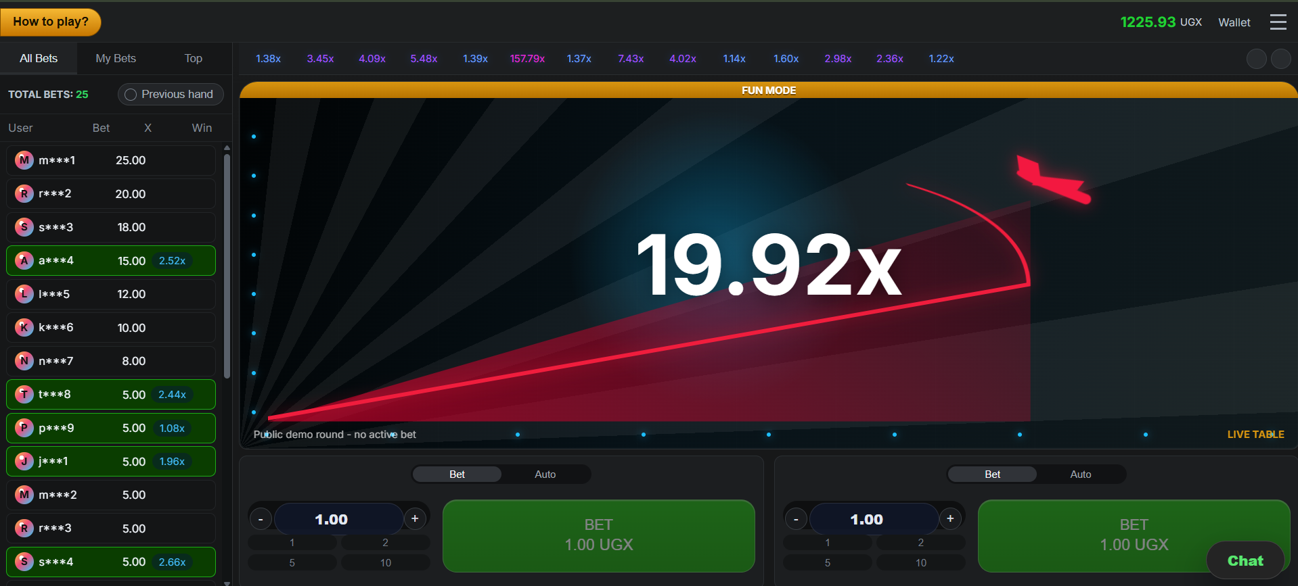

03. Account Menu And Settings
User account drawer with avatar control, sound/music/animation toggles, free bets, bet history, limits, rules, and provably fair settings.
- This screen completes an important part of the user flow and supports the overall usability of the project.
- It demonstrates that navigation and feature access have been implemented beyond the basic game screen.
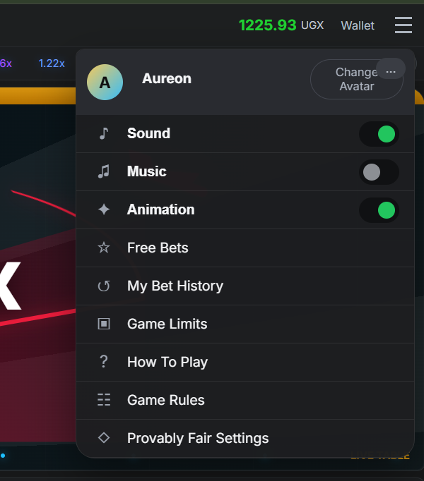

04. Free Bets Management
Free bets modal showing the active free bet area, archive access, and cash/free-bet play mode selection.
- This screen completes an important part of the user flow and supports the overall usability of the project.
- It demonstrates that navigation and feature access have been implemented beyond the basic game screen.
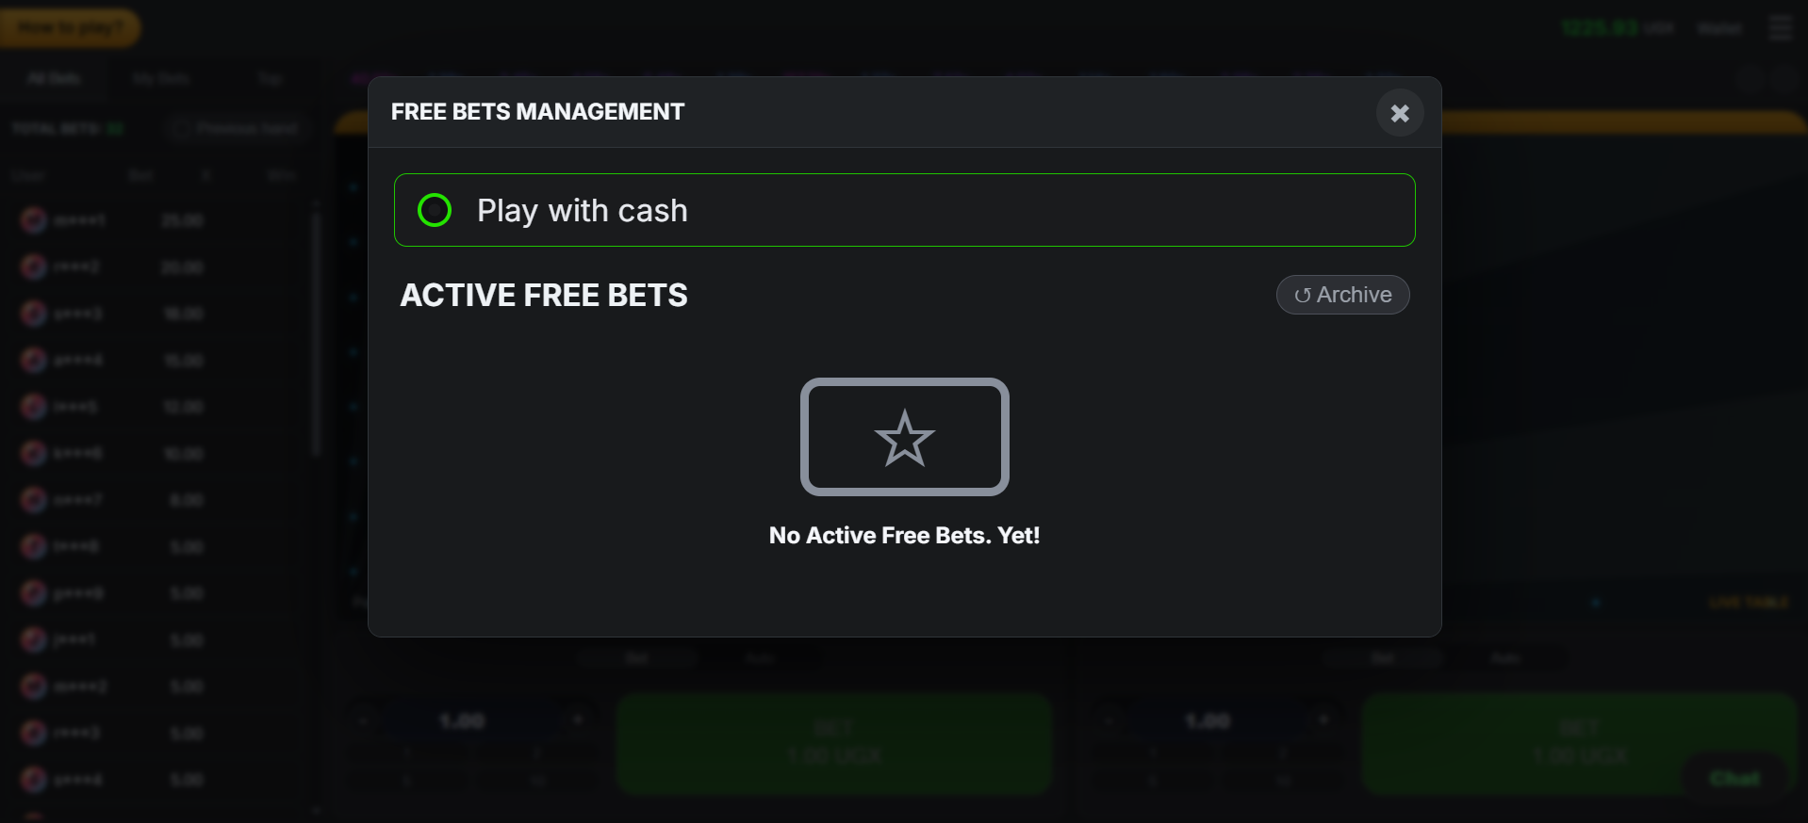

05. Wallet Overview
Wallet dashboard with user identity, verification tier, balance cards, XP progress, deposit limit, KYC status, and recent activity.
- Demonstrates wallet visibility, UGX currency handling, payment forms, payment request records, and deposit/withdraw controls.
- The backend supports completed sandbox deposits and pending withdrawals for operator review.
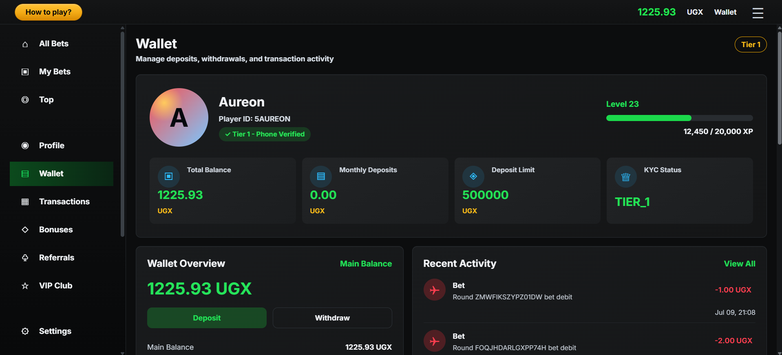

06. Deposit And Withdrawal Forms
Wallet action area for deposits and withdrawals using payment providers such as MTN Mobile Money, plus VIP and preference summaries.
- Demonstrates wallet visibility, UGX currency handling, payment forms, payment request records, and deposit/withdraw controls.
- The backend supports completed sandbox deposits and pending withdrawals for operator review.
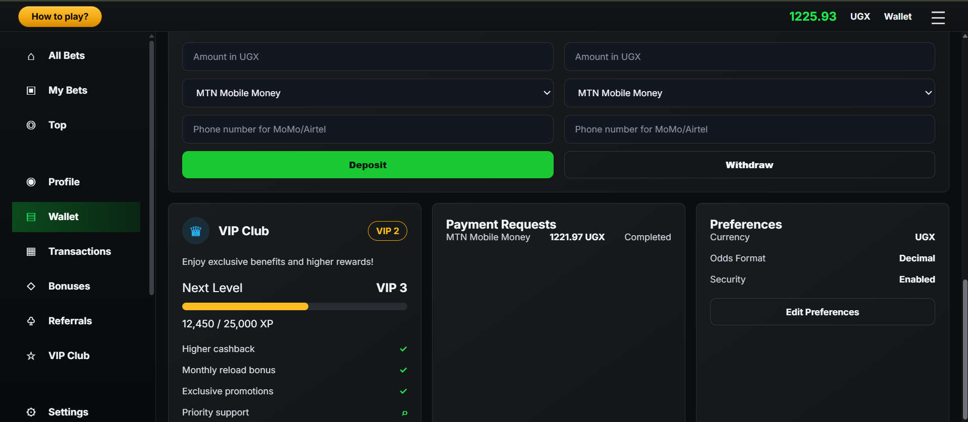

07. Transaction History
Transaction ledger listing deposits, withdrawals, bet debits, win credits, status, date, amount, and total record count.
- This screen completes an important part of the user flow and supports the overall usability of the project.
- It demonstrates that navigation and feature access have been implemented beyond the basic game screen.
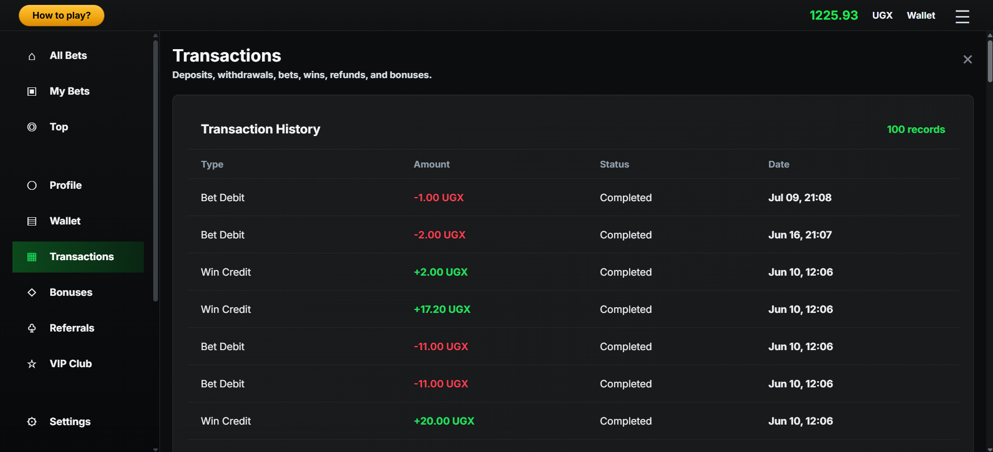

08. Profile Overview
Profile dashboard with player ID, VIP level, verification status, betting totals, winnings, biggest win, and highest multiplier.
- Shows account identity, VIP progress, performance statistics, responsible-gaming limits, KYC submission, and self-exclusion controls.
- These features improve trust, safety, and traceability for a betting-style application.
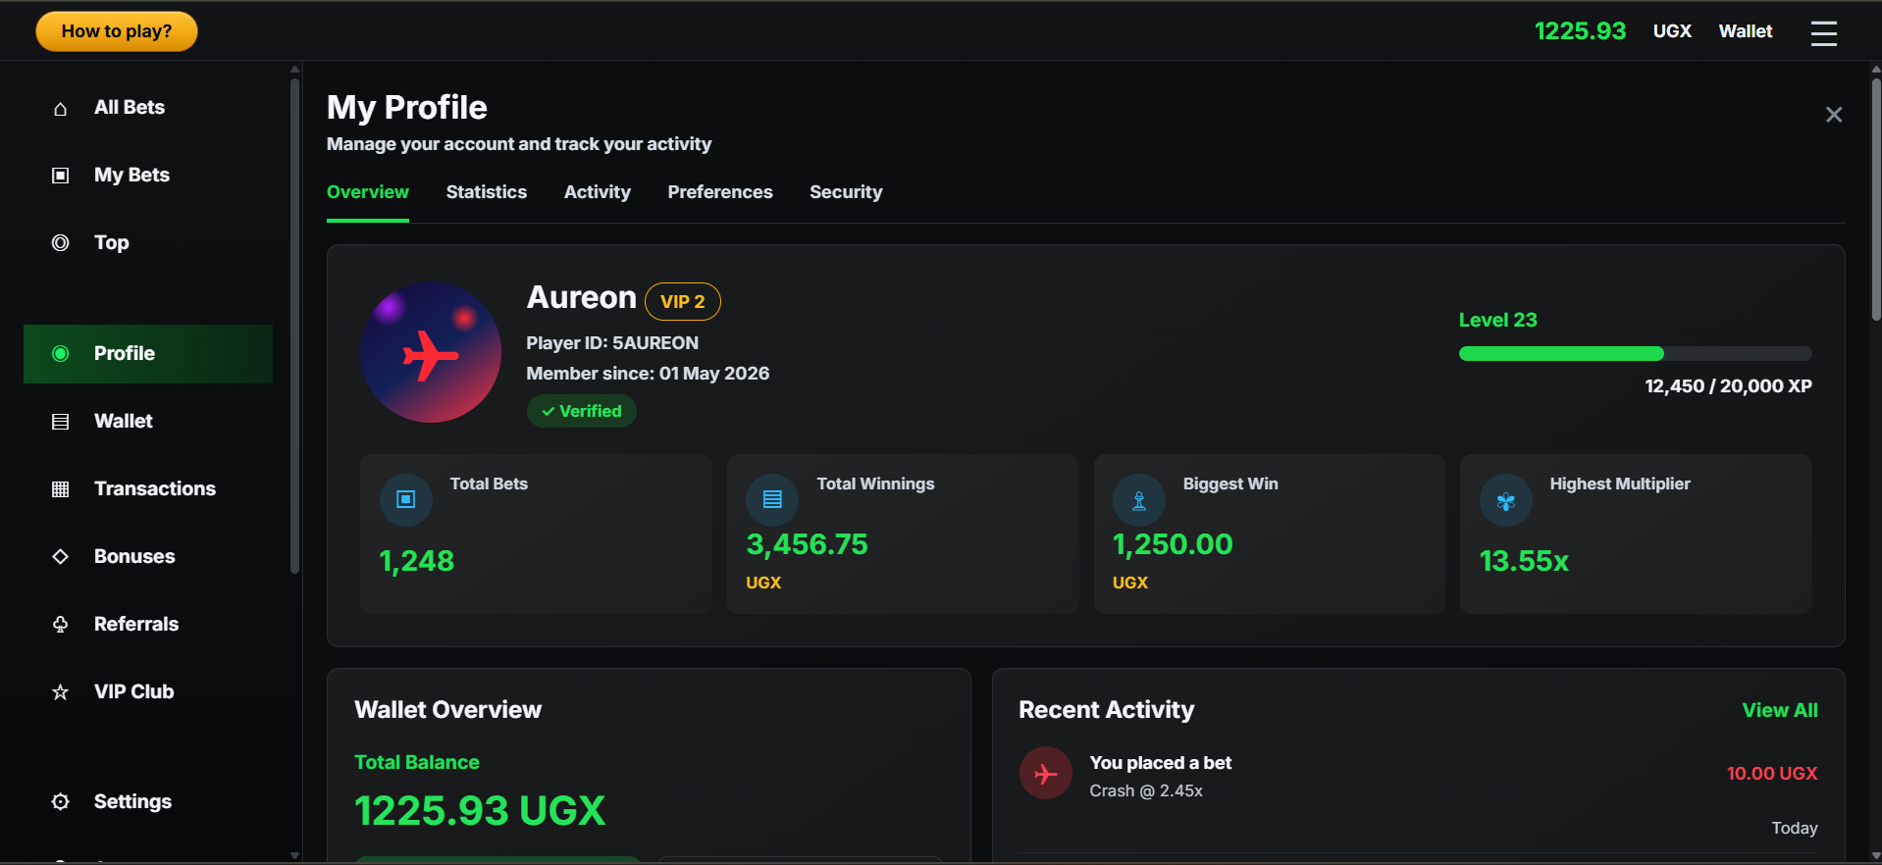

09. Profile Wallet And Recent Activity
Profile continuation showing balance breakdown, daily limits, deposit/withdraw actions, and recent account activity.
- Demonstrates wallet visibility, UGX currency handling, payment forms, payment request records, and deposit/withdraw controls.
- The backend supports completed sandbox deposits and pending withdrawals for operator review.
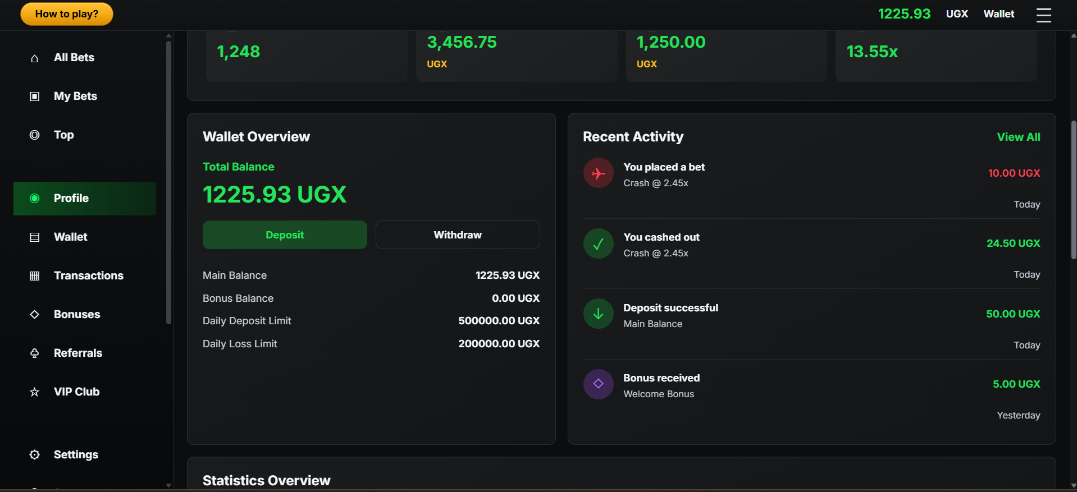

10. Statistics And Compliance Controls
Statistics cards plus compliance settings, KYC submission fields, and self-exclusion protection controls.
- Shows account identity, VIP progress, performance statistics, responsible-gaming limits, KYC submission, and self-exclusion controls.
- These features improve trust, safety, and traceability for a betting-style application.
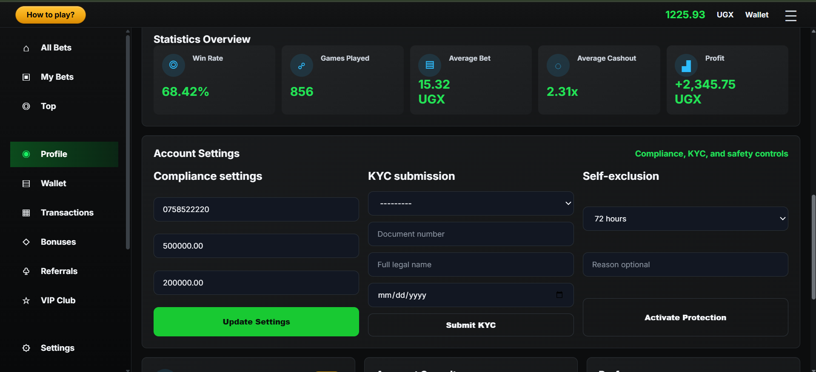

11. Top Dashboard
Top area summarizing balance, recent bets, open rooms, readiness state, and XP progress.
- This screen completes an important part of the user flow and supports the overall usability of the project.
- It demonstrates that navigation and feature access have been implemented beyond the basic game screen.
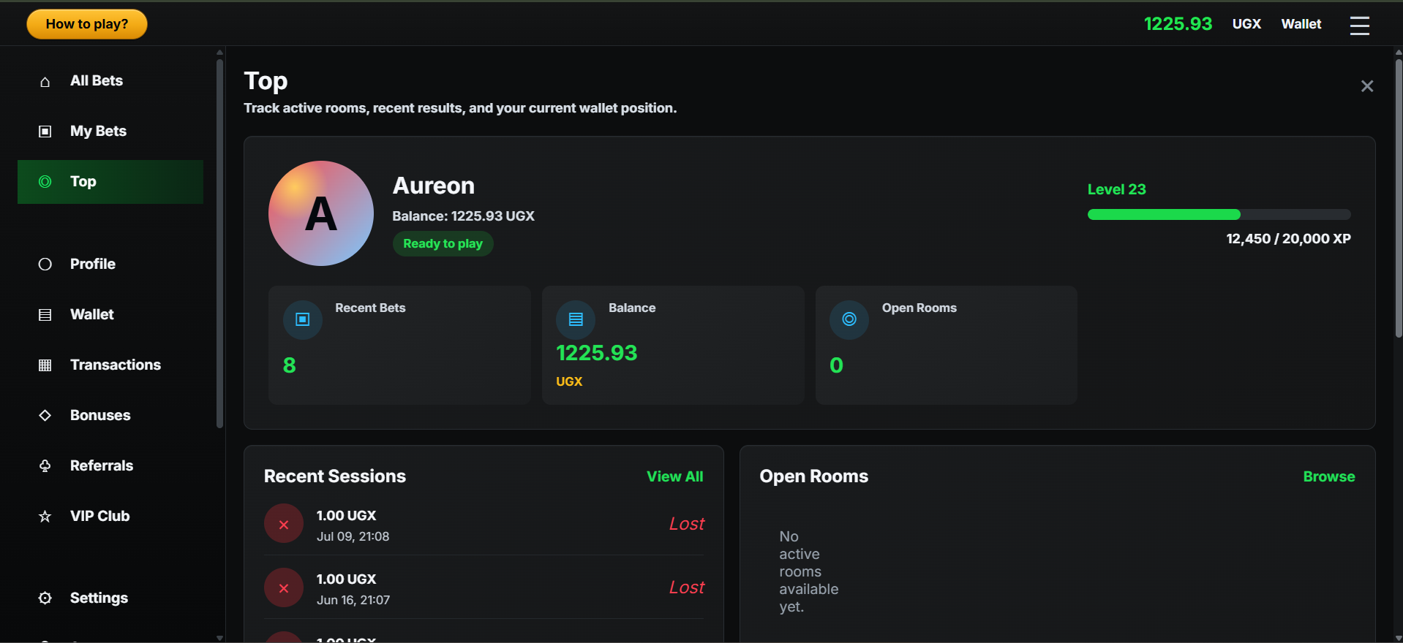

12. Recent Sessions And Open Rooms
Session history with won/lost outcomes and room availability panel for multiplayer game flow.
- This screen completes an important part of the user flow and supports the overall usability of the project.
- It demonstrates that navigation and feature access have been implemented beyond the basic game screen.
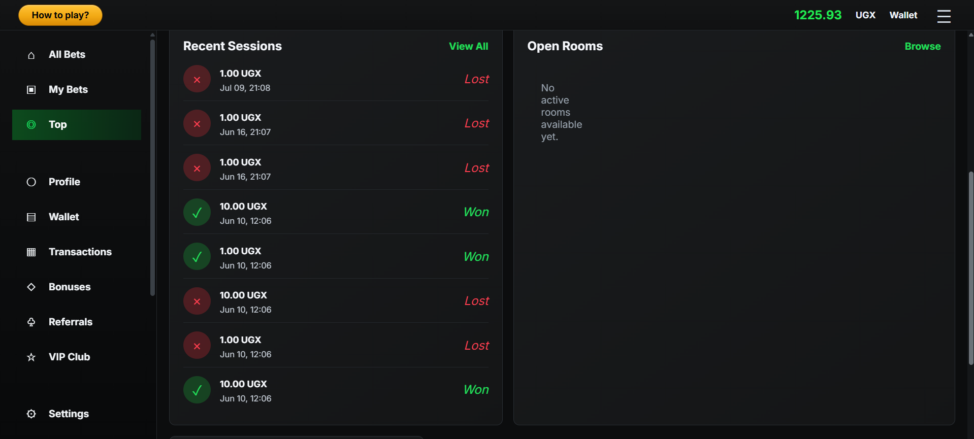

13. Chat Rain Reward Panel
Chat rain interaction where a user can distribute wallet balance across a number of players with calculated per-player amount.
- Shows the social layer: live messages, reactions, emoji picker, online counter, and chat rain reward distribution.
- The backend includes chat moderation checks, reward event creation, and wallet-backed reward distribution.
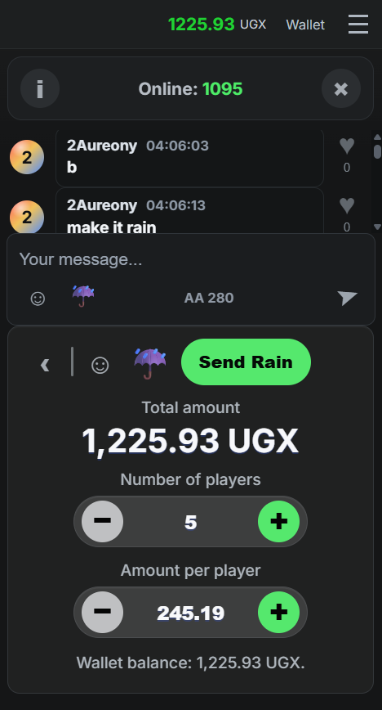

14. Emoji Picker
Chat input enhancements including emoji search and picker, message input, reaction affordance, and send action.
- Shows the social layer: live messages, reactions, emoji picker, online counter, and chat rain reward distribution.
- The backend includes chat moderation checks, reward event creation, and wallet-backed reward distribution.
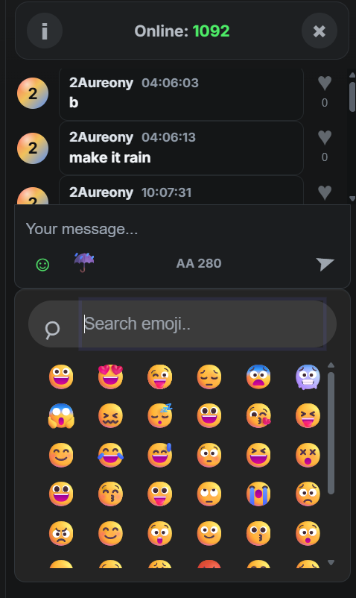

15. Active Betting And Cash Out
Active round with provably fair hash display and cash-out buttons for two simultaneous bets.
- Shows active bet settlement, cash-out value updates, and provably fair hash visibility during gameplay.
- The system records bet debits, win credits, crash/cash-out outcomes, and round audit details.
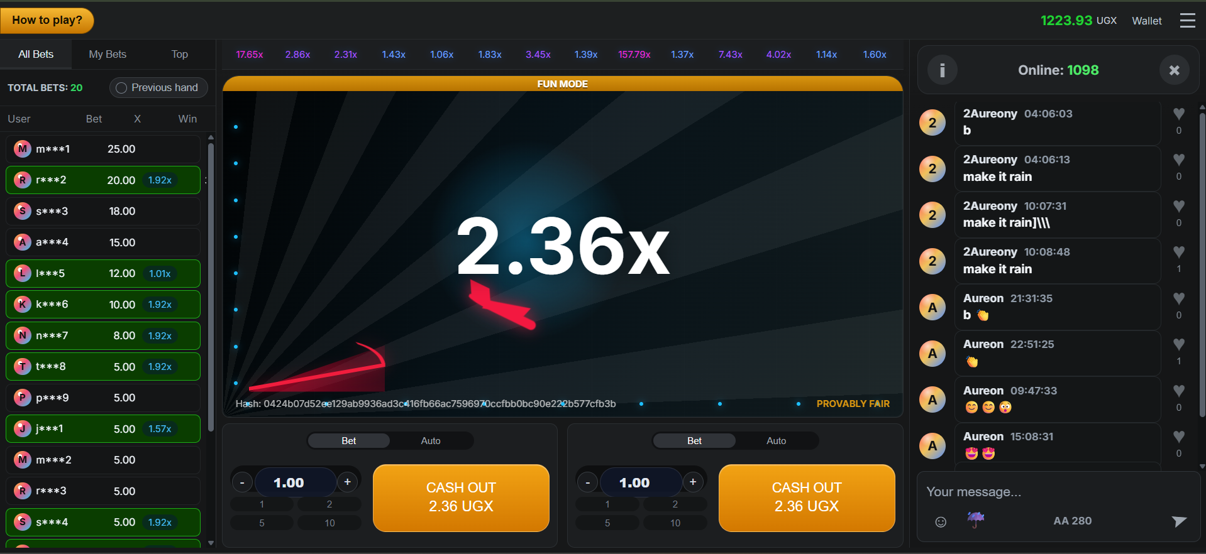

16. High Multiplier Cash Out State
Later round state showing a higher multiplier and updated cash-out value while the round is still flying.
- Shows active bet settlement, cash-out value updates, and provably fair hash visibility during gameplay.
- The system records bet debits, win credits, crash/cash-out outcomes, and round audit details.
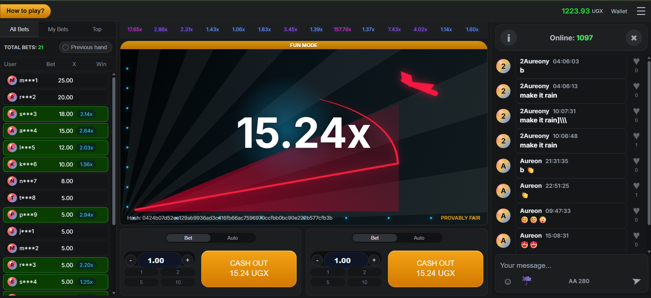

17. How To Play Modal
Instruction modal explaining the basic three-step user flow: place bet, watch multiplier, cash out before crash.
- This screen completes an important part of the user flow and supports the overall usability of the project.
- It demonstrates that navigation and feature access have been implemented beyond the basic game screen.
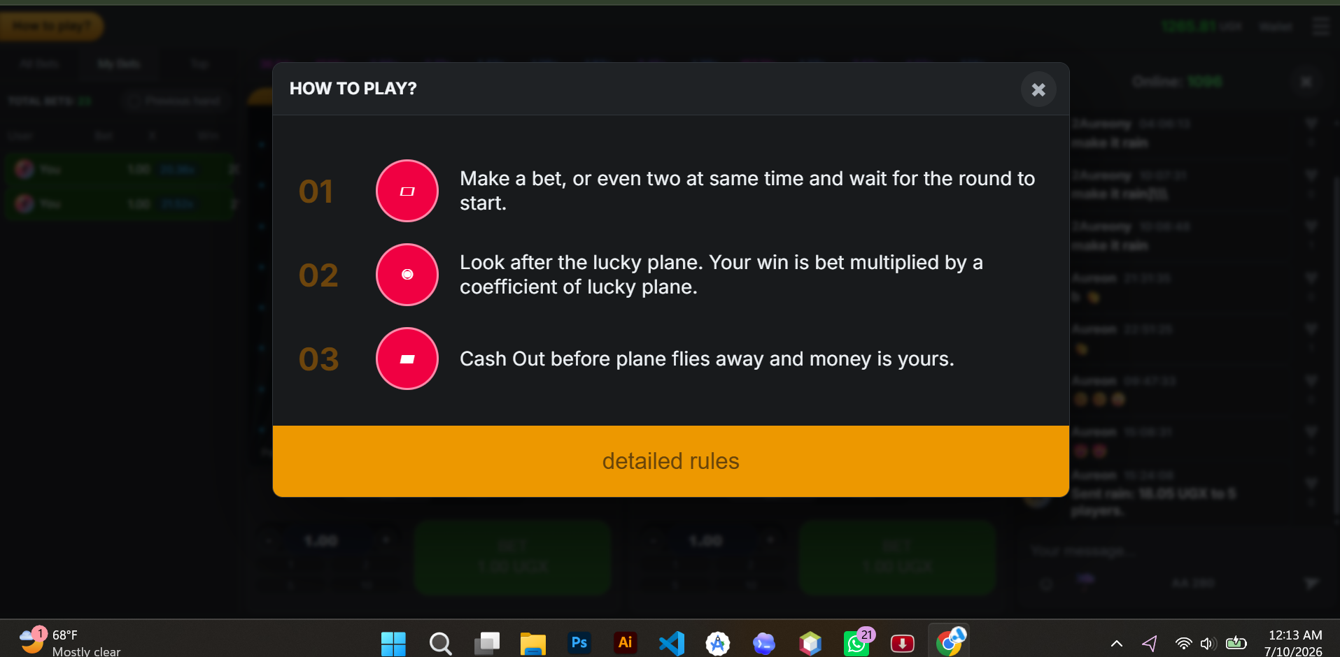

Conclusion And Next Steps
- The project has progressed from a basic Django scaffold into a multi-feature Aviator platform with gameplay, wallet, rewards, compliance, and reporting capabilities.
- The screenshots confirm that the interface is visually consistent, responsive, and organized around real player workflows.
- Recommended next steps are final QA testing, deployment configuration, real payment gateway integration, improved WebSocket production setup, and final security hardening before public release.

