**Team Pixel Perfect Project Plan**



**Date: 09-02-2023**

**Group: Team Pixel Perfect / Group 7**

**Version: 1.0.0**

**Status: Open for corrections**

**Table of Contents:**

1. Project Definition

1.1 Project Background

1.2 Problem description and goals

1.4 Way of Working

1.5 Constraints and scope

1. Project Structure Organization

2.1 Team Members and Roles

1. Deliverables and Non-deliverables

3.1 MoSCoW

1. Planning

**1. Project Definition**

**1.1. Project Background**

A new hardware store called “Media Bazaar” is celebrating the opening of their first shop in Eindhoven. Supported by its parent company “Jupiter”, they are well prepared to dive into the market but are also facing a couple of challenges; one of them being achieving a greater efficiency of their employee/stock management system. They see the need for a good IT solution to have better control and flow over their internal system. That way, they believe that eventually they’ll be able to have a larger proportion in the market and gain more clients.

**1.2. Problem description and the goals**

One of the main issues that they are facing is inefficiency of their currently existing employee/stock management system. Their current system, which is provided by their parent company “Jupiter”, makes use of an online calendar and excel sheets. However, as already mentioned in some of their interviews, those platforms are very efficient as they are too detailed and unreliable. The stakeholders “Media bazaar” believe that this process can be more simplified so they can manage their internal affairs more easily.

The project would improve the issue that the stakeholders of “Media bazaar” is facing by implementing two different applications that rely on one database; one desktop application and one web application. The final goal of this project is to simplify and make more effective the current company’s internal work flows such as the process of assigning shifts to employees, requesting refill for a certain stock, manipulate the existing database of employees by reading, updating and deleting, and having a feature to check each employee’s personal information and their shifts. Even though we have basically two problems to solve, employees and stocks, when it comes to priority employees sit over stocks. Therefore, in our current project we’d focus more on the formal.

The functionalities of the whole software differs by application. For example, the main features of our desktop application would focus more on the management/administration as it’d be used to manage employees and stocks. On the other hand, the web application will be used mainly by the workers to manage their shifts and personal information.

**1.4. Way of Working**

One of the most important aspects of teamwork is communication. Therefore, we’ll make use of various chat platforms such as Discord and Whatsapp to have effective communication anytime from anywhere. To keep track of each progress and deadlines, we’d use integration tables from GitHub Projects. Git will be used as a version control system and Github as hosting provider and we’ll divide our tasks among the team with GitHub Projects. Meetings will be held every Friday and would be mandatory to participate unless one has a valid reason. To work on the prototype or wireframes and so on, platforms such as figma will be used. Development will be conducted in will be conducted in the following GitHub organisation: <https://github.com/PixelPerfectMedia>

**1.5. Constraints and scope**

The priority of our current project is the management of employees which is about assigning shifts, viewing personal information and the ability to manipulate the flow of employees by adding, deleting, reading and updating. Our second priority would be the same but for the stocks. As for now, we have well defined requirements requested by our client. Therefore, whether by our own team or the client, if other features come up in discussions that would require the review of both parties to keep our software in line to meet the final requirements and get the desired outcome.

C# would be used to create a windows form which is gonna be a desktop application for the management and administration, while the web application will use ASP.NET Razor Pages. Both applications will be connected together using ASP.NET as a backend. The workers will be able to view their personal information and shifts. Other constraints would be the budget, therefore any functionality that goes beyond the requirements should be discussed between both parties.

**2. Project Structure Organization**

**2.1. Team Members and Roles**

Bogdan

* Role : development
* Email: [b.nikolov@student.fontys.nl](mailto:b.nikolov@student.fontys.nl)
* Phone: +359899897078

Yordan

* Role: development
* Email: [y.mitev@student.fontys.nl](mailto:y.mitev@student.fontys.nl)
* Phone: +31 6 81180488/+359 88 275 6608

Alexander

* Role: development
* Email: [a.yordanov@student.fontys.nl](mailto:a.yordanov@student.fontys.nl)
* Phone: +359 87 637 0633

Ertugrul

* Role: development
* Email: [418721@student.fontys.nl](mailto:418721@student.fontys.nl)
* Phone: +31 6 36485818

**3. Deliverables and Non-deliverables**

Desktop Application Deliverables and Non Deliverables - By Pixel Perfect Media Store

**Deliverables:**

* CRUD system to manage the overall information of the employees.
* CRUD system to assign shifts to the different employees.
* Employees/stocks statistics.
* A login system for different kinds of users: Administration and management.
* Basic stock management system following CRUD module.

**Non-deliverables:**

* Anything that goes beyond the deliverables.
* Management of employees from third parties.
* Management of stocks from third parties.
* Any functionality that deals with affairs with third companies.
* A guarantee of increased market share or clients as a result of implementing the new systems
* A complete solution for both employees and stocks, as the priority is given to employees in this project.

Web Application Deliverables and Non Deliverables - By Pixel Perfect Media Store

**Deliverables:**

* Login system for the workers.
* A feature to view the general information of the logged user.

**Non-deliverables:**

* Anything that goes beyond the deliverables.
* CRUD system regarding the information of the users.
* CRUD system to manipulate the shifts of logged users.
* A guarantee of increased market share or clients as a result of implementing the new systems.
* A complete solution for both employees and stocks, as the priority is given to employees in this project.

**3.1 MoSCoW chart**

**Must have (M):**

* Database to store employee and stock information.
* Desktop application for management/administration of employees and stock.
* Web application for workers to manage their shifts and personal information.
* Ability to assign shifts to employees.
* Ability to request refill for stock.
* Ability to manipulate the employee database (read, update, delete).
* Ability to check employee personal information and shifts.

**Should have (S):**

* User-friendly interface for both desktop and web applications.
* Security measures to protect employee and stock information.
* Notifications for shifts and stock refill requests.
* Ability to generate reports for employee and stock information.

**Could have (C):**

* Mobile application for workers to manage their shifts and personal information.
* Integration with existing systems (e.g. online calendar, excel sheets).
* Ability to schedule and manage inventory.
* Advanced reporting features for employees and stock information.
* Dark Theme for the web application.

**Won't have (W):**

* Integration with external systems not related to the project (e.g. accounting, payroll).
* Advanced graphical representation of data (e.g. charts, graphs).
* Custom branding and themes for the applications.

**3.2 Wireframes/blueprints**

**Dashboard and login**

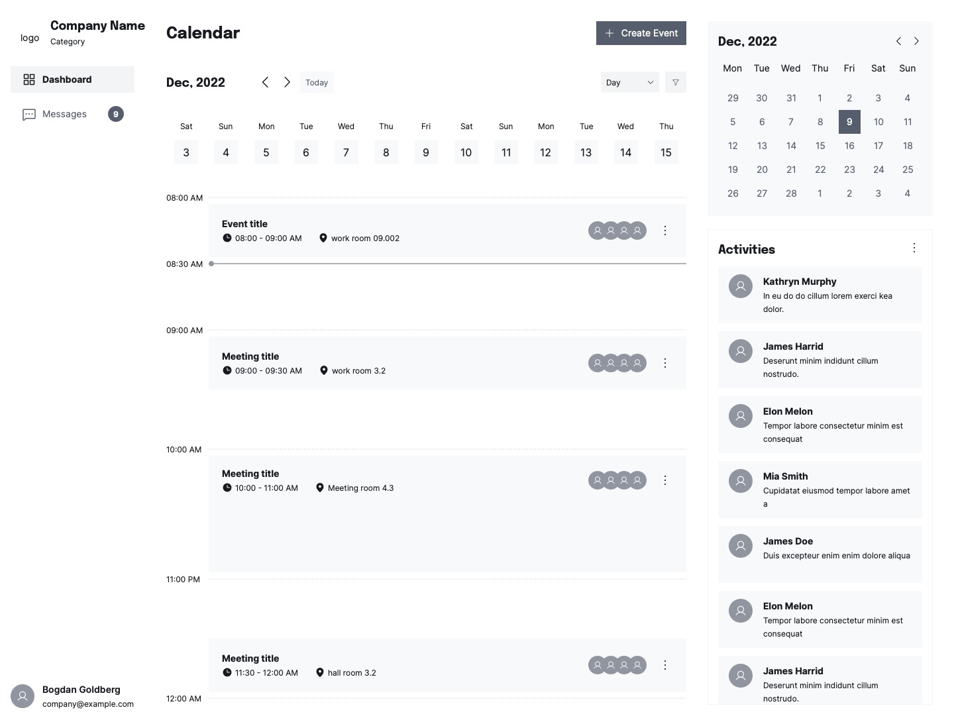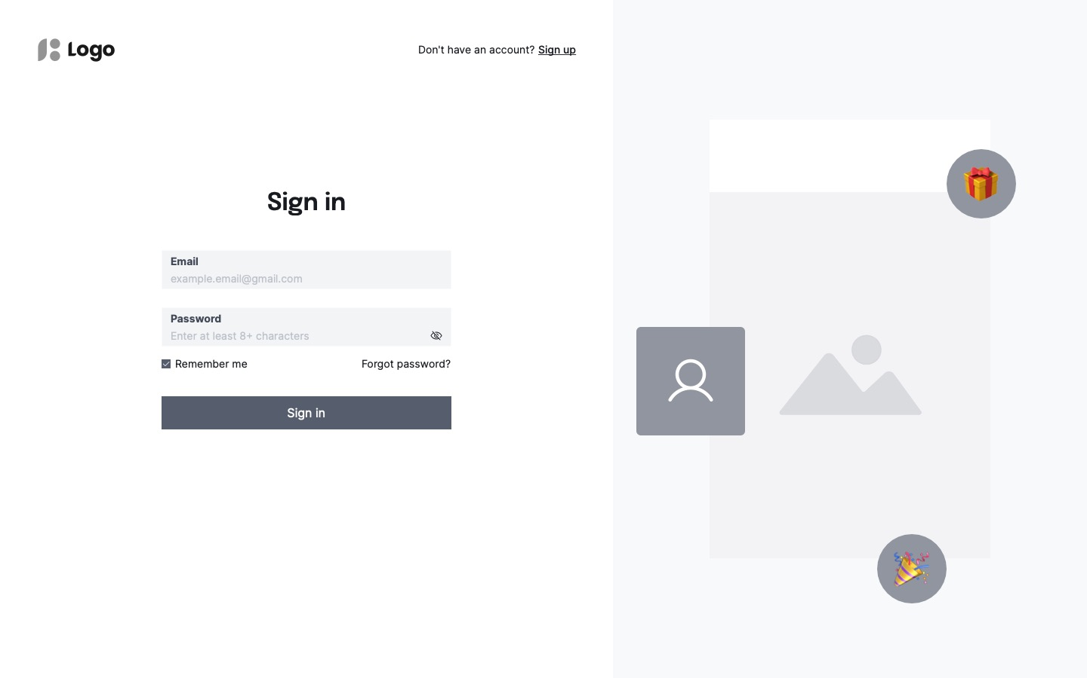

**5. Planning**

