# Storyline:

Once upon a time in the jungle, there was a lumberjack called “brute”. One day he was very drunk as usual and after having some lunch he was going back to work again to collect some timber. As soon as he started swinging his axe, a bunny tries to tease the lumberjack (dancing). Seeing this drunk lumberjack becomes very angry and tries to kill the rabbit. The brute tries to chase the notorious bunny. The bunny eventually escaped and brute stumbles upon the stone and fall.

## Implementation:

The scene is created using Unity real-time engine. The following components are involved in creating this scene:

Timeline: The play sequences are created using the timeline. It includes animation keyframes and various objects lifecycles including brute and the bunny. It also includes the audio tracks used for the scene and the cinemachine virtual cameras as well.

Animation Tracks: Various animation tracks are created using various animated rigs from various sources [1][2]. Some of the bunny animations are pre-loaded with the asset [3]. The positions of the interacting objects are set accordingly in the animation track.

Camera: For this scene, *Cinemachine* virtual cameras have been used. The cameras are setup focussing on various objects and positions in the scene.

Audio Tracks: The audio tracks are used to illustrate various situations in the scene [4].

## Animations:

For the scope of this project, the animations are played in two ways: within the scene timeline and, using the animator controller and scripting. The animations like the *bunny jump*, *bunny dance* and *brute chop* can be triggered via key controls.

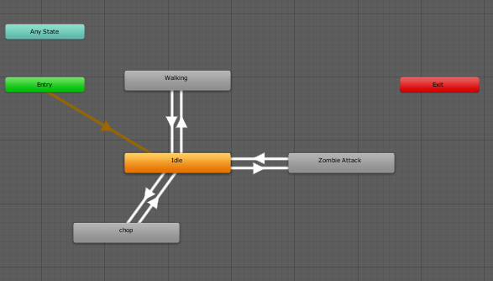

Figure : Brute Animator

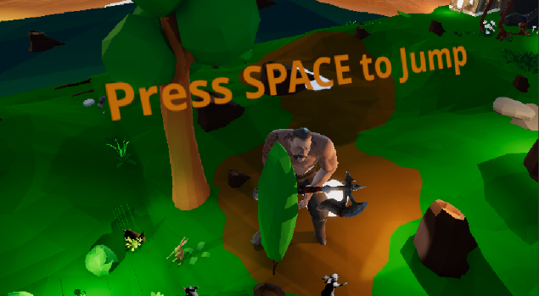

Figure : Interactive Gameplay

### Arcs:

In the scene, the bunny is hopping over the stumps in the arcs. For the arcs, trajectory motion equations [5] have been implemented.

Equation of the range/max distance:

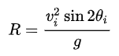

Figure : Range [5]

The height of the bunny can be given by:



Figure : Height at given distance x [5]

The splines are created and bunny is made to move.

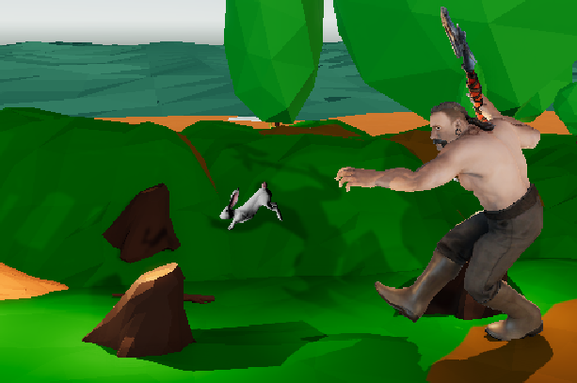

Figure : Bunny Hop on splines

### Anticipation:

In this scene, the anticipation has been implemented using the animation keyframes and modifying the animation rigs.

#### Scene 1:

The brute tries to swing his axe, but when he tries to swing his axe, he moves the hand far away than the normal position and moves his right leg backwards for a better momentum. This is done to give the viewer a hint that brute is going to swing his axe.

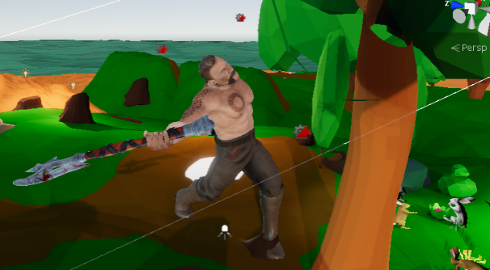

Figure : Brute Exaggeration

#### Scene 2:

The bunny escaped from the brute’s attack when the brute lifts his axe, he got surprised. He responded to the situation by looking left, right and then down to find the bunny.



Figure : Brute in pursuit of finding Bunny

Scene 3:

The rabbit senses the danger from the brute and tries to jump to stump ahead. Before jumping it moves a step back and then makes a jump.

### Exaggeration:

The exaggeration is implemented using character animations.

#### Scene 1:

When the bunny tries to tease brute with dance, the brute turned towards the bunny making his head rotate and leaning his body backwards, an expression of the anger.

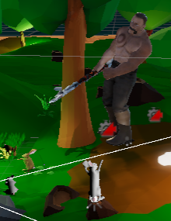

Figure : Brute exaggerated move

### Ease-in, Ease-out:

The ease-in and ease-out feature have been implemented inside the timeline for a smooth transition between various animation clips and for the camera transitions. For example, the rabbit was running initially and then it made a jump on the tree stump.

### Squash and Stretch:

The squash and stretch feature has been implemented using the scaling of the character.

#### Scene 1:

The bunny scaling is increased in x and z-direction and reduced in y-direction when it lands on the stump floor the tree stump floor.

#### Scene 2:

Likewise, brutes scaling is increased in x and z-direction and reduced in y-direction when he stumbles on the ground.

## Additional features:

* As the brute (lumberjack) is drunk, so his walking style is also weird.
* The bonfire has been implemented.
* Lighting.
* Motion editing is implemented for various clips.

# References

[1] Mixamo.com. *Mixamo*. [online] Available at: <https://www.mixamo.com/>.

[2] Assetstore.unity.com. *Unity Asset Store - The Best Assets for Game Making*. [online] Available at: <https://assetstore.unity.com/>.

[3] Unity Asset Store - The Best Assets for Game Making. (2018). *Rabbit Package - Furry and Low Poly*. [online] Available at: <https://assetstore.unity.com/packages/3d/characters/animals/rabbit-package-furry-and-low-poly-101234>.

[4] Freesound.org. *Freesound - Freesound*. [online] Available at: <https://freesound.org/>.

[5] En.wikipedia.org. *Projectile motion*. [online] Available at: <https://en.wikipedia.org/wiki/Projectile_motion>.