Observation of excitons transitions in MoS2 by photocurrent spectroscopy in the low temperature regime

**Electrical characterization of the side contacts at room temperature**

We have done a characterization of the device doing measurements with two contacts and applying a back-gate in the substrate of Si/SiO2 to know the performance of the FET. We have done all the measurements in this section at room temperature and in vacuum (<10-4 mmHg). To perform the measurements, we ground the source contact and apply a voltage in drain, Vsd, measuring the current in the same terminal, Isd. We also apply a back-gate voltage to increase the carriers density of the device and move the Fermi Level.

MoS2 is fully encapsulated with h-BN (hexagonal boron-nitride) and using EBL and electron beam evaporation of Ti/Au (10/50 nm) we defined and deposited side contacts for electric measurements.

In figure 1, we can observe transfer and the output characteristics of the transistor. These curves show an almost hysteresis-free charge transport. We can observe in the output curves an increase of the conductivity in the channel as we apply a voltage bigger than the threshold voltage because of the rise of the charge density carriers. In the transfer curve, we can see the increase of the source-drain current as a function of the back-gate voltage. Over the threshold voltage, occurs a great increase because the Fermi Level is located in the conduction band.

In these curves, we observe that Isd saturates at Vsd. This saturation can be attributed to the ‘pinch-off’ region in the MoS2 channel, because the applied Vsd acts as a gate and can create a depletion region in the channel close to the drain contact. The saturation of the current at such low source-drain voltage shows that these contacts can gate the channel. The Vsd at which the saturation of current happens, depends on the density of charge carriers in the channel. The higher Vg, induces a larger density of charge carriers and therefore charge depletion close to the contacts happens at larger Vsd, so applying a sufficient back-gate voltage we can measure photocurrent without having in consideration the contacts.

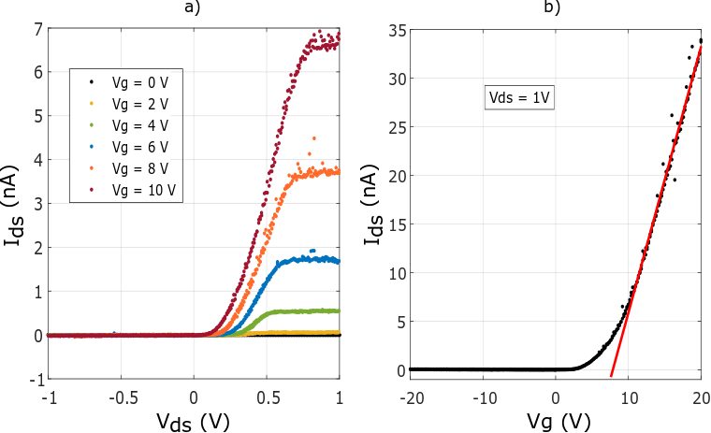

**Figure 1.** Two terminal electrical characterization of the MoS2 encapsulated with h-BN. a) Room temperature output characteristics for different gate voltages. b) Transfer characteristics as a function of the gate voltage, applying a fixed voltage between drain and source.