Machine Learning

Lab-1

Name: Ngu Quoc Phong

ID: 17110060

CLASSIFICATION

1. KNN

1.1 KNN with Iris Dataset

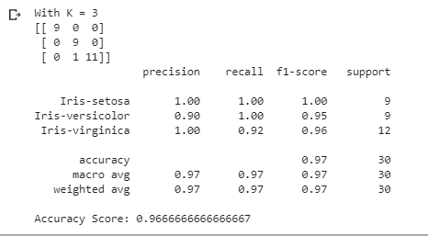

1.2 KNN with Lung Cancer Dataset

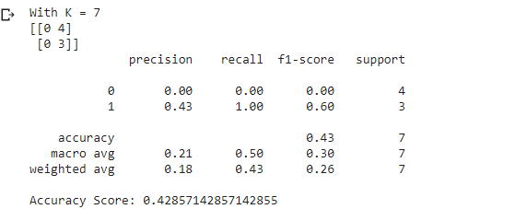

1.3 KNN with Breast Cancer Dataset

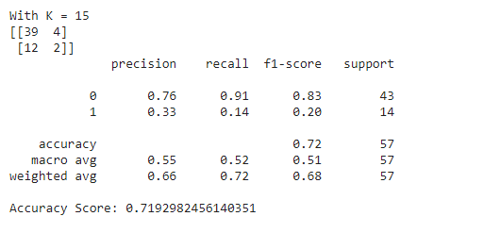

2. Random Forest

2.1 Random Forest with Iris Dataset

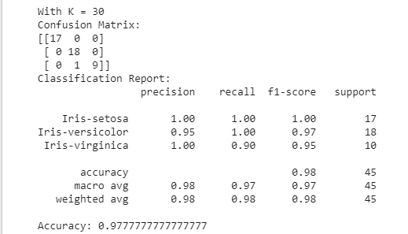

2.2 Random Forest with Lung Cancer Dataset

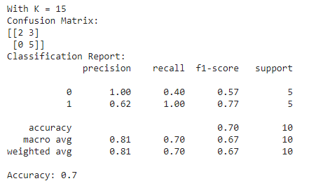

2.3 Random Forest with Breast Cancer Dataset

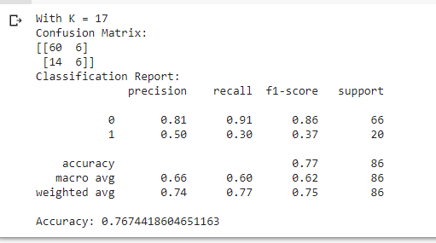

3. Decision Tree

3.1 Decision Tree with Breast Cancer dataset

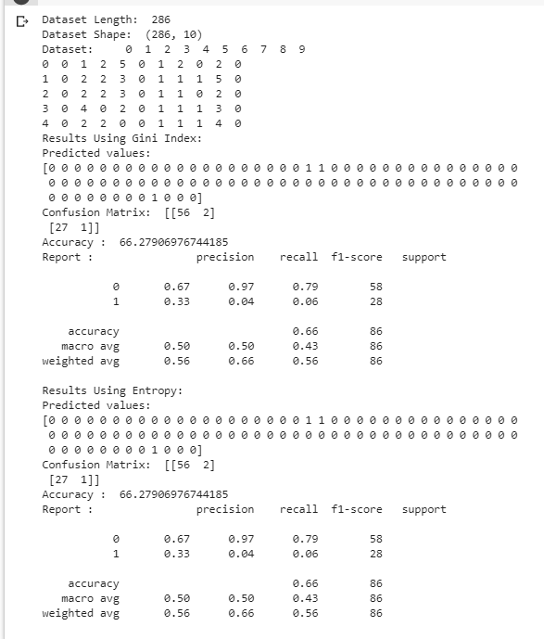

3.2 Decision Tree with Lung Cancer dataset

