**Stopwatch Application**

This repository contains the code for a simple and elegant stopwatch application built using HTML, CSS, and JavaScript.

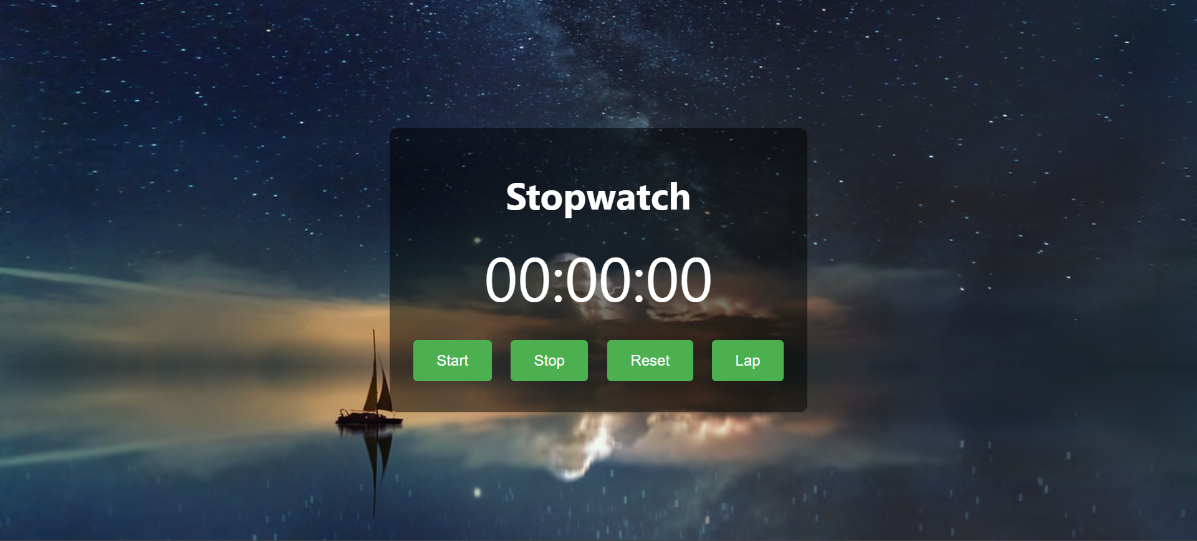

**Features**

* Start, stop, and reset the timer
* Record lap times
* Responsive design with a stylish background image
* User-friendly interface

**Getting Started**

**Prerequisites**

To run this project locally, you need a web browser. No additional installations are required.

**Usage**

* **Start**: Click the Start button to start the stopwatch.
* **Stop**: Click the Stop button to stop the stopwatch.
* **Reset**: Click the Reset button to reset the stopwatch to 00:00:00.
* **Lap**: Click the Lap button to record the current time as a lap.

**Project Structure**

* index.html: The main HTML file containing the structure of the application.
* styles.css: The CSS file for styling the application.
* script.js: The JavaScript file containing the functionality of the stopwatch.

**Customization**

You can customize the appearance of the stopwatch by modifying the styles.css file. For example, you can change the background image, button colors, and fonts.

**Contributing**

Contributions are welcome! If you have any improvements or new features to add, please create a pull request.

**Acknowledgements**

* Background image used from [source].

**Contact**

If you have any questions or feedback, feel free to reach out to [your email].