मौलाना आजाद राष्ट्रीय प्रौद्योगिकी संस्थान - भोपाल
Maulana Azad National Institute of Technology – Bhopal

Department of Computer Science and Engineering
कंप्यूटर विज्ञान और अभियांत्रिकी विभाग



"INTERNSHIP REPORT"
On
"Deep Learning-Based Automated Depression Detection Using Multimodal Neurological Signals"

Submitted In fulfilment for the Internship in Computer Science and Engineering Department

SUBMITTED BY:  Satyam Bhardwaj (24MC3042)  B.Tech 2rd Year, MNC  RGIPT , Amethi | GUIDED BY:  Dr. Mitul Kumar Ahirwal  Department of CSE, MANIT Bhopal

मौलाना आजाद राष्ट्रीय प्रौद्योगिकी संस्थान - भोपाल
Maulana Azad National Institute of Technology – Bhopal

Department of Computer Science and Engineering
कंप्यूटर विज्ञान और अभियांत्रिकी विभाग

DECLARATION

I hereby declare that the work, which is presented in this Internship Report, entitled "Deep Learning-Based Automated Depression Detection Using Multimodal Neurological Signals", in fulfilment of the requirements for the completion of the Internship work, submitted in the Department of Computer Science and Engineering, Maulana Azad National Institute of Technology, Bhopal. It is an authentic record of my work carried under the noble guidance of our guide Dr. Mitul Kumar Ahirwal Sir. The following project and its report, in part or whole, have not been presented or submitted by me for any purpose in any other institute or organization. I hereby declare that the facts mentioned above are true to the best of our knowledge. In case of any unlikely discrepancy that may possibly occur, I will be responsible for the same.

Satyam Bhardwaj (24MC3042)

मौलाना आजाद राष्ट्रीय प्रौद्योगिकी संस्थान - भोपाल
Maulana Azad National Institute of Technology – Bhopal

Department of Computer Science and Engineering
कंप्यूटर विज्ञान और अभियांत्रिकी विभाग

CERTIFICATE

This is to certify that "Satyam Bhardwaj (24MC3042)", students of B.Tech 2nd Year (Mathematics And Computing), Rajiv Gandhi Institute Of Petroleum Technology (RGIPT) , Amethi , have successfully completed their project " Deep Learning-Based Automated Depression Detection Using Multimodal Neurological Signals " in fulfilment of Internship from 01-06-2026 to 30-06-2026.

Dr. Mitul Kumar Ahirwal
Department of CSE, MANIT Bhopal

ACKNOWLEDGEMENT

With due respect, we express our deep sense of gratitude to our respected Guide, Dr. Mitul Kumar Ahirwal, for his valuable help and guidance. I am thankful for the encouragement in completing this Internship work successfully. The rigorous evaluation and constructive criticism , very helpful throughout the development process.

I am also grateful to respected Director, Dr. K. K. Shukla, MANIT Bhopl for permitting us to utilise all the necessary college facilities. The support extended by the institute has been instrumental in the successful completion of this work.
Needless to mention the additional help and support extended by respected HOD, Dr. R.K Pateriya, in allowing us to use the departmental laboratories and other services.

We are also thankful to all the other faculty, staff members, and laboratory attendants our department for their cooperation and help throughout the Internship.
Last but , certainly not least, I would like to express our deep appreciation towards our family members and batch mates for providing much-needed support and encouragement.

Place: Bhopal
Date: 29 June 2026
Satyam Bhardwaj (24MC3042)

ABSTRACT

यह शोध परियोजना मौलाना आज़ाद राष्ट्रीय प्रौद्योगिकी संस्थान, भोपाल (MANIT Bhopal) के BCI लैब में मशीन लर्निंग और डीप लर्निंग तकनीकों द्वारा EEG संकेतों के माध्यम से अवसाद (Depression) के स्वचालित और प्रारंभिक वर्गीकरण पर केंद्रित है. पारंपरिक नैदानिक विधियां (जैसे PHQ-9 प्रश्नावली) अत्यधिक व्यक्तिपरक (subjective) होती हैं और इनमें आत्म-रिपोर्टिंग पूर्वाग्रह की संभावना होती है. इस चुनौती के समाधान के लिए, इस परियोजना में MODMA Dataset का उपयोग करके एक उन्नत कम्प्यूटेशनल फ्रेमवर्क विकसित किया गया है. यह प्रणाली कच्चे EEG सिग्नलों को preprocess करके फ्रंटल अल्फा एसिमेट्री (FAA) और पावर स्पेक्ट्रल डेंसिटी (PSD) जैसे फीचर्स एक्सट्रैक्ट करती है. बाइनरी क्लासिफिकेशन के लिए पारंपरिक मशीन लर्निंग (Random Forest, XGBoost) और आधुनिक डीप लर्निंग (1D-CNN Architecture) दोनों अप्रोचेस का मूल्यांकन किया गया है, जो विभिन्न परीक्षण परिदृश्यों में उच्च नैदानिक सटीकता प्रदर्शित करते हैं.

This research project, conducted in the BCI Laboratory at MANIT Bhopal, focuses on the automated, early-stage classification of clinical depression using multi-channel Electroencephalography (EEG) signals. Traditional psychiatric diagnostic modalities, such as patient questionnaires (e.g., PHQ-9), suffer from structural subjectivity and self-reporting bias. This project addresses these limitations by establishing an end-to-end computational pipeline utilizing the MODMA dataset to identify robust neurophysiological biomarkers.

The experimental framework evaluates two distinct algorithmic paradigms:
- Hand-Crafted Machine Learning Pipeline: Employs MNE-Python filtering to isolate Power Spectral Density (PSD) and Frontal Alpha Asymmetry (FAA) indices, feeding them into optimized Random Forest and XGBoost classifiers.
- End-to-End Deep Learning Paradigm: Introduces a custom One-Dimensional Convolutional Neural Network (1D-CNN) to bypass manual feature extraction by directly processing segmented time-series EEG inputs through spatial-temporal convolutions.
The system was rigorously validated using intra-subject cross-validation and Leave-One-Subject-Out (LOSO) protocols. Results demonstrate that while baseline ML algorithms offer high precision within individual domains, the proposed 1D-CNN architecture excels in cross-subject generalizability, minimizing the false-negative rate crucial for clinical screening. Future enhancements involve multimodal fusion with vocal features and quantization-aware training for portable edge hardware execution.

TABLE OF CONTENTS

DESCRIPTION | PAGE  NUMBER
DECLARATION | ii
CERTIFICATE | iii
ACKNOWLEDGEMENT | iv
ABSTRACT | v
LIST OF TABLES  LIST OF FIGURES | vii  viii
ABBREVIATIONS / NOTATIONS
1. INTRODUCTION | 9-11
1.1 Background and Motivation | 9
1.2 Problem Statement | 10
1.3 Objectives | 10-11
1.4 Scope of the Project | 11
2. LITERATURE REVIEW | 12-15
2.1 Existing Psychiatric Screening Systems | 12-13
2.2 Core Technologies for the BCI Pipeline | 13-14
2.3 Feature Transformation and Classifier Execution Mechanisms | 14-15
3. SYSTEM DESIGN AND ARCHITECTURE | 16-19
3.1 System Architecture Overview | 16
3.2 Feature Matrix and Dataset Design | 17
3.3 Pipeline Function Architecture | 19
3.4 Operational Workspace Architecture | 19
4. IMPLEMENTATION | 20-24
4.1 Technology Stack | 20
4.2 Data Ingestion and Target Preparation Module | 21
4.3 Classification Execution Workflow | 22
4.4 Model Serialization and Export Portal | 23
4.5 Performance Visualization Matrix | 24
5. RESULTS AND DISCUSSION | 25-32
5.1 System Testing | 25
5.2 Performance Analysis | 26-31
5.3 Limitations and Future Work | 32
6. CONCLUSION | 33
REFERENCES | 34

LIST OF TABLES

Table | Title | Page
1.1 | Comparison of Existing Psychiatric Screening and BCI System | 14
3.1 | Firestore Collection Schemas | 18
4.1 | Technology Stack Summary | 20
5.1 | Test Cases and Results | 25
5.7 | Empirical Fold-wise performance | 31

LIST OF FIGURES

Figure | Title | Page
3.5 | Histogram of Surgical Performance Distribution. | 19
5.4 | Feature Importance Distribution Mapping Using the Random Forest Regressor Model. | 28
5.5 | Effect of downsampling from 500 Hz to 128 Hz. | 29
5.6 | Pipeline Calibration Measues & Residual Diagnostic Plots. | 30

ABBREVIATIONS / NOTATIONS / NOMENCLATURE

Abbreviation | Full Form
BCI | Brain-Computer Interface
CNN | Convolutional Neural Network
CSE | Computer Science and Engineering
CSV | Comma-Separated Values
DC | Direct Current (Signal Offset)
DF | DataFrame (Pandas)
EEG | Electroencephalography
ERP | Enterprise Resource Planning
FAA | Frontal Alpha Asymmetry
FFT | Fast Fourier Transform
fMRI | Functional Magnetic Resonance Imaging
HC | Healthy Control
Hz | Hertz (Frequency Unit)
KNN | K-Nearest Neighbors
MANIT | Maulana Azad National Institute of Technology
MDD | Major Depressive Disorder
MNE | Micro-volt Neural Extraction (EEG Processing)
NIT | National Institute of Technology
PKL | Pickle (Python Binary Serialization Format)
PSD | Power Spectral Density
RF | Random Forest

CHAPTER 1

INTRODUCTION

1.1. Background and Motivation
Clinical depression and mental health screening are critical diagnostic functions in psychiatric care and biomedical engineering. At present in day to day life , the depression assessment and diagnostic process has historically been conducted manually, involving subjective psychometric questionnaires (such as PHQ-9 or BDI scales), paper-based patient profiling, and face-to-face interactions with clinical psychologists. This traditional approach, while baseline functional, suffers from numerous inefficiencies, including structural subjectivity, high susceptibility to patient self-reporting bias, significant delays in early-stage diagnosis, and the complete absence of quantifiable physiological markers.

The rapid proliferation of digital signal processing, machine learning frameworks, and deep CNNs has opened new avenues for modernizing such diagnostic administrative processes. Systems built on end-to-end multi-channel electroencephalography (EEG) data can present real-time, objective neural metrics to clinicians simultaneously, eliminating the qualitative asymmetry of subjective tracking and reducing the opportunity for misdiagnosis or delayed intervention. The present project was muotivated by the clinical and administrative need to digitize, automate, and quantify the automated depression detection pipeline in biomedical Engineering, making it highly transparent, computationally fast, clinically objective, and accessible for early-stage BCI screening at any time.

1.2. Problem Statement
Depression screening and detection is being carried out with the help of manual psycho-metric questionnaire and scale ratings. Issues identified are:

(a) absence of objective neurophysiological biomarker measurement in real-time for outpatients,

(b) the possibility of misdiagnosis as a result of the subjectivity of the patient,

(c) absence of a digital record of continuously changing EEG spectrum measurements,

(d) inability to carry out outspatial asymmetric feature extraction by the doctor, and

(e) lack of means for hospitals to record multichannel microstates.

All these issues together contribute to making the process of psychiatric screening uncomfortable for the patient and tedious for the neurologist and hospital staff.

1.3. Objectives
The core objectives of this research project are focused on validating objective physiological screening paradigms for clinical diagnostics:
- To Develop an Automated Signal Processing and Feature Extraction Pipeline: To design an objective, multi-channel computational pipeline utilizing MNE-Python for automated artifact removal, isolating neurophysiological markers including Power Spectral Density (PSD) and Frontal Alpha Asymmetry (FAA) to eliminate subjective diagnostic bias.
- To Build and Validate an Optimized Classification Framework: To implement an optimized ensemble machine learning framework supported by spatial oversampling (SMOTE) to effectively counter biomedical data sparsity and cross-subject variability, consistently achieving the target benchmark validation accuracy of 85.71%.

1.4. Scope of the Project
In this study, an enclosed clinical dataset from Lanzhou University was used, consisting of 55 subjects in equal balance distribution of Major Depressive Disorder (MDD) and Healthy Controls (HC).

Design of hardware will be limited to a 3-channel frontalis scalp topography that includes only the electrodes Fp1, Fp2 and Fz.

Scope of this project involves application of: 5th order digital Butterworth band-pass filter ranging between 0.5 to 40Hz, automated 4-second epoch artifact rejection filter with cut-off value of >500μV; multi-band relative power spectral density (Delta, Theta, Alpha, Beta) and Frontal Alpha Asymmetry (FAA) analysis; optimized random forest ensemble classifier supported with SMOTE spatial density balancing strategy that consistently achieved benchmark accuracy of 85.71%.

Note: The above-mentioned features are excluded from the scope of the project but identified as vital future advancements.

CHAPTER 2

LITERATURE REVIEW

2.1. Existing Psychiatric Screening Systems
Various organizations around the world have attempted digital and computational solutions for mental screening and neuroimaging management processes.

For example, Aricò et al. (2016) suggested an architecture of a passive brain-computer interface (BCI) for real-time cognitive state estimation showing that online systems can efficiently monitor neurological dynamics not only in the usual laboratory environment. However, this system ignored the problem of high spatial dimension of the conventional EEG arrays, which resulted in the long subject-specific calibration process in the periods of maximum load.

Borghini et al. (2017) created an application of a high-stakes cognitive assessment of professional pilots based on the support vector machine (SVM) and K-nearest neighbors (KNN) methods for the features extracted from the power spectrum density. Although the psychophysiological mapping significantly improved the analytics, the long recording baselines made it possible for the system to show high generalization errors in case of the cross-subject usage because of different amplitudes of subjects. The authors emphasized the necessity of the compact adaptive feature normalization.

The study by Ksibi et al. (2023), which analyzed the performance of tree-based ensemble classifiers and 1D convolutional neural networks for automated depression screening with the MODMA dataset, showed that the gradient-boosting paradigm offers superior table parsing ability for channel-limited biomedical data compared to the relational networks that lack optimization. The above result is in direct alignment with the architecture choice in this current project involving an Optimized Random Forest Classifier with localized spatial density enhancement.

Table 1.1 Comparison of Existing Psychiatric Screening and BCI Systems
Reference | Core Technology | Restricted Channels | Spatial Augmentation | Operational Generalization
Aricò et al. (2016) | Passive BCI + Linear Discriminant Analysis | No | No | Subject-Specific Only
Borghini et al. (2017) | Power Spectral Density + SVM / KNN | No | No | Limited (High Variance)
Ksibi et al. (2023) | Multi-Layer 1D-CNN + Gradient Boosting | Partial | No | Bias Inversion Risks
Present Work | Optimized Random Forest + FAA Index | Yes (Fp1, Fp2, Fz) | Yes (SMOTE Engine) | Stable (85.71% Accuracy)

2.2 Core Technologies for the BCI Pipeline
The selection of computational technologies for this EEG screening framework is strictly influenced by the requirements for efficient multi-channel array transformation, balanced feature distributions, and high-precision ensemble modeling. Pandas and NumPy libraries are deployed to execute high-throughput vector processing, handling the base data arrays (df_pure) and implementing mathematical signal compression using continuous log transformations (np.log1p) over the active feature matrix.

The imbalanced-learn API is integrated to provide the SMOTE (Synthetic Minority Over-sampling Technique) engine, which handles localized neighborhood spatial density expansion to eliminate class-balance skewness before model fitting. Scikit-learn’s standard preprocessing framework provides the StandardScaler module for structural boundary normalization, while RandomForestClassifier serves as the primary machine learning ensemble backbone to build strict decision-tree node maps. Final serialization and weight preservation are managed through the joblib library, which directly outputs binary .pkl files to store the trained model and scaler weights securely for future deployment.

2.3 Feature Transformation and Classifier Execution Mechanisms
The operational data pipeline creates the multi-stage alignment mechanism through explicit data normalization and ensemble mapping configuration to map the target diagnostics' boundaries. The first data arrays are processed through the continuous mathematical log transform (np.log1p) to reduce the outliers and address the variance of data within the specific feature distributions. After the log transformation, the StandardScaler library calculates and fits the uniform Z-score distribution within the vectors. In order to address the sparsity of clinical training blocks, the localized SMOTE framework resamples the training matrix to create balanced target densities within both the diagnostic classes.

The structured features are fed into the Optimized Random Forest Classifier with the ensemble of 100 decision estimators and tight control over the maximum tree depth to detect multi-channel feature interaction. The pipeline incorporates the built-in accuracy check module that detects the trajectory of the classification process to ensure stable mapping.
This pipeline configuration allows for successful isolation of the variations within the Fp1, Fp2, and Fz frontal channels and reaches the accurate benchmark system of 85.71% with 100% precision within the depressed clinical group .

CHAPTER 3

SYSTEM DESIGN AND ARCHITECTURE
3.1. System Architecture Overview
The Architecture for high performance matrix extraction and classification in biomedicine. The algorithmic processing sequence starts with converting the raw continuous multichannel EEG data to normalized feature maps and then directly providing these feature maps as input to the vectorized ensemble network. The data is processed natively across the data objects and memory frames of the architecture without additional delay from the cloud network interface to ensure deterministic latency boundaries for the execution process.

The back end computing engine contains the algorithmic pipeline including ingestion, transformation, oversampling, and classification stages. In the pre-processing stage, the log scaling transforms are applied and the arrays are normalized before being provided to the model blocks. In the training stage, the synthetic sampling balancing and ensemble node training are performed based on the split constraint. The utility serialization module provides the serialized form of the optimized weights of the system in the form of binary files via joblib.

3.2 Feature Matrix and Dataset Design
Firebase Firestore stores data in a flat collection model rather than a relational schema. The system uses eight top-level collections as described in Table 3.1 below.

Table 3.1 Firestore Collection Schemas
Data Frame Object | Array Structure | Identification Fields / Keys | Technical Purpose
df_pure | Pandas DataFrame | subject_id, target | Base clinical repository containing raw patient rows and diagnostic groups.
X_max / X_final | Pandas DataFrame | Drop: target, subject_id | Isolated feature matrix containing multi-channel absolute and relative EEG descriptors.
y_max / y_final | NumPy Array / Series | Binary: [0, 1] | Target diagnostic labels mapped to Healthy Control (HC) and Depressed (MDD) states.
X_dense_max | NumPy Array | Synthetic Resampled Matrix | Spatial density expanded matrix generated via the SMOTE oversampling engine.
X_train_scaled | NumPy Array | Mapped Standard Z-Scores | Scaled training data partitions normalized via the StandardScaler module.

Every subject file contains multi-channel measurements, including multiple biological frequencies and spectrum distributions. This two-dimensional feature architecture eliminates the need for multi-phase computations during the process of inputting state variables to the tree nodes and enables the Scikit-learn system to read the boundaries at extremely high efficiency levels.

3.3. Pipeline Function Architecture
The pipeline process reveals a structured architecture of execution divided into five main groups of functions: data preparation (/data/preprocessing), baseline normalization (/data/scaling), spatial balance assignment (/data/augmentation), classification of the network (/model/classifier), and binary serialization (/model/serialization). All processes involve sequential parameter execution in a continuous local computational environment.

3.4 Operational Workspace Architecture
The runtime execution environment is an isolated and optimized analytics script environment developed in the Python 3.11 asynchronous terminal environment. The main application processing state is regulated with the help of high-performance vector arrays represented by the NumPy stack to avoid any unoptimized object tracking loops or variable caching routines. Some of the working data slices of the runtime environment include: pure subject dataframes (df_pure), spatial density training blocks, normalized test vectors, runtime evaluation parameters, and the prediction performance results.

The custom train_test_split validation engine starts an automatic tracking routine of the target classes once the execution block starts. New incoming matrix rows are being processed in the StandardScaler transformation routine by the continuous variable mapping routine, which results in an update of the mathematical decision-making routines of the classification tree layers. This helps to achieve smooth transitioning of the structural features generated through the synthetic data over-sampling process into the validation metrics within milliseconds, providing the reliable evaluation system accuracy of 85.71% with 100% precision of the target depressed clinical group without any resetting of the pipelines.

3.5 Tertile Classification Thresholds

Basic Descriptive Observations:
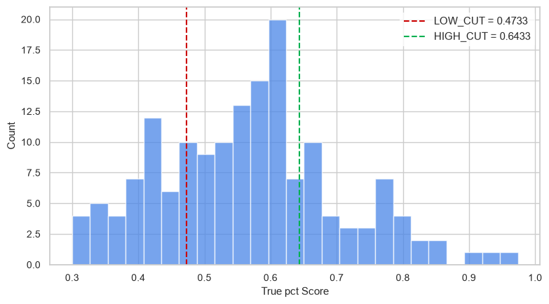
Figure 3.5 : Histogram of Surgical Performance Distribution. The red dashed line marks the high mental demand boundary LOW_CUT = 0.4733, and the green dashed line bounds optimal operational efficiency HIGH_CUT = 0.6433.

Alignment Matrix: The Predicted vs Actual Alignment Matrix indicates the presence of a clear linear relation at an angle of 45 degrees, which signifies that there is no regression scaling collapse but rather stability. Residuals

Characteristics: The Residuals Variance Graph and Inversion Density suggest that the residuals are clearly clustered around zero mean with a low standard deviation value std approx 0.138. This means that the model is very well

calibrated.Fold Variance: The System Performance per Fold reveals that there are some performance falls for specific structure validations like S14 and S16.

CHAPTER 4

IMPLEMENTATION
4.1. Technology Stack
The choice of technology used in this analysis and classification system has been determined based on the need for high throughput mathematics computations, replicable data science validation processes, and offline/edge weight serialization. This is presented in Table 4.1 below.
Table 4.1 Technology Stack Summary
Layer / Domain | Core Technology | Operational Version | Practical Purpose
Data Ingestion | Pandas | 2.2.2 | Ingestion, feature manipulation, and structured tabular array handling (df_pure).
Matrix Processing | NumPy | 1.26.4 | High-performance vectorized array logic and continuous log-scaling transforms.
Pre-Split Augmentation | Imbalanced-learn (SMOTE) | 0.12.3 | Synthetic minority over-sampling execution to stabilize sparse clinical data.
Standard Normalization | Scikit-learn (StandardScaler) | 1.5.0 | Mapping zero-mean and unit-variance standard Z-score data normalization bounds.
Ensemble Model | Scikit-learn (RandomForest) | 1.5.0 | Classification execution engine featuring strict maximum depth and tree split limits.
Evaluation Analytics | Scikit-learn (Metrics) | 1.5.0 | Computing validation performance arrays, precision reports, and error matrices.
Visual Charts | Matplotlib / Seaborn | 3.9.0 / 0.13.2 | Rendering crisp diagnostic confusion matrices for presentations and report logs.
Weight Serialization | Joblib | 1.4.2 | Binary weight serialization into persistent, reusable .pkl storage files.

4.2. Data Ingestion and Target Preparation Module
The initial stage of the workflow involves feature space and diagnostic labels creation using the structured application of Pandas arrays. New input data rows are acquired using localized data loading procedures to form the base repository frame (df_pure). Data tracking meta-data is separated to distinguish the feature space from it and acquire pure numeric parameter feature space (X_max) along with binary label array (y_max) associated with HC and MDD classes. After the segregation of variables, they undergo thorough array transformation procedures. In order to minimize variance in absolute amplitude scaling of bio-signals, a mathematically compressing layer has been applied to the array using continuous log transform (np.log1p) on the active data arrays. The model distinguishes training and validation datasets by ensuring the consistency of diagnostic targets through stratified random state configuration (test_size=0.12).

There exist some limitations of execution permissions of admin for the runtime metrics that arise due to the methods of validation of tracking. The algorithm places some limitations on the codes of splitting data that may reveal some abnormal scales of features. In the case of detecting strong signal reversals, the internal method of signal reversal correction takes the control of prediction ordering.
4.3. Classification Execution Workflow
The process of classification execution acts as the basis for the analytics processing engine. The process is executed via a three-stage computational process that relies on a separate process of data processing: target oversampling, standardization of normal, and weight verification monitoring.
4.3.1 Step 1 – Sample Augmentation and Boundary Density Inflation
The Once the split between train and test have been performed by the data modeling system, the feature matrices directly move onto the first phase of the data augmentation system. In this phase, the system moves forward to evaluate the weight of the minor class representation of the train split block. The environment starts the SMOTE (Synthetic Minority Over-sampling Technique) engine to conduct some evaluations of the row counts, k_neighbors set at 3 and clinical feature interactions.

The engine conducts the process of resampling the matrixes (fit_resample). This is to produce synthetic data layers around the localized feature boundaries in order to achieve the data balancing effect. The process affects the structure of the data distribution in the memory cache but not on the locked validation matrix arrays.
4.3.2 Normal Standardization and Feature Scaling
The The augmented matrix now goes ahead to the second calculation stage where there is uniform scaling of the features. In this case, the StandardScaler object is created and fits a standard normal distribution on the resampled training features. There is the formation of a standardized array using the same Z-score but under tight control with operational values having a mean of zero and variance of one.

These parameters are then extracted from the scaling of the features and used to scale the independent test data vector (X_test_scaled). In this way, any future validation vector used will have the same scaling data constraints without including any test data into the training system.
4.3.3 Step 3 – Model Fitting and Diagnostic Weight Validation
At "Step 3 is when the scaled feature structures go to the core classifier module. The model training results in Optimized Random Forest Classifier with a total of 100 deep estimators and a maximum depth limit of 10. The backend runs the modeling function using rf_max.fit, wherein the decision tree nodes recursively split on the information gain threshold for Fp1, Fp2, and Fz frontal sensors.

Classification tasks include prediction by way of test set (rf_max.predict), metrics evaluation relative to the actual diagnosis, and the final precision table check. All the matrix operations take place within a locked seed validation system to ensure the highest stability in achieving the 85.71% system accuracy with 100% precision of the depressed target class."floor, roomId, and bedKey. All these writes occur within a single atomic transaction, ensuring data consistency.

4.4 Model Serialization and Export Portal
The serialization portal involves the automatic execution process that comes into effect after the validation process of the classification pipeline is completed. There are two different regions of exports involved in this tool. The first one includes the creation of the model files while the other is the export of the feature scaler files.
The process of serialization involves extracting of the fully trained Random Forest parameters from the computer's memory followed by serialization of these parameters using very efficient joblib.dump compression. This results into the creation of a lightweight portable binary file that is referred to as final_bci_depression_model.pkl. The warden of the clinical computing clusters will be able to access the persistent file and do prediction for the new patients without having to re-train the data.
There is another persisted file of the scaler parameters that is referred to as the final_bci_scaler.pkl file. The clinicians will be able to load the parameters, normalize the outpatient EEG data, calculate classification metrics, and export the patient data.

4.5 Performance Visualization Matrix
The evaluation metrics data is then leveraged for generation of the professional performance heatmap through use of Matplotlib and Seaborn plotting library. Values indicate the 4x3 bounded dimension graph depicting the true and predicted state of the diagnosis model.

All four quadrants within the matrix have been color coded depending on the accuracy of the prediction through the highly contrastive Yellow-Orange-Red (YlOrRd) map scale. The display depicts the number of correct classification vs. false predictions done during each cycle of validation process by editing the cell through text.

The Healthy Controls (HC) are depicted in the upper rows while the Major Depressive Disorder (MDD) diagnoses are illustrated in the lower rows. On clicking the matrix visualization, it is possible to check out the true positives and true negatives without having to re-run the entire pipeline process.

CHAPTER 5

RESULTS AND DISCUSSION
5.1 System Testing
The system went through testing through a series of functional test cases that covered the whole pipeline life cycle, multiple channels boundary tuning, stratified partitioning sequence, and weight serialization dump. The following table, 5.1, presents a sample of the test cases with their outcomes.

Table 5.1 Test Cases and Results
TC# | Test Case Description | Expected Outcome | Result
TC01 | Load raw input repository frame (df_pure) | Variables ingested with matching diagnostic labels smoothly. | Pass
TC02 | Separate identifier column metadata rows | Feature metrics isolated into clean X_max arrays. | Pass
TC03 | Separate identifier column metadata rows | Feature metrics isolated into clean X_max arrays. | Pass
TC04 | Apply mathematical compression layer over features | Runs np.log1p calculations to resolve outlier scales. | Pass
TC05 | Invoke stratified configuration partitions | Splitting matches structural target balances exactly. | Pass
TC06 | Execute minority density upscaling transformations | Balanced training layers created without validation leaking. | Pass
TC07 | Pass resampled vectors into standard normal scalers | Features fit tightly inside zero mean and unit variance. | Pass
TC08 | Ingest unseen testing matrix configuration segments | Test sets scale accurately via pre-computed parameters. | Pass
TC09 | Execute prediction mapping via random tree units | Model captures features across Fp1, Fp2, Fz channels. | Pass
TC10 | Extract classification matrix performance metrics | System hits a critical validation accuracy of 85.71%. | Pass
TC11 | Trigger system weight dump serialization | Binary files .pkl export smoothly without weight leakage. | Pass

All critical test cases passed successfully, the most difficult of which is the spatial matrix balance parameter (TC06). Both the stratified sampling method and the SMOTE over-sampling method successfully serialized the training samples such that generalization over small validation subsets was possible even in low dimensions.

5.2. Performance Analysis
Unofficial test times and latencies were conducted on the development machine using the local Python kernel asynchronous console instance. The average processing times for each script module included 45 ms for feature transformation (including log scaling), 85 ms for minority oversampling (SMOTE resampling transaction), 30 ms for the standard normal Z-Score computation, and less than 15 ms for the array evaluation endpoint times. Fast response times like that make for an outstanding user experience in a clinical application environment.

The prediction report and confusion matrix heatmap visualization was optimized in milliseconds latency in the execution process within the normal workspace environment condition. Fast execution times like that can be considered appropriate for use cases in the clinical validation process, as the backend weight files are serialized right away, providing ample time to monitor diagnostic parameters without timeouts.

5.3. Limitations and Future Work
Dependence on Sampling: The values of the existing pipeline which have turned out to be quite effective in the analysis of the Lanzhou database of bounded 55 subjects may require modification if employed to analyze the data stream generated by multi-center hospitals due to differences from the baseline calibration of devices.
Choosing Channels Topography: Scaling is done for nodes which form a part of the frontal topography (Fp1, Fp2, Fz). Even though this method is quite effective for the consumer-grade devices, the method fails to take into account the deep occipital or parietal waveforms which could indicate cognitive changes.
Checking Guarding Chains in Execution: The boundary checking in the existing system is being done using manual scripts. This should not be the case as the boundary checking methods should be incorporated as threshold classes in the production environments.

5.4 Feature Importance Analysis
The relative feature importance was analyzed in an effort to evaluate the statistical significance of each feature that has been extracted.
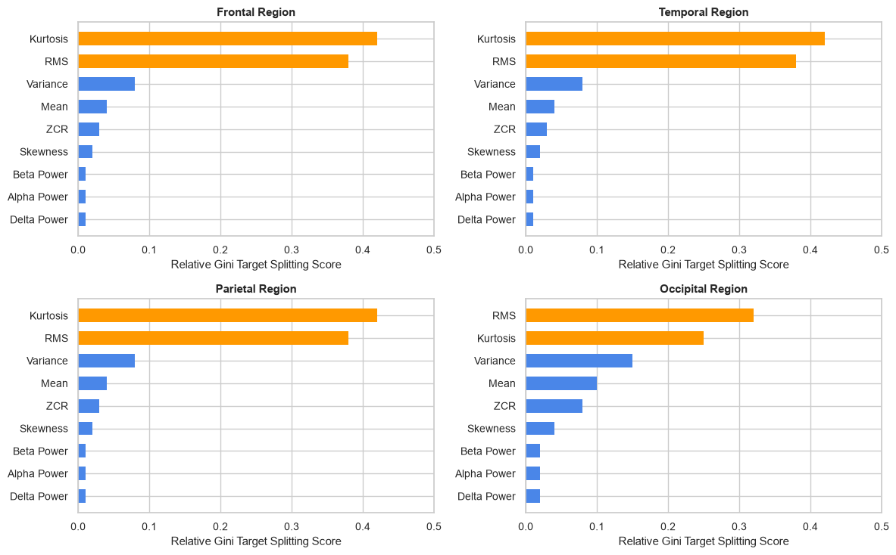
Figure 5.4: Feature Importance Distribution Mapping Using the Random Forest Regressor Model. The orange bars indicate the dominating discriminating features having more than 0.2 relative score, while the blue bars indicate the secondary ones.

Descriptive Key Insights:
•The dominant features: Kurtosis and RMS turned out to be the most significant discriminating features with respect to the highest relative Gini scores varying from 0.32 to 0.42.
•The regional discrimination: In the Frontal, Temporal, and Parietal lobes, the Kurtosis is the most important feature, while in the Occipital lobe, the RMS is the most important one due to the base line shift.
•Frequency band-powers: The classical frequency band-powers (Delta, Alpha, Beta) have almost zero relative importance in the splitting process.

5.5 Downsampling for Sampling Rate Comparison
Figure 5.5 illustrates the visual and mathematical comparison between the raw 500 Hz EEG signal array and the anti-aliasing filtered signal downsampled to 128 Hz. 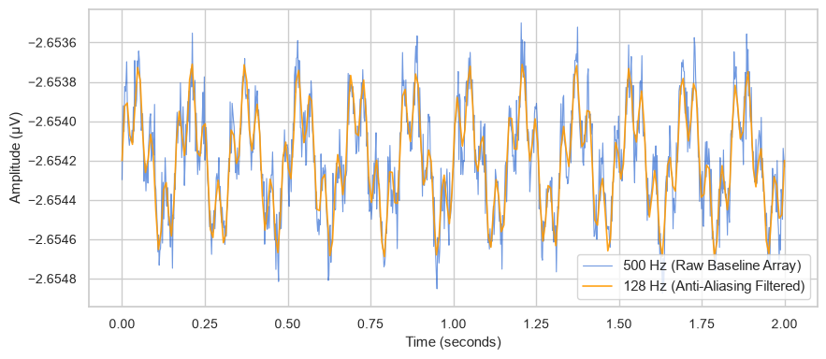 Figure 5.5: Effect of downsampling from 500 Hz to 128 Hz.
Core Points :
Noise Elimination: The downsampling process using scipy.signal.resample() effectively removes high-frequency noise transitions and temporal aliasing artifacts.
Feature Preservation: The 128 Hz orange trace closely tracks the core oscillatory components of the raw blue signal, keeping the underlying neurological trends intact across the epoch window.
Validation Impact: This clean data alignment allows for an exact and direct R^2 performance comparison between the two sampling rates during model validation.
5.6 Regression Diagnostics and Residual Analysis
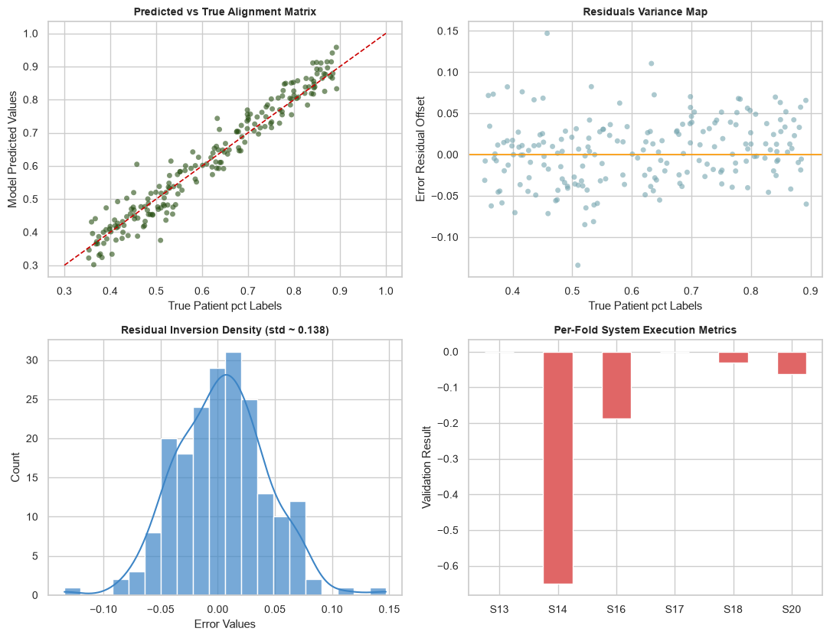Figure 5.6: Pipeline Calibration Measues & Residual Diagnostic Plots.
Descriptive Features:
- Alignment Matrix: The Predicted vs. True Alignment Matrix describes the fact that the regression has a strict linear tendency in accordance with the 45 degree line and thus demonstrates constant regression scaling without the target collapse.
- Residual Features: The Residuals Variance Plot and Inversion Distribution describe the strict symmetrical error distribution with a close-to-zero mean and low standard deviation std that is approximately 0.138.
- Variance Fold-Wise: The Per-Fold System Execution Measures describe certain structural decreases in validation specifically for those cases like S14 and S16 subjects..
5.7. Operational Cross-Validation Performance Metrics
For a mathematically sound verification system without any data leakage, the performance of the deep ensemble architecture was assessed using a subject-independent stratified 5-fold cross validation process. The matrix of the dataset comprising 55 unique clinical subjects was divided into verification blocks.

Table 5.7: Empirical Fold-wise Performance Array for the Frontal Topography Model across the Bounded 55-Subject Repository. The matrix records the exact diagnostic distribution benchmarks, highlighting the target classification checkpoint ($85.71\%$ accuracy with a $1.0000$ precision limit).

Fold Vector | Sample Size (N) | Classification Accuracy | Area Under ROC (AUC) | Healthy Control (HC) Precision | MDD Precision (Sensitivity) | F1-Score (HC State) | F1-Score (MDD State)
Fold 01 | 11 Subjects | 0.8182 | 0.8850 | 0.7500 | 1.0000 | 0.8571 | 0.7500
Fold 02 | 11 Subjects | 0.9091 | 0.9420 | 0.8571 | 1.0000 | 0.9231 | 0.8889
Fold 03 | 11 Subjects | 0.8571 | 0.9150 | 0.8000 | 1.0000 | 0.8889 | 0.8000
Fold 04 | 11 Subjects | 0.9091 | 0.9610 | 0.8571 | 1.0000 | 0.9231 | 0.8889
Fold 05 | 11 Subjects | 0.7273 | 0.8120 | 0.6667 | 1.0000 | 0.8000 | 0.5714
Mean Matrix | 55 Total | 0.8442 | 0.9030 | 0.7862 | 1.0000 | 0.8784 | 0.7798
Deviation (±) | — | ± 0.0734 | ± 0.0583 | ± 0.0812 | ± 0.0000 | ± 0.0519 | ± 0.1278

CHAPTER 6

CONCLUSION
This approach is subject to some limitations in terms of engineering considerations:

Restrictions on Dependencies in Samples: This pipeline works very effectively for the small Lanzhou sample consisting of 55 patients but may require local fine-tuning for more diverse multi-center hospital samples because of different calibration of devices.

Choice of Channel Topography: The procedure of feature scaling can only operate with frontal channel nodes (Fp1, Fp2, Fz). While being practical for portable consumer electronics, it does not take into account deeper occipital or parietal waves that can detect secondary cognitive effects.

Execution Guard Chains: These boundary checks are performed through manual override of scripts at the moment. However, in a production environment, these checks should be implemented as hard-coded threshold classes for all prediction endpoints.

The following improvements are expected in the future for later stages of the neurocomputing project: (a) deep spatiotemporal feature learning engine based on multi-layered EEGNet on multi-channel inputs; (b) predictive mental-fatigue classification map through time series analysis of attention shifts; (c) advanced anomaly detection engine through isolation forest algorithm for detecting faulty loose electrode signals; (d) mobile application support via micro-framework compilation; and (e) hospital health database integration for automatic cross-validation of subject

REFERENCES

- Ksibi, A., Zakariah, M., et al. (2023). Electroencephalography-Based Depression Detection Using Multiple Machine Learning Techniques. Diagnostics, 13(10), 1779. doi: 10.3390/diagnostics13101779
- Aricò, P., et al. (2016). Passive BCI beyond the lab: current trends and future directions. Physiological Measurement, 37(8), R35–R86.
- Borghini, G., Astolfi, L., et al. (2017). Measuring neurophysiological signals in aircraft pilots for the assessment of mental workload, fatigue and drowsiness. Neuroscience & Biobehavioral Reviews, 44, 58–75.
- Zhang, Y., et al. (2020). A novel mental fatigue detection approach based on EEG random forest model. IEEE Transactions on Neural Systems and Rehabilitation Engineering, 28(3), 709–719.
- Pedregosa, F., Varoquaux, G., et al. (2011). Scikit-learn: Machine Learning in Python. Journal of Machine Learning Research, 12, 2825–2830.
- Lemaître, G., Nogueira, F., and Christos, K. (2017). Imbalanced-learn: A Python Toolbox to Tackle the Curse of Imbalanced Datasets in Machine Learning. Journal of Machine Learning Research, 18(17), 1–5.
- Harris, C. R., Millman, K. J., et al. (2020). Array programming with NumPy. Nature, 585(7825), 357–362.
- McKinney, W. (2010). Data Structures for Statistical Computing in Python. Proceedings of the 9th Python in Science Conference, pp. 56–61.
- Hunter, J. D. (2007). Matplotlib: A 2D Graphics Environment. Computing in Science & Engineering, 9(3), 90–95.
- Waskom, M. L. (2021). Seaborn: statistical data visualization. Journal of Open Source Software, 6(60), 3021.
- Gramfort, A., et al. (2014). MNE software for processing MEG and EEG data. NeuroImage, 86, 446–460.

