Résumé

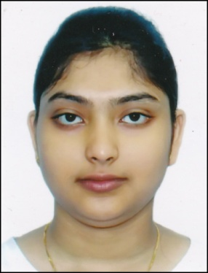
Name: PIYALI NATH
Discipline: B.Tech. in Electrical Engineering.
Current Address: Aspiria Society,
Opposite of Shell Petrol Pump,
Near Hinjewadi Chowk, Pune, Pin-411057.
Email: piyali.ria@gmail.com
Mobile No.: +919774691677
Permanent Address: C/O- Mr. Jagabandhu Nath,
Vill & PO- Durjoynagar,
Agartala, Tripura (West), Pin-799009.
__________________________________________________________________________________

Career Objective:
Looking for a promising and challenging career which will enable me to provide best of my technical, analytical and professional skills. A career which can sharpen my current skills and knowledge and where I can have a good scope for learning and implementing new technologies. I want to succeed in an environment of growth and excellence to meet personal and organizational goals.

Educational Qualifications:
- B. Tech in Electrical Engineering (2013-2015) with a CGPA of 4.10 on 5 point scale, from North Eastern Regional Institute of Science & Technology.
- Diploma in Electrical Engineering (2011-2013) with a CGPA of 4.34 on 5 point scale, from North Eastern Regional Institute of Science & Technology.
- Base Certificate (10+2 Equivalent) in Electrical Engineering (2009-2011) with a CGPA of 4.05 on 5 point scale, from North Eastern Regional Institute of Science & Technology.
- AISSE from CBSE with 88.80% aggregate (2009).

(The duration of B.Tech Programme is 4 years, divided into two Modules: 2 years Diploma & 2 years Degree Module. The Base Module is a Certificate Course in Maintenance Engineering which is equivalent to 10+2. This Modular Pattern is approved by AICTE.)

Project:
- Degree Project: Study of Voltage Stress in Transformer Winding.
(Under the Guidance of Dr. Saibal Chatterjee, Associate Professor, Dept. of Electrical Engineering, North Eastern Regional Institute of Science and Technology)
The aim of the project is to determine the sustainment level of transformer insulation by calculating equivalent series and shunt capacitance of a transformer windings using MATLAB.
- Diploma Project: Study and Analysis of Characteristics of DC Machine.
(Under the Guidance of Dr. O.P Roy, Associate Professor, Dept. of Electrical Engineering, North Eastern Regional Institute of Science and Technology)
The aim of the project is to find out the Speed-Torque characteristics, load analysis of DC machines (both motor and generator) by applying various voltages.
Training:
- Summer Training at Bharat Sanchar Nigam Limited (BSNL), 1st June to 30th June (30 days) 2014, Agartala.
- In-plant training at Tripura State Electricity Corporation Limited (TSECL), 1st June to 30th June (30 days) 2012, Agartala.
Technical Skills:
- Working knowledge of HTML, CSS, JavaScript, C, C++, MATLAB, and Intel 8085 Assembly Language.
- Software Packages: MS Office, Multisim Simulator.
- Operating System: Windows 7/8/XP.
Personal Skills:
Hard working, sincere, adaptive to work in a team, friendly behavior, leadership quality and creative.
Language Proficiency:
- English: Read, Write, Speak, And Translate.
- Hindi: Read, Write, Speak, And Translate.
- Bengali: Read, Write, Speak, And Translate.
Extra-Curricular Activities & Achievements:
- Junior and Senior Diploma in Classical singing from Sarba Bharatiya Sangeet-o-Sanskrit Parishad.
- Junior Diploma in Painting from Sarba Bharatiya Sangeet-o-Sanskrit Parishad.
- Second position holder in group song at Regional Level Social Science Exhibition 2007-2008.
- Gold Medalist at various Athletic events in School level.
- Have knowledge of Bharatnatyam Dance form.
- Won various prizes during cultural and technical festival of the college.
References:
- Dr. Saibal Chatterjee, Associate Professor, Electrical Engineering Department, NERIST.
- Dr. Sarsing Gao, Associate Professor, Electrical Engineering Department, NERIST.
- Dr. Nani Gopal Debnath, Assistant Professor, Center for Studies in Social Exclusion and Inclusive Practice, Tripura University(Central University, Tripura).

Declaration
I hereby declare that the information furnished above is true to the best of my knowledge and belief.
Place: NERIST 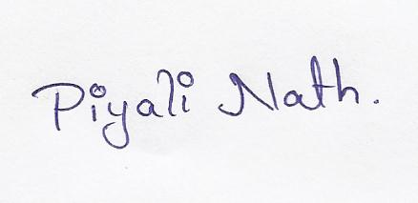
Date: 1st June 2015. (PIYALI NATH)

