A Data-Driven Structural Typology Framework for Pavement Maintenance Prioritization Under Budget Constraints: Evidence from Thai National Highways
Manoj Lohatepanontᵃ, Piyaphat Chaemchuenᵇ,*, Yosuke Uchiyama^{b}, Withit Pansukª, Koravith Tiprak^{c}
ᵃDepartment of Civil Engineering, Chulalongkorn University, Bangkok, Thailand
^{b}Transportation Institute, Chulalongkorn University, Bangkok, Thailand
^{c}Department of Civil and Environmental Engineering, Institute of Science Tokyo, Tokyo, Japan
*Corresponding author: Piyaphat.c@chula.ac.th

Abstract
Maintaining road pavements under chronic budget constraints is fundamentally a prioritization problem. This study develops a data-driven structural typology for maintenance prioritization from 77,230 Falling Weight Deflectometer (FWD) measurements across 440 Thai national highway sections over ten years (2014–2023). K-means clustering of four deflection bowl indices yields three distinct types: Type S (Structurally Sound), Type M (Moderately Deteriorated), and Type C (Critically Deteriorated), validated through back-calculated elastic moduli, remaining service life, and overlay thickness. Type C sections, comprising 38.0% of the network, exhibit near-complete base layer failure (mean base modulus: 344 MPa), severely elevated deflections (mean D0: 661 μm), and a mean remaining service life of 4.0 years. Critically deteriorated measurements persisted at 20.7 to 42.0% of annual totals across 2016–2023 with no downward trend. The framework maps each type to a specific intervention regime, providing highway agencies a replicable, evidence-based foundation for tiered maintenance investment.
Keywords: Falling Weight Deflectometer; pavement structural typology; cluster analysis; maintenance prioritization; decision-support framework

List of Abbreviations
Abbreviation | Full form
AASHTO | American Association of State Highway and Transportation Officials
ASTM | American Society for Testing and Materials
BCI | Base Curvature Index
BDI | Base Damage Index
CH | Caliński–Harabasz index
D0 | Peak deflection at load center
DB | Davies–Bouldin index
DCP | Dynamic Cone Penetrometer
DOH | Department of Highways (Thailand)
E1–E4 | Layer elastic moduli (asphalt, base, subbase, subgrade)
ESAL | Equivalent Single-Axle Load
FHWA | Federal Highway Administration (U.S.)
FWD | Falling Weight Deflectometer
HDM-4 | Highway Development and Management (version 4)
IRI | International Roughness Index
PC1/PC2 | First and second principal components
PCA | Principal Component Analysis
PCI | Pavement Condition Index
PMS | Pavement Management System
SCI | Surface Curvature Index
WCSS | Within-Cluster Sum of Squares

1. Introduction
Thailand's national highway network spans more than 52,000 km, and the Thai Department of Highways (DOH) is responsible for keeping it serviceable under growing traffic demands. The task has grown progressively harder: traffic loads have increased, the network has expanded, and annual maintenance budgets have not kept pace with rehabilitation need (Asian Development Bank, 2017). Road agencies operating under these conditions face a recurring and uncomfortable problem, namely which sections receive funding in a given cycle and which are deferred.
The structural capacity of a pavement cross-section, that is, how effectively the asphalt surface, granular base, subbase, and subgrade together carry traffic loads, determines whether rehabilitation can be deferred or must proceed urgently. The Falling Weight Deflectometer (FWD) is the accepted international standard for measuring this capacity non-destructively. An impulse load applied to the pavement surface generates a deflection bowl recorded at multiple radial offsets; from these readings, four indices are computed: peak deflection (D0), Surface Curvature Index (SCI), Base Damage Index (BDI), and Base Curvature Index (BCI). Each index probes a different depth of the pavement structure, providing layer-specific diagnostic information that roughness-based metrics such as IRI (Sayers & Karamihas, 1998) or PCI (Shahin, 1994) are not designed to capture (Talvik & Aavik, 2009). Highway agencies in Thailand and comparable countries have accumulated years of FWD records, yet these datasets have rarely been exploited for network-level structural classification, partly because the analytical methods required are only recently being adopted in the developing-country literature.
Most pavement management systems in Thailand and comparable developing countries still rely on single deflection thresholds to trigger maintenance decisions. The practical weakness of this approach is well established: two sections can produce nearly identical aggregate deflections while failing in entirely different layers, and the appropriate treatment (thin overlay versus full-depth reconstruction) differs accordingly. A typology derived from the multi-dimensional structure of FWD signals, calibrated to the actual condition distribution of the target network, provides a more defensible basis for making these distinctions than any single threshold can offer.
The paper makes three contributions. On the empirical side, it brings to bear one of the largest longitudinal FWD datasets examined in the developing-country literature: 77,230 measurements from 440 Thai national highway sections over ten consecutive years (2014–2023). The methodological contribution is a multi-dimensional structural typology in which deflection bowl indices serve as the primary clustering signal, with backcalculated quantities reserved for post-hoc validation rather than embedded in the cluster geometry. The policy contribution, which the authors consider the most consequential, is the translation of that typology into an operational maintenance decision framework that assigns each structural class a specific intervention regime, incorporates a quantitative budget prioritization logic, and identifies the transition from Type M to Type C as the point where proactive early investment yields the largest reduction in future rehabilitation costs.
Section 2 surveys the literature on FWD-based structural assessment, cluster analysis in pavement management, and maintenance prioritization under budget constraints. Section 3 describes the dataset and analytical procedure. Section 4 presents the clustering results and typology characterization. Section 5 develops the policy implications and operational maintenance framework. Section 6 summarizes the principal findings and outlines directions for future research.

2. Literature Review

2.1 Falling Weight Deflectometer: Principles and Deflection Bowl Characterization
The Falling Weight Deflectometer has served as the standard instrument for non-destructive structural evaluation of flexible pavements since it was established as an international reference method (ASTM International, 1996; FHWA, 2017). The device applies a calibrated impulse load to the pavement surface, generating stresses similar in magnitude and duration to those from heavy vehicle axles. Deflection sensors positioned at multiple offsets from the load center record the resulting pavement response, producing a deflection bowl from which layer-specific structural information can be extracted.
Four deflection bowl indices are used to characterize structural condition at different depths (Talvik & Aavik, 2009). Peak deflection D0 is measured at the load center and reflects the overall bearing capacity of the pavement system. The Surface Curvature Index (SCI = D0 - D300) is most sensitive to the condition of the asphalt surface layer. The Base Damage Index (BDI = D300 - D600) responds primarily to the structural state of the granular base, which is the layer most commonly implicated in premature failure in developing-country networks. The Base Curvature Index (BCI = D600 - D900) provides information about the lower pavement layers and subgrade. Threshold values for each index have been established through benchmarking studies across varied climatic and traffic conditions, enabling quantitative identification of layer-specific deficiencies (Mosale Ramanath et al., 2020; Talvik & Aavik, 2009; Austroads, 2019).

2.2 Backcalculation of Pavement Layer Moduli
Converting FWD deflection records into layer moduli requires backcalculation: an iterative multilayer elastic model adjusts assumed stiffness values until the computed deflection bowl matches the measured one within a specified tolerance (Lytton, 1989; FHWA, 2017). The procedure yields independent stiffness estimates for the asphalt surface (E1), granular base (E2), subbase (E3), and subgrade (E4), allowing structural deficiency to be localized by depth. Accuracy depends on sensor geometry, assumed layer thicknesses, and the computational algorithm. In tropical climates, temperature correction of the asphalt modulus is particularly important because high surface temperatures reduce asphalt stiffness and inflate measured deflections relative to a standard reference condition, a well-documented effect in high-temperature road networks (Federal Highway Administration, 2017).

2.3 Pavement Structural Classification Methods
Classification of pavement structural condition has evolved gradually from single-index threshold systems toward frameworks that integrate multiple deflection bowl parameters. Earlier approaches relied on D0 or the Structural Number to categorize sections, but threshold-based systems cannot differentiate between sections with similar aggregate deflections arising from different failure modes (Haas et al., 1994). The diagnostic gap is not trivial: surface-layer fatigue and base-layer collapse both produce elevated D0 readings, yet they require fundamentally different treatments with different cost implications. The BDI was developed precisely to resolve this ambiguity, which D0 alone cannot provide.
Multi-parameter frameworks that combine SCI, BDI, and BCI address this limitation more effectively than single-index systems. Talvik and Aavik (2009) demonstrated that combined threshold exceedances for these indices reliably localize distress to the relevant pavement layer under Estonian conditions. Mosale Ramanath et al. (2020) applied a comparable benchmarking approach to Indian national highway data and found improvements in rehabilitation thickness design accuracy relative to D0-only methods. Data-driven classification methods that derive structural categories from the empirical condition distribution of a specific network offer a further advantage: they are inherently calibrated to local conditions and do not require externally imposed threshold values.

2.4 Cluster Analysis and Machine Learning in Pavement Management
Clustering methods have become increasingly common in pavement management as measurement datasets have grown in scale. K-means clustering, which partitions observations by minimizing within-cluster Euclidean distance, remains the most widely applied algorithm for pavement network segmentation, valued for its computational efficiency and interpretable outputs (Sunitha et al., 2012). Sunitha et al. (2012) showed that deterioration models calibrated on cluster-stratified subsets of network data outperformed models fitted to the heterogeneous full-network distribution. Montoya-Alcaraz et al. (2020) demonstrated that condition-based maintenance planning in resource-constrained settings can yield measurable lifecycle cost advantages over uniform threshold policies. Mukhtarli et al. (2023) found that K-means produced more reproducible results than soft clustering alternatives when applied to deflection-based pavement grouping. The typology approach developed here builds on this body of work, following the K-means formulation of MacQueen (1967).

2.5 Maintenance Prioritization and Pavement Management Systems
Budget-constrained maintenance programming is the central applied problem in pavement management. Haas et al. (1994) established the foundational pavement management system (PMS) framework spanning condition monitoring, deterioration prediction, treatment selection, and budget optimization. Markov-chain deterioration models have provided the standard formulation for the prediction step (Butt et al., 1987). A long-established finding in the field is that preventive treatment of structurally sound pavements is substantially more cost-effective than deferred rehabilitation: allowing deterioration to reach poor condition before intervening typically multiplies intervention cost by several times (Haas et al., 1994; Xu & Tsai, 2012). Tools such as the AASHTO ME Pavement Design Guide (AASHTO, 2008) and HDM-4 (Fwa, 2006) have formalized the integration of structural condition, traffic loading, and lifecycle cost modeling into systematic maintenance programming, though both require extensive calibration data and institutional capacity that most developing-country agencies cannot yet fully support (Walls & Smith, 1998). Chootinan et al. (2006) presented a stochastic simulation approach to multi-year programming under budget constraints that is better suited to resource-limited settings.
The gap between technically optimal and practically implemented maintenance strategies is widest in middle-income countries, where network expansion has consistently outpaced rehabilitation capacity (Asian Development Bank, 2017). Even modest improvements in prioritization, achieved by directing rehabilitation toward the most structurally vulnerable segments rather than relying on aggregate condition averages, can extend effective network life within unchanged budget envelopes (Montoya-Alcaraz et al., 2020). This observation motivates the typology-based prioritization framework developed in the present study.

2.6 Pavement Management Challenges in Southeast Asia and Thailand
Pavements in Southeast Asian developing economies deteriorate faster than in temperate-climate settings for reasons that are well understood: high ambient temperatures, intense monsoon rainfall, seasonal flooding, and axle loads that frequently exceed design assumptions all shorten service life (Asian Development Bank, 2017). Thailand's highway network expanded substantially in the post-industrialization period, yet maintenance budgets have not grown commensurately, resulting in accumulated rehabilitation backlogs that place increasing pressure on agencies to make targeted, evidence-based decisions about maintenance prioritization.
The DOH has maintained a systematic FWD survey program for more than two decades, generating longitudinal structural condition records of considerable scientific and policy value. That resource has seen limited use in the published literature for network-level structural classification, however, and the present study attempts to fill that gap.

3. Data and Methodology

3.1 Study Area and Data Source
The analysis draws on FWD measurements collected by the Thai Department of Highways across national highway sections throughout the country. The dataset covers ten consecutive years (2014–2023), with 77,230 individual measurement points recorded across 440 road sections. Spatial coverage extends from 7.22°N to 20.44°N latitude and 97.92°E to 105.49°E longitude, spanning the breadth of the national network. The number of sections surveyed in any given year varied considerably, reflecting shifting survey program priorities, from a single section in 2014 to 142 sections in 2022.
Measurements were collected in accordance with ASTM D4694-96 (see also Matini et al., 2018, for network-level collection protocols). Each test applied a dynamic impulse load to the pavement surface, and the resulting deflection bowl was recorded at nine sensor positions (D0 through D8) at increasing radial offsets from the load center. Individual measurement records contain deflection readings (in micrometers), surface temperature at the time of testing, surface layer thickness, backcalculated layer moduli (E1 through E4 for the asphalt, base, subbase, and subgrade), derived deflection bowl indices (SCI, BDI, BCI), minimum remaining service life, required overlay thickness, and spatial coordinates. The DOH backcalculated layer moduli using iterative multilayer elastic optimization; the specific algorithm and applied load magnitude should be confirmed from the original survey documentation for any cross-study comparison (Federal Highway Administration, 2017).

3.2 Deflection Bowl Indices
Four deflection bowl indices derived from the sensor array serve as the primary structural characterization in this analysis. Peak deflection D0, measured at the load center, captures the overall bearing response of the full pavement cross-section and is the most commonly cited indicator of structural adequacy. The Surface Curvature Index (SCI = D0 - D300) is most sensitive to the condition of the asphalt surface layer. The Base Damage Index (BDI = D300 - D600) responds primarily to the structural state of the granular base, and the Base Curvature Index (BCI = D600 - D900) is associated with the condition of the lower layers and subgrade. Taken together, these four indices characterize structural performance across the full pavement depth.

3.3 Cluster Analysis
Four deflection bowl indices (D0, SCI, BDI, and BCI) drove the cluster analysis, implemented using the scikit-learn library. These indices measure the pavement's deflection response under load from direct sensor output, without the model-dependent assumptions inherent in backcalculation, and they preserve the layer-specific diagnostic resolution that a single composite index would obscure. Six additional derived indicators (minimum remaining service life, required overlay thickness, and layer moduli E1 through E4) were included in the ten-feature clustering space to allow the algorithm to exploit the full information available in the FWD record. Their role is primarily interpretive: they confirm and anchor the engineering meaning of each cluster after the fact, but the structural typology is fundamentally defined by the deflection bowl geometry. All ten features were standardized by z-score normalization prior to clustering to prevent high-magnitude variables from dominating the Euclidean distance metric:
x̂ᵢⱼ = (xᵢⱼ − μⱼ) / σⱼ
Observations in the top and bottom 2% of any feature were removed before standardization to reduce the influence of measurement artifacts and instrumentation errors. This retained 64,606 observations (83.7% of the original 77,230). Excluded records showed no spatial or temporal concentration across sections and years, supporting the inference that the filtering did not introduce systematic bias. All cluster-level statistics in Table 1 and the temporal trend analyses are computed on this filtered dataset; the 77,230 figure cited in the abstract and introduction refers to the full, unfiltered record.
Surface temperature was included as a clustering feature rather than used to apply a pre-processing correction to deflection values. Standard FWD practice corrects D0 and SCI to a reference temperature (typically 20–25°C) to remove the confounding effect of temperature-dependent asphalt stiffness (Lukanen et al., 2000; FHWA, 2017). Full correction was not applied here because the dataset records surface temperature rather than mid-depth asphalt temperature, which the standard adjustment requires. Including surface temperature as a clustering feature instead allows the algorithm to account for its covariation with deflection indices empirically. The practical consequence appears negligible: Pearson correlations between surface temperature and D0 are r = -0.038, -0.001, and -0.005 for Types S, M, and C, respectively, indicating that temperature variation is not the primary driver of cluster separation. Type M and Type S boundary cases could in principle be marginally affected by thermally induced deflection variation, but the Type C cluster, which has the most direct policy consequence, is well delineated and robust to this consideration.
Feature interdependence and the deflection subspace. The four deflection bowl indices are algebraically derived from overlapping sensor readings and are not statistically independent. Including all four in the clustering feature set deliberately concentrates the cluster geometry on the deflection dimension of structural condition, preserving the layer-specific resolution that would be lost by collapsing them into a single composite index. The PCA biplot (Figure 3) confirms this: D0, SCI, BDI, and BCI jointly load on PC1 (45.5% of total variance), forming a coherent structural-severity axis, while the independent modulus features dominate PC2 (16.5%). The ten-feature space thus captures structurally distinct, non-redundant dimensions of pavement condition.
K-means objective. The K-means algorithm partitions n standardized observation vectors {x̂₁, ..., x̂ₙ} ⊂ ℝ¹⁰ into k non-overlapping clusters C₁, ..., Cₖ by minimizing the within-cluster sum of squares (WCSS):
J(C, μ) = ∑ᵢ₌₁ᵏ ∑_{x̂ ∈ Cᵢ} ‖x̂ − μᵢ‖²
where μᵢ = (1/|Cᵢ|) Σᵯ̂∈Cᵢ x̂ is the centroid of cluster i. The algorithm proceeds by iteratively assigning each observation to its nearest centroid and updating centroids until assignments no longer change. Twenty independent random seeds (n_init = 20) were used with random_state = 42 to ensure reproducibility. This follows the formulation of MacQueen (1967).
Selection of k. The number of clusters was set to k = 3 on both quantitative and engineering grounds. The WCSS elbow criterion identified a clear inflection at k = 3 (WCSS₂ = 117,470; WCSS₃ = 86,932; WCSS₄ = 65,523), with marginal gains from each additional cluster declining monotonically beyond that point. The mean silhouette coefficient of 0.380 at k = 3 is modest but consistent with the gradual, continuous character of pavement structural deterioration; published pavement segmentation studies report values in the 0.20–0.26 range, and the silhouette coefficient alone is not evidence of weak cluster structure.
The more decisive consideration is engineering interpretability. Three clusters map onto three operationally distinct treatment regimes — preventive preservation, early intervention, and structural rehabilitation — whereas a four-cluster solution merely subdivides an existing cluster without producing a group with any differentiated maintenance implication.
A two-cluster solution warrants specific comment, as it scores higher than k = 3 on both the silhouette coefficient (0.495 vs. 0.380) and the Caliński–Harabasz index (77,519 vs. 63,722). This statistical superiority, however, reflects the presence of two highly separated extremes in the data — structurally intact sections and sections with near-total base failure — which a binary partition captures cleanly. What k = 2 cannot recover is the intermediate structural state represented by Type M: sections exhibiting moderate deflection levels and elevated base-layer loading that are neither candidates for rehabilitation nor safely deferrable. This transitional class is precisely where proactive maintenance is most cost-effective, because arresting deterioration before sections cross into the critical class avoids the substantially greater expense of structural rehabilitation. Merging Type M into either adjacent class either suppresses the early warning signal (if merged with Type S) or triggers premature rehabilitation expenditure (if merged with Type C). The three-cluster solution therefore sacrifices a modest degree of statistical compactness in order to preserve the full tripartite maintenance decision space that underpins the operational framework in Section 5.
The physical basis for k = 3 is independently confirmed by the near-total collapse of base modulus in Type C (E₂ = 289 MPa, versus 2,089 MPa for Type M and 7,766 MPa for Type S), by the clear separation of the three groups along PC1 in the PCA biplot, and by the stability of within-cluster deflection levels across years (Section 4.3). Supplementary validation metrics — the Caliński–Harabasz index (CH = 63,722; Caliński & Harabasz, 1974) and Davies–Bouldin index (DB = 1.03; Davies & Bouldin, 1979) — are reported in Figure 1.
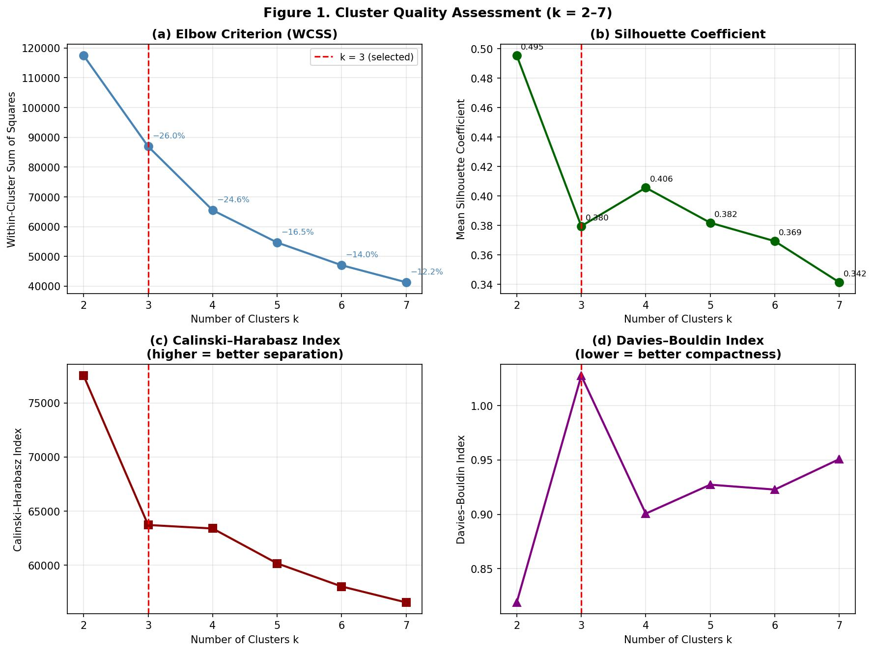
Figure 1 Four-panel cluster quality assessment (k = 2–7): (a) WCSS elbow criterion; (b) mean silhouette coefficient; (c) Caliński–Harabasz index; (d) Davies–Bouldin index. Red dashed line marks the selected k = 3.
Each observation was assigned the label of its nearest centroid. Section-level typology was determined by plurality vote across all FWD measurements recorded for that section. The mapping between cluster indices and typology labels, along with centroid characteristics, is presented in Section 4.1.

4. Results

4.1 Pavement Structural Typology
K-means clustering (k = 3) partitioned the filtered dataset into three structurally distinct pavement types: Type S (Structurally Sound), Type M (Moderately Deteriorated), and Type C (Critically Deteriorated), assigned in order of increasing peak deflection centroid (D0). Table 1 presents mean values of key structural indicators for each type. The three classes differ substantially in deflection bowl geometry, backcalculated layer moduli, remaining service life, and maintenance requirements, confirming that the clusters capture physically and operationally distinct conditions. The silhouette plot (Figure 2) and PCA biplot (Figure 3) support the separability of the three-cluster solution. Type C produces the widest positive silhouette band, a consequence of the near-total base modulus collapse that distinguishes it from the other two classes, and is clearly projected away from Types S and M along PC1 in the biplot.

Table 1 Structural characteristics of the three pavement typologies (mean values)
Indicator | Type S  (Structurally Sound) | Type M  (Moderately Deteriorated) | Type C  (Critically Deteriorated)
Measurement count (% of total) | 30,860 (47.8%) | 20,271 (31.4%) | 13,475 (20.9%)
Peak deflection D0 (µm) | 200 | 406 | 733
Surface Curvature Index SCI (µm) | 74 | 155 | 355
Base Damage Index BDI (µm) | 64 | 155 | 287
Base Curvature Index BCI (µm) | 33 | 57 | 54
Base modulus E2 (MPa) | 7,766 | 2,089 | 289
Mean remaining service life (yr) | 27.6 | 19.2 | 3.3
Mean overlay thickness (mm) | 1.2 | 7.9 | 41.2

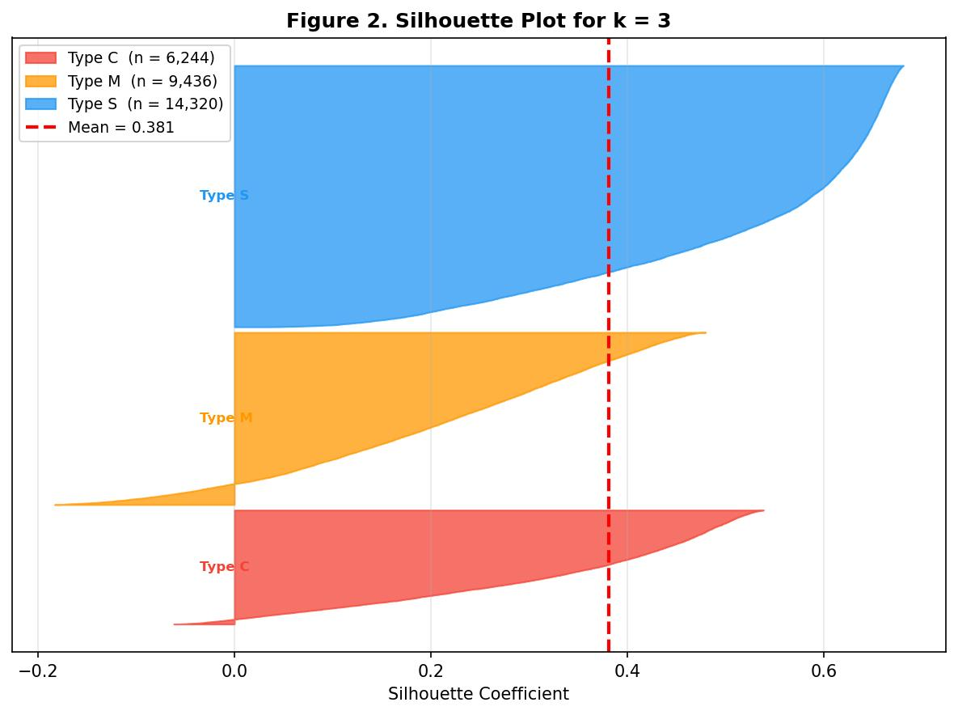
Figure 2 Silhouette plot for k = 3. Each bar represents one FWD measurement; width indicates cohesion strength. Mean silhouette coefficient = 0.380.
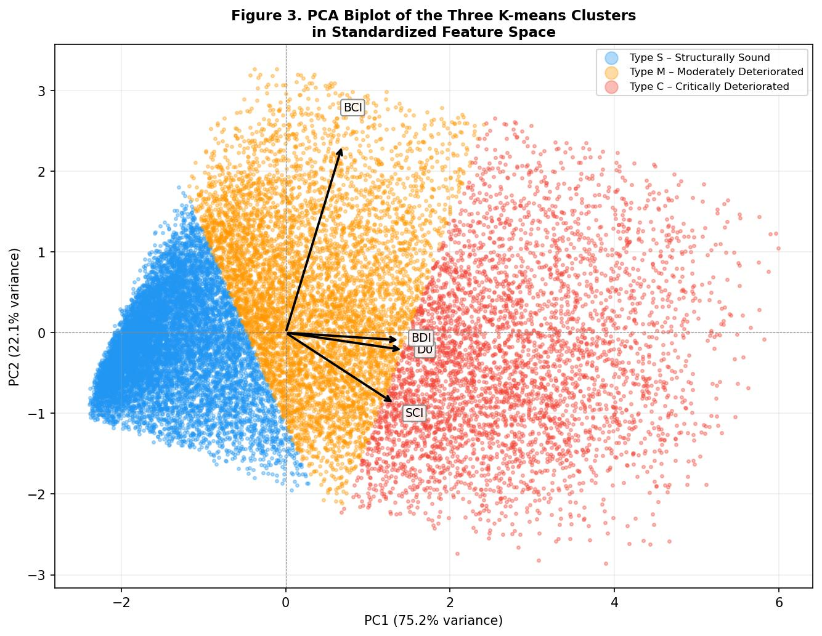
Figure 3 PCA biplot of the three K-means clusters in standardized feature space (PC1 = 75.2%, PC2 = 22.1%). Arrows indicate feature loadings on each principal component.
Type S sections exhibit the lowest deflection levels in the dataset (mean D0 = 200 μm) and the smallest curvature indices, consistent with intact, stiff pavement structures across all layers. The mean base modulus (E2 = 7,766 MPa) and subgrade modulus (E4 = 330 MPa) indicate adequate load-distributing capacity. Mean remaining service life is 27.6 years and the mean required overlay is only 1.2 mm. These sections do not require structural intervention in the near term and are candidates for routine preventive maintenance (surface sealing and periodic structural monitoring) rather than capital rehabilitation.
Type M sections show moderate deflection levels (mean D0 = 406 μm) with a notably elevated BDI (mean = 155 μm, compared with 64 μm for Type S), pointing to increasing structural demand at the base-layer depth. The backcalculated base modulus (E2 = 2,089 MPa) is substantially lower than for Type S (7,766 MPa), consistent with progressive loss of base-layer stiffness relative to the sound class. Mean remaining service life is 19.2 years and mean overlay requirements are 7.9 mm, indicating that Type M sections retain overall structural function but are not well-positioned for continued deferral of intervention. The elevated BDI is the diagnostically significant feature: it signals a transitional structural state in which base-layer loading is intensifying, raising the risk of progression to the critical class if left unaddressed. The appropriate management response is enhanced monitoring and early intervention before the section advances to the critical stage.
Type C sections exhibit a structural profile that differs qualitatively, not merely quantitatively, from the other two classes. Mean peak deflection is 733 μm (3.7 times the Type S mean), and the mean SCI (355 μm) and BDI (287 μm) indicate severe structural impairment at both the asphalt surface and base layer depths. The mean base modulus of 289 MPa is approximately 14% of the base stiffness observed in Type M sections, consistent with near-complete structural disintegration of the granular base. The maintenance implications are not ambiguous: 82.8% of Type C measurements show fewer than five years of remaining service life, and the mean required overlay of 41.2 mm (with 34.2% of measurements requiring overlays exceeding 50 mm) indicates structural rehabilitation rather than surface treatment as the warranted response.
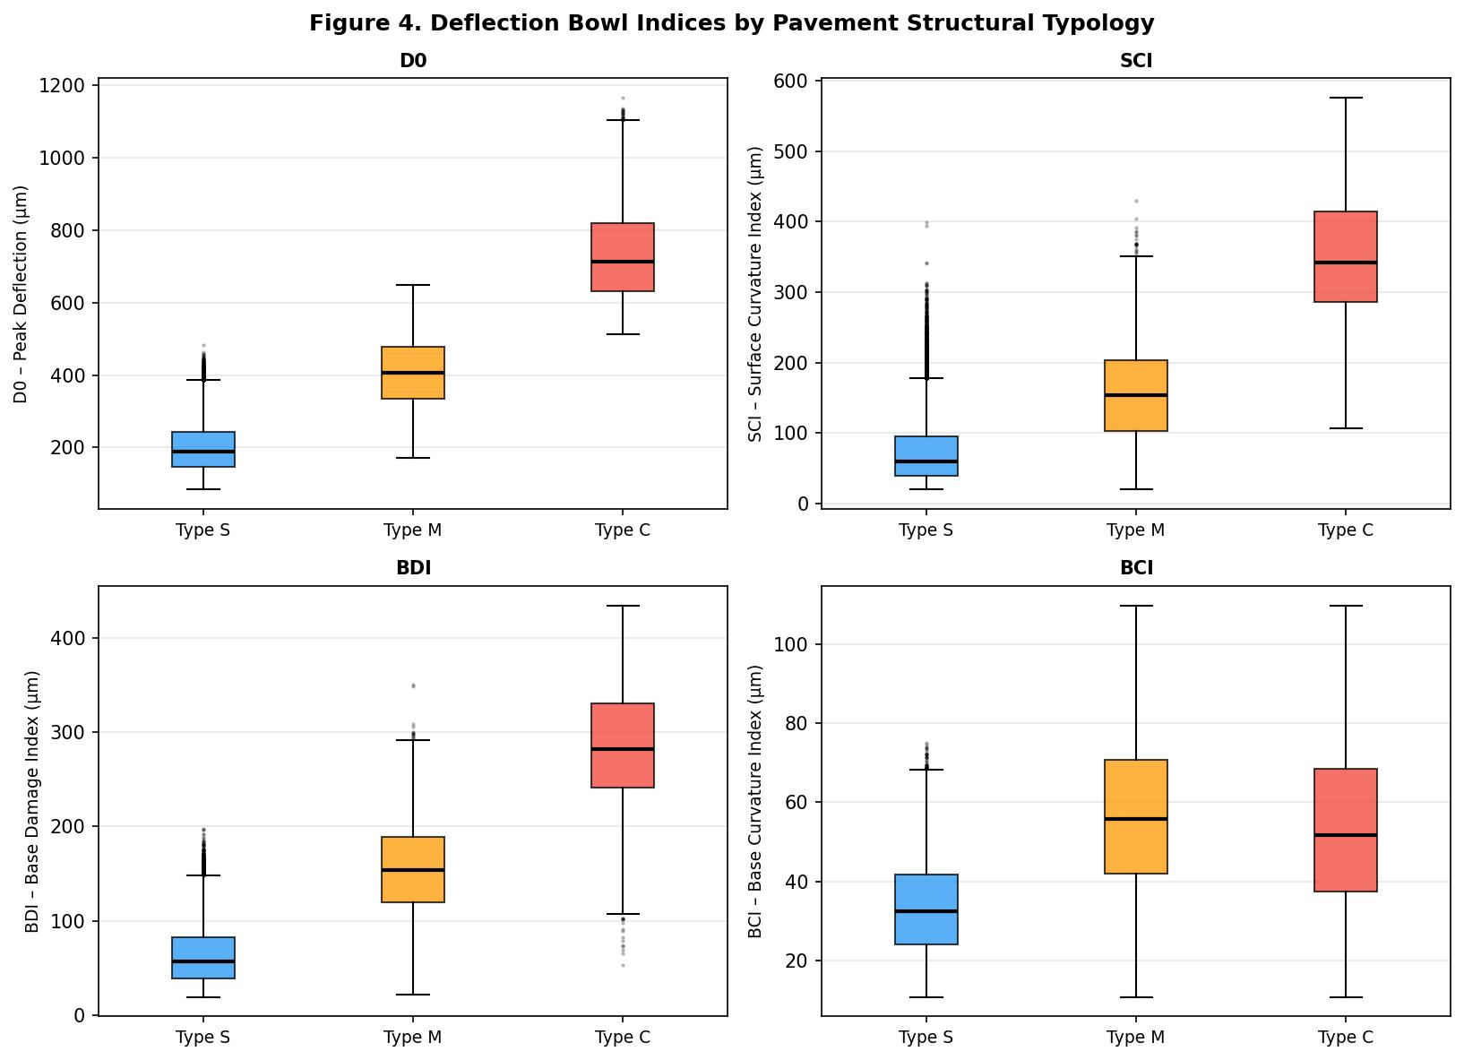
Figure 4 Box plots of deflection bowl indices (D0, SCI, BDI, BCI) by pavement structural typology.
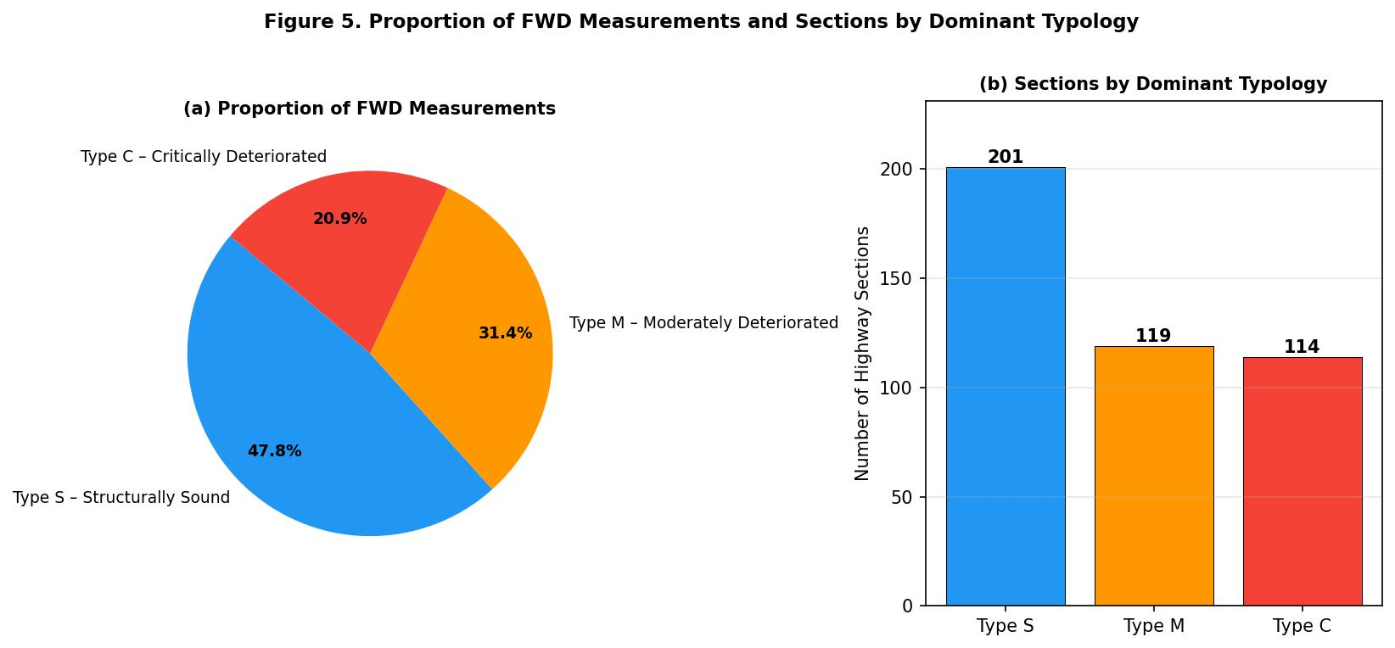
Figure 5 (a) Proportion of FWD measurements and (b) number of sections by dominant structural typology.
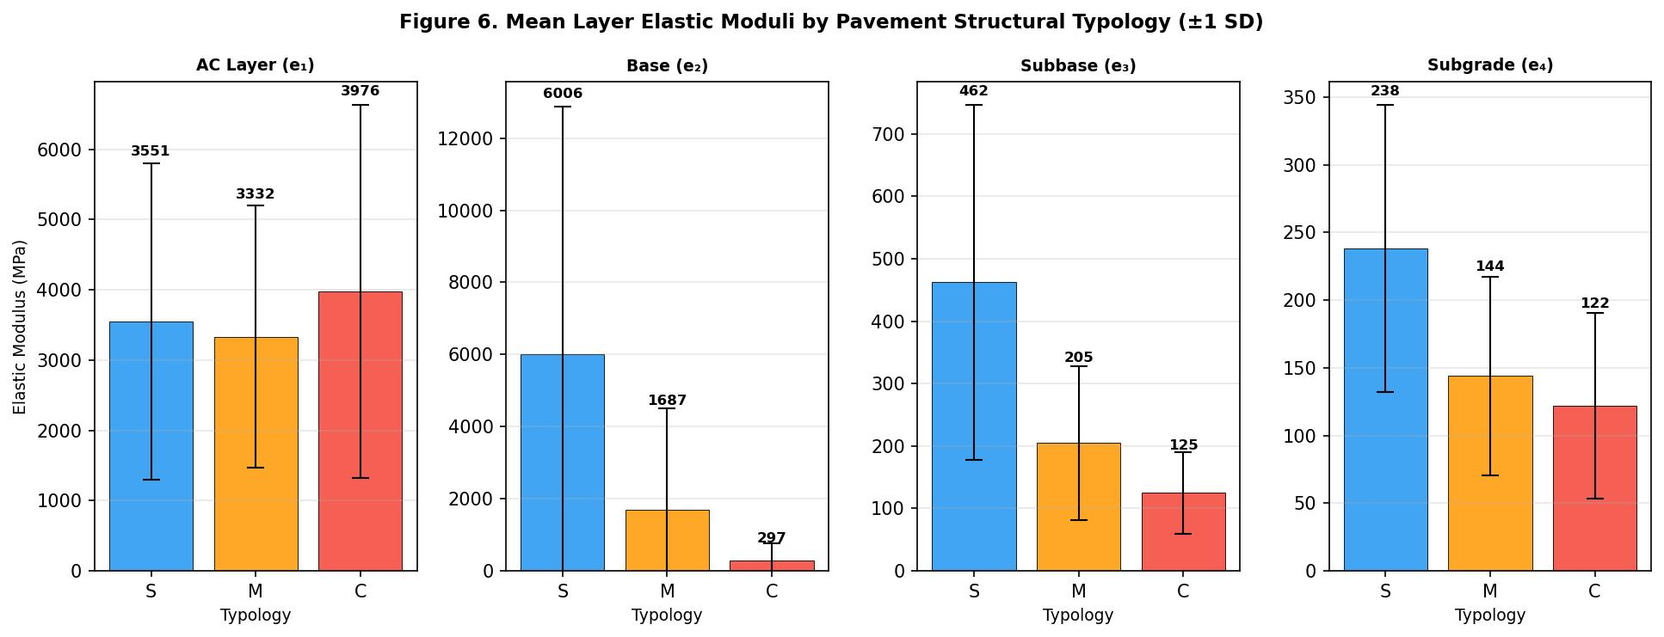
Figure 6 Mean layer elastic moduli (±1 SD) by pavement structural typology.

4.2 Section-Level Classification and Within-Section Heterogeneity
At the section level, plurality assignment classified 119 sections (27.4%) as predominantly Type M, 114 sections (26.3%) as predominantly Type C, and 201 sections (46.3%) as predominantly Type S. The proportion in the critical class, more than a quarter of all surveyed sections, reflects the scale of structural vulnerability in the Thai national highway network and the corresponding demand for rehabilitation investment.
Within-section structural heterogeneity emerged as a practically important feature of the results. Homogeneity was quantified using the plurality fraction, defined as the share of measurements within a section belonging to the dominant cluster. Median plurality fractions were 0.54, 0.50, and 0.62 for Types C, M, and S, respectively. In a typical section, therefore, the assigned typology label reflects only slightly over half of the underlying point measurements. Among the 434 sections, only 60 (13.8%) reached a plurality fraction of 0.80 or above, and 135 sections (31.1%) had plurality fractions below 0.50, meaning the assigned type did not represent a majority of point-level evidence (Figure 7). Section-level typology assignments are best treated as network triage signals rather than as the primary basis for scoping rehabilitation work. Engineers should review the full point-level FWD record for each section, particularly those with plurality fractions below 0.60, before finalizing treatment boundaries and cost estimates. The generally low homogeneity values also suggest that point-level spatial segmentation would add meaningful precision to standard section-level reporting.
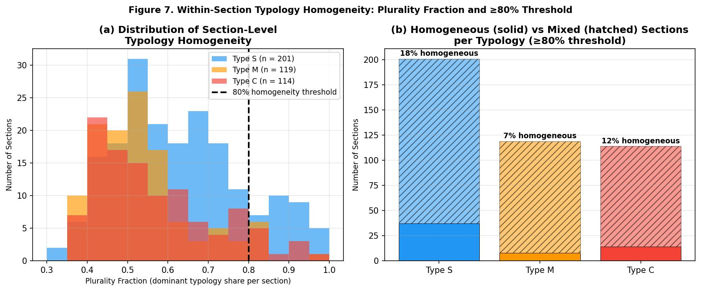
Figure 7 Within-section typology homogeneity: (a) distribution of plurality fractions by dominant typology; (b) share of sections meeting the ≥80% homogeneity threshold.
The three typologies are distributed across the full geographic extent of the surveyed network, with no region dominated exclusively by a single class (Figure 8). The spatial intermixing indicates that structural condition does not cluster geographically, and network-level maintenance planning therefore cannot be organized around spatially contiguous zones alone.
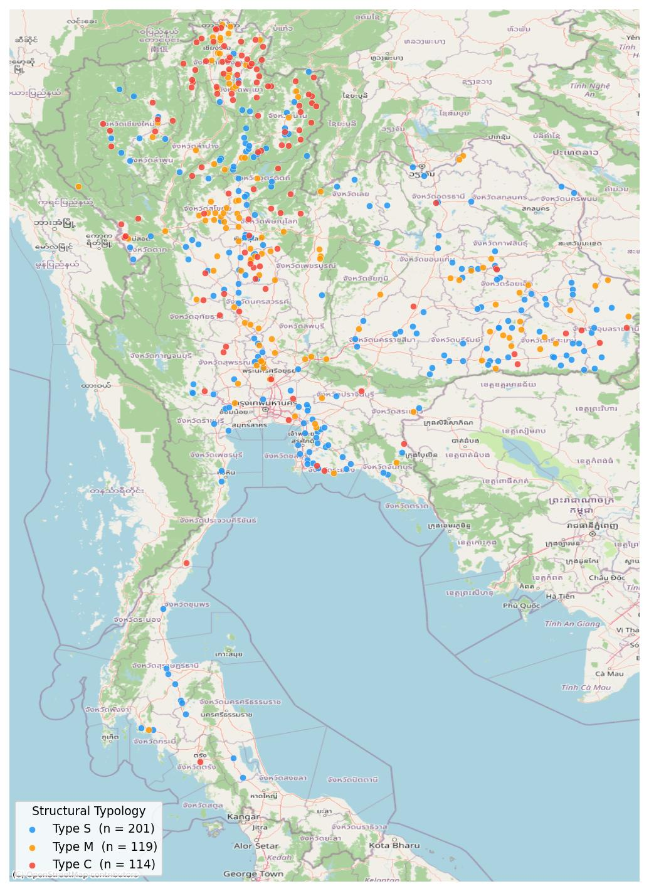
Figure 8 Spatial distribution of dominant pavement structural typology across Thai national highway sections (2014–2023).

4.3 Temporal Trends in Structural Condition
Figure 9 shows the annual proportion of measurements classified as each structural type from 2016 to 2023; the two preceding years (2014: 72 measurements; 2015: 28 measurements) are excluded owing to insufficient sample sizes. The Type C proportion ranged between 11.1% and 24.3% across the period, with peaks in 2018 (24.3%) and 2019 (23.4%), a decline to 14.0% in 2020, and a subsequent increase to 23.2% in 2022. No sustained downward trend is apparent over the study period.
Table 2 Annual distribution of measurements by structural typology (2016–2023)
Year | Total measurements | Type S (%) | Type M (%) | Type C (%)
2016 | 1,810 | 48.6 | 29.7 | 21.7
2017 | 7,593 | 44.0 | 32.7 | 23.4
2018 | 11,897 | 44.1 | 31.6 | 24.3
2019 | 7,448 | 44.2 | 32.4 | 23.4
2020 | 5,537 | 54.1 | 32.0 | 14.0
2021 | 12,872 | 56.2 | 26.6 | 17.2
2022 | 14,126 | 43.7 | 33.1 | 23.2
2023 | 2,982 | 52.2 | 36.7 | 11.1

Interpreting these annual proportions requires care. Because different section subsets were surveyed each year, temporal changes in typology proportions conflate genuine structural condition change with changes in the composition of the surveyed sample. In years when a disproportionate share of recently rehabilitated or structurally sound sections entered the survey program, the apparent Type C proportion will fall independently of any actual network-wide improvement. This sampling composition effect cannot be cleanly separated from genuine rehabilitation impact in the present analysis. The temporary decline in Type C prevalence in 2020 and 2021 may therefore reflect, at least in part, the smaller and potentially less-deteriorated section samples in those years (50 and 87 sections, respectively) rather than confirmed network-wide improvement.
To partially separate structural trends from sampling composition effects, a sub-analysis was conducted on the 24 sections surveyed in three or more years. Within this fixed cohort, the Type C proportion ranged from 7.9% to 31.9% across the main observation window (2018–2022), a variability comparable to the full-network range of 11.1%–24.3% (Figure 10). This result indicates that sampling composition effects do not fully account for full-network year-to-year fluctuation; genuine structural condition variation across sections is also present. The cohort of 24 sections is, however, too small for statistically robust conclusions and should be treated as directional evidence only. Proper longitudinal monitoring requires a purposively designed fixed panel measured on a consistent annual schedule. Regardless of how the variation is attributed, the persistence of Type C measurements above 11% throughout the entire observation period confirms that critical structural deterioration is a chronic rather than episodic feature of the network.
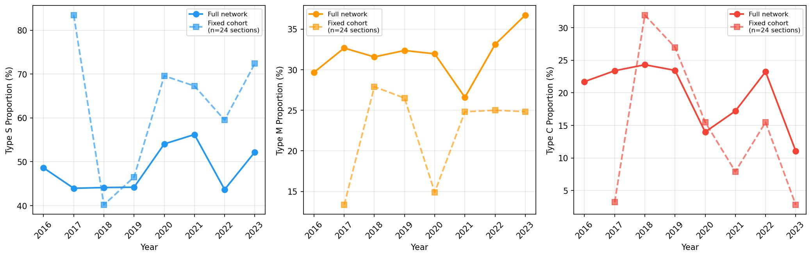
Figure 9 Annual structural typology trends: full network (Top) versus fixed cohort of 24 sections surveyed in ≥3 years (Bottom).
Mean peak deflection by cluster was stable across years (Type C: 612–908 μm; Type S: 164–339 μm; Type M: 225–299 μm). This stability indicates that the clusters reflect persistent structural states rather than transient measurement variation, and supports the interpretability of the typology across the full study period.
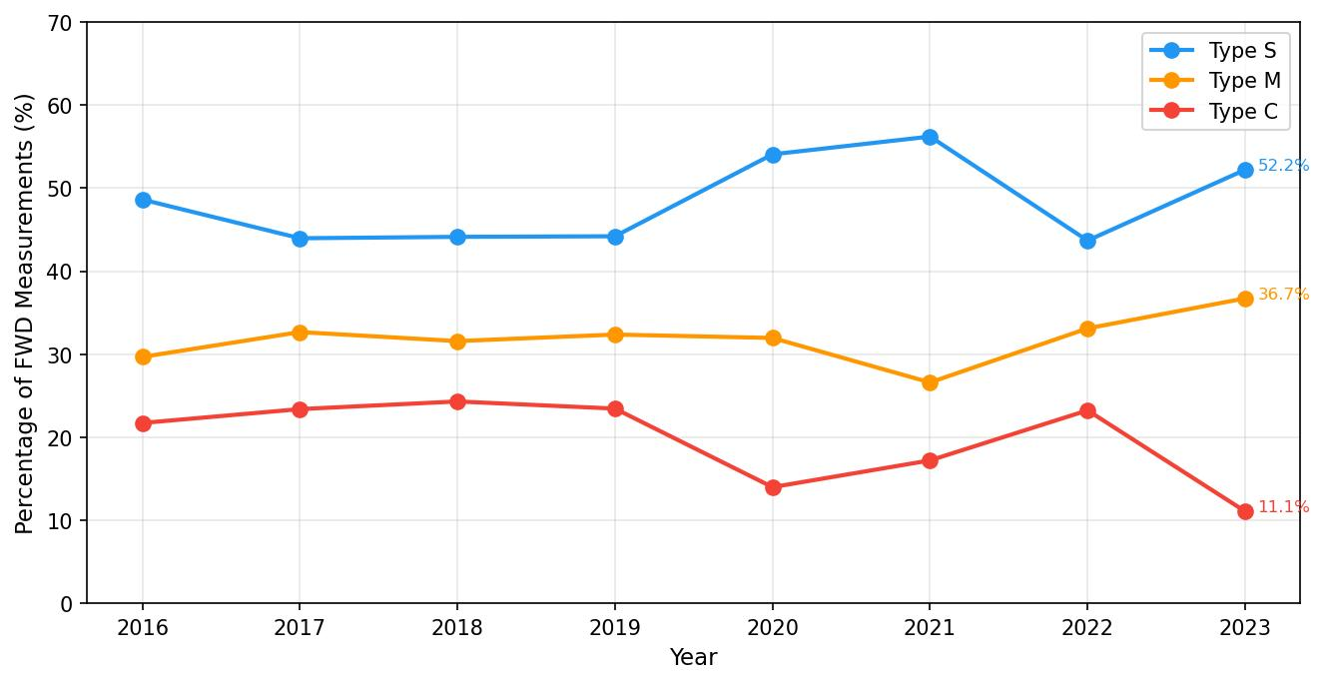
Figure 10 Annual proportion of FWD measurements by pavement structural typology (2016–2023).

4.4 Maintenance Requirements by Typology
Table 3 summarizes maintenance implications by typology, derived from overlay thickness and remaining service life distributions. Type S sections require negligible overlay (mean 1.2 mm) and carry mean remaining service lives exceeding 27 years; structural interventions are not warranted in the near term, and routine preventive maintenance is the appropriate response. Type M sections present a comparable aggregate picture (low mean overlay requirements, long mean remaining lives), suggesting adequate structural function at present. These derived indicators, however, are subject to the same backcalculation artifact described in Section 4.1 that inflates the Type M base modulus; the deflection bowl profile, and BDI in particular, provides a more reliable basis for Type M management decisions than remaining life or overlay estimates alone. Sections with BDI values near the upper quartile of the Type M distribution warrant closer attention, however, because elevated base-layer loading places them at greater risk of near-term transition to the critical class.
Table 3 Maintenance requirements and urgency by pavement typology
Parameter | Type S | Type M | Type C
Mean overlay required (mm) | 1.2 | 7.9 | 41.2
% requiring overlay > 50 mm | < 1% | 3.9% | 34.2%
Mean remaining service life (yrs) | 27.6 | 19.2 | 3.3
% with remaining life < 5 yrs | 3.9% | 23.8% | 82.8%
Recommended intervention | Preventive / Routine | Monitor / Preventive | Structural Rehabilitation

Type C tells a different story. With 82.8% of measurements showing fewer than five years of remaining service life and a mean required overlay of 41.2 mm, these sections need structural rehabilitation rather than surface maintenance. The 34.2% of Type C measurements requiring overlays greater than 50 mm indicate that a substantial share of the critical network has passed the point where conventional overlay is an adequate response. Among the 34.2% requiring overlays exceeding 50 mm, the most severely impaired sections warrant full-depth reclamation or reconstruction rather than conventional overlay, particularly where traffic volumes are high. The distinction matters for cost estimation: treating all Type C sections as overlay candidates will systematically understate the total rehabilitation investment required.
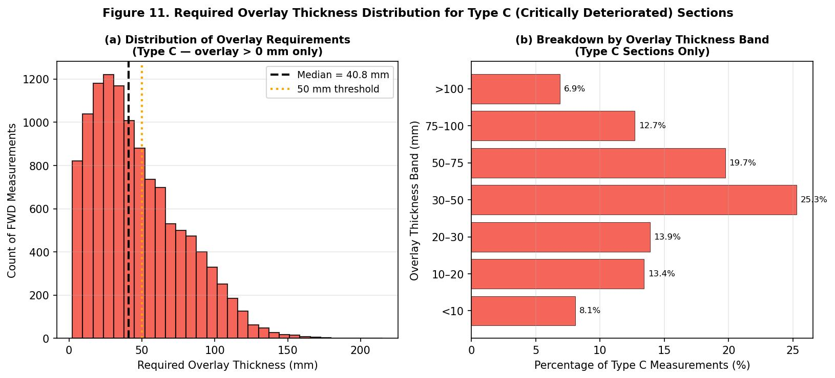
Figure 11 Required overlay thickness distribution for Type C (Critically Deteriorated) sections.

5. Discussion

5.1 Operational Maintenance Decision Framework
The three-typology framework has a straightforward translation into operational maintenance decision logic. Current practice in Thailand and most developing countries applies maintenance decisions based on single deflection thresholds that cannot integrate the multi-dimensional structural information available from FWD testing. The typology framework operationalizes that information into three treatment categories that can be aligned with the DOH's annual maintenance budgeting cycle.
Type S sections (201 sections; 46.3% of the network) carry decades of remaining structural life and do not require capital rehabilitation expenditure in the current planning horizon. The appropriate response is a preservation strategy: routine surface maintenance, crack sealing, and periodic structural re-assessment at three-to-five-year intervals. The economic case for this approach is well established, because timely preventive treatment is substantially less expensive than allowing deterioration to advance until structural rehabilitation becomes necessary.
For Type M sections (119 sections; 27.4% of the network), the principal management objective is preventing deterioration from advancing to the critical class. Annual FWD re-assessment is recommended for sections with BDI exceeding approximately 134 μm (the 75th percentile of the Type M BDI distribution), targeting those with the highest base-layer loading and the greatest near-term deterioration risk. Combined with targeted thin overlay or surface treatment where appropriate, early intervention at this threshold can arrest structural decline before sections cross into Type C territory. With 119 sections in this class, retaining even a fraction below the critical threshold over a budget cycle would meaningfully reduce future demand for expensive structural rehabilitation.
Type C sections (114 sections; 26.3% of the network) require immediate structural rehabilitation. The near-complete base layer failure evidenced by mean base modulus (E2) of 289 MPa means that surface-level treatments will not restore structural capacity and may accelerate deterioration of the underlying foundation. Rehabilitation design should be guided by the observed overlay requirements: conventional hot-mix asphalt overlay for sections requiring 50 mm or less, and full-depth reclamation or reconstruction for those with substantially greater overlay demands. The ten highest-priority Type C sections by mean peak deflection are listed in Appendix A as candidates for immediate intervention.

5.2 Budget Allocation under Resource Constraints
Allocating maintenance budgets across competing demands under chronic underfunding is the central practical challenge for highway agencies in developing economies. The typology framework supports this allocation by providing a structured engineering basis for sequencing investments. The classical principle in pavement management (that preventive treatment of sound pavements generates several dollars of deferred rehabilitation cost per dollar spent) argues for protecting Type S sections first, then arresting Type M deterioration, with the largest capital allocations directed to Type C rehabilitation. Given that critical deterioration has characterized more than 28% of all measurements over the study decade and 38.0% of sections at the section level, however, the sequencing must also account for the cost of inaction: a Type C section not rehabilitated in the current cycle will require progressively more expensive intervention as base-layer failure advances (Xu & Tsai, 2012).
Within the Type C class, a risk-based prioritization framework combining typology membership with remaining service life provides a tractable approach to ranking sections for budget allocation (Tighe, 2001). Sections with remaining service life below two years and BDI above 300 μm represent the highest structural urgency and should receive first-priority rehabilitation funding. Sections with two to five years of remaining life constitute a second tier, while those at five years or more, though still classified as critical, may be addressed in subsequent budget cycles without incurring unacceptable structural risk. This within-class tiering allows the DOH to sequence rehabilitation investments to maximize structural preservation per budget unit, even when total funding is insufficient to address all Type C sections in a single cycle.
The most cost-effective long-term strategy extends beyond rehabilitating existing Type C sections to slowing the rate at which Type M sections enter the critical class. The cohort analysis suggests that the network sustains a persistent Type C prevalence of roughly 20–26% even among consistently monitored sections, implying that some portion of annual Type C incidence represents preventable transitions from Type M. Allocating a defined share of the annual maintenance budget to early intervention for high-BDI Type M sections, prioritizing those above the 134 μm threshold, constitutes a proactive measure that reduces future Type C demand and associated rehabilitation costs. The absence of a consistent downward trend in Type C proportions throughout 2016–2023 suggests that current maintenance levels are roughly offsetting deterioration without achieving net improvement in network structural condition, a pattern consistent with maintenance deficit dynamics documented in comparable middle-income developing economies (Montoya-Alcaraz et al., 2020). Sustained structural improvement at the network level will likely require a deliberate reallocation of budget share toward upstream Type M intervention.

5.3 Applicability to Other Developing Country Contexts
Although this study is specific to Thailand's national highway network, the analytical framework is applicable in other developing countries that have invested in FWD measurement programs. Deflection bowl indices are derived from direct sensor readings and are independent of local pavement design standards or traffic loading conventions, so the clustering approach can be implemented wherever FWD data are collected. Countries in Southeast Asia, South Asia, and Sub-Saharan Africa that have accumulated FWD data but lack systematic methods for translating those records into maintenance priorities could apply a three-typology framework of this kind without significant methodological modification.
A cluster-based typology has a practical advantage over threshold-based classification in transferable applications: cluster boundaries emerge from the actual structural condition distribution of the target network, so the typology is calibrated to local conditions without requiring externally imposed thresholds that may not hold in different climatic or design environments. When applied in networks with different pavement standards, traffic compositions, or climatic conditions, the cluster profiles will differ, but the underlying decision logic that maps cluster membership to an intervention regime remains applicable. The combination of deflection bowl-driven typology with a transition-prevention prioritization logic is the methodological element most likely to generalize to other developing-country contexts.

5.4 Limitations and Future Research Directions
Several aspects of the analysis limit the scope of the conclusions and point toward productive extensions. The cluster analysis draws exclusively on FWD-derived structural indicators and does not incorporate surface condition metrics (IRI, PCI) or traffic loading data (ESALs). The absence of traffic loading is a substantive constraint: two sections with identical structural typology may warrant different rehabilitation urgency depending on traffic demand. Integrating structural typology with ESAL data, in a framework analogous to the AASHTO ME Pavement Design Guide (AASHTO, 2008) or HDM-4 (Fwa, 2006), is a natural next step.
The section-level classification based on plurality vote masks within-section heterogeneity, a limitation that Section 4.2 quantifies but does not resolve. Point-level spatial segmentation analysis would improve the precision of rehabilitation boundary delineation. Linking the DOH's maintenance expenditure records to the typology classification would enable a more rigorous cost-benefit analysis of the proposed intervention strategies and validate the budget allocation logic in Section 5.2. External validation against independent structural evidence, such as pavement cores, dynamic cone penetrometer profiles, or post-rehabilitation condition surveys, would strengthen confidence in the typology's operational applicability.
The dataset does not include seasonal measurement metadata. FWD surveys in Thailand's tropical climate span both dry (November–April) and wet (May–October) seasons, and subgrade moisture content may shift measured deflections substantially and independently of structural condition. Future studies should record the season of testing and apply standard temperature and seasonal moisture corrections before clustering. Establishing a fixed longitudinal monitoring panel, covering a consistent set of sections surveyed annually, would also substantially improve the reliability of temporal trend analysis, addressing the sampling composition limitation identified in Section 4.3.

6. Conclusion
This study analyzed 77,230 FWD measurements from 440 Thai national highway sections collected over ten years (2014–2023) to construct a data-driven structural typology for pavement maintenance prioritization. The principal findings are summarized below.
K-means clustering of deflection bowl indices identified three structurally distinct pavement classes (Type S, Type M, and Type C) that differ substantially in bearing capacity, layer moduli, remaining service life, and maintenance requirements. Restricting the primary clustering signal to measured deflection bowl indices and using backcalculated quantities for post-hoc validation only grounds the typology in direct structural evidence rather than in model-dependent estimates. The three classes provide a more differentiated basis for maintenance decision-making than single-indicator threshold approaches can offer.
The prevalence of Type C sections is striking. With 114 of 434 surveyed sections (26.3%) predominantly classified as critically deteriorated, a mean remaining service life of 3.3 years, and 82.8% of measurements showing fewer than five years before structural failure, the data reflect a maintenance situation that cannot be addressed incrementally. The near-complete collapse of the base layer in Type C sections (mean base modulus (E2) of 289 MPa, approximately 5% of the stiffness observed in the other two classes) confirms that surface treatments will not restore structural adequacy and that full-depth intervention is required across a substantial portion of the network.
Within-section structural heterogeneity is a substantive result, not a methodological limitation to be noted in passing. Median plurality fractions ranging from 0.50 to 0.62 across typologies establish that section-level typology assignments describe the structural character of a section only in a general sense. Network-level typology screening should therefore be followed by point-level FWD profile review before rehabilitation scopes and boundaries are finalized, and this distinction has practical implications for the accuracy of rehabilitation cost estimates across the DOH network.
The operational maintenance framework (preventive preservation for Type S, enhanced monitoring and early intervention for Type M with emphasis on arresting the M-to-C transition, and structural rehabilitation for Type C) provides a differentiated decision logic for budget allocation. Temporal analysis shows that the share of critically deteriorated measurements ranged between 11.1% and 24.3% throughout 2016–2023 with no consistent downward trend, indicating that existing maintenance programs have not achieved net structural improvement across the network. Sustained improvement will likely require deliberate upstream investment in Type M intervention, not only downstream rehabilitation of Type C sections.
Taken together, these findings offer highway agencies in Thailand and comparable developing economies a field-calibrated, analytically tractable basis for pavement maintenance prioritization. The cluster-based typology can be reproduced wherever FWD data are systematically collected, and the decision framework built around it, pairing structural class membership with a risk-tiered prioritization logic, represents a practical step toward condition-responsive infrastructure management under the budget constraints that characterize most developing-country road programs.
Acknowledgement
The authors gratefully acknowledge the support of the Department of Highways, Thailand, for providing the data and resources that made this study possible. They also thank colleagues in the Department of Civil Engineering and the Transportation Institute at Chulalongkorn University for peer review and constructive feedback. All analysis codes are publicly available at github.com/PiyaphatC.

References
- AASHTO. (2008). Mechanistic-empirical pavement design guide: A manual of practice (1st ed.). American Association of State Highway and Transportation Officials.
- Asian Development Bank. (2017). Meeting Asia's infrastructure needs. Asian Development Bank. https://doi.org/10.22617/TCS178846-2
- ASTM International. (1996). ASTM D4694-96: Standard test method for deflections with a falling-weight-type impulse load device. ASTM International.
- Federal Highway Administration. (2017). Using falling weight deflectometer data with mechanistic-empirical design and analysis, volume III: Guidelines for deflection testing, analysis, and interpretation (Report No. FHWA-HRT-16-011). U.S. Department of Transportation.
- Haas, R., Hudson, W. R., & Zaniewski, J. (1994). Modern pavement management. Krieger Publishing.
- Montoya-Alcaraz, M., Mungaray-Moctezuma, A., & García, L. (2020). Sustainable road maintenance planning in developing countries based on pavement management systems: Case study in Baja California, México. Sustainability, 12(1), Article 36. https://doi.org/10.3390/su12010036
- Mosale Ramanath, A., Venkateshappa, A., Macheri Srinivasarao, A., & Veeraragavan, A. (2020). Benchmarking falling weight deflectometer deflection bowl parameters: Case study for Indian conditions and the applications to rehabilitation design. Journal of Transportation Engineering, Part B: Pavements, 146(3), Article 04020038. https://doi.org/10.1061/JPEODX.0000204
- Mukhtarli, K., Nik-Bakht, M., & Amador-Jimenez, L. (2023). Data-driven homogeneous pavement groups—soft versus hard clustering. International Journal of Pavement Research and Technology, 16, 1135–1157. https://doi.org/10.1007/s42947-022-00186-7
- Rousseeuw, P. J. (1987). Silhouettes: A graphical aid to the interpretation and validation of cluster analysis. Journal of Computational and Applied Mathematics, 20, 53–65. https://doi.org/10.1016/0377-0427(87)90125-7
- Sunitha, V., Veeraragavan, A., Srinivasan, K. K., & Mathew, S. (2012). Cluster-based pavement deterioration models for low-volume rural roads. ISRN Civil Engineering, 2012, Article 565948. https://doi.org/10.5402/2012/565948
- Talvik, O., & Aavik, A. (2009). Use of FWD deflection basin parameters (SCI, BDI, BCI) for pavement condition assessment. The Baltic Journal of Road and Bridge Engineering, 4(4), 196–202.
- MacQueen, J. B. (1967). Some methods for classification and analysis of multivariate observations. Proceedings of the 5th Berkeley Symposium on Mathematical Statistics and Probability, 1, 281–297. University of California Press.
- Davies, D. L., & Bouldin, D. W. (1979). A cluster separation measure. IEEE Transactions on Pattern Analysis and Machine Intelligence, 1(2), 224–227. https://doi.org/10.1109/TPAMI.1979.4766909
- Caliński, T., & Harabasz, J. (1974). A dendrite method for cluster analysis. Communications in Statistics, 3(1), 1–27. https://doi.org/10.1080/03610927408827101
- Sayers, M. W., & Karamihas, S. M. (1998). The little book of profiling: Basic information about measuring and interpreting road profiles. University of Michigan Transportation Research Institute.
- Shahin, M. Y. (1994). Pavement management for airports, roads, and parking lots. Chapman & Hall.
- Lytton, R. L. (1989). Backcalculation of pavement layer properties. In Nondestructive testing of pavements and backcalculation of moduli (ASTM STP 1026). ASTM International.
- Lukanen, E. O., Stubstad, R., & Briggs, R. (2000). Temperature predictions and adjustment factors for asphalt pavement (Report No. FHWA-RD-98-085). Federal Highway Administration.
- Matini, N., Tabatabaee, N., & Abbasghorbani, M. (2018). Protocol for FWD data collection at network-level pavement management in Iran. Transportation Research Record, 2672(40), 68–77. https://doi.org/10.1177/0361198118758392
- Austroads. (2019). Guide to pavement technology part 5: Pavement evaluation and treatment design (AGPT05-19). Austroads.
- Fwa, T. F. (Ed.). (2006). The handbook of highway engineering. CRC Press.
- Walls, J., & Smith, M. R. (1998). Life-cycle cost analysis in pavement design (Report No. FHWA-SA-98-079). Federal Highway Administration.
- Tighe, S. (2001). Guidelines for probabilistic pavement life-cycle cost analysis. Transportation Research Record, 1769, 28–38. https://doi.org/10.3141/1769-04
- Xu, Y., & Tsai, Y. (2012). Financial consequences of delaying pavement rehabilitation: Case study using LTPP data. Journal of Transportation Engineering, 138(8). https://doi.org/10.1061/(ASCE)TE.1943-5436.0000387
- Chootinan, P., Chen, A., Horrocks, M. R., & Bolling, D. (2006). A multi-year pavement maintenance program using a stochastic simulation-based genetic algorithm approach. Transportation Research Part A, 40(9), 725–743. https://doi.org/10.1016/j.tra.2005.12.007
- Butt, A. A., Shahin, M. Y., Feighan, K. J., & Carpenter, S. H. (1987). Pavement performance prediction model using the Markov process. Transportation Research Record, 1123, 12–19.

Appendix A: Ten Highest-Priority Critical Sections by Mean Peak Deflection
Section ID | No. of Measurements | Mean D0 (µm) | Mean Remaining Life (yr) | Mean Overlay (mm)
4197 | 23 | 942.0 | 1.4 | 36.4
10153 | 33 | 932.9 | 0.6 | 59.2
2673 | 14 | 908.9 | 1.3 | 42.6
1 | 13 | 906.6 | 1.4 | 40.3
6100 | 40 | 900.7 | 3.8 | 39.8
189 | 54 | 883.6 | 0.6 | 41.5
2282 | 22 | 862.5 | 10.2 | 17.1
4957 | 25 | 858.5 | 2.0 | 47.1
367 | 17 | 857.8 | 4.6 | 32.9
4931 | 24 | 856.0 | 0.4 | 53.0

