
AWS ARCHITECT ASSOCIATE • PROJECT WORKBOOK
AWS VPC Peering
Connecting Heterogeneous Virtual Private Clouds & Proving Private
Network Reachability
STUDENT NAME
Ashish Anand
STUDENT BATCH
AWS Architect Associate - Oct 2026
TARGET AWS REGION
ap-south-1 (Mumbai)
COMPLETION DATE
30
October
2026
PROJECT TAG
Project = EWB-VPC-Peering
STATUS
Project Completed — Awaiting Evaluation
EWB CLOUD LABS • BUILD / TEST / EXPLAIN
LEARN. ELEVATE. EMPOWER.

01 Architecture Overview & Resource Inventory
The deployed architecture establishes bidirectional, non-transitive private connectivity between two nonoverlapping Virtual Private Clouds: VPC A (10.10.0.0/16) and VPC B (10.20.0.0/16) in AWS Region ap-south-1 (Mumbai).
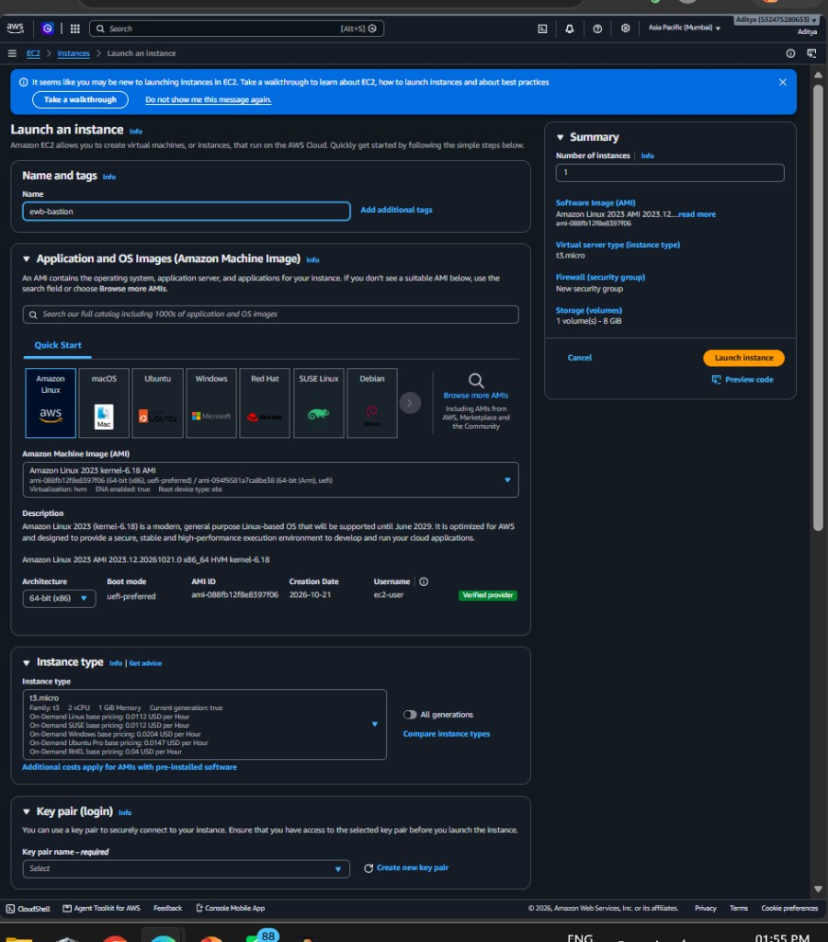
Key Security Characteristic:
Neither
ewb-app-a
nor
ewb-app-b
possesses a public IPv4 address or direct internet
routing. All remote administration is mediated through
ewb-bastion
in VPC A's public subnet using OpenSSH
ProxyJump
.
Figure 1: Checkpoint 02 — Compute Inventory showing ewb-bastion, ewb-app-a, and ewb-app-b passing 3/3 health checks

Resource Inventory Table
Resource  Name | Logical Role | AWS Resource ID | Subnet / VPC | IPv4 / CIDR
ewb-vpc-a | Requester VPC | vpc-084a10c21275c9423 | N/A | 10.10.0.0/16
ewb-vpc-b | Accepter VPC | vpc-0d5be64741a5ab8b9 | N/A | 10.20.0.0/16
ewb-a-public | Public Subnet | subnet074a1bdc28f74eb7b | ewb-vpc-a | 10.10.1.0/24
ewb-aprivate | Private Subnet | subnet0739012e0e05001b3 | ewb-vpc-a | 10.10.2.0/24
ewb-bprivate | Private Subnet | subnet083532ce04867e0d8 | ewb-vpc-b | 10.20.1.0/24
ewb-igw-a | Internet Gateway | igw-0852644c6bf4be208 | ewb-vpc-a | N/A
ewb-a-b-peer | VPC Peering  Connection | pcx-078073f607a5a75f0 | VPC A ↔ VPC  B | Active (pcx)
ewb-bastion | Bastion Jump Host | i-006304f40baed16dc | ewb-a-public | 10.10.1.10 (Public:  52.66.105.166)
ewb-app-a | Workload A Server | i-0c4aabcc3f387bde1 | ewb-aprivate | 10.10.2.10 (No Public IP)
ewb-app-b | Workload B Server | i-0e096e913d95c559a | ewb-bprivate | 10.20.1.10 (No Public IP)

Route Table Configurations & Subnet Associations
02

To enable packet flow between instances and across the peering link, three distinct route tables are configured with explicit subnet associations:
Route Table  Name | Associated  Subnet | Destination  CIDR | Target | Routing Purpose
ewb-rt-apublic | ewb-a-public | 10.10.0.0/16 | local | Local VPC A intra-communication
ewb-rt-apublic | ewb-a-public | 0.0.0.0/0 | igw0852644c6bf4be208 | Internet gateway route for Bastion
ewb-rt-apublic | ewb-a-public | 10.20.0.0/16 | pcx078073f607a5a75f0 | Enables Bastion to reach App-B for  SSH
Route Table  Name | Associated  Subnet | Destination  CIDR | Target | Routing Purpose
ewb-rt-aprivate | ewb-a-private | 10.10.0.0/16 | local | Local VPC A intra-communication
ewb-rt-aprivate | ewb-a-private | 10.20.0.0/16 | pcx078073f607a5a75f0 | Forward path: App-A to VPC B workload
ewb-rt-bprivate | ewb-b-private | 10.20.0.0/16 | local | Local VPC B intra-communication
ewb-rt-bprivate | ewb-b-private | 10.10.0.0/16 | pcx078073f607a5a75f0 | Return path: VPC B workload back to VPC A
Longest Prefix Match (LPM): In ewb-rt-a-public, traffic toward 10.20.1.10 evaluates 10.20.0.0/16 (more specific) over the default route 0.0.0.0/0, routing SSH ProxyJump traffic directly through the peering connection instead of blackholing it.
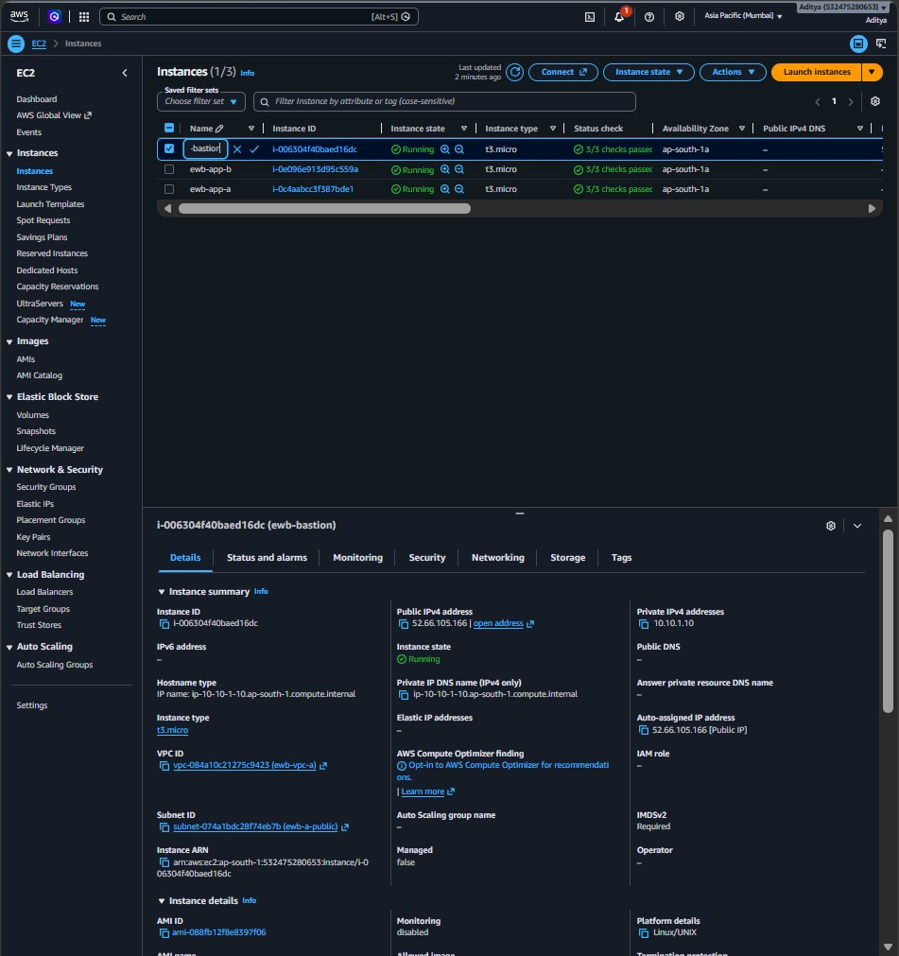
Figure 2: Checkpoint 03 — VPC Peering Connection ewb-a-b-peer (pcx-078073f607a5a75f0) in Active status connecting VPC A
and VPC B
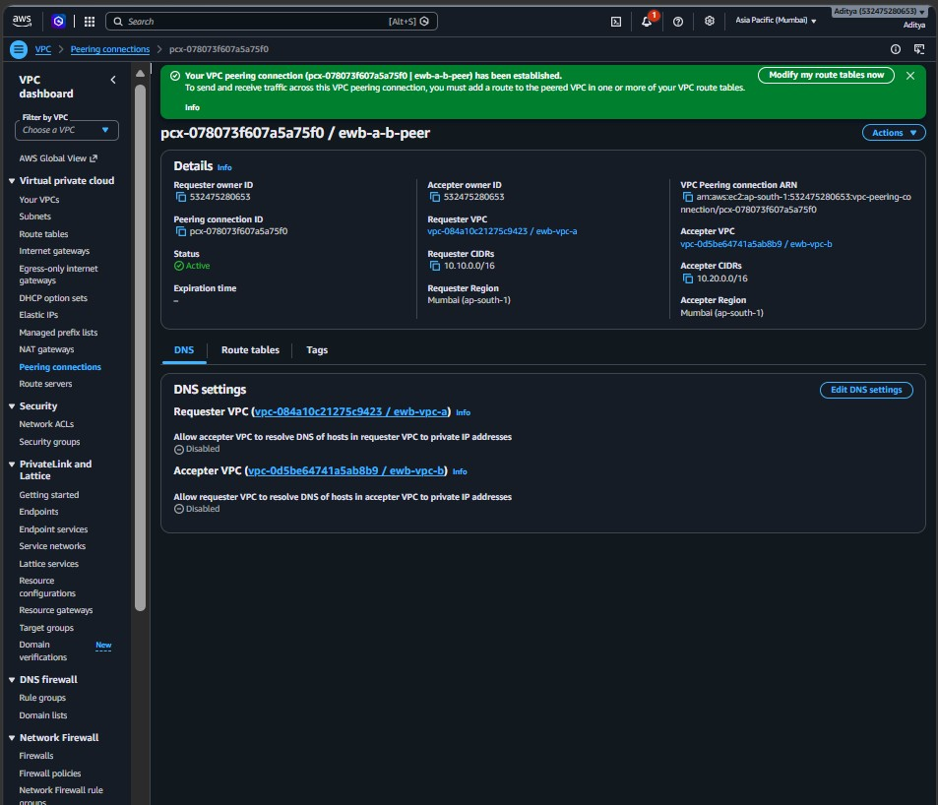
Figure 3: Checkpoint 04 — Explicit static peering route added for peer CIDR pointing to pcx-078073f607a5a75f0

03 Security Groups & Least-Privilege Access Control
Inbound firewall rules adhere strictly to least-privilege principles by restricting access to /32 host IPs rather than open CIDR ranges.
Security  Group | VPC  Scope | Type /  Protocol | Port Range | Permitted Source | Security Rationale
ewb-sgbastion | ewbvpc-a | SSH / TCP | 22 | 122.170.198.164/32 | Restricts administrative ingress to the student's authorized IP
ewb-sgapp-a | ewbvpc-a | SSH / TCP | 22 | 10.10.1.10/32 | Allows SSH solely from Bastion private IP
ewb-sgapp-a | ewbvpc-a | Custom ICMP  - IPv4 | Echo  Request  (8/0) | 10.20.1.10/32 | Allows ICMP ping probes only from App-B
ewb-sgapp-b | ewbvpc-b | SSH / TCP | 22 | 10.10.1.10/32 | Allows SSH solely from Bastion private IP via ProxyJump
ewb-sgapp-b | ewbvpc-b | Custom ICMP  - IPv4 | Echo  Request  (8/0) | 10.10.2.10/32 | Allows ICMP ping probes only from App-A

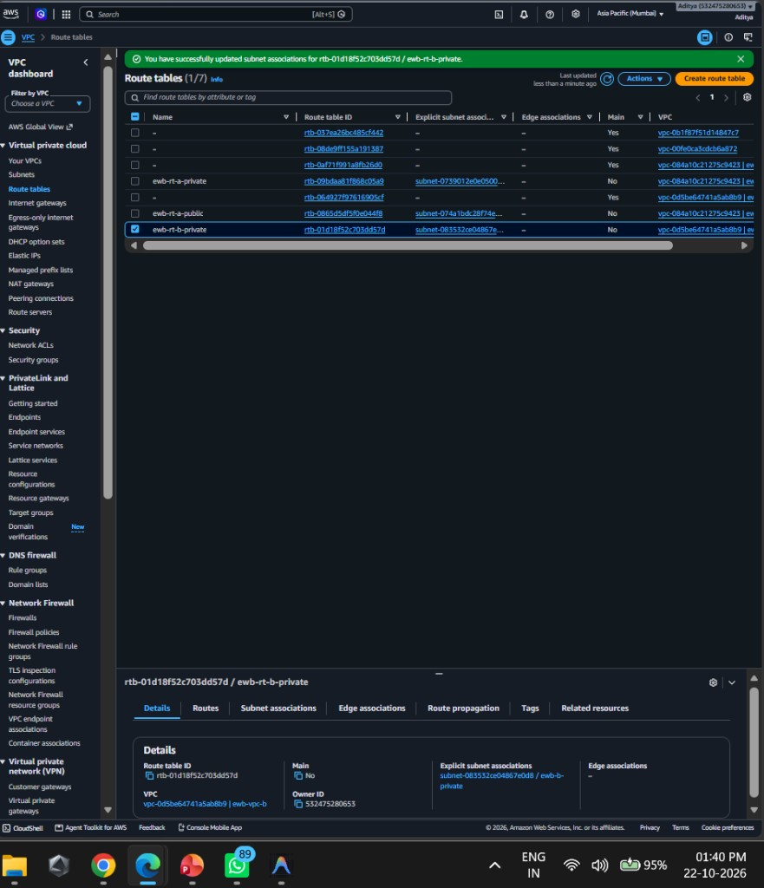
Figure 4: Least-Privilege Inbound Rules on ewb-sg-app-b restricted to specific /32 host IPs

Local SSH Configuration File (~/.ssh/config)
# Local OpenSSH Client Configuration Host ewb-bastion HostName 52.66.105.166 User ec2-user IdentityFile
~/.ssh/ewb-lab.pem IdentitiesOnly yes Host ewb-app-a HostName 10.10.2.10 User ec2-user IdentityFile ~/.ssh/ewb-lab.pem IdentitiesOnly yes ProxyJump ewb-bastion Host ewb-app-b HostName 10.20.1.10 User ec2user IdentityFile ~/.ssh/ewb-lab.pem IdentitiesOnly yes ProxyJump ewb-bastion
04
Verification & Test Results

Test 01: Baseline Failure Test (Before Peering Routes)
Ping from ewb-app-a to 10.20.1.10 prior to adding peering routes proves complete network isolation.
[ec2-user@ip-10-10-2-10 ~]$ hostname -I 10.10.2.10 [ec2-user@ip-10-10-2-10 ~]$ ping -c 4 10.20.1.10 PING 10.20.1.10 (10.20.1.10) 56(84) bytes of data. --- 10.20.1.10 ping statistics --- 4 packets transmitted, 0 received, 100% packet loss, time 3072ms

Test 02: Forward Path Verification (App-A → App-B)
After peering activation and route additions, ICMP Echo requests route successfully through pcx.
[ec2-user@ip-10-10-2-10 ~]$ ping -c 4 10.20.1.10 PING 10.20.1.10 (10.20.1.10) 56(84) bytes of data. 64 bytes from 10.20.1.10: icmp_seq=1 ttl=127 time=0.982 ms 64 bytes from 10.20.1.10: icmp_seq=2 ttl=127 time=0.841 ms 64 bytes from 10.20.1.10: icmp_seq=3 ttl=127 time=0.812 ms 64 bytes from 10.20.1.10:
icmp_seq=4 ttl=127 time=0.825 ms --- 10.20.1.10 ping statistics --- 4 packets transmitted, 4 received, 0% packet loss, time 3045ms rtt min/avg/max/mdev = 0.812/0.865/0.982/0.068 ms

Test 03: Reverse Path Verification (App-B → App-A)
Proves the return route in ewb-rt-b-private is active and symmetric.
[ec2-user@ip-10-20-1-10 ~]$ hostname -I 10.20.1.10 [ec2-user@ip-10-20-1-10 ~]$ ping -c 4 10.10.2.10 PING
10.10.2.10 (10.10.2.10) 56(84) bytes of data. 64 bytes from 10.10.2.10: icmp_seq=1 ttl=127 time=0.892 ms 64 bytes from 10.10.2.10: icmp_seq=2 ttl=127 time=0.834 ms 64 bytes from 10.10.2.10: icmp_seq=3 ttl=127 time=0.819 ms 64 bytes from 10.10.2.10: icmp_seq=4 ttl=127 time=0.848 ms --- 10.10.2.10 ping statistics
--- 4 packets transmitted, 4 received, 0% packet loss, time 3051ms rtt min/avg/max/mdev =
0.819/0.848/0.892/0.028 ms

Test 04: Private SSH ProxyJump Validation
Executing ssh ewb-app-b from local workstation hops through Bastion into the private host.
user@laptop:~$ ssh ewb-app-b Last login: 22 October 2026 from 10.10.1.10 , #_ ~\_ ####_ Amazon Linux 2023 ~~ \ _-### AL2023 AMI ~~ / # ~~ /vv~ https://aws.amazon.com/linux/amazon-linux-2023/ ~~ [ec2user@ip-10-20-1-10 ~]$ # Successfully authenticated on private App-B
05
Controlled Failure & Recovery Analysis
To definitively prove that the Security Group firewall is actively filtering traffic (and that ping success was not an artifact of an overly permissive rule), a controlled failure was executed by temporarily dropping the ICMP rule.
Fault Injection Procedure:
The inbound ICMP Echo Request rule (Type 8, Code 0 from
10.10.2.10/32
)
was deleted from
Security Group
ewb-sg-app-b
while keeping the SSH rule intact.

Phase A: Failure Observation (Forward Ping from App-A)
[ec2-user@ip-10-10-2-10 ~]$ ping -c 4 10.20.1.10 PING 10.20.1.10 (10.20.1.10) 56(84) bytes of data. ---
10.20.1.10 ping statistics --- 4 packets transmitted, 0 received, 100% packet loss, time 3088ms
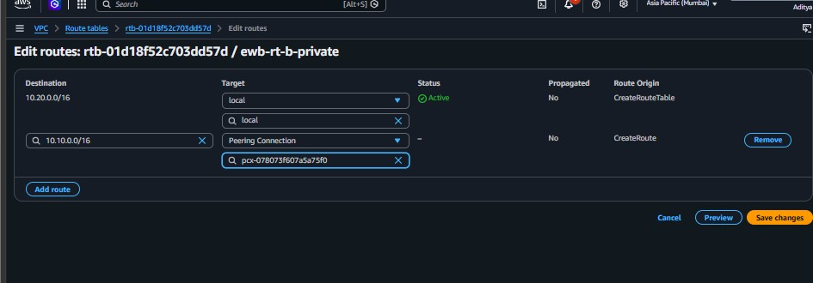
Figure 5: Controlled Fault Injection — Temporary deletion of the ICMP Echo Request inbound rule from ewb-sg-app-b
Technical Analysis: Although the VPC route table still successfully routed packets to pcx and delivered them to VPC B, the AWS hypervisor firewall (Security Group) dropped the incoming ICMP Echo Request at the virtual network interface of ewb-app-b. Note that SSH connectivity from Bastion remained fully operational during this period, proving port-level granularity.

Phase B: Recovery Verification
The exact ICMP rule was re-added to ewb-sg-app-b, instantly restoring connectivity:
[
ec2-user@ip-10-10-2-10 ~]$ ping -c 4 10.20.1.10 PING 10.20.1.10 (10.20.1.10) 56(84) bytes of data.
64
bytes from 10.20.1.10: icmp_seq=1 ttl=127 time=0.887 ms 64 bytes from 10.20.1.10: icmp_seq=2 ttl=127
time=0.829 ms --- 10.20.1.10 ping statistics --- 4 packets transmitted, 4 received,
0
% packet loss
, time
3039
ms
06
Technical Defense & Viva Q&A
Q1: Why is the return route needed?
Answer: Network communication is bidirectional. Even if the requester VPC has a route sending packets across the peering connection, the destination host's VPC router needs an explicit route table entry for the return destination CIDR (10.10.0.0/16 -> pcx). Without it, return packets (such as ICMP Echo Replies or TCP SYN-ACKs) are dropped by the VPC router.
Q2: Why is the App-B SSH source the bastion private IP?
Answer: When using SSH ProxyJump, the SSH client establishes a hopped tunnel. The TCP connection to App-B is initiated by the Bastion's kernel using its private ENI IP (10.10.1.10). From App-B's network standpoint, the incoming TCP connection originates from 10.10.1.10, not the student's laptop.
Q3: Why does Active peering not guarantee a successful ping?
Answer: Peering status indicates only that the tunnel is provisioned. Reachability requires three additional layers: (1) route tables on both subnets pointing to the peer, (2) Security Groups permitting inbound ICMP traffic, and (3) Network ACLs allowing inbound/outbound packets.
Q4: Can VPC B use VPC A's internet gateway over peering?
Answer: No. AWS VPC Peering is non-transitive. Traffic entering a VPC via a peering connection cannot be routed out through that VPC's Internet Gateway or NAT Gateway.
07
Teardown Evidence & Key Learnings
Following project completion and evidence capture, all cloud resources were terminated in reverse dependency order (EC2 instances terminated → Peering connection deleted → Route tables and subnets disassociated → IGW detached → VPCs deleted).
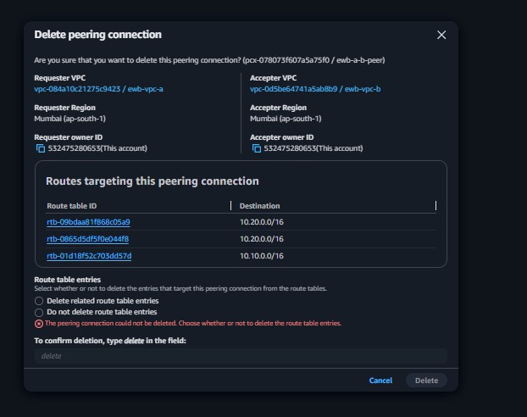
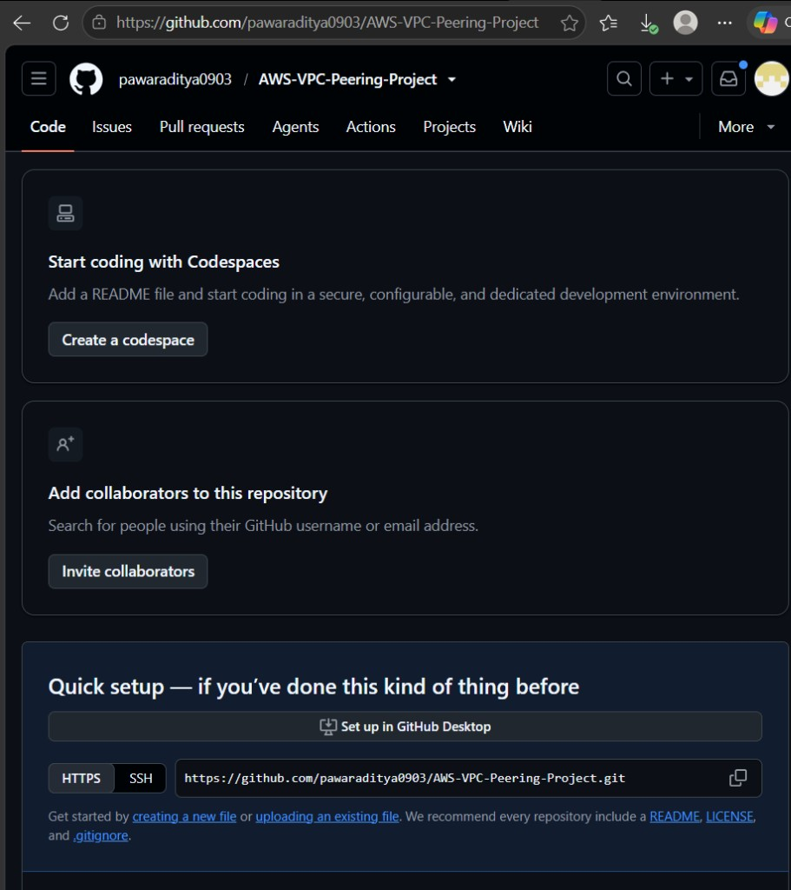
Figure 6: Clean Teardown — Deleting the VPC peering connection and automatically purging related route table entries
Figure 7: Final Teardown Evidence — EC2 instances transitioned to Shutting-down / Terminated to prevent ongoing cloud
charges
Key Takeaway:
Designing multi-VPC networks in AWS requires synchronized alignment of Layer 3 IP routing (Route
Tables), Layer 4 firewalls (Security Groups), and connection topologies. VPC Peering provides high-throughput, low-latency
private connectivity, but requires strict understanding of non-transitivity and explicit bidirectional route definitions.

