CT/2021/015-Wijewardhana.N.P

Lab Worksheet 03-Defining Classes

Q01) Code:

package Q_01_AND_Q_02;  
  
public class Temperature {  
 private double celsius;  
 public Temperature(){  
  
 }  
 public Temperature(double celsius){  
 this.celsius=celsius;  
 }  
  
 public double tocelsius(){  
 return celsius;  
 }  
  
 public double toFahrenheit(){  
 return (celsius*((double)9/5)+32 );  
 }  
 public void setcelsius(double celsius){  
 this.celsius=celsius;  
 }  
  
 public void setFahrenheit(double fahrenheit){  
 this.celsius=(fahrenheit-32)*((double)5/9 );  
 }  
  
}

package Q_01_AND_Q_02;  
import java.util.Scanner;  
public class Main {  
 public static void main(String[] args) {  
 Scanner scan=new Scanner(System.*in*);  
  
 System.*out*.println("Enter the temperature celsius:");  
 double celsius=scan.nextDouble();  
  
 Temperature temp=new Temperature();  
 temp.setcelsius(celsius);  
 System.*out*.println("the celsius is convert in to fahrenheit:"+temp.toFahrenheit());  
 }  
  
}

Output:

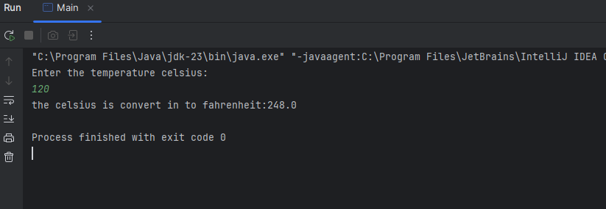

Q02) Code:

package Q_01_AND_Q_02;  
import java.util.Scanner;  
  
public class Main_Q_02 {  
 public static void main(String[] args) {  
 Scanner scan = new Scanner(System.*in*);  
  
 System.*out*.println("Enter the temperature fahrenheit:");  
 double fahrenheit=scan.nextDouble();  
  
 Temperature temp1=new Temperature();  
 temp1.setFahrenheit(fahrenheit);  
 System.*out*.println("the fahrenheit is convert in to celsius :"+temp1.tocelsius());  
  
  
 }  
  
}

Output:

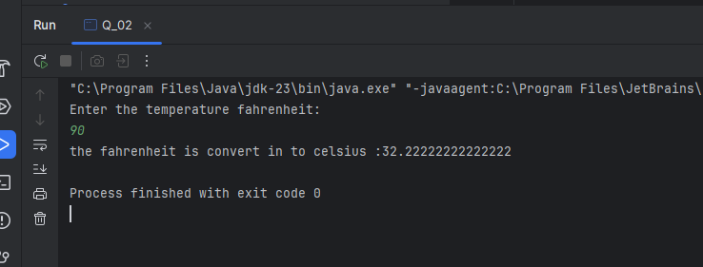

Q03) Code:

package Q_03;  
public class Circle {  
 private double r;  
  
 public Circle() {  
 }  
 public Circle(double r){  
 this.r=r;  
 }  
  
 public double getR() {  
 return r;  
 }  
  
 public void setR(double r) {  
 this.r = r;  
 }  
  
 public double computeArea(){  
 return Math.*PI*\*r*r;  
 }  
  
 public double computeCircumference(){  
 return 2*Math.*PI*\*r;  
 }  
}

package Q_03;  
import java.util.Scanner;  
public class Q_03 {  
 public static void main(String[] args) {  
 Scanner scan=new Scanner(System.*in*);  
  
 System.*out*.println("Enter the radius inner circle:");  
 double innerRadius=scan.nextDouble();  
  
 System.*out*.println("Enter the radius outer circle:");  
 double outerRadius=scan.nextDouble();  
  
 Circle outerCircle=new Circle(outerRadius);  
 Circle innerCircle=new Circle(innerRadius);  
 double area=outerCircle.computeArea()-innerCircle.computeCircumference();  
 System.*out*.println("The area is"+area);  
 }  
}

Output:

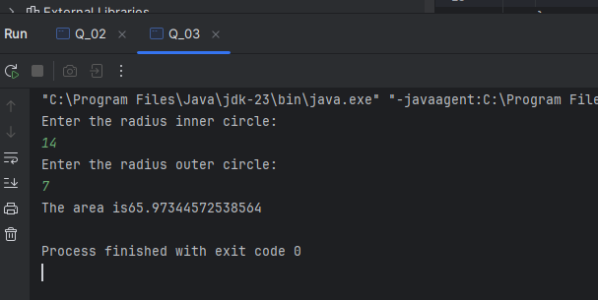­

Q04) code:

package Q_04;  
  
public class Owner {  
 // Data Member  
 private String ownerName;  
 private String phoneNo;  
  
  
 public Owner(String name,String num) {  
 this.ownerName = name;  
 this.phoneNo = num;  
 }  
  
 public String getOwnerName() {  
 return ownerName;  
 }  
  
 public void setOwnerName(String name) {  
 ownerName = name;  
 }  
 public String getPhoneNo() {  
 return phoneNo;  
 }  
  
 public void setPhoneNo(String num) {  
 phoneNo = num;  
 }  
 }

package Q_04;  
  
public class BicycleNew {  
 Owner bicycleOwner;  
  
 public BicycleNew(Owner bicycleOwner ) {  
 this.bicycleOwner = bicycleOwner;  
 }  
  
 public Owner getBicycleOwner() {  
 return bicycleOwner;  
 }  
  
 public void setBicycleOwner(Owner bicycleOwner) {  
 this.bicycleOwner = bicycleOwner;  
 }  
}

package Q_04;  
  
public class Q_04_Main {  
 public static void main(String[] args) {  
 Owner Piyumi=new Owner("Piyumi","077-1234567");  
 BicycleNew tomahawk=new BicycleNew(Piyumi);  
 System.*out*.println("Owner Name:"+tomahawk.getBicycleOwner().getOwnerName());  
 System.*out*.println("Owner Tel-Num:"+tomahawk.getBicycleOwner().getPhoneNo());  
 }  
}

Output:

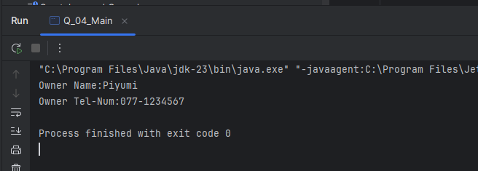

Q_05) Code:

package Q_05;  
  
public class Course {  
 private String CourseName;  
 private String CourseCode;  
 private Lecturer lecturerIncharge;  
  
 public String getCourseName() {  
 return CourseName;  
 }  
  
 public void setCourseName(String courseName) {  
 CourseName = courseName;  
 }  
  
 public String getCourseCode() {  
 return CourseCode;  
 }  
  
 public void setCourseCode(String courseCode) {  
 CourseCode = courseCode;  
 }  
  
 public Lecturer getLecturerIncharge() {  
 return lecturerIncharge;  
 }  
  
 public void setLecturerIncharge(Lecturer lecturerIncharge) {  
 this.lecturerIncharge = lecturerIncharge;  
 }  
}

package Q_05;  
  
public class Lecturer {  
 private String LecturerName;  
 private String CourseTeaching;  
  
 public String getLecturerName() {  
 return LecturerName;  
 }  
  
 public void setLecturerName(String lecturerName) {  
 LecturerName = lecturerName;  
 }  
  
 public String getCourseTeaching() {  
 return CourseTeaching;  
 }  
  
 public void setCourseTeaching(String courseTeaching) {  
 CourseTeaching = courseTeaching;  
 }  
}

package Q_05;  
  
public class Student {  
 private String StudentName;  
 private String DegreeName;  
 private String CourseFollowing;  
  
 public String getStudentName() {  
 return StudentName;  
 }  
  
 public void setStudentName(String studentName) {  
 StudentName = studentName;  
 }  
  
 public String getDegreeName() {  
 return DegreeName;  
 }  
  
 public void setDegreeName(String degreeName) {  
 DegreeName = degreeName;  
 }  
  
 public String getCourseFollowing() {  
 return CourseFollowing;  
 }  
  
 public void setCourseFollowing(String courseFollowing) {  
 CourseFollowing = courseFollowing;  
 }  
}

package Q_05;  
  
public class Main {  
 public static void main(String[] args) {  
 Course course=new Course();  
 course.setCourseName("OOP");  
 course.setCourseCode("CTEC-22043");  
  
  
 Lecturer lecturer=new Lecturer();  
 lecturer.setLecturerName("Dr.A.B.Perera");  
 lecturer.setCourseTeaching("OOP");  
  
 Student student=new Student();  
 student.setStudentName("Piyumi");  
 student.setCourseFollowing("OOP");  
 student.setDegreeName("BICT");  
  
 System.*out*.println("Course Name:"+course.getCourseName());  
 System.*out*.println("Course Code:"+course.getCourseCode());  
  
 System.*out*.println("Lecture Name:"+lecturer.getLecturerName());  
 System.*out*.println("Course Teaching:"+lecturer.getCourseTeaching());  
  
 System.*out*.println("Student Name:"+student.getStudentName());  
 System.*out*.println("DegreeName:"+student.getDegreeName());  
 System.*out*.println("Course Following:"+student.getCourseFollowing());  
  
 }  
}

Output:

