Lab worksheet 4: Selection Statements

CT/2021/015-N.P.wijewardhana.

01)Code:

package Q01;  
import java.util.Scanner;  
public class Q01 {  
 public static void main(String[] args) {  
 Scanner scan =new Scanner(System.*in*);  
 System.*out*.println("Enter First integer:");  
 int num1= scan.nextInt();  
 System.*out*.println("Enter Second integer:");  
 int num2= scan.nextInt();  
 System.*out*.println("Enter Third integer:");  
 int num3= scan.nextInt();  
  
 int smallest=num1;  
 if (num2<smallest){  
 smallest=num2;  
 }  
 if(num3<smallest){  
 smallest=num3;  
 }  
  
 System.*out*.println("Smallest Value:"+smallest);  
 }  
}

Output:

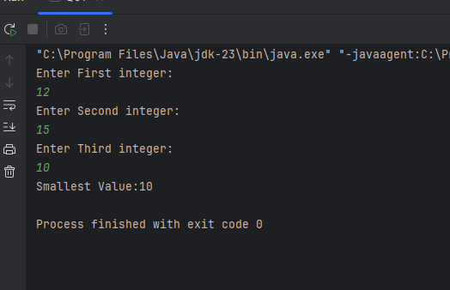

02)Code:

package Q02;  
import java.util.Scanner;  
  
public class Q02 {  
 public static void main(String[] args) {  
 Scanner scan = new Scanner(System.*in*);  
 System.*out*.println("Enter a num between(0-4):");  
 int number=scan.nextInt();  
 String color;  
 switch (number){  
 case 0:  
 color="Magenta";  
 break;  
 case 1:  
 color="Cyan";  
 break;  
 case 2:  
 color="Red";  
 break;  
 case 3:  
 color="Blue";  
 break;  
 case 4:  
 color="Green";  
 break;  
 default:  
 color=null;  
 break;  
  
 }  
  
 if(color==null){  
 System.*out*.println("Invalid Selection");  
 }  
 else{  
 System.*out*.println("You are selected:"+color);  
 }  
 }  
}

Output:

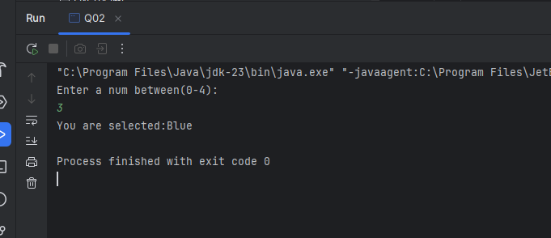

03)Cade:

package Q03;  
import java.util.Scanner;  
public class Q03 {  
 public static void main(String[] args) {  
 Scanner scan = new Scanner(System.*in*);  
 System.*out*.println("Enter the 10 power:");  
 int power= scan.nextInt();  
 String massage;  
  
 switch (power){  
 case 6:  
 massage="Million";  
 break;  
 case 9:  
 massage="Billion";  
 break;  
 case 12:  
 massage="Trillion";  
 break;  
 case 15:  
 massage="Quadrillion";  
 break;  
 case 18:  
 massage="Quintillion";  
 break;  
 case 21:  
 massage="Sextillion";  
 break;  
 case 30:  
 massage="Nonillion";  
 break;  
 case 100:  
 massage="Googol";  
 break;  
 default:  
 massage=null;  
 break;  
 }  
 if(massage==null){  
 System.*out*.println("Invalid value");  
 }  
 else {  
 System.*out*.println("your selection:"+massage);  
 }  
 }  
}

Output:

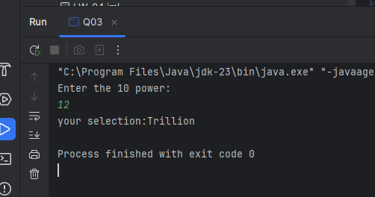

04)Code:

package Q04;  
import java.util.Scanner;  
public class Q04 {  
 public static void main(String[] args) {  
 Scanner scan = new Scanner(System.*in*);  
 System.*out*.println("Enter the year:");  
 int year= scan.nextInt();  
 boolean isLeapYear=false;  
 if(year%4==0){  
 if(year%400==0||year%100!=0){  
 isLeapYear=true;  
 }  
 }  
 if(isLeapYear){  
 System.*out*.println("The given year("+year+")"+"is leap year");  
 }  
 else{  
 System.*out*.println("The given year("+year+")"+"is not leap year");  
 }  
 }  
  
}

Output:

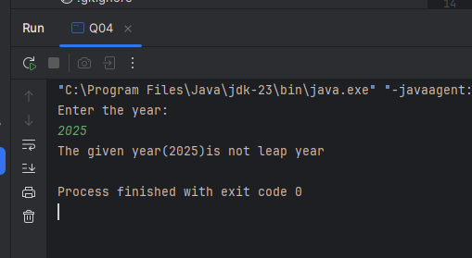

05)Code:

package Q05;  
import java.util.Scanner;  
public class Q05 {  
 public static void main(String[] args) {  
 Scanner scan = new Scanner(System.*in*);  
 System.*out*.println("Entree(Enter a num between(1-4)):");  
 int entree= scan.nextInt();  
 String chooseA;  
  
 System.*out*.println("Side Dish(Enter a num between(1-4)):");  
 int sideDish= scan.nextInt();  
 String chooseB;  
  
 System.*out*.println("Drink(Enter a num between(1-4)):");  
 int drink= scan.nextInt();  
 String chooseC;  
  
 switch (entree){  
 case 1:  
 chooseA="Tofu Burger-$3.49";  
 break;  
 case 2:  
 chooseA="Cajun Chicken-$4.59";  
 break;  
 case 3:  
 chooseA="Buffalo Wings-$3.99";  
 break;  
 case 4:  
 chooseA="Rainbow Fillet-$2.99";  
 break;  
 default:  
 chooseA=null;  
 break;  
 }  
 switch (sideDish){  
 case 1:  
 chooseB="Rice Cracker-$0.79";  
 break;  
 case 2:  
 chooseB="No-Salt Fries-$0.69";  
 break;  
 case 3:  
 chooseB="Zucchini-$1.09";  
 break;  
 case 4:  
 chooseB=" Brown Rice-$0.59";  
 break;  
 default:  
 chooseB=null;  
 break;  
  
 }  
  
 switch(drink){  
 case 1:  
 chooseC="Cafe Mocha-$1.99";  
 break;  
 case 2:  
 chooseC="Cafe Latte-$1.90";  
 break;  
 case 3:  
 chooseC="Espresso-$2.49";  
 break;  
 case 4:  
 chooseC=" Oolong Tea-$0.99";  
 break;  
 default:  
 chooseC=null;  
 break;  
 }  
 System.*out*.println("Entree:"+chooseA);  
 System.*out*.println("Side Dish :"+chooseB);  
 System.*out*.println("Drink:"+chooseC);  
  
 }  
}

Output:

