Lab Worksheet 5: Repetition Statements

CT/2021/015-Wijewardhana.N.P

01) Code:

package Q1;  
  
public class Q01 {  
 public static void main(String[] args) {  
 int number=10;  
 while (number<=49){  
 System.*out*.print(number+" ");  
 if(number%10==9){  
 System.*out*.println();  
 }  
 number=number+1;  
 }  
 }  
}

Output:

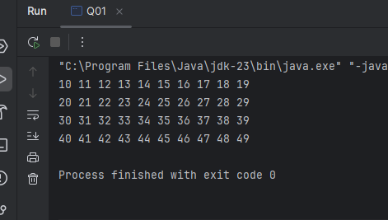

02) Code:

package Q2;  
import java.util.Scanner;  
public class Q02 {  
 public static void main(String[] args) {  
 Scanner scanner=new Scanner(System.*in*);  
 int num;  
 do{  
 System.*out*.println("Enter a num:");  
 num=scanner.nextInt();  
  
 if(num>=0){  
 int digit=*digitCount*(num);  
 System.*out*.println("The no has"+digit+" digit");  
 }  
  
 }while (num>=0);  
  
 }  
 public static int digitCount(int num){  
 int count=0;  
 while (num>0){  
 num=num/10;  
 count ++;  
 }  
 return count;  
 }  
}

Output:

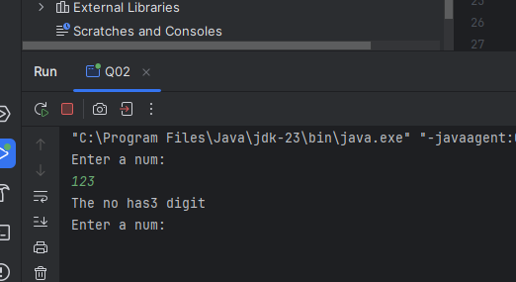

03) Code:

package Q3;  
import java.util.Scanner;  
public class Q03 {  
 public static void main(String[] args) {  
 Scanner scanner=new Scanner(System.*in*);  
 int N;  
 System.*out*.println("Enter N:");  
 N= scanner.nextInt();  
  
 for (int i=1;i<=10;i++){  
 int result=N\*i;  
 System.*out*.println("Result Is:"+N+"\*"+i+"="+result);  
 }  
 }  
}

Output:

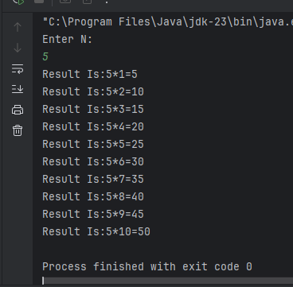

04)Code:

package Q4;  
import java.util.Scanner;  
public class Q04 {  
 public static void main(String[] args) {  
 Scanner scanner=new Scanner(System.*in*);  
  
 System.*out*.println("Enter Row:");  
 int row=scanner.nextInt();  
 int space=row-1;  
 int asterisks=1;  
  
 for(int i=0;i<row;i++){  
 for(int j=0;j<space;j++){  
 System.*out*.print(" ");  
 }  
 for(int k=0;k<asterisks;k++){  
 System.*out*.print("\*");  
 }  
 System.*out*.println();  
 asterisks +=2;  
 space--;  
 }  
 }  
  
}

Output:

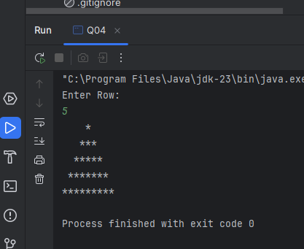

05)Code:

public class Q05 {  
 public static void main(String[] args) {  
 Scanner scanner = new Scanner(System.*in*);  
 System.*out*.println("Enter the word:");  
 String word = scanner.nextLine();  
  
 if (*isPalindrome*(word)) {  
 System.*out*.println("The given word is a palindrome.");  
 } else {  
 System.*out*.println("The given word is not a palindrome.");  
 }  
  
 scanner.close();  
 }  
  
 public static boolean isPalindrome(String word) {  
 String reverseWord = "";  
 for (int i = word.length() - 1; i >= 0; i--) {  
 reverseWord += word.charAt(i);  
 }  
 return word.equalsIgnoreCase(reverseWord);  
 }  
}

Output:

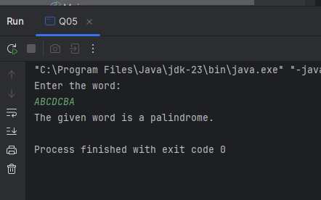

06)Code:

package Q6;  
import java.util.Scanner;  
import java.util.Random;  
public class Q06 {  
 public static void main(String[] args) {  
 Scanner input = new Scanner(System.*in*);  
 Random rand = new Random();  
 int guess;  
 int attempts=0;  
 int secretNumber = rand.nextInt(100) + 1;  
 System.*out*.println("Welcome to the number guessing game!");  
 do{  
 System.*out*.println("Enter your guess(1-100)");  
 guess=input.nextInt();  
 attempts++;  
   
 if(guess>secretNumber){  
 System.*out*.println("Higher");  
 }  
 else if(guess<secretNumber){  
 System.*out*.println("Lower");  
 }  
 else{  
 System.*out*.println("Congratulations! you guessed the secret number correctly in"+attempts+"attempts");  
 }  
 }while (guess!=secretNumber);  
 }  
}

Output:

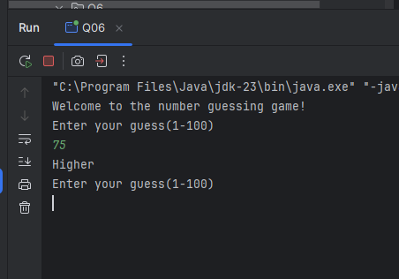

07)Code:

package Q7;  
import java.util.Scanner;  
public class Q07 {  
 public static void main(String[] args) {  
 Scanner scanner = new Scanner(System.*in*);  
  
 System.*out*.println("Enter a sentence:");  
 String sentence = scanner.nextLine();  
  
 System.*out*.println("Enter the word to be replaced:");  
 String wordToReplace = scanner.nextLine();  
  
 System.*out*.println("Enter the replacement word:");  
 String replacementWord = scanner.nextLine();  
  
 String modifiedSentence = *replaceWords*(sentence, wordToReplace, replacementWord);  
 System.*out*.println("Modified sentence: " + modifiedSentence);  
  
 scanner.close();  
 }  
 public static String replaceWords(String sentence, String wordToReplace, String replacementWord) {  
 String[] words = sentence.split(" ");  
 for (int i = 0; i < words.length; i++) {  
 // Remove punctuation if needed for cleaner matching  
 if (words[i].equalsIgnoreCase(wordToReplace)) {  
 words[i] = replacementWord;  
 }  
 }  
 return String.*join*(" ", words);  
 }  
}

