CT/2021/015-Wijewardhana.N.P

Lab worksheet 1: Introduction to Program Components

Q1) Code:

package Q_01;  
import javax.swing.*;  
public class Q1 {  
 public static void main(String[] args) {  
 JFrame myWindow;  
 myWindow = new JFrame();  
 myWindow.setSize(800, 600);  
 myWindow.setTitle(" Welcome to Java");   
 myWindow.setVisible(true);  
 }  
  
}

output:

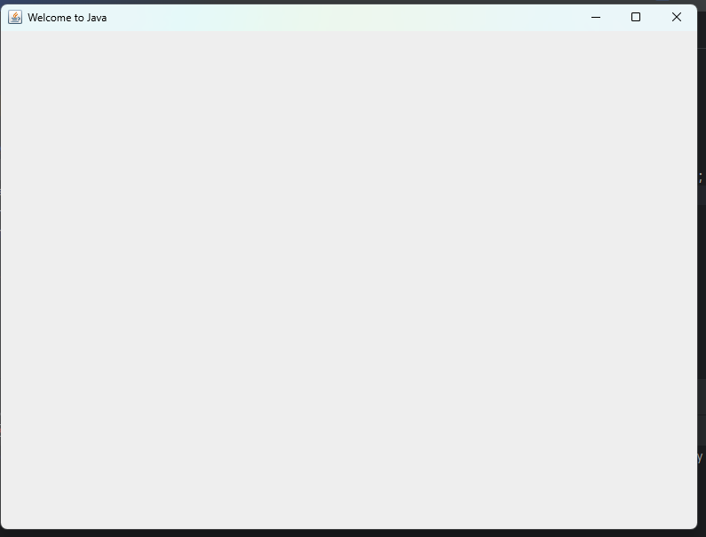

Q2) Code:

package Q_02;  
import javax.swing.*;  
import java.util.Scanner;  
  
public class Q2 {  
  
 public static void main(String[]args){  
 Scanner Scanner =new Scanner(System.*in*) ;  
 String firstName,lastName;  
 System.*out*.println("Enter your FistName");  
 firstName= Scanner.next();  
 System.*out*.println("Enter your LastName");  
 lastName=Scanner.next();  
  
 JFrame myWindow;  
 myWindow = new JFrame();  
 myWindow.setSize(300, 400);  
 myWindow.setTitle(firstName+" "+lastName);  
 myWindow.setVisible(true);  
  
  
 }  
  
  
 }

output:

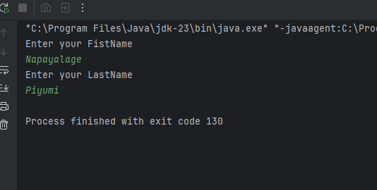

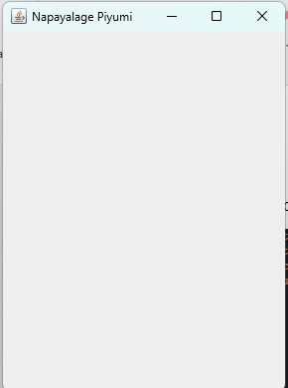

Q3) Cade:

package Q_03;  
import java.util.Scanner;  
public class Q3 {  
 public static void main(String[] args) {  
 Scanner Scanner = new Scanner(System.*in*);  
 String firstName, middleName, lastName;  
 System.*out*.println("Enter your FistName:");  
 firstName = Scanner.next();  
 System.*out*.println("Enter your MiddleName:");  
 middleName = Scanner.next();  
 System.*out*.println("Enter your LastName:");  
 lastName = Scanner.next();  
  
 System.*out*.println(firstName+" "+ middleName.substring(0,1)+"."+ lastName);  
  
 }  
}

Output:

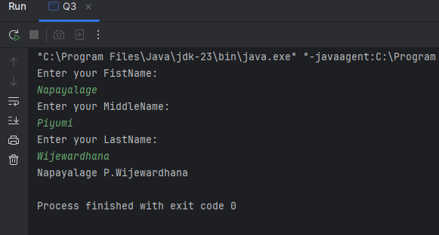

Q4) Code:

package Q_04;  
import java.text.SimpleDateFormat;  
import java.util.Date;  
  
public class Q4 {  
 public static void main(String[] args) {  
 Date today;  
 SimpleDateFormat sdf;  
 today = new Date();  
 sdf = new SimpleDateFormat("dd MMMM yyyy");  
 System.*out*.println(sdf.format(today));  
  
 }  
}

Output:

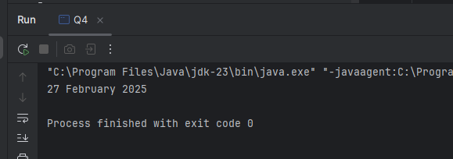

Q5) Code:

package Q_05;  
import javax.swing.*;  
import java.text.SimpleDateFormat;  
import java.util.Date;  
import javax.swing.*;  
public class Q5 {  
 public static void main(String[] args) {  
 Date today;  
 SimpleDateFormat sdf;  
 today = new Date( );  
 sdf = new SimpleDateFormat("EEEE,MMMM dd,yyyy");  
 System.*out*.println(sdf.format(today));  
 }  
  
}

Output:



Q06) Code:

package Q_06;  
import javax.swing.*;  
import java.util.Scanner;  
  
public class Q6 {  
 public static void main(String[] args) {  
 Scanner scanner = new Scanner(System.*in*);  
  
 System.*out*.println("Enter window width (W): ");  
 int width = scanner.nextInt();  
 System.*out*.println("Enter window height (H): ");  
 int height = scanner.nextInt();  
 System.*out*.println("Enter window title: ");  
 String W_title = scanner.next();  
  
  
 JFrame myWindow;  
 myWindow = new JFrame();  
 myWindow.setSize(width, height);  
 myWindow.setTitle(W_title);  
 myWindow.setVisible(true);  
 }  
  
}

Output:

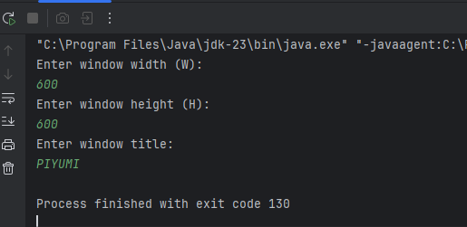

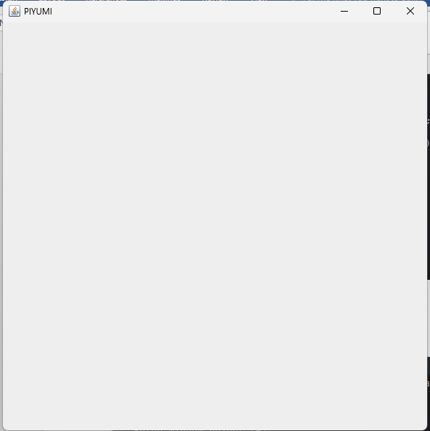

Q07) Code:

package Q_07;  
import javax.swing.*;  
import java.text.SimpleDateFormat;  
import java.util.Date;  
  
public class Q7 {  
 public static void main(String[] args) {  
 Date today;  
 SimpleDateFormat sdf;  
 today = new Date( );  
 sdf = new SimpleDateFormat("HH:mm:ss a");  
  
 JFrame myWindow;  
 myWindow = new JFrame();  
 myWindow.setSize(600, 600);  
 myWindow.setTitle(sdf.format(today));  
 myWindow.setVisible(true);  
 }  
  
}

Output:

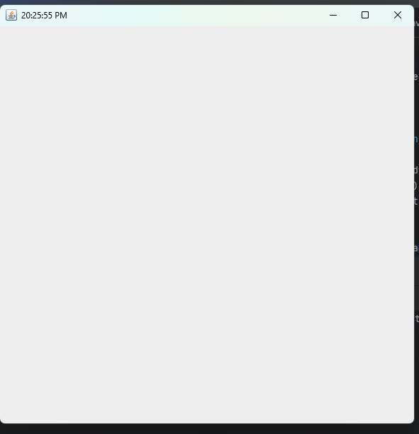

Q08) Code:

package Q_08;  
import java.util.Scanner;  
public class Q8 {  
 public static void main(String[] args) {  
 Scanner scanner=new Scanner(System.*in*);  
 String word = scanner.nextLine();  
 int length=word.length();  
 int index=word.indexOf("!");  
 System.*out*.println(word.substring(0,index));  
 System.*out*.println(word.substring(index+1,length));  
 }  
}

Output:

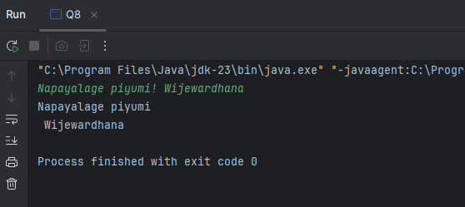

Q09) Code:

package Q_09;  
import java.util.Scanner;  
public class Q9 {  
 public static void main(String[] args) {  
 Scanner Scan=new Scanner(System.*in*);  
 String string;  
 string=Scan.nextLine();  
 System.*out*.println(string.length());  
 System.*out*.println(string.charAt(0));  
 System.*out*.println(string.charAt(string.length()-1));  
  
 }  
 }

Output:

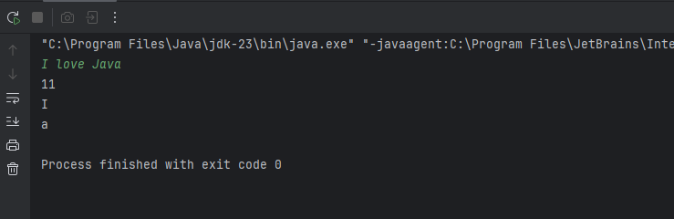

Q10) Code:

package Q_10;  
import java.util.Scanner;  
public class Q10 {  
 public static void main(String[] args) {  
 Scanner scanner = new Scanner(System.*in*);  
 System.*out*.println("Enter word:");  
 String input = scanner.nextLine();  
  
 int length = input.length();  
 int middleIndex = length / 2;  
 System.*out*.print("Middle character is:");  
 System.*out*.println(input.substring(middleIndex, middleIndex + 1));  
  
 }  
  
}

output:

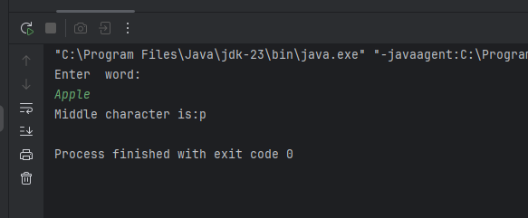

Q11) code:

package Q_11;  
import java.util.Scanner;  
public class Q11 {  
 public static void main(String[] args) {  
 Scanner name = new Scanner(System.*in*);  
 String firstName, middleName, lastName;  
 System.*out*.println("Enter your FistName:");  
 firstName = name.next();  
 System.*out*.println("Enter your MiddleName:");  
 middleName = name.next();  
 System.*out*.println("Enter your LastName:");  
 lastName = name.next();  
 System.*out*.println(lastName + "," + firstName + " " + middleName.substring(0, 1)+".");  
 }  
 }

Output:

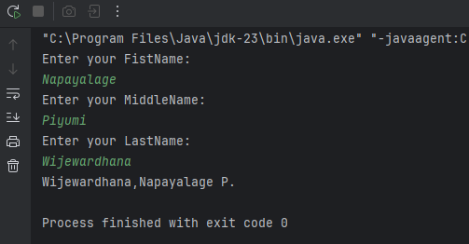

Q12) code:

package Q_12;  
import javax.swing.*;  
public class Q12 {  
 public static void main(String[] args) {  
 JFrame myWindow;  
 myWindow = new JFrame();  
 myWindow.setSize(300, 200);  
 myWindow.setTitle(" My First Frame");  
 myWindow.setLocation(50, 100);  
 myWindow.setVisible(true);  
 }  
 }

Output:

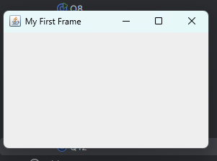

Q13) Code:

package Q_13;  
import javax.swing.*;  
public class Q13 {  
 public static void main(String[] args) {  
 JFrame myWindow;  
 myWindow = new JFrame();  
 myWindow.setSize(500, 250);  
 myWindow.setTitle("UOK");  
 myWindow.setVisible(true);  
 try {Thread.*sleep*(500);} catch(Exception e) { }  
 myWindow.setVisible(false);  
 try {Thread.*sleep*(500);} catch(Exception e) { }  
 myWindow.setVisible(true);  
 }  
 }

Output:

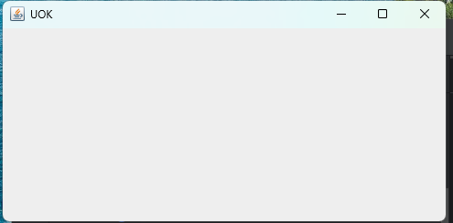

Code Explanation:

import javax.swing.*;  
  
class SampleWindow {  
 public static void main(String[] args) {  
 // Create a JFrame object  
 JFrame myWindow;  
 myWindow = new JFrame();  
  
 // Set the size of the window (Width: 500, Height: 250)  
 myWindow.setSize(500, 250);  
  
 // Set the title of the window  
 myWindow.setTitle("UOK");  
  
 // Make the window visible  
 myWindow.setVisible(true);  
  
 // Pause execution for 500 milliseconds (0.5 seconds)  
 try { Thread.*sleep*(500); } catch (Exception e) { }  
  
 // Make the window invisible  
 myWindow.setVisible(false);  
  
 // Pause execution for another 500 milliseconds  
 try { Thread.*sleep*(500); } catch (Exception e) { }  
  
 // Make the window visible again  
 myWindow.setVisible(true);  
 }  
}