CT/2021/015-Wijewardhana.N.P

Lab Worksheet 02: Numerical Data

Q-01)

Code:

package Q_01;  
public class Q01 {  
 public static void main(String[] args) {  
 int A=10;  
 int B=20;  
 int C=30;  
 int X=40;  
 int Y=50;  
 int r=7;  
  
 double result1=Math.*sqrt*(Math.*pow*(B,2)+4*A*C);  
 double result2=Math.*sqrt*(X+4*Math.*pow*(Y,3));  
 double result3=Math.*cbrt*(X*Y);  
 double area=Math.*PI*\*Math.*pow*(r,2);  
  
 System.*out*.println(result1);  
 System.*out*.println(result2);  
 System.*out*.println(result3);  
 System.*out*.println(area);  
 }  
}

Output:

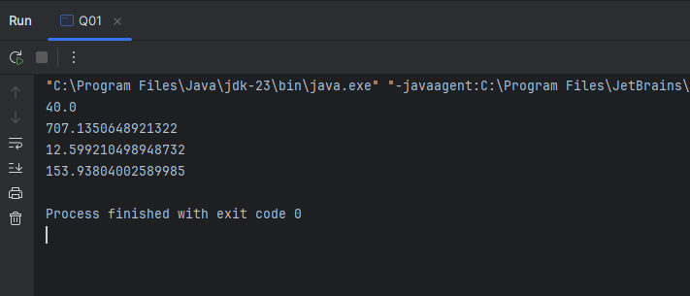

Q-02)

Code:

package Q_02;  
import java.util.Scanner;  
public class Q02 {  
 public static void main(String[] args) {  
 Scanner Scanner =new Scanner(System.*in*);  
 System.*out*.println("Enter value in Centimeter:");  
 float value= Scanner.nextFloat();  
 float outputInch=(float) (value/2.54);  
 float outputFeet=(float)(outputInch/12);  
 System.*out*.println("Inch Value:"+outputInch);  
 System.*out*.println("Feet Value:"+outputFeet);  
 }  
}

Output:

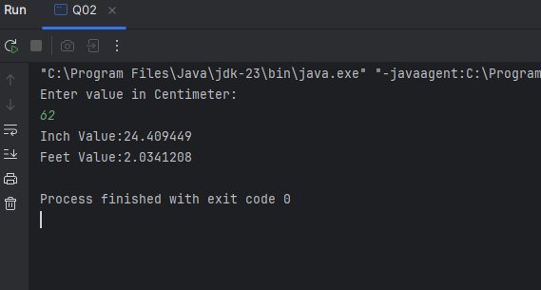

Q-03)

Code:

package Q_03;  
import java.util.Scanner;  
public class Q03 {  
 public static void main(String[] args) {  
 Scanner scan=new Scanner(System.*in*);  
 System.*out*.println("Enter value in Celsius:");  
 int c=scan.nextInt();  
 double output=(1.8*c)+32;  
 System.*out*.println("Fahrenheit Value:"+output);  
 }  
}

Output:

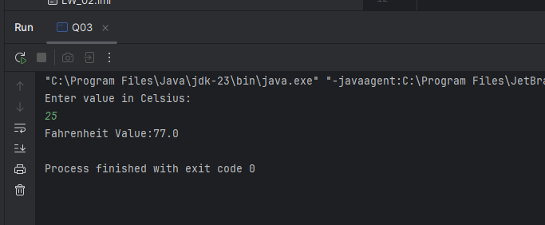

Q-04)

Code:

package Q_04;  
  
import java.util.Scanner;  
public class Q04 {  
 public static void main(String[] args) {  
 Scanner scan=new Scanner(System.*in*);  
 System.*out*.println("Enter Body weight:");  
 int BW=scan.nextInt();  
 double output=BW*19;  
 System.*out*.println("Calories:"+output);  
 }  
}

Output:

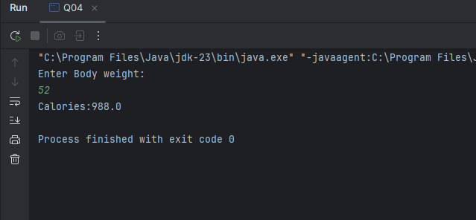

Q-05)

Code:

import java.util.Scanner;  
  
public class Q05 {  
 public static void main(String[] args) {  
 Scanner scan=new Scanner(System.*in*);  
 System.*out*.println("Enter value in Fahrenheit:");  
 int F=scan.nextInt();  
 double output=(9/5)*(F-32);  
 System.*out*.println("Celsius Value:"+output);  
 }  
}

Out Put:

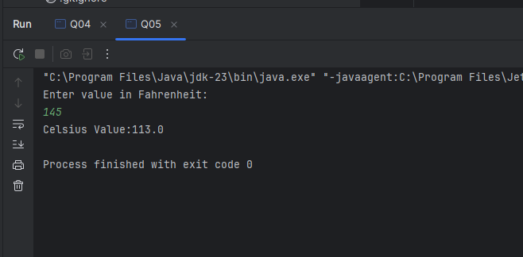

Q-06)

Code:

package Q_06;  
import java.text.SimpleDateFormat;  
import java.util.Date;  
import java.util.Scanner;  
  
public class Q06 {  
 public static void main(String[] args) {  
 Scanner scan=new Scanner(System.*in*);  
 System.*out*.println("Enter Born year: ");  
 int born_year= scan.nextInt();  
 Date date=new Date();  
 SimpleDateFormat sdf=new SimpleDateFormat("yyyy");  
 int age= Integer.*parseInt*(sdf.format(date))-born_year;  
 System.*out*.println("You were born in "+ born_year+" " +"and will be (are)"+" " +  
 age+ " " +"this year");  
 }  
}

Output:

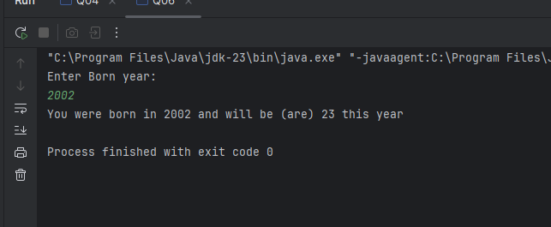

Q-06)

Code:

package Q_07;  
import java.util.Scanner;  
public class Q07 {  
 public static void main(String[] args) {  
 Scanner scan=new Scanner(System.*in*);  
 System.*out*.println("Enter weight(kg):");  
 int weight=scan.nextInt();  
 System.*out*.println("Enter height(cm):");  
 int height= scan.nextInt();  
 Double BMI= (Double) (weight/Math.*pow*((height/100.0),2));  
 System.*out*.println("BMI is:"+BMI);  
 }  
}

Output:

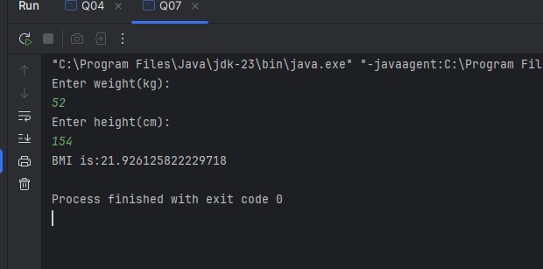

Q-02)

Code:

package Q_08;  
import java.util.Scanner;  
public class Q08 {  
 public static void main(String[] args) {  
 Scanner scan=new Scanner(System.*in*);  
 System.*out*.println("Input r: ");  
 int r= scan.nextInt();  
 double v= (4.0/3)*(Math.*PI*\*Math.*pow*(r,3));  
 System.*out*.println("volume of a sphere: " + v);  
 }  
}

Output:

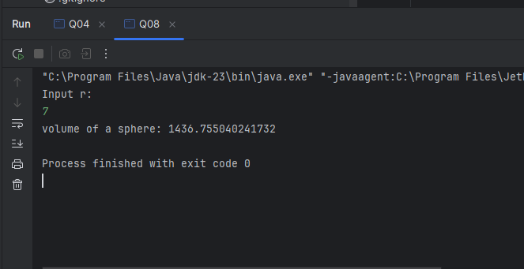

Q-09)

Code:

package Q_09;  
import java.util.Scanner;  
public class Q09 {  
 public static void main(String[] args) {  
 Scanner scan=new Scanner(System.*in*);  
 System.*out*.println("invest dollars: ");  
 double P= scan.nextDouble();  
 System.*out*.println("Enter Percentage: ");  
 double R= scan.nextDouble();  
 System.*out*.println("How many years: ");  
 int N= scan.nextInt();  
 double a=P*(1+Math.*pow*((R/100),N));  
 System.*out*.println("Amount: "+a);  
 }  
}

Output:

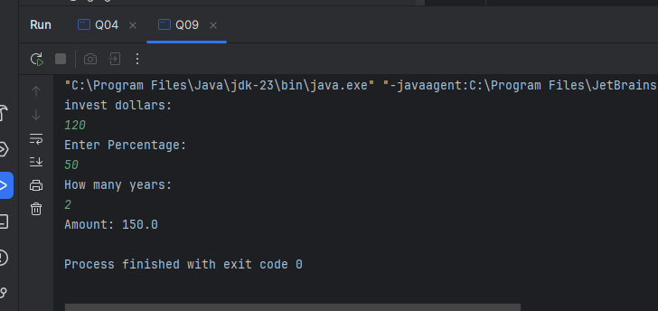

Q-10)

Code:

package Q_10;  
import java.util.Scanner;  
public class Q10 {  
 public static void main(String[] args) {  
 Scanner scan=new Scanner(System.*in*);  
  
 System.*out*.println("Enter loan amount:");  
 double loanAmount = scan.nextDouble();  
  
 System.*out*.print("Enter annual interest rate: ");  
 double annualInterestRate = scan.nextDouble();  
  
 System.*out*.print("Enter loan period (in years): ");  
 int loanPeriod = scan.nextInt();  
  
 double monthlyInterestRate = annualInterestRate / 100 / 12;  
 int numberOfPayments = loanPeriod * 12;  
  
 double monthly_Payment = (loanAmount * monthlyInterestRate) /  
 (1 - Math.*pow*(1 + monthlyInterestRate, -numberOfPayments));  
 double total_Payment = monthly_Payment * numberOfPayments;  
  
 System.*out*.printf("Monthly Payment: %.2f\n", monthly_Payment);  
 System.*out*.printf("Total Payment: %.2f\n", total_Payment);  
 }  
}

Output:

