**Lab worksheet 7: GUI and Event Driven Programming**

CT/2021/015

Wijewardhana.N.P.

01)Code:

package Q1;  
  
import javax.swing.*;  
  
public class Q1 {  
 public static void main(String[] args) {  
 String input1= JOptionPane.*showInputDialog*("Enter the first no:");  
 int Num1=Integer.*parseInt*(input1);  
  
 String input2= JOptionPane.*showInputDialog*("Enter the Second no:");  
 int Num2=Integer.*parseInt*(input2);  
  
 String input3= JOptionPane.*showInputDialog*("Enter the Third no:");  
 int Num3=Integer.*parseInt*(input3);  
  
 int sum=Num1 + Num2 + Num3;  
 JOptionPane.*showMessageDialog*(null,"The sum of the three integer is: "+sum);  
 }  
}

Output:

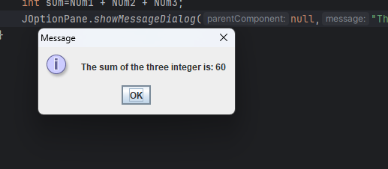

02)Code:

package Q2;  
import javax.swing.*;  
import java.awt.*;  
public class MyFrame extends JFrame {  
 public MyFrame(){  
 setSize(400,450);  
 getContentPane().setBackground(Color.*BLUE*);  
 setDefaultCloseOperation(JFrame.*EXIT_ON_CLOSE*);  
 }  
  
}

package Q2;  
public class Q2 {  
 public static void main(String[] args) {  
 MyFrame myFrame=new MyFrame();  
 myFrame.setVisible(true);  
 }  
}

OutPut:

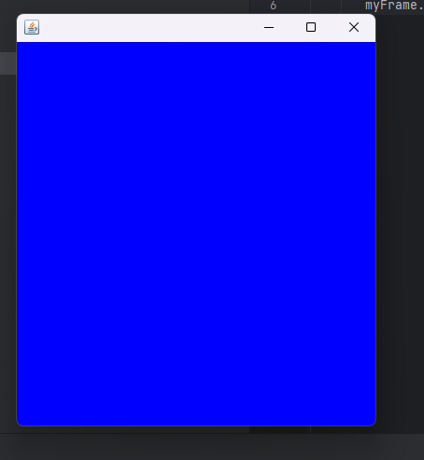

03)Code:

import java.awt.*;  
import java.awt.event.ActionEvent;  
public class MyFrame extends JFrame {  
 public MyFrame(){  
 setSize(400,450);  
 getContentPane().setBackground(Color.*BLUE*);  
 setDefaultCloseOperation(JFrame.*EXIT_ON_CLOSE*);  
  
 JButton button= new JButton("Click me");  
 button.addActionListener(new AbstractAction() {  
 @Override  
 public void actionPerformed(ActionEvent e) {  
 JOptionPane.*showMessageDialog*(null,"You clicked");  
 }  
 });  
  
 add(button);  
 setDefaultCloseOperation(JFrame.*EXIT_ON_CLOSE*);  
 }  
  
 }

package Q3;  
  
import Q3.MyFrame;  
  
public class Main {  
 public static void main(String[] args) {  
 MyFrame myFrame=new MyFrame();  
 myFrame.setVisible(true);  
 }  
}

OutPut:

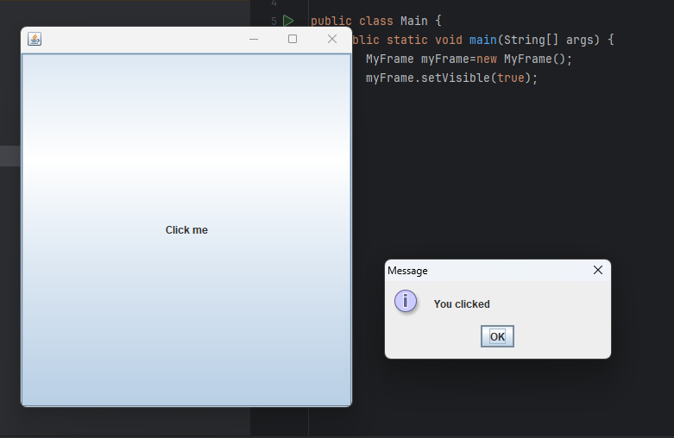

04)Code:

package Q4;  
import javax.swing.*;  
import java.awt.event.ActionEvent;  
public class MyFrame extends JFrame {  
 private JTextField textField;  
 public MyFrame(){  
 setSize(400,450);  
 textField=new JTextField();  
 JButton button=new JButton("Change Title");  
 button.addActionListener(new AbstractAction() {  
 @Override  
 public void actionPerformed(ActionEvent e) {  
 String title=textField.getText();  
 setTitle(title);  
  
 }  
 });  
 add(textField);  
 add(button);  
 setLayout(null);  
 textField.setBounds(50,50,200,30);  
 button.setBounds(100,100,100,30);  
  
 setDefaultCloseOperation(JFrame.*EXIT_ON_CLOSE*);  
   
 }  
}

package Q4;  
public class Main {  
 public static void main(String[] args) {  
 MyFrame myFrame=new MyFrame();  
 myFrame.setVisible(true);  
 }  
 }

Output:

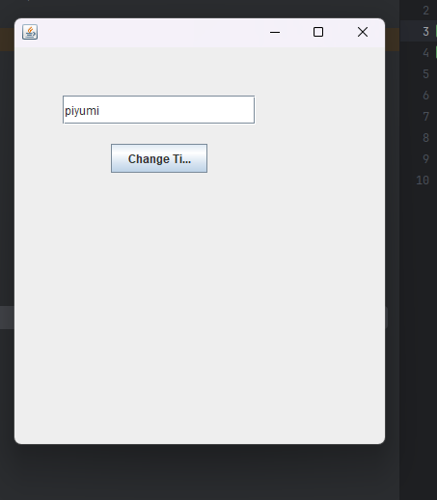

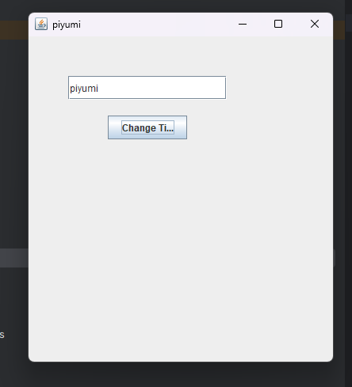

05)Code:

package Q05;  
import javax.swing.*;  
import java.awt.*;  
import java.awt.event.ActionEvent;  
import java.awt.event.ActionListener;  
  
public class MyFrame extends JFrame{  
 private JButton toggleButton;  
 private Color initialColor;  
 private String initialButtonText;  
  
 public MyFrame(){  
 setSize(200,200);  
 initialColor=Color.*GREEN*;  
 initialButtonText="OFF";  
  
  
 JPanel contentPane=new JPanel();  
 contentPane.setBackground(initialColor);  
 setContentPane(contentPane);  
  
 toggleButton= new JButton(initialButtonText);  
  
 toggleButton.addActionListener(new ActionListener() {  
 @Override  
 public void actionPerformed(ActionEvent e) {  
 if(getContentPane().getBackground().equals(initialColor)){  
 getContentPane().setBackground(Color.*RED*);  
 toggleButton.setText("ON");  
 }  
 }  
 });  
  
 contentPane.add(toggleButton);  
  
 }  
  
  
}

package Q05;  
public class Main {  
 public static void main(String[] args) {  
 MyFrame myFrame=new MyFrame();  
 myFrame.setVisible(true);  
 }  
}

Output:

