Programming Java EE 03

Assignment 1

Creation of secure web sign-up/login pages with Java, HTML/JSP and Servlet

using Java Development Kit (JDK), Eclipse (IDE), Apache Tomcat

Group B

Aanchal Arora C0000000

Pauline Balamores C0901339

Parth Kalsi C0000000

Fuchun Li C0901297

Sameer Pathania C0000000

Piyumika Samarasuriyage C0900440

Roshan Shrestha C0901142

Full Stack Software Development, Lambton College Mississauga

2024S-T3 CSD 4464 - Cloud Computing 01 (FSDM Group 1 & Group 2)

Prof. Robin Singh

June 4, 2024

1. Creating the dynamic web project.

1. Create index.jsp

3. Create package  
  
4. Create servlet

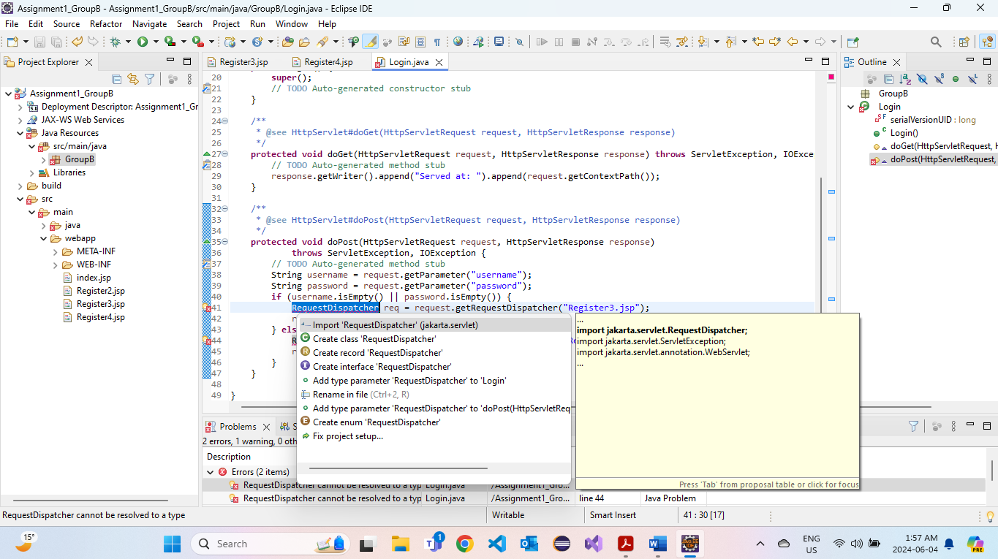

Run

