**Vision and Mission of the Institute and Department**

**Vision of the Institute**

“To make IMSEC an Institution of Excellence for empowering students through technical education coupled with incorporating values and developing engineering acumen for innovations and leadership skills for the betterment of society.”

**Mission of the Institute**

* To promote academic excellence by continuous learning in core and emerging Engineering areas using innovative teaching and learning methodologies.
* To inculcate values and ethics among the learners.
* To promote industry interactions and produce young entrepreneurs.
* To create a conducive learning and research environment for life-long learning to develop the students as technology leaders and entrepreneurs for addressing societal needs.

**Vision of the Department**

To provide globally competent professionals in the field of Computer Science & Engineering embedded with sound technical knowledge, aptitude for research and innovation with ethical values to cater to the industrial & societal needs.

**Mission of the Department**

M1: To provide quality undergraduate education in both the theoretical & applied foundations of Computer Science Engineering.

M2: Conduct research to advance the state of the art in Computer Science & Engineering and integrate the research results as innovations.

M3: To inculcate team building skills and promote life-long learning with high societal and ethical values**.**

**Program Outcomes (POs)**

|  |  |
| --- | --- |
| **S. No.** | **Program Outcomes / Program Specific Outcomes** |
| **PO1.** | **Engineering knowledge**: Apply the knowledge of mathematics, science, engineering fundamentals, and an engineering specialization to the solution of complex engineering problems. |
| **PO2.** | **Problem analysis:** Identify, formulate, review research literature, and analyze complex engineering problems reaching substantiated conclusions using first principles of mathematics, natural sciences, and engineering sciences. |
| **PO3.** | **Design/development of solutions:** Design solutions for complex engineering problems and design system components or processes that meet the specified needs with appropriate consideration for the public health and safety, and the cultural, societal, and environmental considerations. |
| **PO4.** | **Conduct investigations of complex problems:** Use research-based knowledge and research methods including design of experiments, analysis and interpretation of data, and synthesis of the information to provide valid conclusions. |
| **PO5.** | **Modern tool usage:** Create, select, and apply appropriate techniques, resources, and modern engineering and IT tools including prediction and modelling to complex engineering activities with an understanding of the limitations. |
| **PO6.** | **The engineer and society:** apply reasoning informed by the contextual knowledge to assess societal, health, safety, legal and cultural issues and the consequent responsibilities relevant to the professional engineering practice. |
| **PO7** | **Environment and sustainability:** Understand the impact of the professional engineering solutions in societal and environmental contexts, and demonstrate the knowledge of, and need for sustainable development. |
| **PO8.** | **Ethics**: Apply ethical principles and commit to professional ethics and responsibilities and norms of the engineering practice. |
| **PO9.** | **Individual and team work**:Function effectively as an individual, and as a member or leader in diverse teams, and in multidisciplinary settings. |
| **PO10.** | **Communication:** Communicate effectively on complex engineering activities with the engineering community and with society at large, such as, being able to comprehend and write effective reports and design documentation, make effective presentations, and give and receive clear instructions. |
| **PO11.** | **Project management and finance:** Demonstrate knowledge and understanding of the engineering and management principles and apply these to one’s own work, as a member and leader in a team, to manage projects and in multidisciplinary environments. |
| **PO12.** | **Life-long learning:** Recognize the need for, and have the preparation and ability to engage in independent and life-long learning in the broadest context of technological change. |

**Program Specific Outcomes (PSOs)**

PSO1: To apply standard software engineering practices & strategies in real-time software project development.

PSO2: To apply latest programming languages in creating innovative career opportunities.

**Program Educational Objectives (PEOs)**

Graduate Will:

PEO1: Possess knowledge to enable continued professional development.

PEO2: Engage in life-long learning to foster personal & organization growth.

PEO3: Work productively as successful professionals in diverse career paths.

PEO4: Effectively communicate ideas to promote collaboration in accordance with societal standards & ethical practices.

**Course Outcomes**

|  |  |  |
| --- | --- | --- |
| **CO. No.** | **DESCRIPTION** | **COGNITIVE LEVEL (BLOOMS TAXONOMY)** |
| **CO1(C209.1)** | Developing a technical artifact requiring new technical skills and effectively utilizing a new software tool to complete a task. | **K4,K5** |
| **CO2(C209.2)** | Writing requirements documentation, Selecting appropriate technologies, identifying and creating appropriate test cases for systems. | **K5,K6** |
| **CO3(C209.3)** | Demonstrating understanding of professional customs & practices and working with professional standards. | **K4,K5** |
| **CO4(C209.4)** | Improving problem-solving, critical thinking skills and report writing. | **K4,K5** |
| **CO5(C209.5)** | Learning professional skills like exercising leadership, behaving professionally, behaving ethically, listening effectively, participating as a member of a team, developing appropriate workplace attitudes | **K2,K4** |

**CO-PO-PSO Mapping**

|  |  |  |  |  |  |  |  |  |  |  |  |  |  |  |
| --- | --- | --- | --- | --- | --- | --- | --- | --- | --- | --- | --- | --- | --- | --- |
|  | **PO1** | PO2 | PO3 | PO4 | PO5 | PO6 | PO7 | PO8 | PO9 | PO10 | PO11 | PS12 | PSO1 | PSO2 |
| **C209.1** | 3 | 3 | 3 | 3 | 3 | 2 | 1 | 2 | 2 | 2 | 2 | 3 | 3 | 3 |
| **C209.2** | 3 | 3 | 2 | 2 | 2 | 1 | 1 | 2 | 2 | 3 | 1 | 1 | 2 | 3 |
| **C209.3** | 1 | 1 | 1 | 1 | 1 | 3 | 2 | 3 | 2 | 2 | 2 | 2 | 2 | 1 |
| **C209.4** | 3 | 3 | 3 | 3 | 3 | 2 | 1 | 1 | 2 | 3 | 1 | 3 | 1 | 1 |
| **C209.5** | 1 | 1 | 1 | 1 | 1 | 2 | 2 | 3 | 3 | 3 | 3 | 1 | 1 | 1 |
| **C209** | **2.2** | **2.2** | **2** | **2** | **2** | **2** | **1.4** | **2.2** | **2.2** | **2.6** | **1.8** | **2** | **1.8** | **1.8** |

***DECLARATION***

*I hereby declare that this submission is my own work and that, to the best of my knowledge and belief, it contains no material previously published or written by another person nor material which to a substantial extent has been accepted for the award of any other degree or diploma of the university or other institute of higher learning, except where due acknowledgment has been made in the text.*

### Signature *:*

**Name** *:* Anshika Srivastava

**Roll No** *:* 2101430100031

**Date** *:* 27/02/2023

### Signature *:*

**Name** *:* Anshul Kumari

**Roll No** *:* 2101430100032

**Date** *:* 27/02/2023

### Signature *:*

**Name** *:* Ashutosh Verma

**Roll No** *:* 2101430100043

**Date** *:* 27/02/2023

### Signature *:*

**Name** *:* Ayush Shukla

**Roll No** *:* 2101430100050

**Date** *:* 27/02/2023

### Signature *:*

**Name** *:* Deepali Yadav

**Roll No** *:* 21014300059

**Date** *:* 27/02/2023

***CERTIFICATE***

This is to certify that Mini Project/Internship Assessment Report entitled “**Epicureans**” which is submitted by **Ashutosh Verma** in partial fulfillment of the requirement for the award of degree B. Tech. in Department of Computer Science and Engineering of Dr. APJ Abdul Kalam Technical University, Uttar Pradesh, Lucknow is a record of the candidate’s own work carried out by him/her under my supervision. The matter embodied in this report is original and has not been submitted for the award of any other degree.

**Supervisor : Mr. Amit Katoch**

**Date : 27/02/2023**

***ACKNOWLEDGEMENT***

I would like to express my gratitude to **Mr. Amit Katoch** my supervisor for this project. I would like to thank her for her constant support, enthusiastic encouragement and useful critiques. I would like to thank our Director **Dr.Vikram Bali** and HOD of Computer Science and Engineering **Dr. Sonali Mathur** for providing me this opportunity.

***ABSTRACT***

The purpose of epicureans is to automate the existing manual system by the help of computerized equipment’s and full-fledged computer software, fulfilling their requirements, so that their valuable data / information can be stored for a longer period with easy accessing and manipulation of the same. The required software and hardware are easily available and easy to work with.

The Epicureans main purpose is to maintain track of information such as Item Category, Food, Delivery Address, Order, and Shopping Cart. It keeps track of information about the Item Category, the Customer, the Shopping Cart, and the Item Category. Only the administrator gets access to the project because it is totally built at the administrative level. The project's purpose is to develop software that will cut down on the time spent manually managing Item Category, Food, Customer, and Delivery Address. It saves the Delivery Address, Order, and Shopping Cart information.

**CHAPTER 1**

**INTRODUCTION**

Today, Epicurians is the leading food ordering and delivery platform in India. The innovative technology, large and nimble delivery service, and exceptional consumer focus at Swiggy enabled a host of benefits that includes lightning-fast deliveries, live order tracking and no restrictions on order amount, all while having the pleasure of enjoying your favourite meal wherever you'd like it.

Epicureans is a food ordering and delivery company based out of Ghaziabad, India.

Epicureans was inspired by the thought of providing a complete food ordering and delivery solution from the best neighbourhood restaurants to the urban foodie. A single window for ordering from a wide range of restaurants, Epicureans has their own exclusive fleet of delivery personnel to pick up orders from restaurants and deliver it to customers. Having their own fleet gives us the flexibility to offer customers a no minimum order policy on any restaurant and accept online payments for all partner restaurants that they work with. Their delivery personnel carry one order at a time which ensures they get reliable and fast deliveries.

**1.1 Rationale**

There are several good reasons to create an Epicureans. There is a lot of demand, which is why so many restaurants are utilizing online ordering. Customers enjoy how convenient it is to purchase food online and have it delivered to their place of residence or workplace. By providing the services, you may maintain your competitiveness in the restaurant business.

**1.2 Objectives**

The management of the information regarding item category, food, delivery address, order, and shopping cart is the system's primary goal. It oversees the management of all customer, shopping cart, and item category information. Since the project was entirely developed on the administrative end, only the administrator is assured access.

The goal is to develop an epicurean’s program to simplify managing the food consumer item category. It keeps note of every delivery address requested.

**1.3 Needs of epicureans**

Helping customers in placing meal orders whenever they want. Customers will be able to order their preferred foods at any time, but as we've already mentioned, this is only a limited option. As a result, restaurants need to have a specific system in place that will allow them to serve a large number of customers while streamlining operations. One of the best platforms is ordering, which offers all of these services in addition to a host of cutting-edge features that have helped countless small and large enterprises establish themselves as market leaders.

**1.4 Functionalities**

* Provides search options based on a variety of criteria. like Food Item, Customer, Order and Order Confirmation.
* Epicureans also manage payment information for order details, order confirmation details, and food items online.
* It keeps track of all the data regarding Categories, Payments, Orders, etc.
* Manage the category's details.
* Displays the food item's information and description for the customer. Easy to manage the Food Item, Category more effectively.
* It focuses on keeping track of order's data and transactions.
* Manage the food item's information.
* Improvements in editing, adding, and updating records lead to proper resource management of food item data.
* Manage the order's information by combining all Confirm Order data.

**1.5 Features**

* Based on products and components.
* Easily creating and altering issues.
* Issue List can be queried in any detail.
* Reporting & Charting in a more thorough manner.
* User accounts are used to manage access and uphold security.
* Straight forward status & resolutions.
* Priorities and severity levels at various levels as well as targets and milestones for the programmers to follow.
* Attachments & Additional Comments for more information.
* A solid database back end.
* Various levels of reports are provided with many filtering options.
* Information retrieval is simple and quick. nicely crafted reports.
* Reduce the workload of the person using the current manual system.
* Individual access to any information.
* Work progresses quickly. Simple information updates.

**CHAPTER 2**

**BACKGROUND STUDY**

The Epicureans is one of the latest servicers most fast food restaurants in the western world are adopting. With this method, food is ordered online and delivered to the customer. This is made possible through the use of electronic payment system. Customers pay with their credit cards, although credit card customers can be served even before they make payment either through cash or cheque. So, the system designed in this project will enable customers go online and place order for their food.[1]

Due to the great increase in the awareness of internet and the technologies associated with it, several opportunities are coming up on the web. So many businesses and companies now venture into their business with ease because of the internet.[3] One of such business that the internet introduced is an Epicureans. In today’s age of fast food and take out, many restaurants have chosen to focus on quick preparation and speedy delivery of orders rather than offering a rich dining experience. Until recently, most of this delivery orders were placed over the phone, but there are many disadvantages to this system.

It is possible for anybody to order any goods via the internet and have the goods delivered at his/her doorsteps. But while trying to discuss the transfer method of the goods and services, attention is focused on the payment mode. This then leads to the discussion of the economic consequences of digital cash. Since the world is fast becoming a global village, the necessary tool for this process is communication of which telecommunication is a key player. A major breakthrough is the wireless telephone system which comes in either fixed wireless telephone lines or the Global System of Mobile communication (GSM).[2]

What I propose is an epicureans originally designed for use in college cafeterias, but just as applicable in any food delivery industry. The main advantage of this system is that it greatly simplifies the ordering process for both the customer and the restaurant. [8] The Epicureans also greatly lightens the load on the restaurants end, as the entire process of taking orders is automated. Once an order is placed on the webpage that will be designed, it is placed into the database and then retrieved, in pretty much real-time, by a desktop application on the restaurants end. Within this, all items in the order are

displayed, along with their corresponding options and delivery details, in a concise and easy to read manner. This allows the restaurant employees to quickly go through the orders as they are placed and produce the necessary items with minimal delay and confusion. The greatest advantage of this is its FLEXIBILITY.[6]

**CHAPTER 3**

**METHODOLOGY**

**3.1 Complete Visualization of Epicureans**

An easy-to-use table management system will also be included in a good restaurant reservation setup. This enables restaurants to see their restaurant hour by hour and receive reservations through a variety of ways. [As shown in fig 3.1]

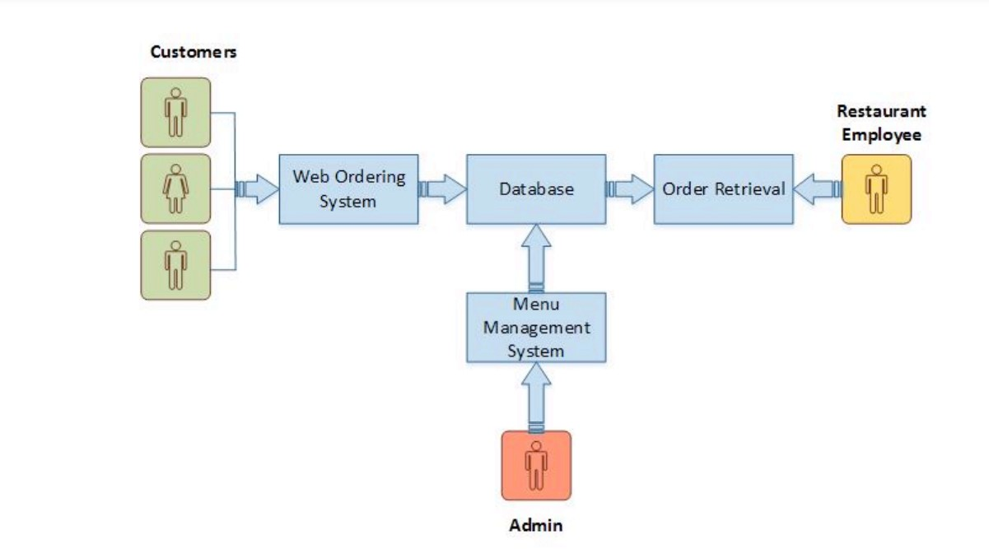

**Fig 3.1 Complete Visualization of epicureans.**

**3.2 Admin Workflow Process**

User goes to home page of the domain. If he/she has an account then he/she can login in epicureans otherwise he/she need to register an account after successful registration, they can login in home page.[As shown in fig 3.2]

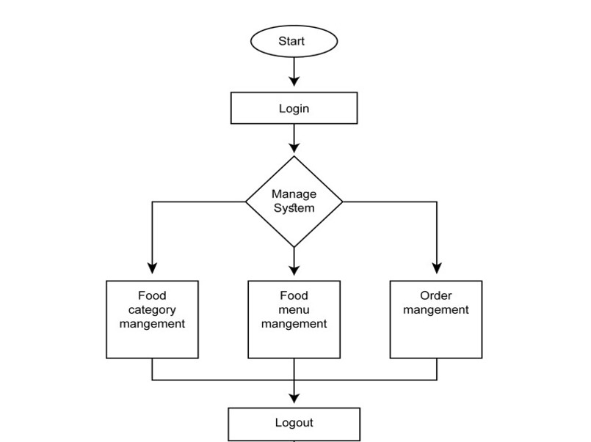

**Fig 3.2 Flow chart of Login System.**

**3.3 Customer Workflow Process**

Initially to visit the food categories or food menu, users don’t need to login/register an account. After checking out the categories and menu items, if the user finds his/her desired menu and if they want to order that particular item they can go to order page. During placing any order the customer needs to provide his/her required information mentioned the order section. [As shown in fig 3.3]

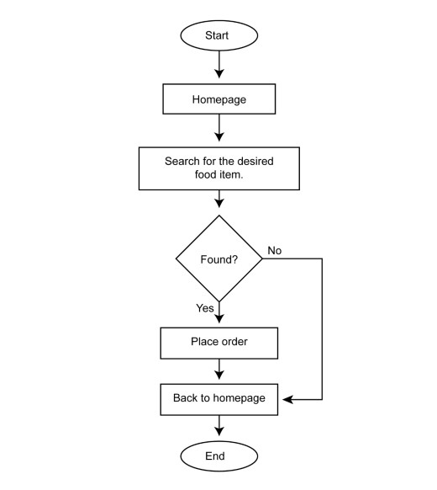

**Fig 3.3 Flow chart Customer Workflow Process.**

**CHAPTER 4**

**TOOLS & TECHNIQUE**

The technological tool that here we are using is Laptop. Laptops are embraced because of the technological tools they offer combined with their portability.

An HTTP server i.e; a computer (software) program (or even a software component included in another program) that plays the role of a server in a client–server model by implementing the server part of the HTTP and/or HTTPS network protocol(s).

This project will be an Internet application to be developed in following tools and technologies.

**4.1 PHP**

Hypertext Pre-processor (or simply PHP) is a a server-side scripting language used for general programming purposes as well as Web development. The PHP Group now produces the PHP reference implementation, which was first developed by Rasmus Lerdorf in 1994. Personal Home Page was the first meaning of PHP, however it has since evolved into PHP: Hypertext Preprocessor. PHP code can be used alone, in conjunction with different web template systems, web content management systems, and web frameworks, or it can be incorporated into HTML code. A PHP interpreter, which can be either a web server module or a Common Gateway Interface (CGI) executable, is typically used to process PHP code. The output of the interpreted and executed PHP code, which could be any kind of data, including graphics, is combined with the created web page by the web server. PHP code can be used to create standalone graphical apps and can also be run using a command-line interface (CLI).

**4.2 XAMPP**

XAMPP is a stack of free and open source PHP and Perl interpreters, the MariaDB database, and the Apache HTTP Server are the primary components of Apache Friends' free and open source cross-platform web server solution stack. Cross-Platform (X), Apache (A), MariaDB (M), PHP (P), and Perl make up the acronym XAMPP (P). It is a straightforward, lightweight installation of Apache that makes setting up a local web server for testing and deployment very simple for developers. An extractable file contains the server program (Apache), database (MariaDB), and scripting language

(PHP) required to set up a web server. Cross-platform means that XAMPP functions equally well on Linux, Mac, and Windows. Since XAMPP uses the same components as the majority of real web server deployments, switching from a local test server to a live server is also incredibly simple.

**4.3 MySQL**

MySQL Workbench is a comprehensive visual tool for DBAs, database architects, and developers. Data modeling, SQL creation, and extensive administrative tools for server configuration, user management, backup, and other tasks are all provided by MySQL Workbench. There are versions of MySQL Workbench for Windows, Linux, and Mac OS X.

**4.4 HTML**

Hypertext Markup Language (HTML) is the industry-standard markup language for developing web apps and pages. s. HTML originally featured cues for the document's design and semantically explains the structure of a web page. The foundation of HTML pages are HTML components. Images and other objects, like interactive forms, may be embedded within the produced page using HTML techniques. By indicating structural semantics for text elements like headings, paragraphs, lists, links, quotations, and other objects, HTML offers a way to generate structured texts.

**4.5 JavaScript**

JavaScript often abbreviated as JS, is an interpreted, high-level programming language. Additionally, it is a dynamic, weakly typed, prototype-based, and multi-paradigm language. One of the three fundamental technologies of the World Wide Web, together with HTML and CSS, is JavaScript. JavaScript is a crucial component of online applications because it makes web pages interactive. The vast majority of websites make use of it, and every significant web browser has an engine specifically designed to run JavaScript.

**4.6 CSS**

Cascading Style Sheets (CSS) is a language for creating style sheets that describe how a document produced in a markup language like HTML will look. Layout, color, and font may all be separated from content and presentation using CSS. By describing the pertinent 11 CSS in a separate CSS file, this separation can make content more accessible, give definition of presentation features greater freedom and control, allow numerous web pages to share formatting, and reduce complexity and repetition in structural content.

**CHAPTER 5**

**IMPLEMENTATION**

**HOME PAGE:**

**This page shows different tabs of the home page mentioned below shown in fig.5.1.**

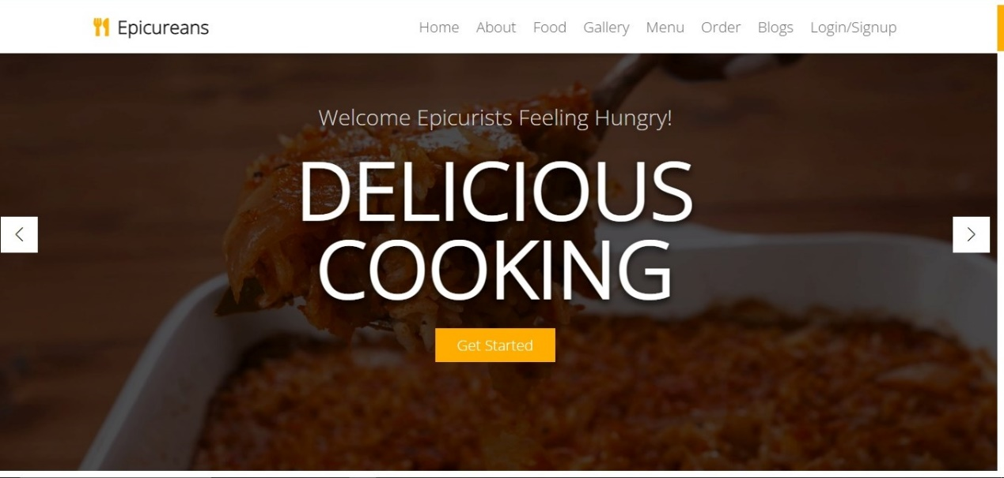

**Fig.5.1: Home page of the website.**

**MENU PAGE:**

**The implementation of the menu page of the website is given in the fig.5.2, 5.3, 5.4 below.**

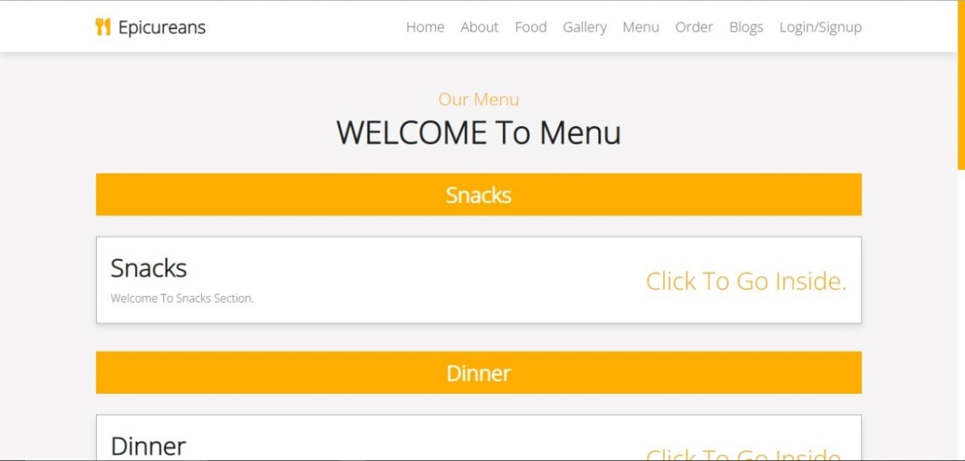

**Fig.5.2: Menu page of the website.**

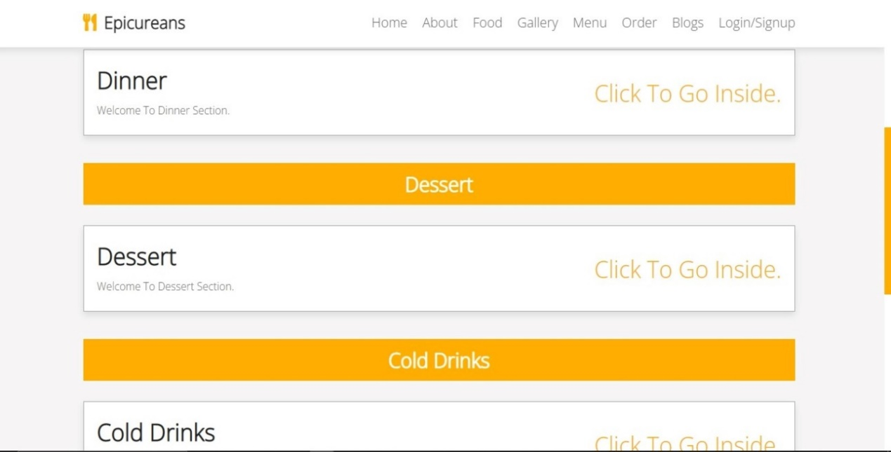

**Fig.5.3: Menu page of the website.**

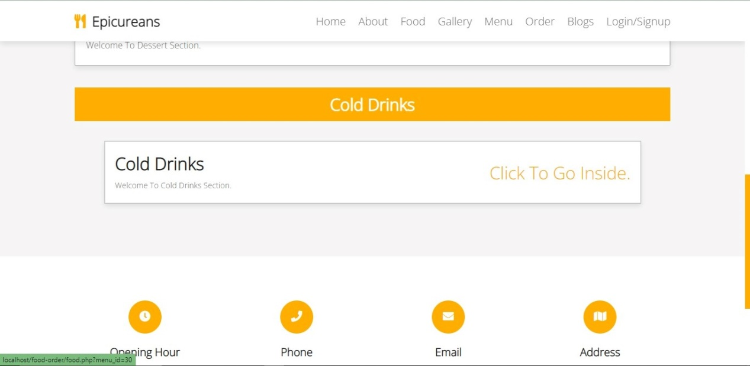

**Fig.5.4: footer section of the menu.**

**FOOD PAGE:**

**The implementation of the food page of the website is given in the fig. 5.5, 5.6. below:**

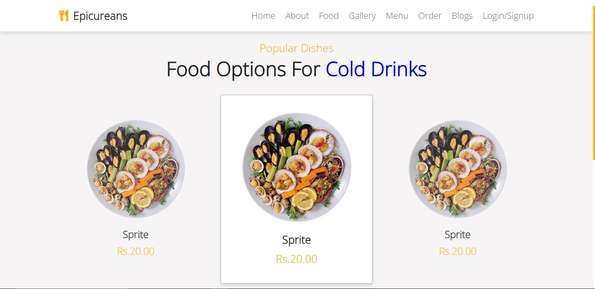

**Fig.5.5: Food page of the website.**

**The figure5.6 allow us to buy our selected food item on clicking the BUY NOW option we get directed to order page.**

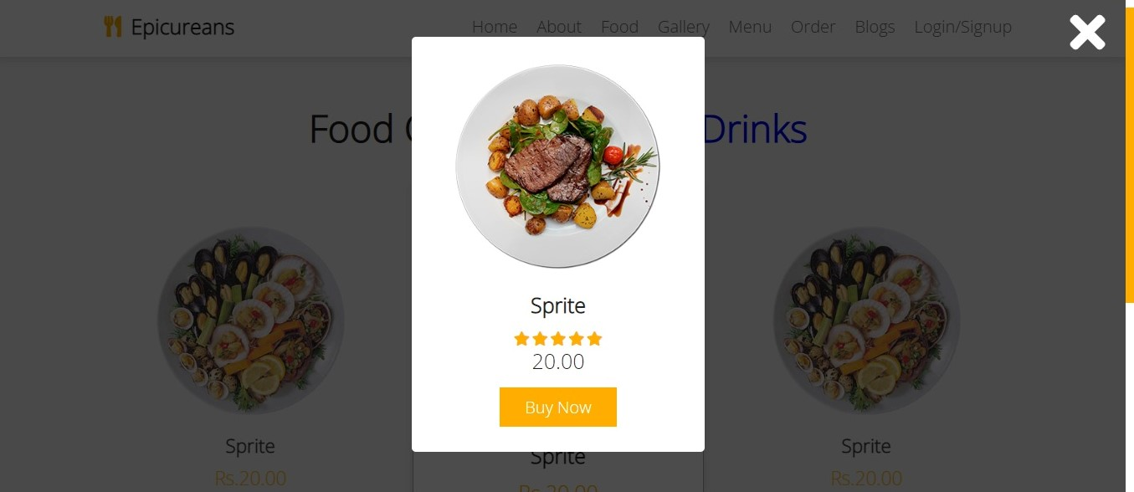

**Fig.5.6: BUY NOW of food page.**

**ORDER PAGE:**

**The implementation of our order page in the fig.5.6. This page allows us to insert our personal details and order the food.**

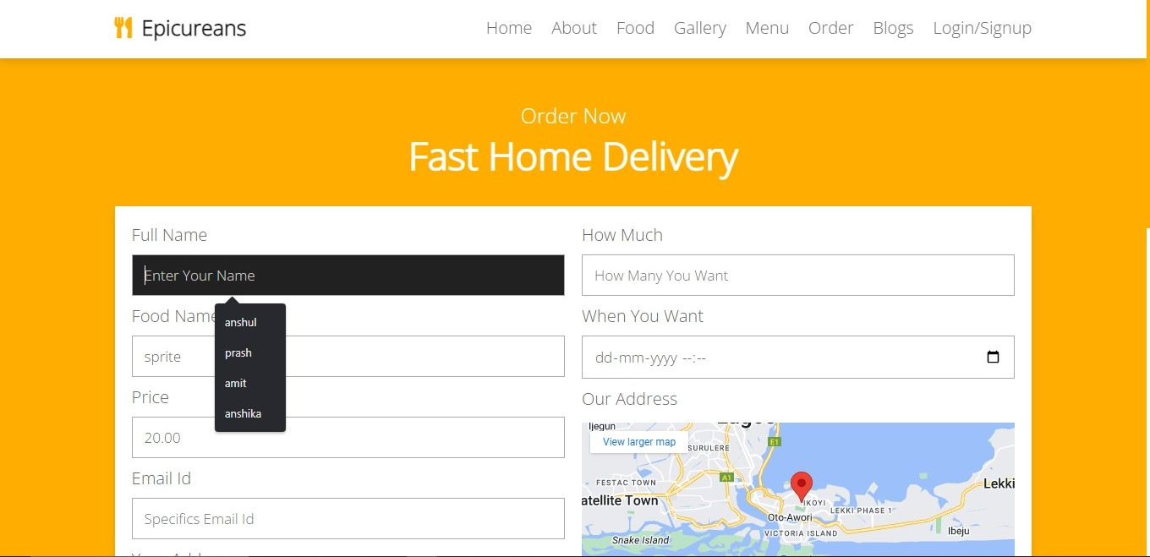**Fig.5.7: Order page.**

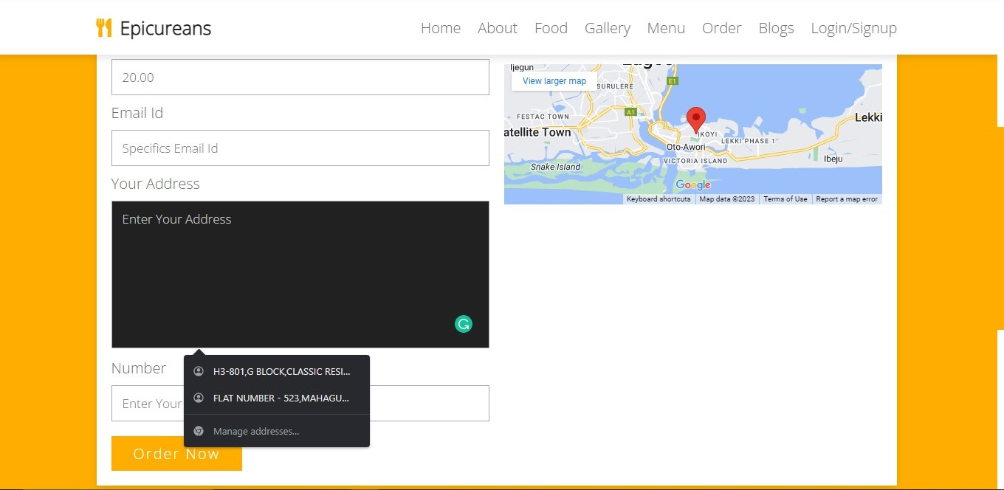

**Fig.5.8: Order page.**

**LOGIN PAGE:**

New user will enter his/her credentials like name & password to create an account as shown in Figure 5.9

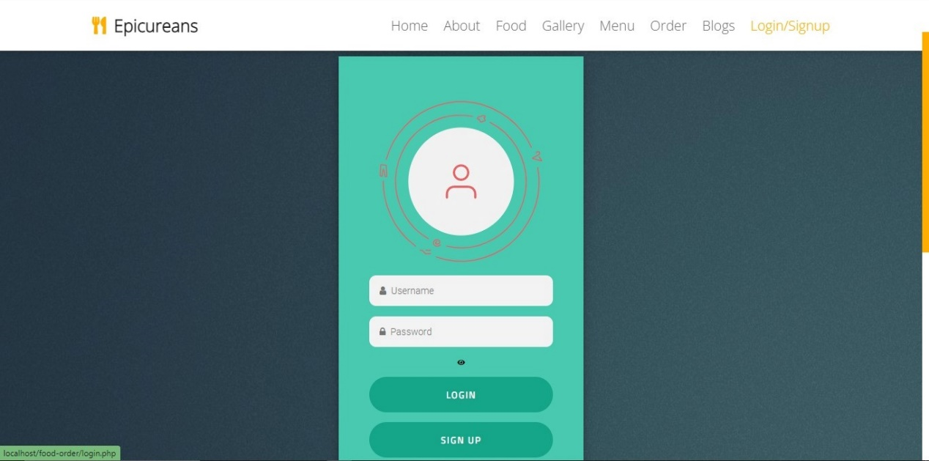

**Fig.5.9: Our login /signup page.**

**GALLERY PAGE:**

**This figure5.10 is the implementation of our gallery page.**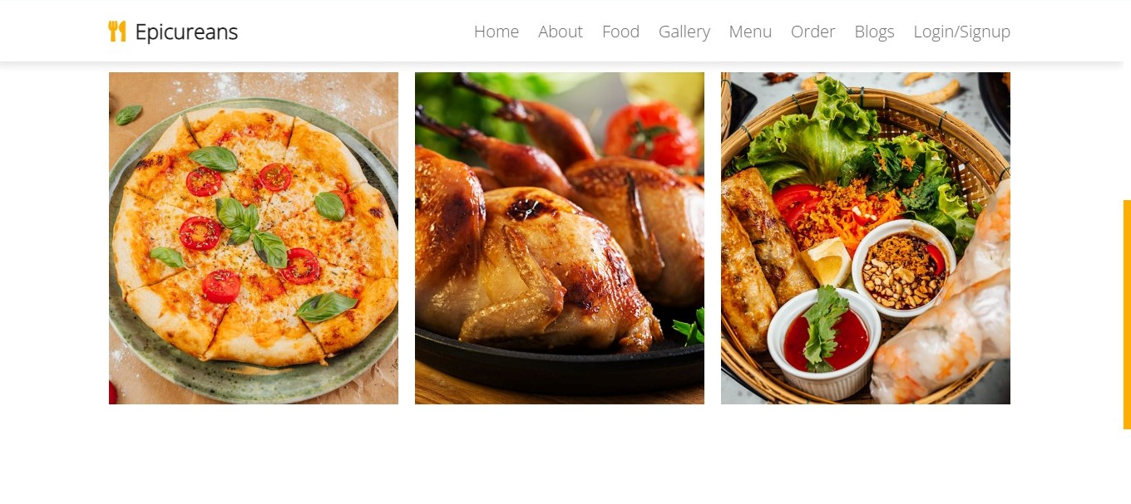

**Fig.5.10: Gallery page.**

**BLOG PAGE:**

**This figure 5.11. below is the implementation of our blogs page. On clicking the READ MORE button we get the more recent blogs posted by people retailed to our page.**

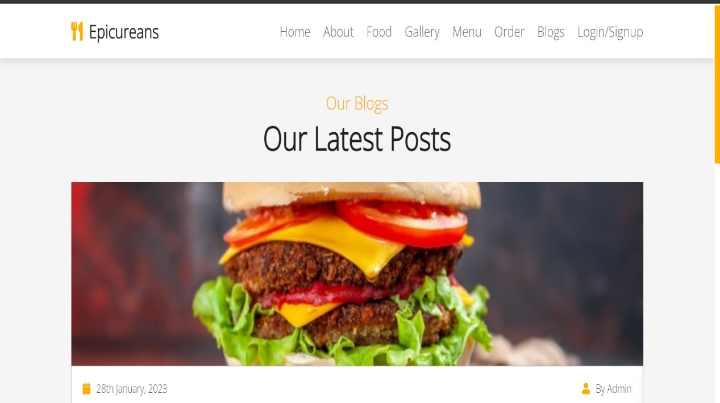

**Fig.5.11: Blogs Page.**

**ABOUT PAGE:**

**The fig.5.12 is the implementation of our about page. On clicking the READ MORE button we get the more information about our website.**

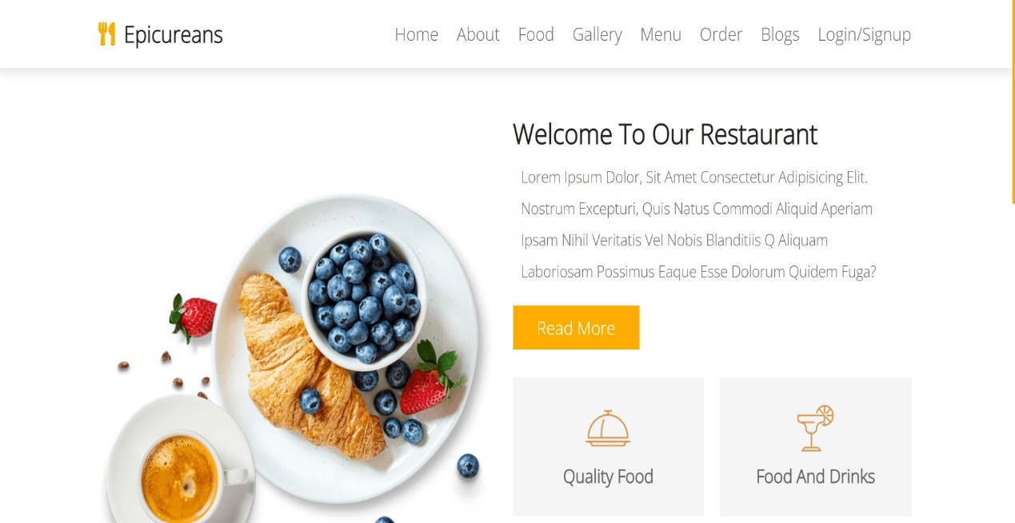

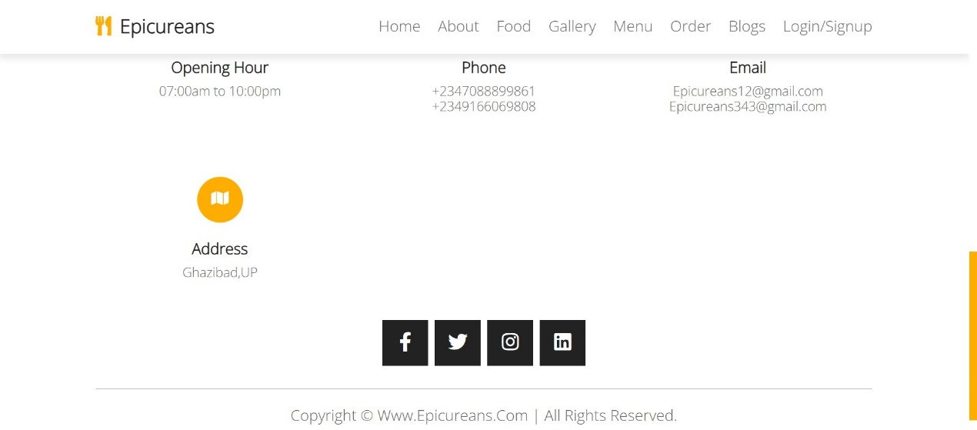

**Fig.5.12: About page.**

**CHAPTER 6**

**CONCLUSION & FUTURE SCOPE**

**6.1 Conclusion**

Epicureans is a web-based technology that aids the restaurant industry in carrying out tasks effectively and efficiently. It aids in managing cash flow for managers. Managers can view analytics data to assess company growth. The manager can control orders and employee schedules by using this system. It provides access to the Online Order platform, third-party connectors software, and comprehensive CRM solution, which together cover a sizable portion of your restaurant's requirements. They are not the outdated hardware and software sets for restaurants that were previously offered. They are the hottest things around, smooth, manageable, inexpensive, and quick. In the " epicureans Project," we made every effort to meet all the demands of the restaurant. Because it is straightforward and adaptable, the project is successful. The biggest benefit of my project is that it draws plenty of users because of its simplicity. A novice user may operate it with ease. Any type of restaurant can utilize our software. By automating meal ordering, billing, and inventory control, the restaurant management system assists the restaurant manager in managing the restaurant more successfully and efficiently. The system handles the transaction and stores the data produced. These data will be used to create reports that assist the restaurant manager in making wise business decisions. For example, the manager can decide whether more waiters, delivery men, delivery carts, and cooks are needed based on how many clients will be present during a specific time period. When this project is finished, all security concerns will be resolved. Additionally, a quick and secure authentication process will be used for record maintenance. Because it automatically pulls information about a consumer from the database on subsequent visits, data entry is quick and easy. As a result, our program will undoubtedly succeed in replacing the antiquated manual way of storing secure information. The work plan also specifies the specific front end and back end characteristics of the technology being used in the project. Future project goals and its scope have been elaborated.

**6.2 Future Work**

Each project should pay close attention to future development because it contains the system's most recent features. It lessens software issues and defects. It develops a close relationship with customers based on their comments or preferences. Developer will incorporate certain dynamic elements that are briefly described below into my EPICURE system. Reporting module with real time mechanism.

• Modern architecture with smooth transitions.

• System for email and mobile confirmation.

• Selling Point.

**REFERENCES**

[1]. Kirti Bhandge, Tejas Shinde, Dheeraj Ingale, Neeraj Solanki, Reshma Totare,”A Proposed System for Touchpad Based Food Ordering System Using Android Application”, International Journal of Advanced Research in Computer Science Technology (IJARCST 2015).

[2]. Varsha Chavan, Priya Jadhav,Snehal Korade,Priyanka Teli, ”Implementing Customizable Online Food Ordering System Using Web Based Application”, International Journal of Innovative Science, Engineering Technology(IJISET) 2015.

[3]. Resham Shinde, Priyanka Thakare, Neha Dhomne, Sushmita Sarkar, ”Design and Implementation of Digital dining in Restaurants using Android”, International Journal of Advance Research in Computer Science and Management Studies 2014.

[4]. Ashutosh Bhargave, Niranjan Jadhav, Apurva Joshi, Prachi Oke, S. R Lahane,“Digital Ordering System for Restaurant Using Android”, International Journal of Scientiﬁc and Research Publications 2013.

[5]. Khairunnisa K., Ayob J., Mohd. Helmy A. Wahab, M. Erdi Ayob, M. Izwan Ayob, M. Aﬁf Ayob, ”The Application of Wireless Food Ordering System” MASAUM Journal of Computing 2009.

[6]. Noor Azah Samsudin, Shamsul Kamal Ahmad Khalid, Mohd Fikry Akmal Mohd Kohar, Zulkiﬂi Senin, Mohd Nor Ihkasan,” A customizable wireless food ordering system with real time customer feedback”, IEEE Symposium on Wireless Technology and Applications(ISWTA) 2011.

[7]. Serhat Murat Alagoza, Haluk Hekimoglub,” A study on tam: analysis of customer attitudes in online food ordering system”, Elsevier Ltd. 2012.

[8]. Patel Krishna, Patel Palak, Raj Nirali, Patel Lalit,” Automated Food Ordering System”, International Journal of Engineering Research and Development (IJERD) 2015.

[9]. Mayur D. Jakhete, Piyush C. Mankar,” Implementation of Smart Restaurant with e-menu Card,” International Journal of Computer Applications 2015 of Smart Restaurant with e-menu Card, ”International Journal of Computer Applications 2015.