My Task is to monitor metrices and of Multiple Containers in **CloudWatch** and pull those metrics to the **GRAFANA** and visualize there.

First, I have deployed two containers (Nginx and Grafana) to the ECS FARGATE cluster, In which two task is running .

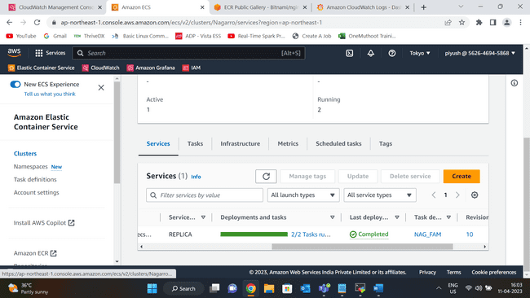

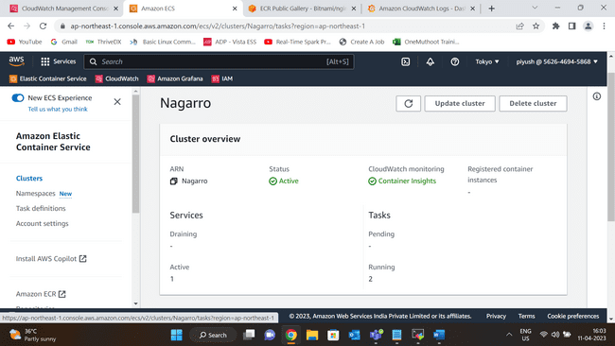

The next step is go to CloudWatch Service -> Log Group and then I select the log group for which I want to create **Metric Filter**.

Add I select the **Log Event** and then created a **Filter Pattern** for that .

I have create a custom namespace in which I created a dimension called Container Name . After selecting the dimension I am able to see metrics of my each container in Cloud Watch.

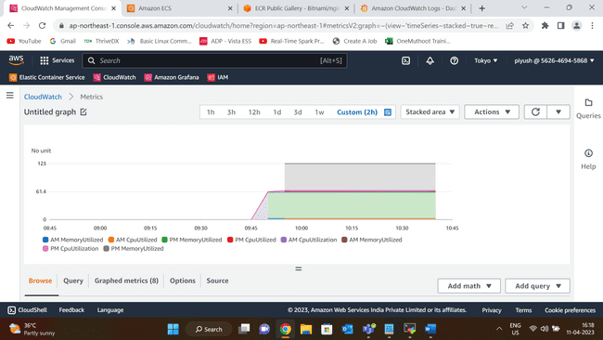

I have also created a dashboard and add new panel for each metrics to see the metrics in more detail.

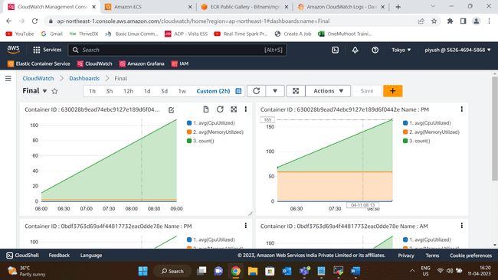

And my next is to pull these metrices Grafana.

In Grafana first I choose the Data Source as Cloud Watch and then in setting section I do authorization , selected region and add my namespace for custom metrics that I have creates in cloud watch.

Then I created a new dashboard , selected the new panel and add metrics that I want to monitor.

I have added Multiple panel in the dashboard.

