Create a docker images and push it into ECR

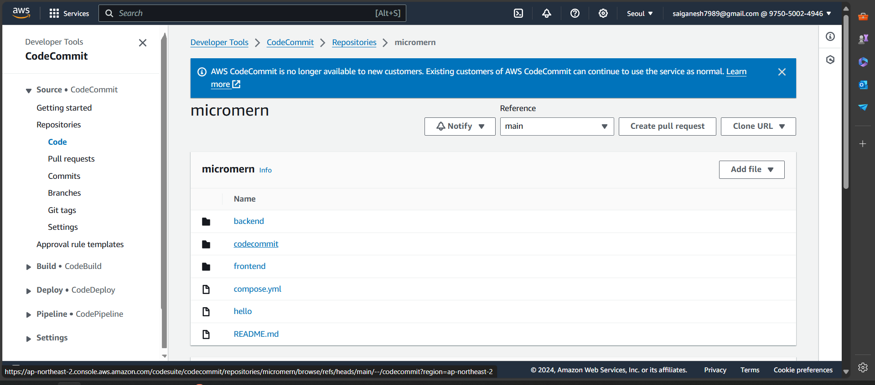

Go to AWS console and create a repository

Clone a repository in a empty repository in a local system with git installed

The Steps were given in the clone button to push the code

Generate the credentials for code commit by using IAM access

Now create a instance for Jenkins

Installation

* Update and upgrade system
* Make sure your ram is more than 1 gigs
* Follow this url for Jenkins installation <https://www.jenkins.io/doc/book/installing/linux/>
* Also Change password to no password to ease of pipeline control
* navigate to path of

cd /etc/

sudo nano sudoers

add a user as shown in below picture

* Now create a new pipeline name it something
* Add, plugins of ssh server, publish over ssh, docker pipeline
* Add a user and ssh details in system details
* Navigate to Jenkins user using

sudo su

su Jenkins

* Do install aws cli using snapd
* Then configure it

Now go back to Jenkins server and host a pipeline by using Jenkins file in the repositor

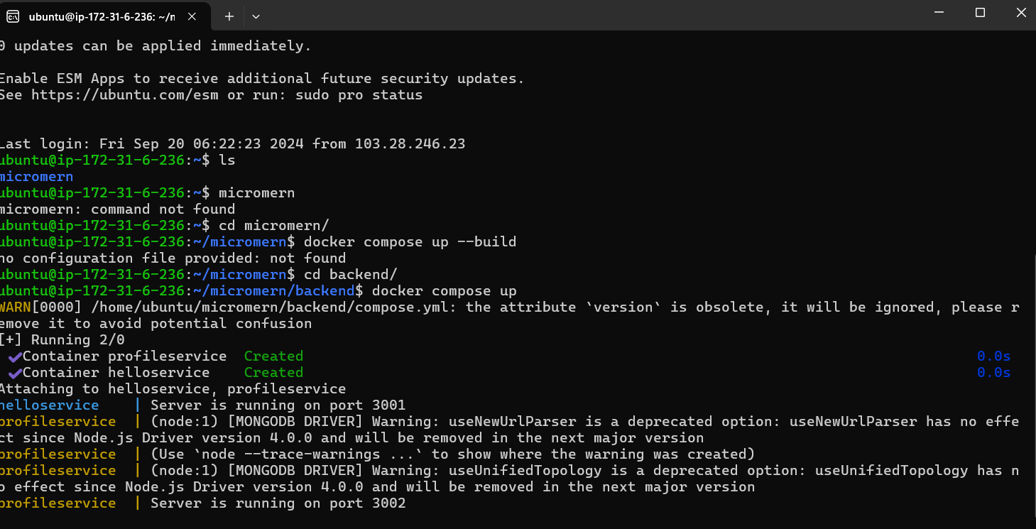

USING EKSCTL to create clusters for deployment using helm

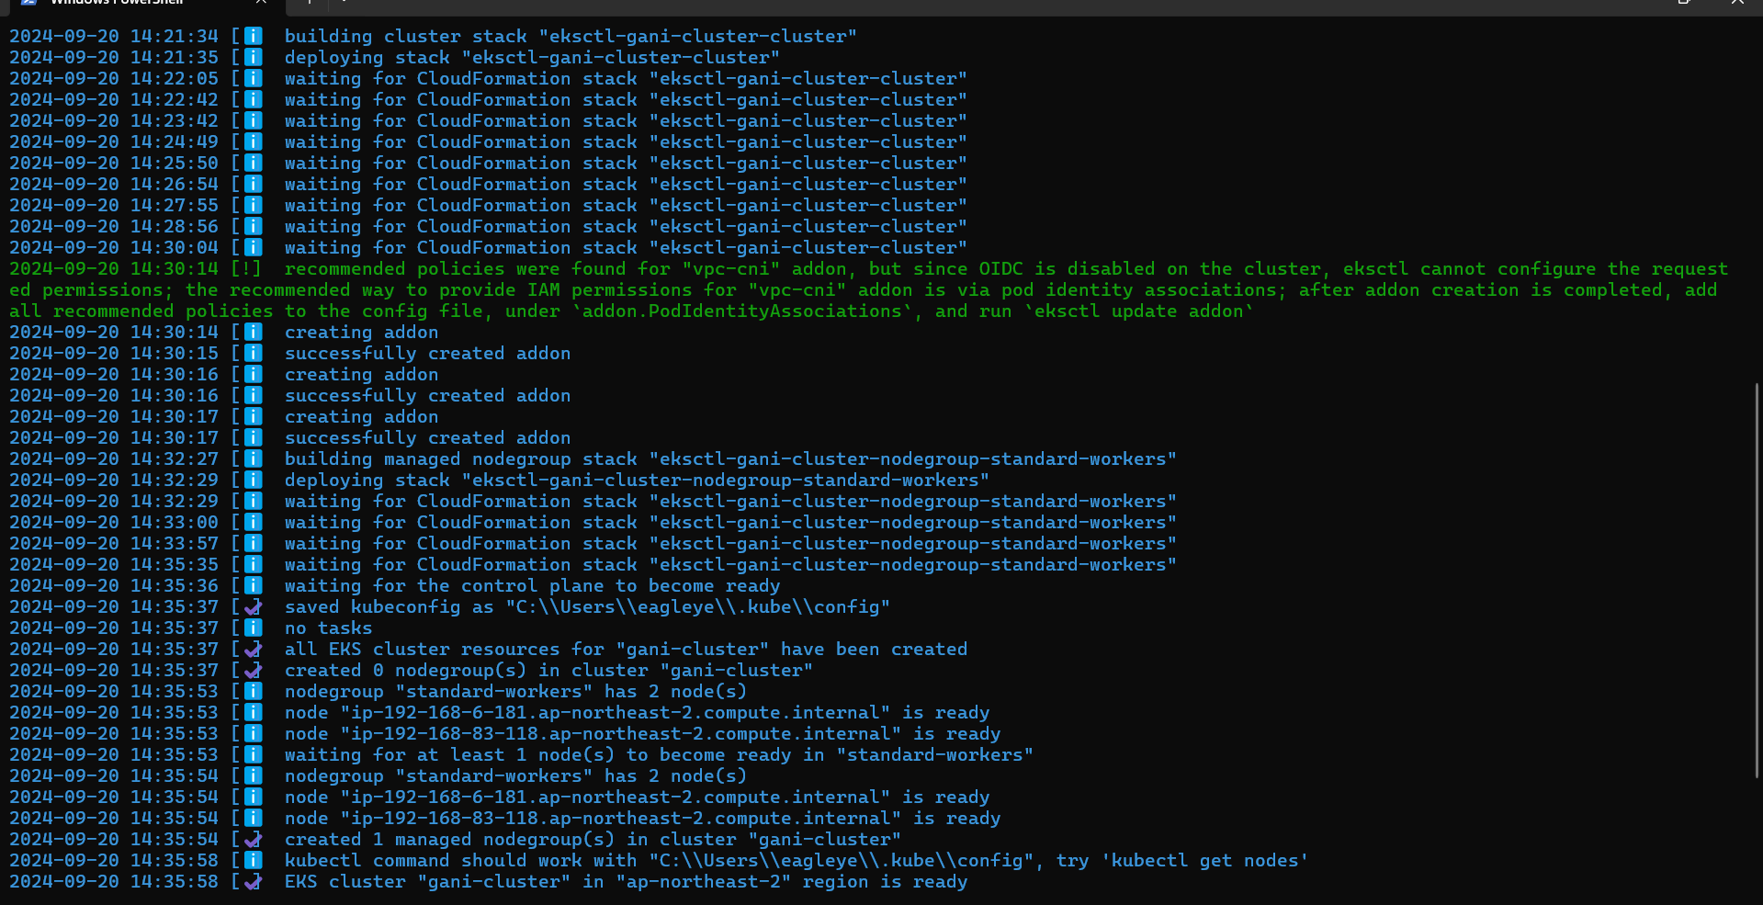

Create deployment and services for mongodb, frontend, backend services and execute it by using kubectl apply -f deployment, services

The clusters get created you can cross verify using kubectl get pods nor go back to console and navigate to eks and check for your cluster and click on pods, services and navigate around to see logs and stuff

Integration with HELM

Steps to reproduce

* Create EKS Cluster or Minikube cluster
* Then, create helm application by following command

helm create resumeai

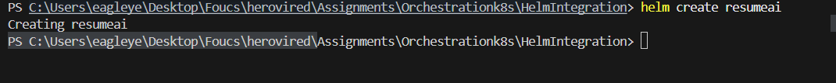

* Delete templates folder

* Create a new template folder
* Now copy paste whole deployment files in template folder
* Now prepare a chart to map microservices

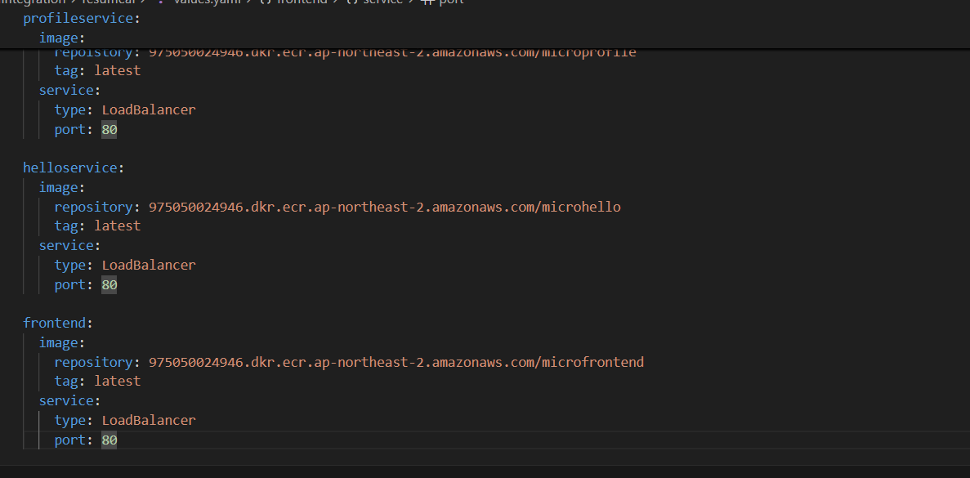

* Now do helm install
* Make changes and update clusters that’s how it’s done

Done

