Fork this repo or download as zip

git clone https://github.com/UnpredictablePrashant/ResumeAI

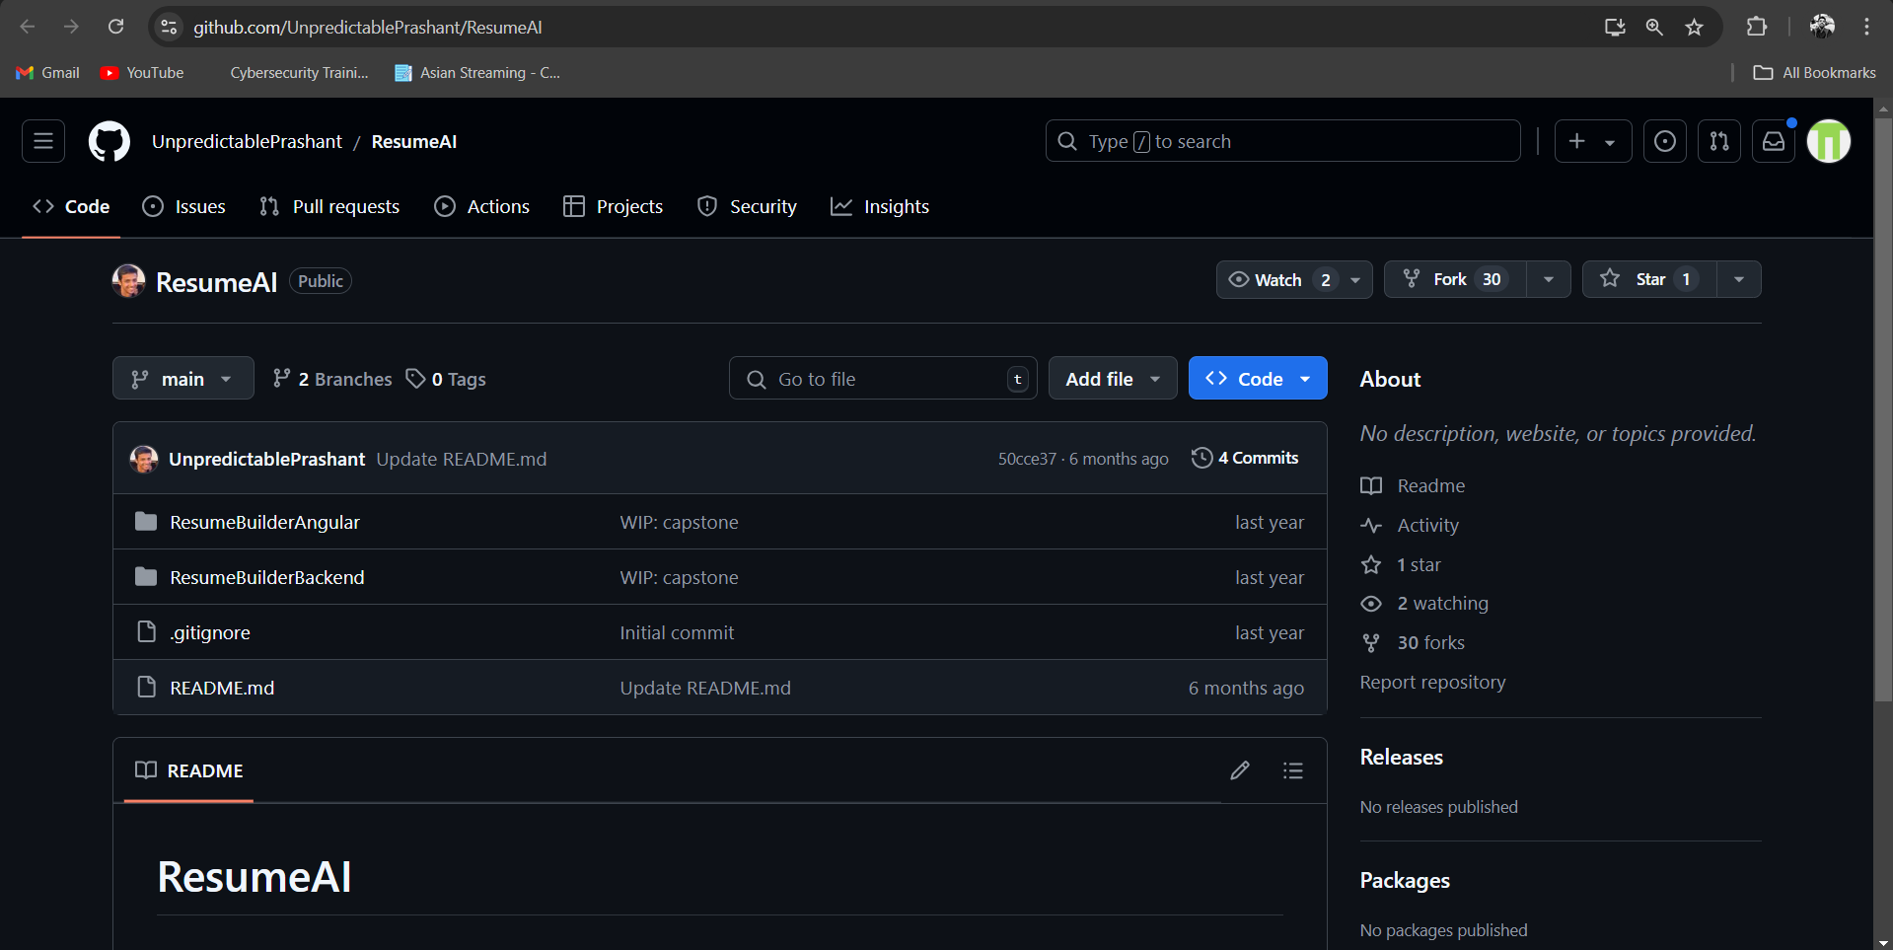

Steps:

1. Dockerise the frontend and backend
2. Firstly, push the backend so that we can get load balancer URL for backend and so that we can put listening address for frontend and Dockerise its
3. 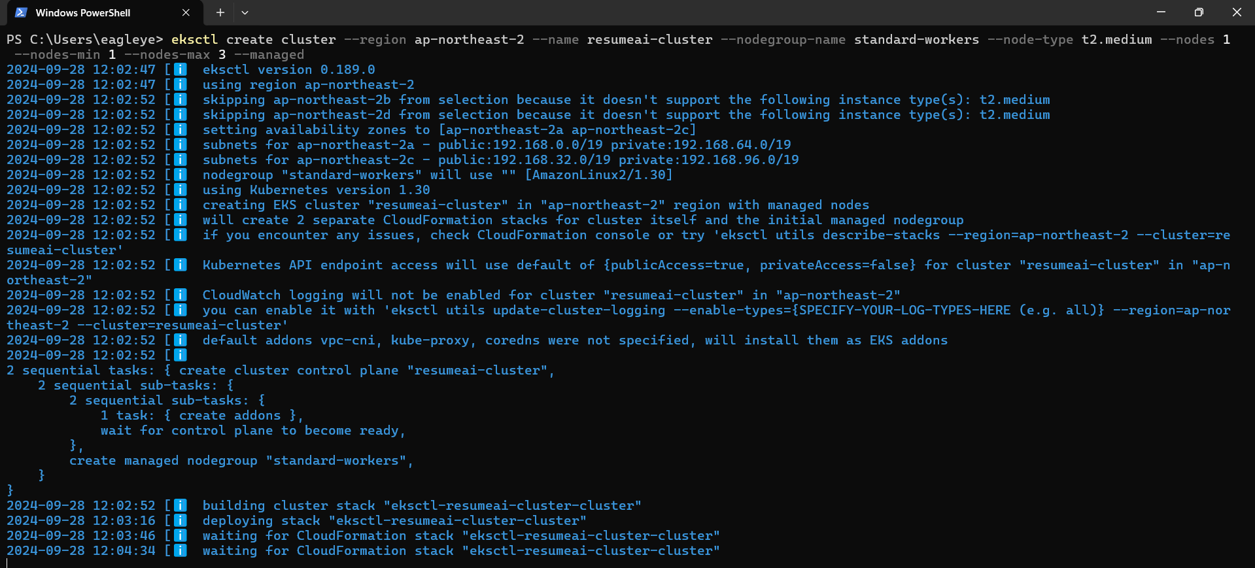Create a cluster in AWS using eksctl.
4. Set default cluster to aws cluster so that it doesn’t misconfigure between local and aws cluster



1. Describe service of the current Kubernetes system

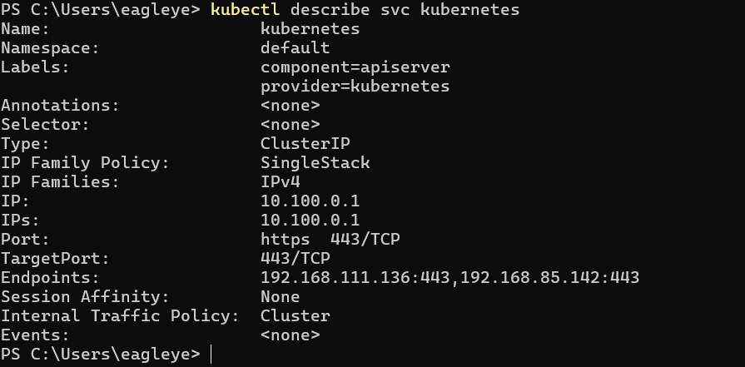

1. Now apply deployment and services files
2. Note: Service Type should be load balancer
3. Start with backend after applying you end up getting this dns name copy this dns name and use it in angular proxy of api in frontend

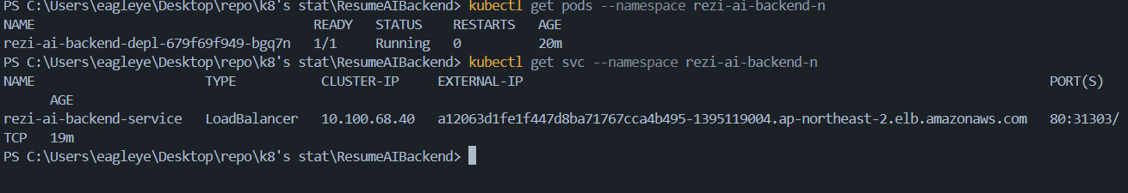

1. Now build it and push it to ECR
2. And create deployment and service files for it
3. Apply those files note the port should 80 when load balancer is used
4. Backend

1. Frontend

