Genedrift Editorial Publishing Platform
A clear path from
idea to publication
A calm, practical guide to the Creator workspace, review decisions, publishing controls and public delivery.
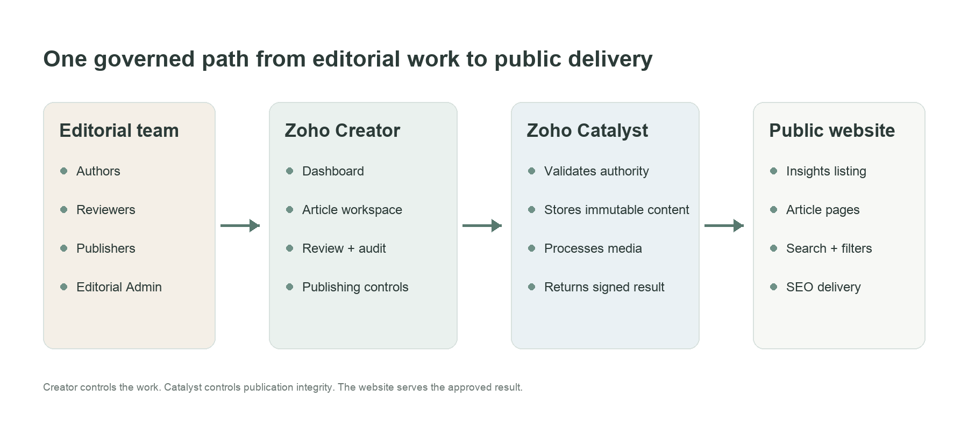
Platform orientation — editorial control, trusted publication and public delivery.
DESIGNED FOR CLARITY Each person sees the work relevant to their role, while every important decision remains traceable in the audit history.
Prepared for Genedrift stakeholders · Version 1.0 · September 2026

01 / CLIENT FIELD GUIDE

The platform in one view
Genedrift combines a role-aware editorial workspace with a controlled publishing engine and a modern public Insights experience.
The end-to-end platform map.

How the pieces work together
- Zoho Creator manages content, roles, reviews, status and audit history.
- The Article Workspace supports day-to-day writing, reviewing and publishing.
- Zoho Catalyst validates the approved revision, stores immutable files and returns a signed result.
- The public website displays only content that completed the governed path.
CORE PRINCIPLE Approval confirms that content is ready. Publication is a separate Publisher decision.

02 / CLIENT FIELD GUIDE

Who does what
Access is role-based. Combined roles are possible, but each action is still checked against its own permission.
Role | Primary responsibilities | Key guardrail
Editorial Author | Create drafts, write, add media and metadata, submit, respond to requested changes. | Cannot review their own work or publish.
Reviewer | Claim assigned or queued reviews, comment, approve, request changes or reject. | Cannot edit the author’s draft or publish unless separately assigned Publisher.
Publisher | See approved/scheduled work, publish now, schedule, reconcile and retract. | Cannot alter the approved revision or record review decisions without Reviewer access.
Editorial Admin | Supervise workload, roles, taxonomy, policies, audit, reviews and publishing operations. | Immutable submitted, approved and published revisions remain protected.

What role-aware means
The same dashboard adapts to the signed-in person. Authors see their work, reviewers see eligible review tasks, publishers see content ready for delivery, and admins can supervise the whole system.
IMPORTANT The CEO/owner account is not intended as the everyday editorial admin profile. Normal client operations should use the dedicated roles above.

03 / CLIENT FIELD GUIDE

Creator structure and forms
The workspace is the everyday interface; its forms are the auditable system of record.
Area | Core forms | Purpose
Content | Articles | Master record: owner, category, policy, workflow state and active revision pointers.
Content | Article Revisions | Versioned content and SEO details; submitted, approved and published versions are protected.
Content | Media Assets | Cover and inline images with file details, alt text, caption, credit and processing status.
Discovery | Categories and Tags | Reusable taxonomy used in the editor, dashboard filters and public Insights archive.
People | Employees and Role Assignments | Maps users to active Author, Reviewer, Publisher and Admin capabilities.
Review | Approval Policies | Defines review model and number of distinct approvals required.
Review | Review Assignments and Comments | Reviewer slots, claims, decisions, summaries and discussion history.
Publishing | Publication Jobs and Published Versions | Tracks publish, schedule and retract actions plus the immutable Catalyst version.
Governance | Audit Events, Redirects and Site Settings | Preserves transitions and controls public behavior.

CLIENT USE Use forms for configuration and supervision; use the Article Workspace for lifecycle actions.

04 / CLIENT FIELD GUIDE

Dashboard orientation
Start here to understand what needs attention, then narrow the workspace using scope, work type and filters.
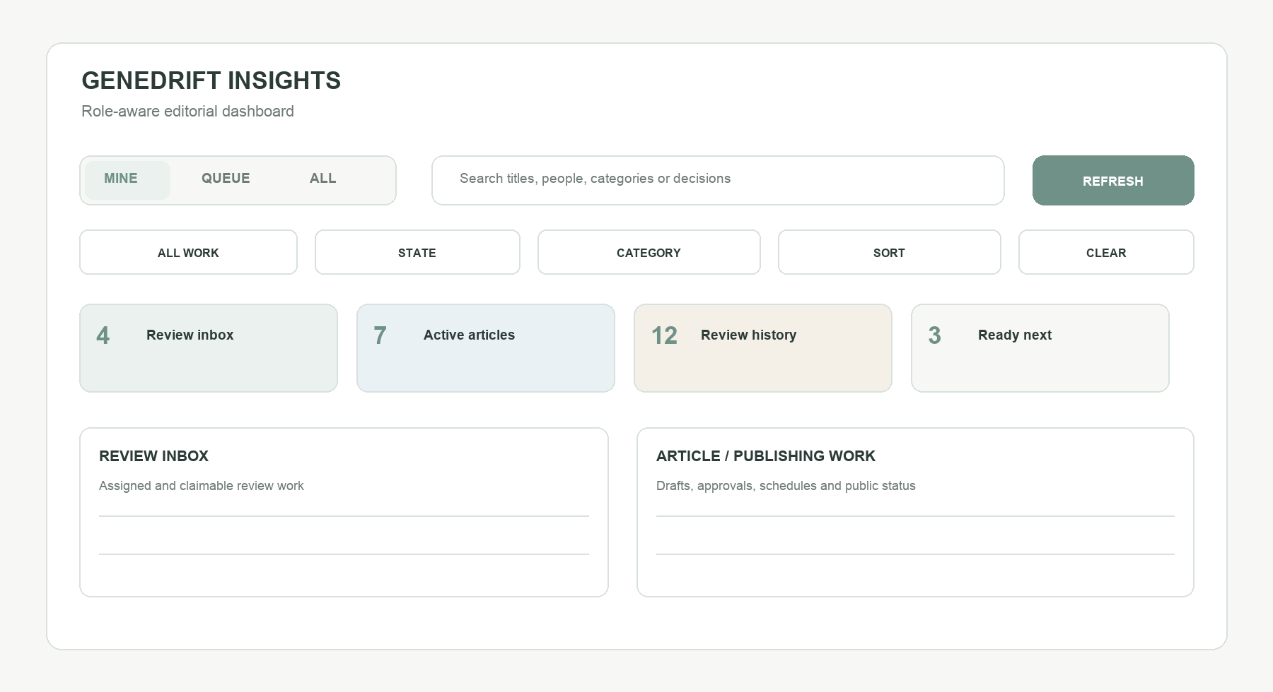
Dashboard orientation — scope first, then work type, filters and task panels.

The three scopes
- Mine — your authored articles and review assignments personally assigned to or claimed by you.
- Queue — unclaimed shared reviews and publisher-ready work that your current role can act on.
- All — cross-team visibility for Editorial Admin/owner supervision; unavailable to users without that authority.

Find the right work quickly
Choose All work, Articles, Reviews or Publishing, then refine the result by state, category and sort order. Search can find titles, people, categories and review decisions. Clear filters returns to the default view without changing any content.

05 / CLIENT FIELD GUIDE

Create and prepare an article
The writing workspace keeps editorial content, media, metadata and workflow context together.

Start a draft
- Select New article from the dashboard.
- Enter a working title, category and approval policy, then choose Create and open. Use Open full form only for administrative setup.

Complete the writing workspace
Workspace area | What to complete
Writing surface | Body copy, H2–H4 headings, links, lists, quotes, tables and inline images.
Article settings | Excerpt, category and tags.
Cover image | JPG/PNG/WebP/GIF up to 10 MB, with required accessible alt text; caption and credit are optional.
Search settings | SEO title, SEO description and robots directive.
Revision summary | Current revision state, word count and estimated reading time.

BEFORE SUBMISSION Preview the article, confirm the cover and metadata, then submit the saved draft. The submitted revision becomes read-only so the reviewed content cannot silently change.

06 / CLIENT FIELD GUIDE

Choose the right review model
Both models use independent reviewers and the same controlled publishing path.
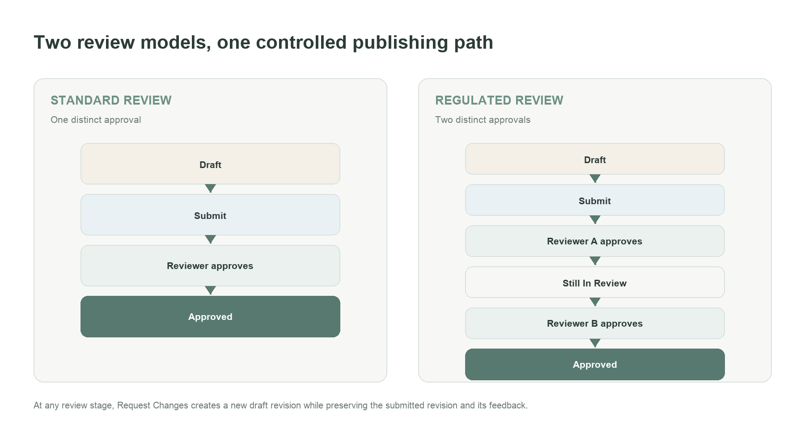
Standard and Regulated Review paths.

Reviewer assignment
The author can name eligible reviewers or use the shared queue; unfilled approval slots are queued automatically.
- Self-review is blocked, and one reviewer cannot satisfy both Regulated Review slots.
- Every claim, comment and decision is connected to the exact reviewed revision.

07 / CLIENT FIELD GUIDE

How a Standard Review article travels
Use this path for normal editorial content that requires one independent approval.
- Author drafts the article, completes media and metadata, and selects Standard Review.
- Author submits to a named reviewer or the shared queue. The article becomes In Review and the submitted revision is locked.
- Reviewer opens the Review Inbox, claims the assignment when required, reads the exact revision and adds discussion comments if needed.
- Reviewer chooses Approve, Request Changes or Reject. Request Changes and Reject require a clear decision summary.
- One approval moves the article to Approved. A Publisher can then publish immediately or schedule it.

If changes are requested
The system preserves the submitted revision and creates Revision N+1 as a new Draft. The author sees the reviewer’s comments, updates the new draft and resubmits it through the same controlled path.
RESULT The public site never receives a draft or an in-review revision—only the exact approved revision handed to publishing.

08 / CLIENT FIELD GUIDE

How a Regulated Review article travels
Use this path when the content requires two independent approvals before it can reach publishing.
- Author selects Regulated Review and submits the completed draft.
- The system creates two reviewer slots using named reviewers, queue slots or a combination of both.
- Reviewer A claims and approves the first slot. The article deliberately remains In Review.
- Reviewer A cannot claim or approve the second slot for the same revision.
- Reviewer B reviews independently and approves the second slot. The article becomes Approved exactly once.
- Publisher completes immediate or scheduled publication using the same publishing boundary as Standard Review.

Decision outcomes
Decision | System behavior
Approve | Records that reviewer’s independent decision; the article advances only when the policy threshold is met.
Request Changes | Returns the article to the author, closes remaining open assignments and creates Draft Revision N+1.
Reject | Stops the current review path with a required reason; admin policy determines any future reopening.

09 / CLIENT FIELD GUIDE

Publishing and public delivery
One approved revision becomes a durable public version through a secure, verified handoff.
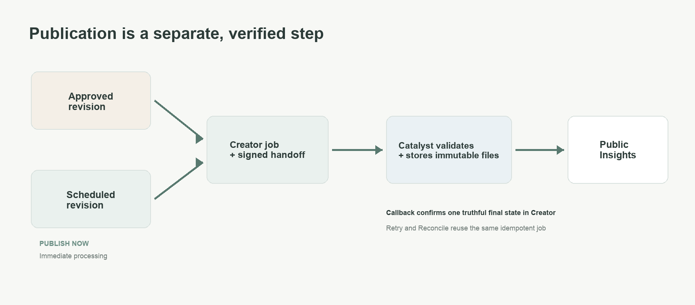
Immediate and scheduled publication converge on the same verified handoff.

Publisher controls
- Publish or Schedule — release the exact approved revision now or at a future time.
- Reconcile — confirm a completed job if the final Creator callback has not settled.
- Retract — stop public serving with a reason while preserving publication history.
SAFETY Retries and reconciliation reuse the same job, preventing duplicate public versions.

10 / CLIENT FIELD GUIDE

Using the dashboard by role
A practical starting view for each type of user.
User | Recommended starting view | Typical next action
Author | Mine → Articles | Open a Draft, continue Changes Requested work or create a new article.
Reviewer | Mine → Reviews, then Queue → Reviews | Handle assigned work first; claim eligible shared-queue work when capacity allows.
Publisher | Queue → Publishing | Publish or schedule Approved items; monitor Processing, Scheduled and Needs retry states.
Editorial Admin | All → All work | Review bottlenecks, queue depth, changes requested, approved work and recent activity.

What the main panels mean
- Review Inbox — active assignments that are assigned, queued or claimed.
- Article Work — drafts, changes requested and content currently in review.
- Publishing Queue — approved, scheduled, processing or retryable publication work.
- Published / Retracted — current public outcome with immutable history retained.
- Review History and Activity — closed decisions and the chronological audit trail.

Automatic email notifications
The platform sends best-effort, role-aware email updates after the related workflow action is safely recorded: reviewers are alerted when work is submitted; the author/owner is alerted when a review is claimed or decided; publishers are alerted when an article becomes ready; and the author/owner receives scheduling, publication, retraction or failure updates.
REMEMBER Email is a convenience alert. The dashboard, workflow state and Activity history remain the source of truth if an email is delayed or filtered.
LIVE DATA The dashboard refreshes normally and checks more frequently while active publication jobs are running.

11 / CLIENT FIELD GUIDE

Status guide and good operating habits
Use the state first: it tells you who owns the next step and which actions are safe.
Status | Meaning / next owner
Draft | Editable working revision — Author.
In Review | Submitted revision is locked; waiting for reviewer decisions — Reviewer(s).
Changes Requested | A new draft revision is available with feedback — Author.
Approved | Review threshold is complete; waiting for publication — Publisher.
Scheduled / Processing | Planned or active Catalyst delivery — Publisher monitors status and uses Reconcile only when prompted.
Published | Visible on the public Insights site — Publisher/Admin monitors.
Unpublished / Retracted | Removed from public serving; immutable history remains — Publisher/Admin.

Recommended habits
- Use the Article Workspace for lifecycle actions; avoid editing workflow records directly.
- Before submission, confirm the policy, reviewers, alt text and SEO metadata.
- Read the decision summary before responding; reconcile only when prompted and retract rather than delete.
WHEN UNSURE Confirm the article’s state and revision, then read Workflow facts and Activity for the next step.

