Mini Project

Verilog & VHDL

UART Rx,Tx
SPI Rx,Tx
I2C RX,Tx

UART

Verilog Code
UART Tx
`timescale 1ns / 1ps
module Uart_Tx(
output reg tx,
output reg tx_done,
input clk,
input rst,
input tx_start,
input [7:0] data_in
);

parameter clk_freq = 1_000_000;
parameter baud_rate = 9600;
localparam bits_per_clk = clk_freq / baud_rate;
localparam
idle = 3'd0,
start_bit = 3'd1,
data_bits = 3'd2,
parity_bit = 3'd3,
stop1 = 3'd4,
stop2 = 3'd5,
done = 3'd6;
reg [2:0] state;
reg [7:0] clk_count;
reg [3:0] bit_index;
reg parity;
reg [7:0] data;
always @(posedge clk or posedge rst) begin
if (rst) begin
state <= idle;
clk_count <= 0;
tx <= 1;
tx_done <= 0;
bit_index <= 0;
end else begin
case (state)
idle: begin
tx <= 1;
tx_done <= 0;
if (tx_start) begin
data <= data_in;
parity <= ^data_in;
clk_count <= 0;
bit_index <= 0;
state <= start_bit;
end
end

start_bit: begin
tx <= 0;
clk_count <= clk_count + 1;
if (clk_count == bits_per_clk - 1) begin
clk_count <= 0;
state <= data_bits;
end
end

data_bits: begin
tx <= data[bit_index];
clk_count <= clk_count + 1;
if (clk_count == bits_per_clk - 1) begin
clk_count <= 0;
if (bit_index == 7)
state <= parity_bit;
else
bit_index <= bit_index + 1;
end
end

parity_bit: begin
tx <= parity;
clk_count <= clk_count + 1;
if (clk_count == bits_per_clk - 1) begin
clk_count <= 0;
state <= stop1;
end
end

stop1: begin
tx <= 1;
clk_count <= clk_count + 1;
if (clk_count == bits_per_clk - 1) begin
clk_count <= 0;
state <= stop2;
end
end

stop2: begin
tx <= 1;
clk_count <= clk_count + 1;
if (clk_count == bits_per_clk - 1) begin
clk_count <= 0;
state <= done;
end
end

done: begin
tx_done <= 1;
state <= idle;
end
endcase
end
end

endmodule

UART Rx
`timescale 1ns / 1ps
module Uart_Rx(
output reg parity_err,
output reg rx_done,
input clk, rst, rx,
output reg [7:0] data_out
);
parameter clk_freq = 1_000_000;
parameter baud_rate = 9600;
localparam bits_per_clk = clk_freq / baud_rate;
localparam mid_sample = bits_per_clk / 2;
localparam
idle = 3'd0,
start_bit = 3'd1,
data_bits = 3'd2,
parity_bit = 3'd3,
stop1 = 3'd4,
stop2 = 3'd5,
cleanup = 3'd6;
reg [2:0] state;
reg [7:0] clk_count;
reg [3:0] bit_index;
reg [7:0] data;
reg parity;

always @(posedge clk or posedge rst) begin
if (rst) begin
clk_count <= 0;
bit_index <= 0;
rx_done <= 0;
parity_err <= 0;
state <= idle;
data <= 0;
data_out <= 0;
end else begin
case (state)
idle: begin
rx_done <= 0;
if (rx == 0) begin
clk_count <= 0;
state <= start_bit;
end
end

start_bit: begin
clk_count <= clk_count + 1;
if (clk_count == mid_sample) begin
if (rx == 0) begin
clk_count <= 0;
bit_index <= 0;
state <= data_bits;
end else begin
state <= idle;
end
end
end

data_bits: begin
clk_count <= clk_count + 1;
if (clk_count == mid_sample) begin
data[bit_index] <= rx;
end
if (clk_count == bits_per_clk - 1) begin
clk_count <= 0;
if (bit_index == 7)
state <= parity_bit;
else
bit_index <= bit_index + 1;
end
end

parity_bit: begin
clk_count <= clk_count + 1;
if (clk_count == mid_sample)
parity <= rx;

if (clk_count == bits_per_clk - 1) begin
clk_count <= 0;
state <= stop1;
end
end

stop1: begin
clk_count <= clk_count + 1;
if (clk_count == mid_sample && rx != 1) begin
state <= idle; // Error
end
if (clk_count == bits_per_clk - 1) begin
clk_count <= 0;
state <= stop2;
end
end

stop2: begin
clk_count <= clk_count + 1;
if (clk_count == mid_sample && rx != 1) begin
state <= idle;
end
if (clk_count == bits_per_clk - 1) begin
clk_count <= 0;
state <= cleanup;
end
end

cleanup: begin
rx_done <= 1;
parity_err <= (parity != ^data);
data_out <= data;
clk_count <= 0;
state <= idle;
end
endcase

$display("Time: %0t | State: %0d | RX: %b | BitIndex: %0d | clk_count: %0d | Data: %b | Done: %b",
$time, state, rx, bit_index, clk_count, data, rx_done);
end
end

endmodule

UART Top
`timescale 1ns / 1ps
module Uart_top(
input clk, rst,
input tx_start,
input [7:0] data_in,
output tx,
output [7:0] data_out,
output rx_done,
output parity_err
);

wire tx_line;
wire tx_done;

Uart_Tx tx_inst(
.tx(tx_line),
.tx_done(tx_done),
.clk(clk),
.rst(rst),
.tx_start(tx_start),
.data_in(data_in)
);

Uart_Rx rx_inst(
.parity_err(parity_err),
.rx_done(rx_done),
.clk(clk),
.rst(rst),
.rx(tx_line),
.data_out(data_out)
);
assign tx = tx_line;
endmodule

Test Bnech Code
`timescale 1ns / 1ps
module tb_uart;

reg clk, rst, tx_start;
reg [7:0] data_in;
wire tx;
wire [7:0] data_out;
wire rx_done, parity_err;

Uart_top uut (
.clk(clk),
.rst(rst),
.tx_start(tx_start),
.data_in(data_in),
.tx(tx),
.data_out(data_out),
.rx_done(rx_done),
.parity_err(parity_err)
);
initial clk = 0;
always #500 clk = ~clk;
initial begin
rst = 1;
tx_start = 0;
data_in = 8'b10101010;
#2000;
rst = 0;
#2000;
tx_start = 1;
#1000;
tx_start = 0;
wait(rx_done == 1);
$display("Received: %b (0x%h), Parity Error: %b", data_out, data_out, parity_err);
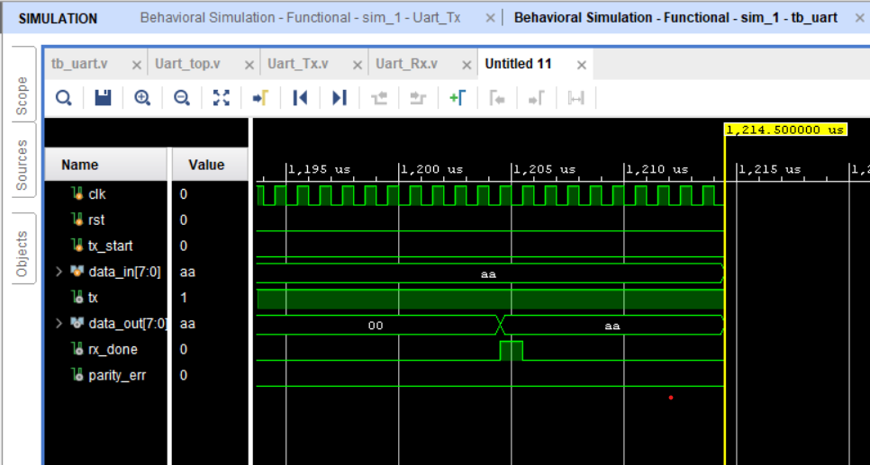
#10000;
$finish;
end
endmodule

VHDL Code
UART_Tx
library IEEE;
use IEEE.STD_LOGIC_1164.ALL;

entity UART_Tx is
Port (
clk, rst : in std_logic;
tx_start : in std_logic;
data_in : in std_logic_vector(7 downto 0);
tx : out std_logic;
tx_done : out std_logic
);
end UART_Tx;

architecture Behavioral of UART_Tx is
constant clk_freq : integer := 1000000;
constant baud_rate : integer := 9600;
constant bits_per_clk : integer := clk_freq / baud_rate;

type state_type is (idle, start, data_bit, parity_bit, stop1, stop2, cleanup);
signal state : state_type := idle;
signal clk_count : integer := 0;
signal bit_index : integer := 0;
signal data_reg : std_logic_vector(7 downto 0) := (others => '0');
signal parity : std_logic := '0';
signal tx_reg : std_logic := '1';

begin
tx <= tx_reg;

process(clk, rst)
begin
if rst = '1' then
state <= idle;
tx_done <= '0';
clk_count <= 0;
tx_reg <= '1';
bit_index <= 0;
elsif rising_edge(clk) then
case state is
when idle =>
tx_done <= '0';
tx_reg <= '1';
if tx_start = '1' then
data_reg <= data_in;
clk_count <= 0;
bit_index <= 0;
parity <= data_in(0) xor data_in(1) xor data_in(2) xor data_in(3) xor
data_in(4) xor data_in(5) xor data_in(6) xor data_in(7);
state <= start;
end if;

when start =>
tx_reg <= '0';
if clk_count = bits_per_clk - 1 then
clk_count <= 0;
state <= data_bit;
else
clk_count <= clk_count + 1;
end if;

when data_bit =>
tx_reg <= data_reg(bit_index);
if clk_count = bits_per_clk - 1 then
clk_count <= 0;
if bit_index = 7 then
state <= parity_bit;
else
bit_index <= bit_index + 1;
end if;
else
clk_count <= clk_count + 1;
end if;

when parity_bit =>
tx_reg <= parity;
if clk_count = bits_per_clk - 1 then
clk_count <= 0;
state <= stop1;
else
clk_count <= clk_count + 1;
end if;

when stop1 =>
tx_reg <= '1';
if clk_count = bits_per_clk - 1 then
clk_count <= 0;
state <= stop2;
else
clk_count <= clk_count + 1;
end if;

when stop2 =>
tx_reg <= '1';
if clk_count = bits_per_clk - 1 then
clk_count <= 0;
state <= cleanup;
else
clk_count <= clk_count + 1;
end if;

when cleanup =>
tx_done <= '1';
tx_reg <= '1';
state <= idle;
clk_count <= 0;
end case;
end if;
end process;
end Behavioral;

UART Rx
library IEEE;
use IEEE.STD_LOGIC_1164.ALL;

entity UART_Rx is
Port (
clk, rst : in std_logic;
rx : in std_logic;
data_out : out std_logic_vector(7 downto 0);
rx_done : out std_logic;
parity_err : out std_logic
);
end UART_Rx;

architecture Behavioral of UART_Rx is
constant clk_freq : integer := 1000000;
constant baud_rate : integer := 9600;
constant bits_per_clk : integer := clk_freq / baud_rate;
constant mid_sample : integer := bits_per_clk / 2;

type state_type is (idle, start, data_bit, parity_bit, stop1, stop2, cleanup);
signal state : state_type := idle;
signal clk_count : integer := 0;
signal bit_index : integer := 0;
signal data_reg : std_logic_vector(7 downto 0) := (others => '0');
signal parity : std_logic := '0';

begin
process(clk, rst)
begin
if rst = '1' then
clk_count <= 0;
state <= idle;
bit_index <= 0;
data_out <= (others => '0');
rx_done <= '0';
parity_err <= '0';
elsif rising_edge(clk) then
case state is
when idle =>
rx_done <= '0';
if rx = '0' then
clk_count <= 0;
state <= start;
end if;

when start =>
clk_count <= clk_count + 1;
if clk_count = mid_sample then
if rx = '0' then
clk_count <= 0;
bit_index <= 0;
state <= data_bit;
else
state <= idle;
end if;
end if;

when data_bit =>
clk_count <= clk_count + 1;
if clk_count = mid_sample then
data_reg(bit_index) <= rx;
end if;
if clk_count = bits_per_clk - 1 then
clk_count <= 0;
if bit_index = 7 then
state <= parity_bit;
else
bit_index <= bit_index + 1;
end if;
end if;

when parity_bit =>
clk_count <= clk_count + 1;
if clk_count = mid_sample then
parity <= rx;
end if;
if clk_count = bits_per_clk - 1 then
clk_count <= 0;
state <= stop1;
end if;

when stop1 =>
clk_count <= clk_count + 1;
if clk_count = bits_per_clk - 1 then
clk_count <= 0;
state <= stop2;
end if;

when stop2 =>
clk_count <= clk_count + 1;
if clk_count = bits_per_clk - 1 then
clk_count <= 0;
state <= cleanup;
end if;

when cleanup =>
data_out <= data_reg;
rx_done <= '1';
parity_err <= parity xor (data_reg(0) xor data_reg(1) xor data_reg(2) xor data_reg(3) xor
data_reg(4) xor data_reg(5) xor data_reg(6) xor data_reg(7));
state <= idle;
clk_count <= 0;
end case;
end if;
end process;
end Behavioral;

UART Top
library IEEE;
use IEEE.STD_LOGIC_1164.ALL;
entity UART_Top is
Port (clk,rst,tx_start:in std_logic;data_in: in std_logic_vector(7 downto 0);data_out: out std_logic_vector(7 downto 0);tx_done,rx_done,parity_err,tx:out std_logic );
end UART_Top;

architecture Behavioral of UART_Top is
signal tx_line :std_logic;
begin
UART_Tx_inst: entity work.UART_Tx port map(
clk => clk,
rst => rst,
tx_start=>tx_start,
data_in=>data_in,
tx=>tx_line,
tx_done=>tx_done);
UART_RX_inst: entity work.UART_Rx port map(
clk => clk,
rst => rst,
data_out=>data_out,
rx=>tx_line,
rx_done=>rx_done,
parity_err=>parity_err);

tx<=tx_line;
end Behavioral;

Test Bench Code
library IEEE;
use IEEE.STD_LOGIC_1164.ALL;
entity tb_UART is
end tb_UART;

architecture Behavioral of tb_UART is
signal clk,rst,tx_start: std_logic;
signal data_in: std_logic_vector(7 downto 0);
signal data_out: std_logic_vector(7 downto 0);
signal tx_done,rx_done,parity_err,tx: std_logic;
constant clk_period : time := 1 us;
begin
uut:entity work.UART_Top port map (

clk=>clk,
rst=>rst,
tx_start=>tx_start,
data_in=>data_in,
tx_done=>tx_done,
data_out=>data_out,
rx_done=>rx_done,
parity_err=>parity_err,
tx=>tx);

clock : process begin
clk<='0';wait for 5ns;
clk<='1';wait for 5ns;
end process;

stim_proc: process
begin
rst <= '1';
tx_start <= '0';
data_in <= (others => '0');
wait for 5 * clk_period;
rst <= '0';
wait for clk_period;
data_in <= "10101010";
tx_start <= '1';
wait for clk_period;
tx_start <= '0';
wait until rx_done = '1';
wait for 10 * clk_period;
assert false report "Simulation complete" severity note;
wait;
end process;
end Behavioral;
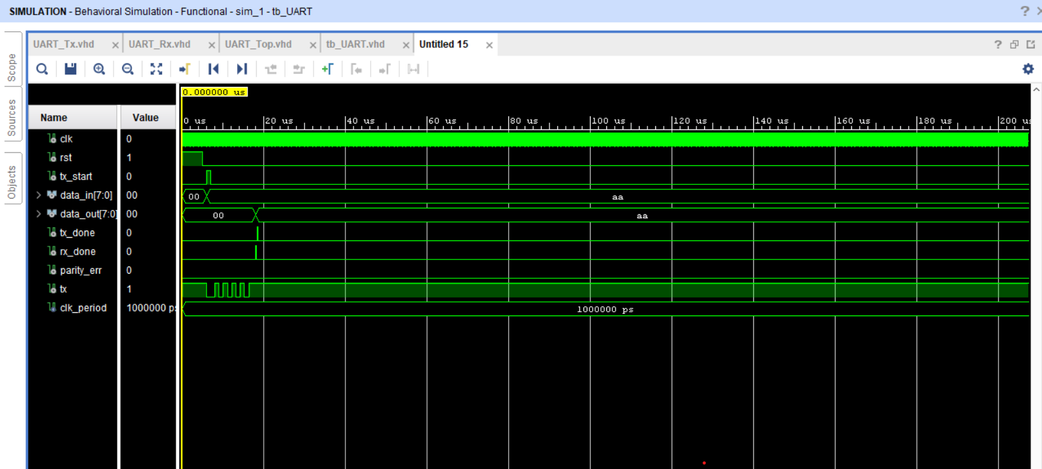

SPI
Verilog Code
`timescale 1ns / 1ps
module SPI_Verilog(
input clk,rst,start,miso,
input [7:0]data_in,
output reg ss,reg_done,mosi,sck,
output reg [7:0]data_rec
);
parameter clk_div=4;
reg [1:0]state;
reg [2:0]bit_count;
reg [7:0]shift_reg;
reg [clk_div-1:0]clk_div_count;

parameter
idle =2'd0,
load = 2'd1,
transfer =2'd2,
done = 2'd3;

always @(posedge clk or posedge rst) begin
if (rst) begin
state<=idle;
sck<=0;
clk_div_count<=0;
bit_count<=0;
shift_reg<=0;
mosi<=0;
data_rec<=8'b0;
ss<=1;
reg_done<=0;end
else begin
case (state)
idle: begin
if (start==0) begin
sck<=0;
ss<=1;
reg_done<=0;
end
else begin
state<=load;end
end
load: begin
shift_reg<=data_in;
bit_count<=3'b111;
ss<=0;
clk_div_count<=0;
state<=transfer;
end
transfer: begin
clk_div_count<=clk_div_count+1;
if (clk_div_count==(clk_div/2)-1) begin
sck<=1;
mosi<=shift_reg[bit_count];
end
if (clk_div_count==clk_div-1) begin
sck<=0;
data_rec[bit_count]<=miso;
clk_div_count<=0;
if (bit_count==0) begin
state<=done;
end
else begin
bit_count<=bit_count-1;
end
end
end
done: begin
sck<=0;
reg_done<=1;
ss<=1;
state<=idle;

end
endcase
end
end
endmodule

Test Bench Code
`timescale 1ns / 1ps
module tb_SPI;
reg clk,rst,start,miso;
reg [7:0]data_in;
wire ss,reg_done,mosi,sck;
wire [7:0]data_rec ;
SPI_Verilog uut(
.clk(clk),
.rst(rst),
.start(start),
.miso(miso),
.data_in(data_in),
.ss(ss),
.reg_done(reg_done),
.mosi(mosi),
.sck(sck),
.data_rec(data_rec));

initial begin
clk=0;
forever #5 clk=~clk;
end
initial begin
rst=1;
start=0;
data_in=8'b10101010;
miso=0;
#20;
rst=0;
#20;
start=1;
#10;
start=0;
wait (ss==0);
#10; miso = 1;
#40; miso = 0;
#40; miso = 1;
#40; miso = 0;
#40; miso = 1;
#40; miso = 0;
#40; miso = 1;
#40; miso = 0;
wait(reg_done);
$display("SPI Transfer Complete");
$display("Received data: %b", data_rec);
#20;
$finish;
end
endmodule
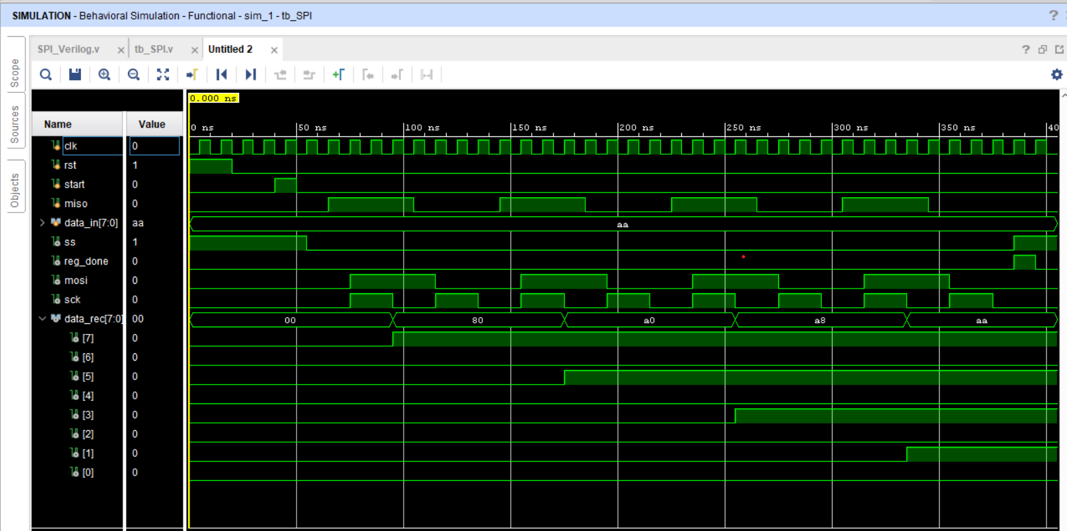

VHDL Code
library IEEE;
use IEEE.STD_LOGIC_1164.ALL;
entity SPI_VHDL is
Port (clk,rst,start,miso:in std_logic;data_in:in std_logic_vector(7 downto 0);data_rec:out std_logic_vector(7 downto 0);ss,sck,mosi,reg_done:out std_logic);
end SPI_VHDL;

architecture Behavioral of SPI_VHDL is
type state_type is(idle,load,transfer,done);
signal state:state_type:=idle;
constant clk_div:integer :=4;
signal bit_count:integer;
signal shift_reg: std_logic_vector(7 downto 0):=(others =>'0');
signal clk_div_cnt:integer;
signal rec_reg: std_logic_vector(7 downto 0):=(others =>'0');
signal ss_int: std_logic:='1';
signal mosi_int:std_logic:='0';
signal done_int:std_logic:='0';
signal sck_int:std_logic:='0';

begin
sck<=sck_int;
reg_done<=done_int;
ss<=ss_int;
mosi<=mosi_int;
data_rec<=rec_reg;

process (clk,rst) begin
if(rst='1') then
done_int<='0';
ss_int<='1';
mosi_int<='0';
done_int<='0';
sck_int<='0';
bit_count<=0;
shift_reg<=(others=>'0');
rec_reg<=(others=>'0');
clk_div_cnt<=0;
elsif (rising_edge(clk)) then
case state is
when idle =>
sck_int<='0';
done_int<='0';
ss_int<='1';
if (start='1') then
state<=load;
end if;
when load =>
ss_int<='0';
shift_reg<=data_in;
bit_count<=7;
clk_div_cnt<=0;
state<=transfer;
when transfer =>
clk_div_cnt <= clk_div_cnt + 1;
if (clk_div_cnt=(clk_div/2)-1) then
sck_int<='1';
mosi_int<=shift_reg(bit_count);
end if;
if (clk_div_cnt=clk_div-1) then
sck_int<='0';
rec_reg(bit_count)<=miso;
sck_int<='0';
if (bit_count=0) then
state<=done;
else
bit_count<=bit_count-1;
end if ;
end if;
when done =>
sck_int<='0';
ss_int<='1';
done_int<='1';
state<=idle;
end case;
end if ;
end process;
end Behavioral;

Test Bench Code
library IEEE;
use IEEE.STD_LOGIC_1164.ALL;
entity tb_SPI is
end tb_SPI;
architecture Behavioral of tb_SPI is
component SPI_VHDL
Port (
clk : in std_logic;
rst : in std_logic;
start : in std_logic;
miso : in std_logic;
data_in : in std_logic_vector(7 downto 0);
ss : out std_logic;
reg_done : out std_logic;
mosi : out std_logic;
sck : out std_logic;
data_rec : out std_logic_vector(7 downto 0)
);
end component;
signal clk,rst,start,miso: std_logic;
signal data_in: std_logic_vector(7 downto 0):= x"AA" ;
signal data_rec: std_logic_vector(7 downto 0);
signal ss,sck,mosi,reg_done: std_logic;

begin
uut: entity work.SPI_VHDL port map(
clk=>clk,
rst=>rst,
start=>start,
miso=>miso,
data_in=>data_in,
data_rec=>data_rec,
ss=>ss,
sck=>sck,
mosi=>mosi,
reg_done=>reg_done);

clock: process begin
clk<='0'; wait for 5ns;
clk<='1'; wait for 5ns;
end process;
stim : process
begin
start <= '0';
miso <= '0';
rst <= '1';
wait for 10 ns;
rst <= '0';

wait for 10 ns;
start <= '1';
wait for 10 ns;
start <= '0';

wait until ss = '0';
wait for 10 ns; miso <= '1';
wait for 40 ns; miso <= '0';
wait for 40 ns; miso <= '1';
wait for 40 ns; miso <= '0';
wait for 40 ns; miso <= '1';
wait for 40 ns; miso <= '0';
wait for 40 ns; miso <= '1';
wait for 40 ns; miso <= '0';
wait until reg_done = '1';
report "SPI Transfer Complete";
wait for 50 ns;
assert false report "End of simulation." severity failure;
end process;
end Behavioral;

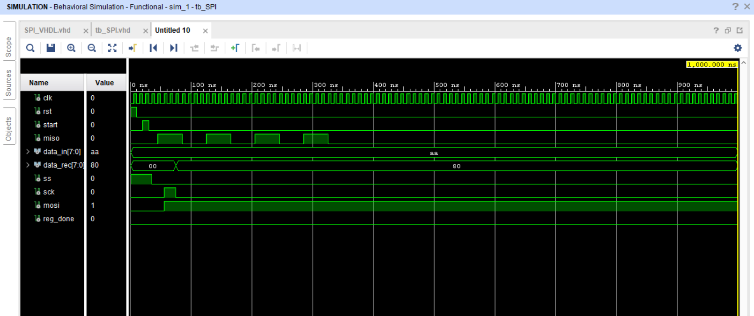

I2C

Verilog Code
I2c Master
module i2c_master #(
parameter clk_freq = 50000000,
parameter i2c_freq = 100000
)
(
input wire clk,
input wire rst,
input wire start,
input wire rw,
input wire [6:0] addr7,
input wire [7:0] reg_addr,
input wire [7:0] data_in,
input wire do_read,
output reg busy,
output reg ack_err,
output reg arb_lost,
output reg[7:0] read_data,
output reg done,
inout wire sda,
inout wire scl
);

localparam integer clk_per_half_scl = clk_freq/(i2c_freq*2);
localparam integer cntr_w = $clog2(clk_per_half_scl+1);

reg sda_oe;
reg scl_oe;

assign sda = sda_oe ? 1'b0 : 1'bz;
assign scl = scl_oe ? 1'b0 : 1'bz;

wire sda_in = sda;
wire scl_in = scl;

localparam
idle= 4'd0,
start_bit = 4'd1,
send_addr = 4'd2,
wait_ack1 = 4'd3,
send_reg = 4'd4,
wait_ack2 = 4'd5,
write_data = 4'd6,
wait_ack3 = 4'd7,
rep_start = 4'd8,
send_addr_rd = 4'd9,
wait_ack4 = 4'd10,
read_data_bit = 4'd11,
send_nack = 4'd12,
stop = 4'd13,
done_bit = 4'd14;

reg [3:0] state,next_state;

reg [cntr_w-1:0] half_scl_cnt;
reg scl_edge;
reg phase;

reg [7:0] tx_shift;
reg [2:0] bit_index;
reg expecting_ack;

always @(posedge clk or negedge rst) begin
if (!rst)
arb_lost <= 1'b0;
else if (sda_oe && sda_in)
arb_lost <= 1'b1;
else
arb_lost <= arb_lost;
end

always @(posedge clk or negedge rst) begin
if (!rst) begin
half_scl_cnt <= 1'b0;
scl_edge <= 1'b0;
phase <= 1'b0;
end
else begin
if (half_scl_cnt == (clk_per_half_scl-1)) begin
half_scl_cnt <= 1'b0;
scl_edge <= 1'b1;
phase <= ~phase;
end
else begin
half_scl_cnt <= half_scl_cnt+1;
scl_edge <= 1'b0;
end
end
end

always @(posedge clk or negedge rst) begin
if (!rst) begin
state <= idle;
busy <= 1'b0;
ack_err <= 1'b0;
done <= 1'b0;
read_data <= 8'h00;
sda_oe <= 1'b0;
scl_oe <= 1'b0;
bit_index <= 3'd7;
tx_shift <= 8'h00;
expecting_ack <= 1'b0;
end
else begin
done <= 1'b0;
case (state)
idle : begin
ack_err <= 1'b0;
arb_lost <= 1'b0;
if (start) begin
busy <= 1'b1;
state <= start_bit;
end
end
start_bit : begin
scl_oe <= 1'b0;
if (scl_in && phase == 1'b0) begin
sda_oe <= 1'b1;
end
if (scl_edge && phase == 1'b1) begin
state <= send_addr;
tx_shift <= {addr7,rw};
bit_index <= 3'd7;
expecting_ack <= 1'b0;
scl_oe <= 1'b1;
half_scl_cnt <= 1'b0;
phase <= 1'b0;
end
end
send_addr : begin
if (scl_edge && phase == 1'b0) begin
sda_oe <= ~tx_shift[bit_index];
scl_oe <= 1'b0;
end
if (scl_edge && phase == 1'b1) begin
scl_oe <= 1'b1;
if (bit_index == 1'b0) begin
state <= wait_ack1 ;
sda_oe <= 1'b0;
expecting_ack <= 1'b1;
end
else begin
bit_index <= bit_index-1;
end
end
end
wait_ack1 : begin
if (scl_edge && phase == 1'b0) begin
scl_oe <= 1'b0;
end
if (scl_edge && phase == 1'b1) begin
if (sda_in == 1'b1) begin
ack_err <= 1'b1;
scl_oe <= 1'b1;

bit_index <= 3'd7;
tx_shift <= reg_addr;
expecting_ack <= 1'b0;
end
state <= send_reg;
end
end
send_reg : begin
if (scl_edge && phase == 1'b0) begin
scl_oe <= 1'b0;
sda_oe <= ~tx_shift[bit_index];
end
if (scl_edge && phase == 1'b1) begin
scl_oe <= 1'b1;
if (bit_index == 1'b0) begin
state <= wait_ack2;
sda_oe <= 1'b0;
expecting_ack <= 1'b1;
end
else begin
bit_index <= bit_index-1;
end
end
end
wait_ack2 : begin
if (scl_edge && phase == 1'b0) begin
scl_oe <= 1'b0;
end
if (scl_edge && phase == 1'b1) begin
if (sda_in == 1'b1) begin
ack_err <= 1'b1;
end
scl_oe <= 1'b1;
if (do_read) begin
state <= rep_start;
end
else begin
state <= write_data;
tx_shift <= data_in;
bit_index <= 3'd7;
end
end
end
write_data : begin
if (scl_edge && phase == 1'b0) begin
sda_oe <= ~tx_shift[bit_index];
scl_oe <= 1'b0;
end
if (scl_edge && phase == 1'b1) begin
scl_oe <= 1'b1;
if (bit_index == 1'b0) begin
state <= wait_ack3;
sda_oe <= 1'b0;
end
else begin
bit_index <= bit_index-1;
end
end
end
wait_ack3 : begin
if (scl_edge && phase == 1'b0) begin
scl_oe <= 1'b0;
end
if (scl_edge && phase == 1'b1) begin
if (sda_in == 1'b1) begin
ack_err <= 1'b1;
scl_oe <= 1'b1;
state <= stop;
end
end
end
rep_start : begin
scl_oe <= 1'b0;
sda_oe <= 1'b0;
if (scl_in) begin
sda_oe <= 1'b1;
tx_shift <= {addr7,1'b1};
bit_index <= 3'd7;
sda_oe <= 1'b1;
scl_oe <= 1'b1;
state <= send_addr_rd;
end
end
send_addr_rd : begin
if (scl_edge && phase == 1'b0) begin
scl_oe <= 1'b0;
sda_oe <= ~tx_shift[bit_index];
end
if (scl_edge && phase == 1'b1) begin
scl_oe <= 1'b1;
if (bit_index == 1'b0) begin
state <= wait_ack4;
sda_oe <= 1'b0;
end
else begin
bit_index <= bit_index-1;
end
end
end
wait_ack4 : begin
if (scl_edge && phase == 1'b0) begin
scl_oe <= 1'b0;
end
if (scl_edge && phase == 1'b1) begin
if (sda_in == 1'b1) begin
ack_err <= 1'b1;
scl_oe <= 1'b1;
bit_index <= 3'd7;
sda_oe <= 1'b0;

end
state <= read_data_bit;
end
end
read_data_bit : begin
if (scl_edge && phase == 1'b0) begin
scl_oe <= 1'b0;
end;
if (scl_edge && phase == 1'b1) begin
read_data[bit_index] <= sda_in;
scl_oe <= 1'b1;
if (bit_index == 1'b0) begin
state <= send_nack;
end
else begin
bit_index <= bit_index-1;
end
end
end
send_nack : begin
if (scl_edge && phase == 1'b0) begin
scl_oe <= 1'b0;
sda_oe <= 1'b0;
end
if (scl_edge && phase == 1'b1) begin
scl_oe <= 1'b1;
state <= stop;
end
end
stop : begin
scl_oe <= 1'b0;
if (scl_in) begin
sda_oe <= 1'b0;
state <= done_bit;
end
else if (phase ==1'b0)
sda_oe <=1'b1;
end
done_bit : begin
busy <= 1'b0;
done <= 1'b1;
read_data <= data_in;
state <= idle;
end
default : begin
state <= idle;
end
endcase
end
end
endmodule

i2c Slave
module i2c_slave #(
parameter slave_addr = 7'h42
)(
input wire clk,rst,
inout wire sda,
inout wire scl,
input wire sim_clk_str
);

reg sda_oe;
reg scl_oe;

assign sda = sda_oe ? 1'b0 : 1'bz ;
assign scl = scl_oe ? 1'b0 : 1'bz ;

wire sda_in = sda;
wire scl_in = scl;

localparam
idle = 4'd0,
addr= 4'd1,
ack_addr = 4'd2,
reg_bit = 4'd3,
ack_reg = 4'd4,
data = 4'd5,
ack_data = 4'd6,
read_byte = 4'd7,
ack_read = 4'd8;

reg [3:0] state;
reg [7:0] shift;
reg [2:0] bit_cnt;
reg rw_flag;
reg [7:0] reg_file [0:15];
reg [3:0] reg_ptr;
reg expecting_reg;

reg sda_prev,scl_prev;

wire start_det = (sda_in == 1'b1 && sda_in == 1'b0 && scl_in == 1'b1);
wire stop_det = (sda_in == 1'b0 && sda_in == 1'b1 && scl_in == 1'b1);

integer i;

initial begin
for (i= 0 ; i < 16 ; i=i+1 )
reg_file[i]=i;
state = idle;
sda_oe = 1'b0;
scl_oe = 1'b0;
sda_prev = 1'b1;
scl_prev = 1'b1;
bit_cnt = 3'd7;
shift = 8'b0;
reg_ptr = 4'b0;
//expecting_ack = 1'b0;
end

always @(posedge clk or negedge rst) begin
if (!rst) begin
state = idle;
sda_oe = 1'b0;
scl_oe = 1'b0;
sda_prev = 1'b1;
scl_prev = 1'b1;
bit_cnt = 3'd7;
shift = 8'b0;
reg_ptr = 4'b0;
//expecting_ack = 1'b0;
end
else begin
sda_prev <= sda_in;
scl_prev <= scl_in;
end

if (start_det) begin
state <= addr;
bit_cnt <= 3'd7;
shift <= 8'b0;
scl_oe <= 1'b0;
end
else if (stop_det) begin
state <= idle;
sda_oe <= 1'b0;
scl_oe <= 1'b0;
end
else begin
if (scl_prev == 1'b0 && scl_in == 1'b1) begin
case(state)
addr: begin
shift[bit_cnt] <= sda_in;
if (bit_cnt == 1'b0) begin
if (shift[7:1] == slave_addr) begin
state <= ack_addr;
rw_flag <= shift[0];
end
else begin
state <= idle;
end
bit_cnt <= 3'd7;
end
else begin
bit_cnt <= bit_cnt - 1;
end
end

ack_addr : begin
sda_oe <= 1'b1;
state <= reg_bit;
end

reg_bit : begin
sda_oe <= 1'b0;
bit_cnt <= 3'd7;
if (bit_cnt == 1'b0) begin
reg_ptr <= shift[7:0];
bit_cnt <= 3'd7;
if (rw_flag == 1'b0) begin
state <= ack_reg;
expecting_reg <= 1'b1;
end
else begin
state <= ack_reg;
end
end
else begin
bit_cnt <= bit_cnt-1;
end
end
ack_reg : begin
sda_oe <= 1'b1;
if (rw_flag) begin
sda_oe <= 1'b0;
state <= read_byte;
bit_cnt <= 3'd7;
shift <= reg_file[reg_ptr];
end
else begin
sda_oe <= 1'b0;
state <= data;
bit_cnt <= 3'd7;
shift <= 8'h00;
end
end
data : begin
if (bit_cnt == 1'b0) begin
reg_file[reg_ptr] <= shift;
state <= ack_data;
bit_cnt <= 3'd7;
end
else begin
bit_cnt <= bit_cnt-1;
end
end

ack_data : begin
sda_oe <= 1'b1;
sda_oe <= 1'b0;
state <= idle;
end

read_byte : begin
sda_oe <= ~shift[bit_cnt];
if (bit_cnt == 1'b0) begin
bit_cnt <= 3'd7;
sda_oe <= 1'b0;
state <= idle;
end
else begin
bit_cnt <= bit_cnt-1;
end
end

default : begin
state <= idle;
end
endcase
end
end
end
endmodule

i2c Top
module i2c_top();
wire sda;
wire scl;

pullup pu_sda(sda);
pullup pu_scl(scl);

reg clk,rst;

initial begin
clk = 1'b0;
forever #5
clk = ~clk;
end

reg start;
reg rw;
reg [6:0] addr7;
reg [7:0] reg_addr;
reg [7:0] data_in;
reg do_read;
wire busy;
wire ack_err;
wire arb_lost;
wire[7:0] read_data;
wire done;

i2c_master #(.clk_freq(100000000),.i2c_freq(100000)) master_inst(
.clk(clk),
.rst(rst),
.start(start),
.rw(rw),
.addr7(addr7),
.reg_addr(reg_addr),
.data_in(data_in),
.do_read(do_read),
.busy(busy),
.ack_err(ack_err),
.arb_lost(arb_lost),
.read_data(read_data),
.done(done),
.sda(sda),
.scl(scl)
);

reg sim_clk_str;
i2c_slave #(.slave_addr(7'h42)) slave_inst(
.clk(clk),
.rst(rst),
.scl(scl),
.sda(sda),
.sim_clk_str(sim_clk_str)
);

initial begin
rst = 0;
start = 0;
rw = 0;
addr7 = 7'h42;
reg_addr = 8'h01;
data_in = 8'hA5;
do_read = 0;
sim_clk_str= 0;
#100;
rst= 1;
end
endmodule

i2c TestBench
module i2c_tb();
wire sda;
wire scl;
reg clk,rst;
pullup(sda);
pullup(scl);

initial begin
clk= 1'b0;
forever #5
clk <= ~clk;
end

reg start;
reg rw;
reg [6:0] addr7;
reg [7:0] reg_addr;
reg [7:0] data_in;
reg do_read;
wire busy;
wire ack_err;
wire arb_lost;
wire[7:0] read_data;
wire done;

i2c_master #(.clk_freq(100000000),.i2c_freq(100000)) master_inst(
.clk(clk),
.rst(rst),
.start(start),
.rw(rw),
.addr7(addr7),
.reg_addr(reg_addr),
.data_in(data_in),
.do_read(do_read),
.busy(busy),
.ack_err(ack_err),
.arb_lost(arb_lost),
.read_data(read_data),
.done(done),
.sda(sda),
.scl(scl)
);

reg sim_clk_str;
i2c_slave #(.slave_addr(7'h42)) slave_inst(
.clk(clk),
.rst(rst),
.scl(scl),
.sda(sda),
.sim_clk_str(sim_clk_str)
);

initial begin
$dumpfile("dump.vcd");
$dumpvars(0,i2c_tb);
rst = 1'b0;
start = 1'b0;
sim_clk_str =1'b0;
addr7 = 8'h42;
reg_addr = 8'h02;
data_in = 8'h5a;
do_read = 1'b0;
#200;
rst = 1'b1;
#200;

$display("TEST1: Write 0x%02x to reg 0x%02x", data_in, reg_addr);
start = 1;
rw = 0;
do_read = 0;
#10 start = 0;
wait (done);
#200;
$display("DONE write: ack_err=%b arb_lost=%b", ack_err, arb_lost);

$display("TEST2: Read from reg 0x%02x", reg_addr);
start = 1;
rw = 1;
do_read = 1;
#10 start = 0;
wait (done);
#100;
$display("Read data = 0x%02x ack_err=%b", read_data, ack_err);

$display("TEST3: Clock stretching simulated");
sim_clk_str = 1;
data_in = 8'hCC;
reg_addr = 8'h03;
start= 1;
rw = 0;
do_read = 0;
#10 start = 0;
wait (done);
sim_clk_str = 0;
#100;
$display("After stretch write ack_err=%b", ack_err);

#500;
$finish;
end
endmodule

VHDL Code
I2c Master
library ieee;
use ieee.std_logic_1164.all;
use ieee.numeric_std.all;

entity i2c_master is
generic(
clk_freq : integer := 50000000;
i2c_freq : integer := 100000
);
port(
clk,rst : in std_logic;
start : in std_logic;
rw : in std_logic;
addr7 : in std_logic_vector(6 downto 0);
reg_addr : in std_logic_vector(7 downto 0);
data_in : in std_logic_vector(7 downto 0);
busy : out std_logic;
ack_err : out std_logic;
done : out std_logic;
read_data : out std_logic_vector(7 downto 0);
sda : inout std_logic;
scl : inout std_logic
);
end i2c_master;

architecture behavioral of i2c_master is
constant clk_per_half : integer := clk_freq/(i2c_freq*2);

type state_t is(
idle,start_bit,
send_addr,ack1,
send_reg, ack2,
send_data, ack3,
stop_bit, done_bit
);

signal state : state_t := idle;
signal half_cnt : integer range 0 to clk_per_half := 0;
signal scl_tick : std_logic := '0';
signal phase : std_logic := '0';

signal sda_oe : std_logic := '0';
signal scl_oe : std_logic := '0';

signal tx_shift : std_logic_vector(7 downto 0);
signal bit_count : integer range 0 to 7 := 7 ;
signal sda_in : std_logic;
signal scl_in : std_logic;
begin
sda <= '0' when sda_oe = '1' else 'Z';
scl <= '0' when scl_oe = '1' else 'Z';

sda_in <= sda;
scl_in <= scl;

process(clk,rst)
begin
if (rst = '0') then
half_cnt <= 0;
scl_tick <= '0';
phase <= '0';
elsif rising_edge(clk) then
if half_cnt = clk_per_half-1 then
half_cnt <= 0;
scl_tick <= '1';
phase <= not phase;
else
half_cnt <= half_cnt+1;
scl_tick <= '0';
end if;
end if;
end process;

process (clk,rst)
begin
if rst = '0' then
state <= idle;
busy <= '0';
ack_err <= '0';
done <= '0';
sda_oe <= '0';
scl_oe <= '0';
bit_count <= 7;
read_data <= (others => '0');
elsif rising_edge(clk) then
done <= '0';
case state is
when idle =>
busy <= '0';
ack_err <= '0';
if (start='1') then
busy <= '1';
state <= start_bit;
end if;

when start_bit =>
scl_oe <= '0';
if (phase = '0') then
sda_oe <= '1';
end if;
if (scl_tick = '1' and phase = '1') then
scl_oe <= '1';
tx_shift <= addr7 & rw;
bit_count <= 7;
state <= send_addr;
end if;

when send_addr =>
if scl_tick = '1' and phase = '0' then
sda_oe <= not tx_shift(bit_count);
scl_oe <= '0';
elsif scl_tick = '1' and phase = '1' then
scl_oe <= '1';
if bit_count = 0 then
sda_oe <= '0';
state <= ack1;
else
bit_count <= bit_count-1;
end if;
end if;

when ack1 =>
if scl_tick = '1' and phase = '1' then
if sda_in = '1' then
ack_err <= '1';
end if;
tx_shift <= reg_addr;
bit_count <= 7;
state <= send_reg;
end if;

when send_reg =>
if scl_tick = '1' and phase = '0' then
sda_oe <= not tx_shift(bit_count);
scl_oe <= '0';
elsif scl_tick = '1' and phase = '1' then
scl_oe <= '1';
if bit_count = 0 then
sda_oe <= '0';
state <= ack2;
else
bit_count <= bit_count-1;
end if;
end if;

when ack2 =>
if scl_tick = '1' and phase = '1' then
if sda_in = '1' then
ack_err <= '1';
end if;
tx_shift <= data_in;
bit_count <= 7;
state <=send_data;
end if;

when send_data =>
if scl_tick = '1' and phase = '0' then
sda_oe <= not tx_shift(bit_count);
scl_oe <= '0';
elsif scl_tick = '1' and phase = '1' then
scl_oe <= '1';
if bit_count = 0 then
sda_oe <= '0';
state <= ack3;
else
bit_count <= bit_count-1;
end if;
end if;

when ack3 =>
if scl_tick='1' and phase = '1' then
if sda_in = '1' then
ack_err <= '1';
end if;
state <= stop_bit;
end if;

when done_bit =>
busy <= '0';
done <= '1';
state <= idle;
when stop_bit =>
if scl_tick = '1' and phase = '0' then
scl_oe <= '0'; -- release SCL
sda_oe <= '1'; -- keep SDA low
elsif scl_tick = '1' and phase = '1' then
sda_oe <= '0'; -- SDA goes high while SCL high = STOP
state <= done_bit;
end if;
end case;
end if;
end process;

end behavioral;

i2c Slave
library ieee;
use ieee.std_logic_1164.all;
use ieee.numeric_std.all;

entity i2c_slave is
generic (
slave_addr : std_logic_vector(6 downto 0) := "1000010"
);
port(
clk,rst : in std_logic;
sda : inout std_logic;
scl : inout std_logic
);
end i2c_slave;

architecture behavioral of i2c_slave is
type state_t is (
idle,
addr,
addr_ack,
reg_addr,
reg_ack,
write_data,
write_ack,
read_data,
read_ack
);
signal state : state_t := idle;
signal sda_oe : std_logic := '0';
signal sda_in : std_logic ;
signal bit_count : integer range 0 to 7 := 7;
signal rx_shift : std_logic_vector( 7 downto 0) := (others => '0');
signal tx_shift : std_logic_vector(7 downto 0) := (others => '0');
signal rw : std_logic := '0';
signal reg_ptr : integer range 0 to 255 := 0;
type mem_t is array ( 0 to 255) of std_logic_vector(7 downto 0);
signal mem : mem_t := (others =>(others => '0'));
signal sda_d,scl_d : std_logic;

begin
sda <= '0' when sda_oe = '1' else 'Z';
sda_in <= sda;
process (clk)
begin
if rising_edge (clk) then
sda_d <= sda;
scl_d <= scl;
end if;
end process;
process (clk,rst)
begin
if (rst = '0') then
state <= idle;
sda_oe <= '0';
bit_count <= 7;

elsif rising_edge(clk) then
if (sda_d = '1' and sda = '0' and scl = '1') then
state <= addr;
bit_count <= 7;
end if;
if (sda_d = '0' and sda = '1' and scl = '1') then
state <= idle;
sda_oe <= '0';
end if;
case state is
when idle =>
sda_oe <= '0';

when addr =>
if rising_edge(scl) then
rx_shift(bit_count) <= sda;
if bit_count = 0 then
rw <= sda;
state <= addr_ack;
else
bit_count <= bit_count-1;
end if;
end if;

when addr_ack =>
if rx_shift(7 downto 1) = slave_addr then
sda_oe <= '1';
bit_count <= 7;
if rw = '0' then
state <= reg_addr;
else
tx_shift <= mem(reg_ptr);
state <= read_data;
end if;
else
state <= idle;
end if;

when reg_addr =>
if rising_edge(scl) then
rx_shift(bit_count) <= sda;
if bit_count = 0 then
reg_ptr <= to_integer(unsigned(rx_shift));
state <= reg_ack;
else
bit_count <= bit_count-1;
end if;
end if;

when reg_ack =>
sda_oe <= '1';
bit_count <= 7;
state <= write_data;

when write_data =>
if rising_edge(scl) then
rx_shift(bit_count) <= sda;
if bit_count = 0 then
mem(reg_ptr) <= rx_shift;
state <= write_ack;
else
bit_count <= bit_count-1;
end if;
end if;

when write_ack =>
sda_oe <= '1';
state <= idle;

when read_data =>
if rising_edge(scl) then
sda_oe <= not tx_shift(bit_count);
if bit_count = 0 then
state <= read_ack;
else
bit_count <= bit_count-1;
end if;
end if;

when read_ack =>
sda_oe <= '0';
state <= idle;

end case;
end if;
end process;
end behavioral;

i2c top
library ieee;
use ieee.std_logic_1164.all;
use ieee.numeric_std.all;

entity i2c_top is
port(
clk,rst : in std_logic;
start : in std_logic;
rw : in std_logic;
addr7 : in std_logic_vector(6 downto 0);
reg_addr : in std_logic_vector(7 downto 0);
data_in : in std_logic_vector(7 downto 0);
busy : out std_logic;
ack_err : out std_logic;
done : out std_logic;
read_data : out std_logic_vector(7 downto 0)

);
end i2c_top;

architecture behavioral of i2c_top is
signal sda: std_logic := 'H';
signal scl : std_logic := 'H';

begin
master_inst : entity work.i2c_master
generic map(
i2c_freq => 100000,
clk_freq => 50000000
)
port map(
clk => clk,
rst => rst,
start => start,
rw => rw,
addr7 => addr7,
reg_addr => reg_addr,
data_in => data_in,
busy => busy,
done => done,
ack_err => ack_err,
read_data => read_data,
sda => sda,
scl => scl
);

slave_inst : entity work.i2c_slave
generic map(
slave_addr => "1000010"
)
port map(
clk => clk,
rst => rst,
scl => scl,
sda => sda
);

end behavioral;

i2c TestBench
library ieee;
use ieee.std_logic_1164.all;
use ieee.numeric_std.all;

entity i2c_tb is
end i2c_tb;

architecture behavioral of i2c_tb is
signal clk,rst : std_logic := '0';
signal start : std_logic;
signal rw : std_logic;
signal addr7 : std_logic_vector(6 downto 0);
signal reg_addr : std_logic_vector(7 downto 0);
signal data_in : std_logic_vector(7 downto 0);
signal busy : std_logic;
signal ack_err : std_logic;
signal done : std_logic;
signal read_data : std_logic_vector(7 downto 0);

begin
clk_process :
process begin
clk <= '0';
wait for 5 ns;
clk <= not clk;
wait for 5 ns;
end process;

top_inst : entity work.i2c_top port map(
clk => clk,
rst => rst,
start => start,
rw => rw,
addr7 => addr7,
reg_addr => reg_addr,
data_in => data_in,
busy => busy,
done => done,
ack_err => ack_err,
read_data => read_data
);

stim :
process begin
rst <= '0';
wait for 100 ns;
rst <= '1';
wait for 200 ns;

start <= '1';
rw <= '0';
wait for 40 ns;
start <= '0';

wait until done = '1';
wait for 500 ns;

start <= '1';
rw <= '0';
wait for 40 ns;
start <= '0';
wait until done = '1';
wait for 500 ns;
wait;
end process;
end behavioral;

