Scenario 1
Metrics- Faithfulness
Input (User question):What is selenium
Actual output (Models Actual output):Selenium is a web automation framework for testing web application
Retrieval context -Selenium is a web automation framework for testing web application
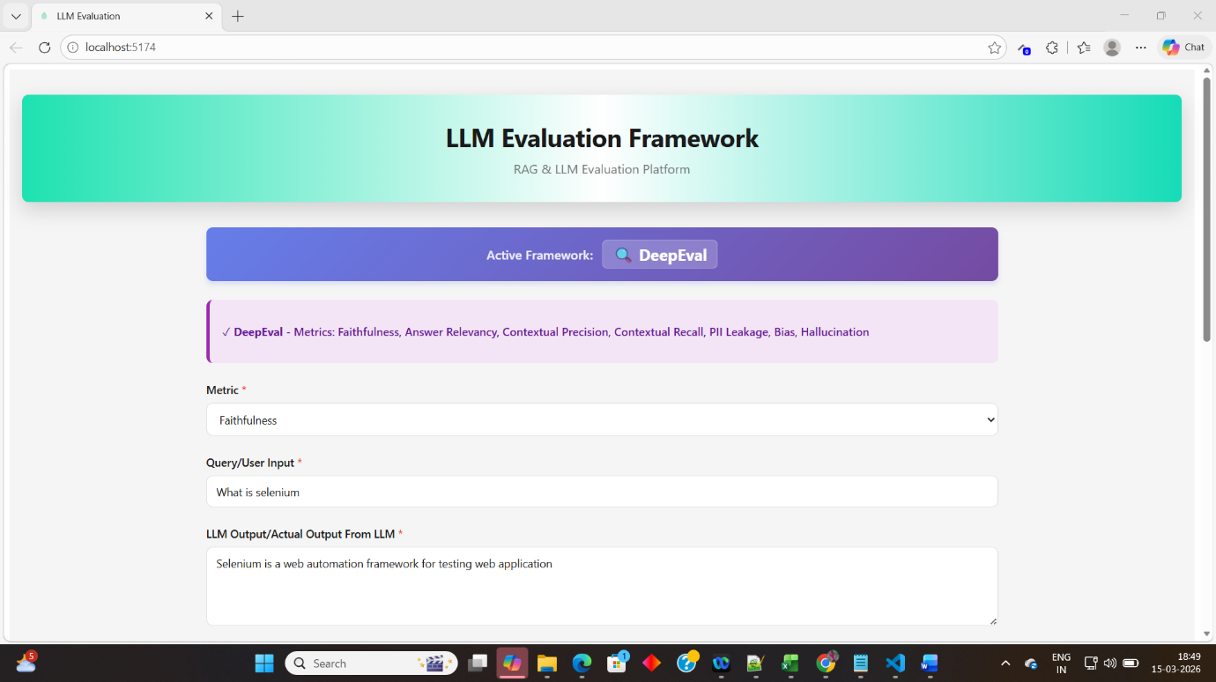

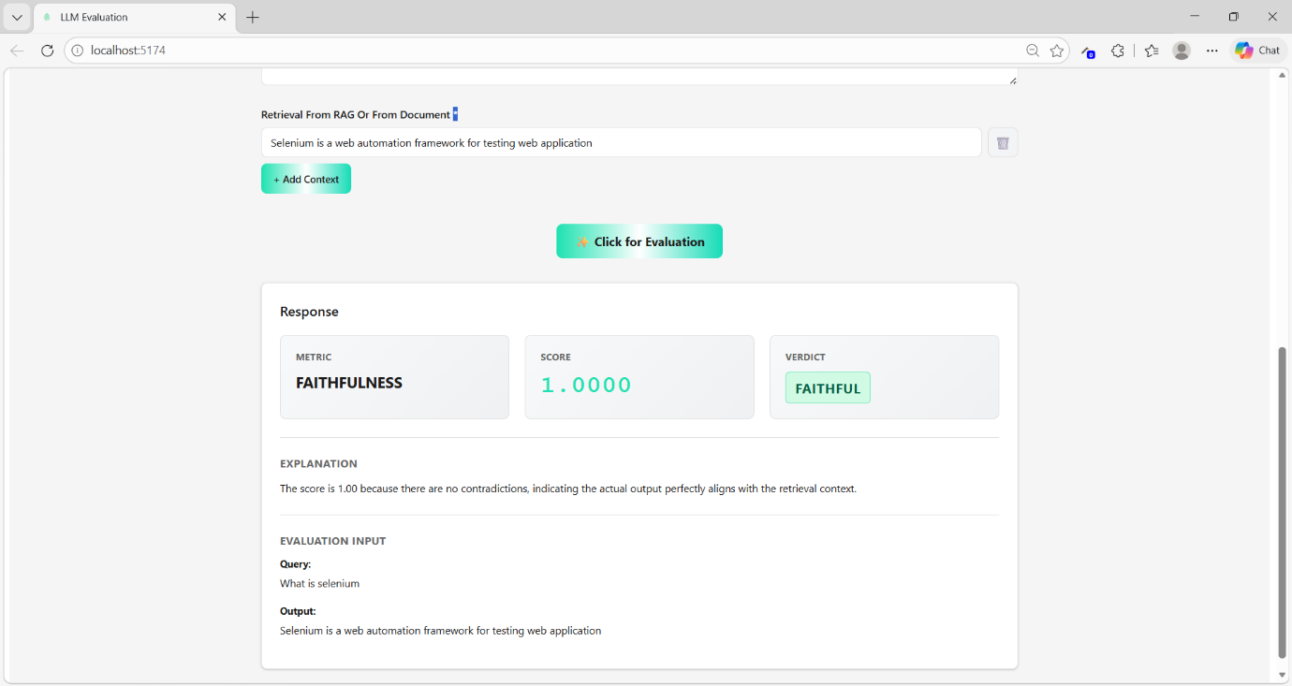

Scenario 2
Metrics-Faithfulness
Input:What is selenium
Actual output (Models Actual output):Selenium is a web automation framework for testing web application
Retrieval context-Selenium is a rare element
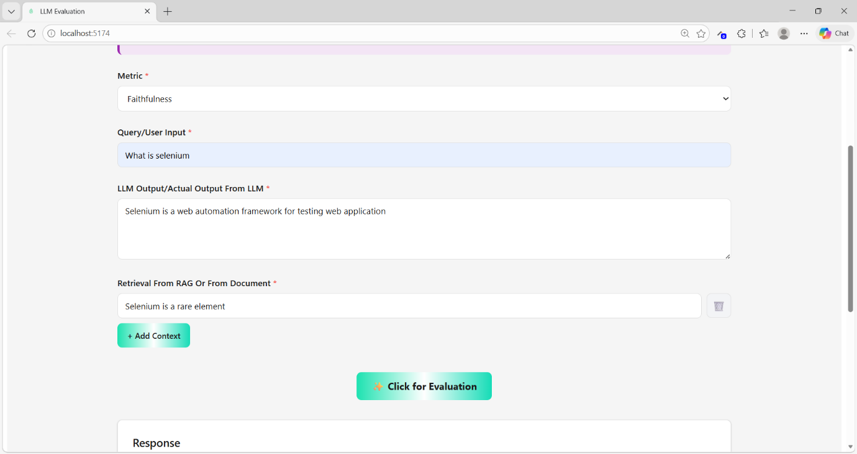

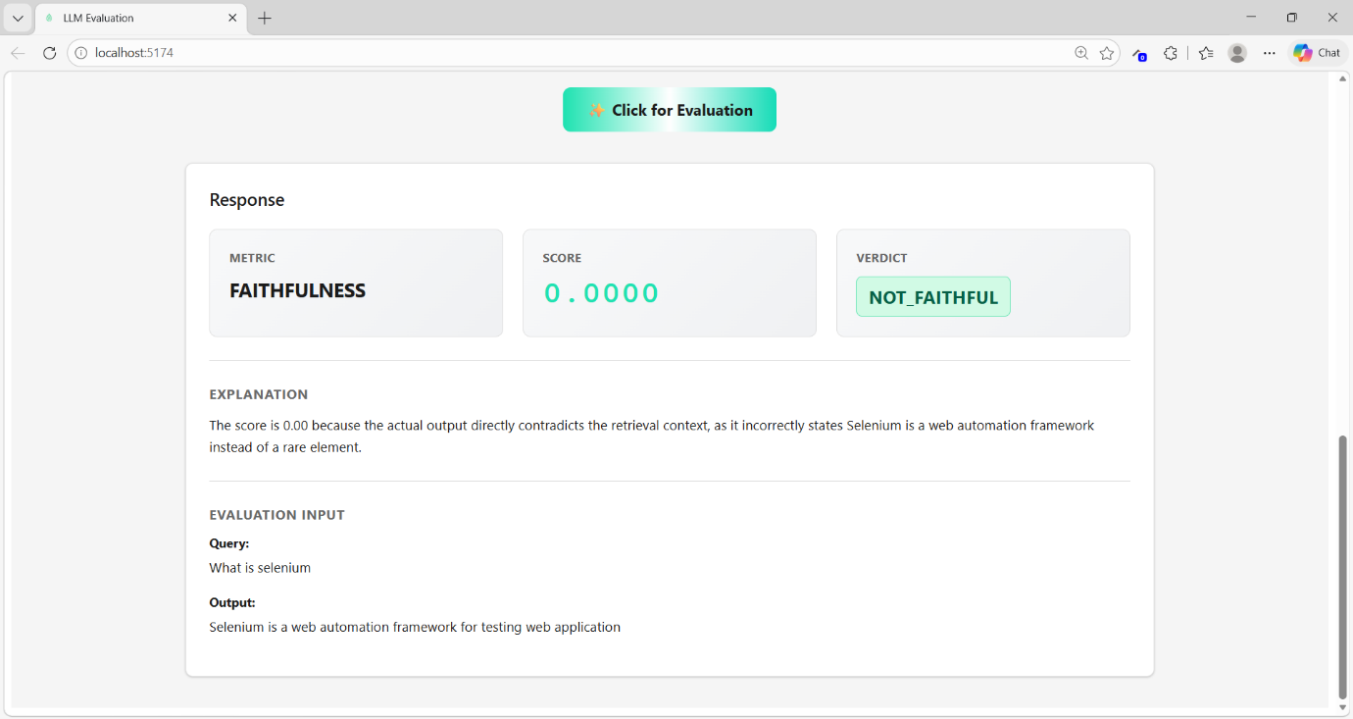

Scenario 3
Metrics-Faithfulness
Input (User question):What is selenium
Actual output (Models Actual output):Selenium is a automation framework for testing web and desktop application
Retrieval context -Selenium is a web automation framework for testing web application(From Mongo)
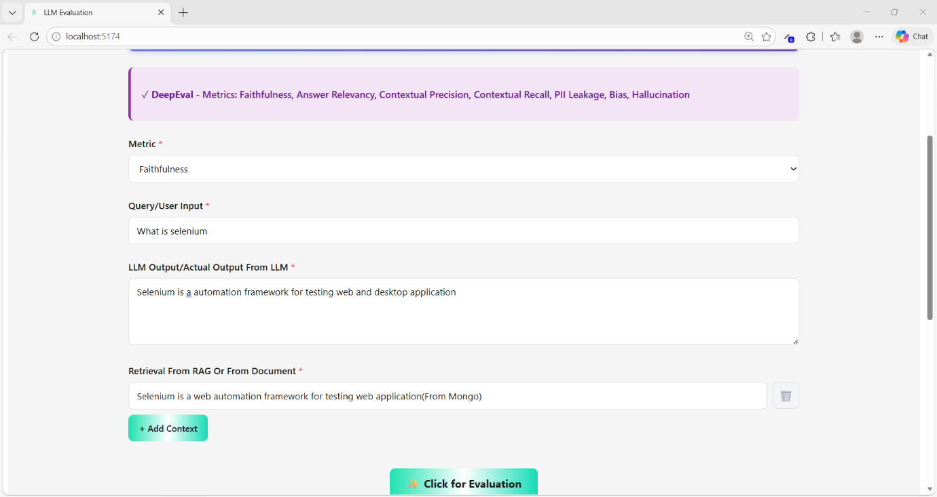

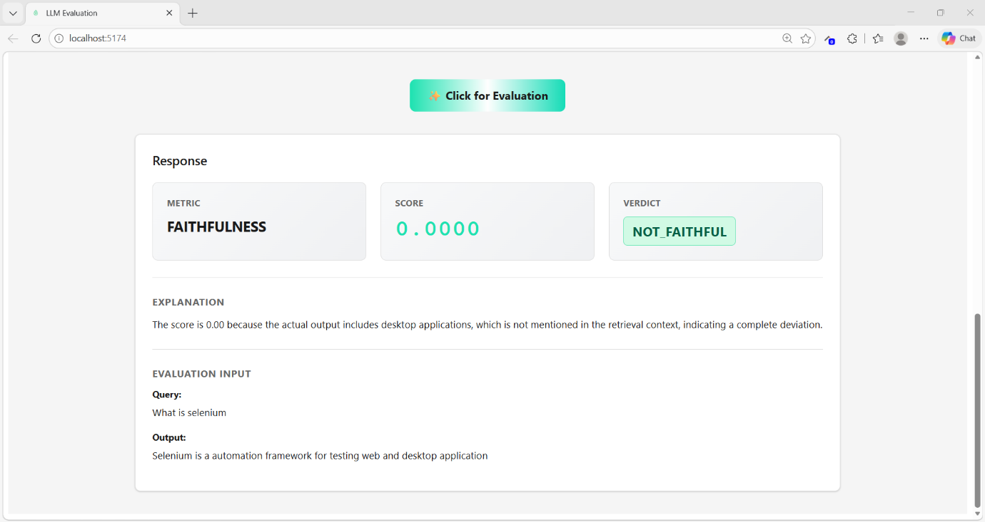
Scenario 4
Baahubali is brave.
Baahubali fights Bhallaladeva.
Baahubali is brave.
Baahubali fights Bhallaladeva.
Baahubali goes to space.
