**Module-2 Assignment-1**

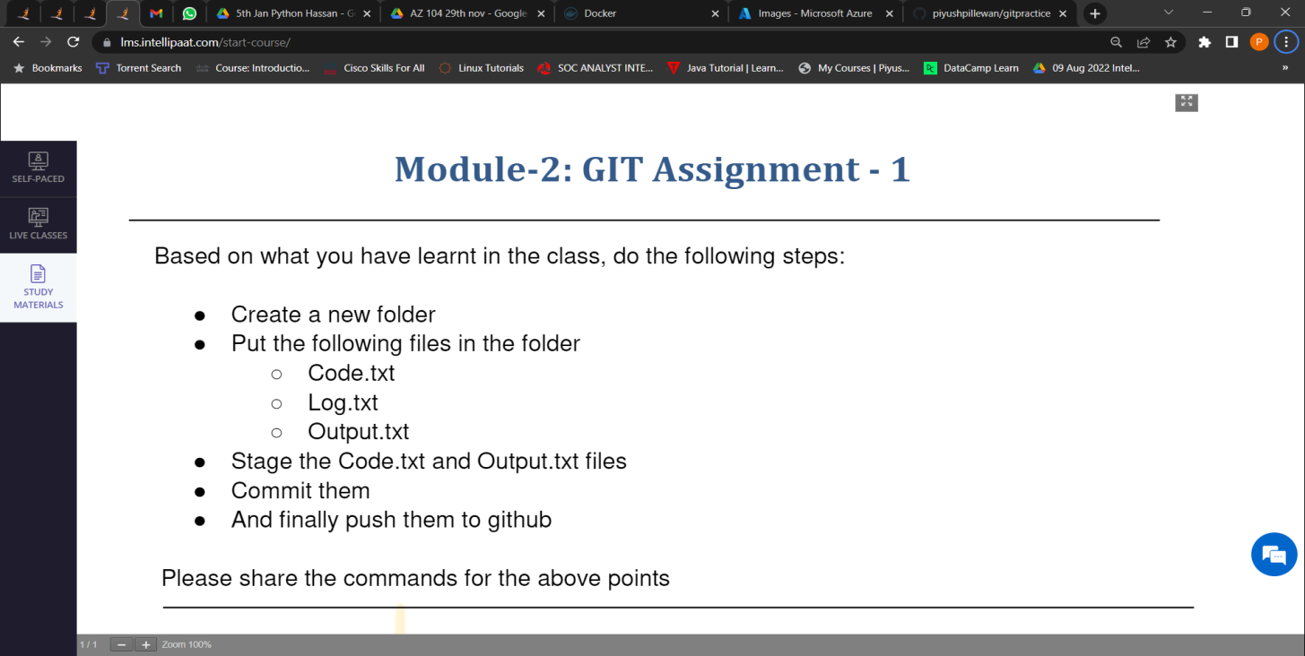

1. Created a new Folder by the name **gitassignment**.

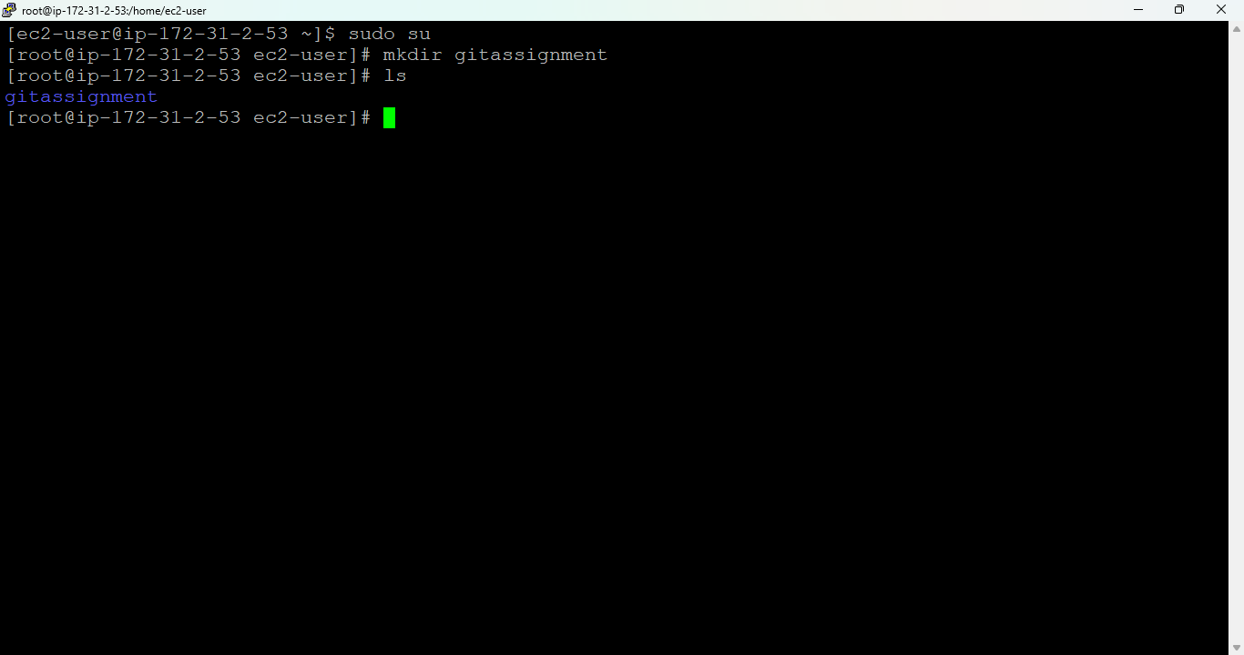

1. Created Files Code.txt, Log.txt, Output.txt inside gitassignment.

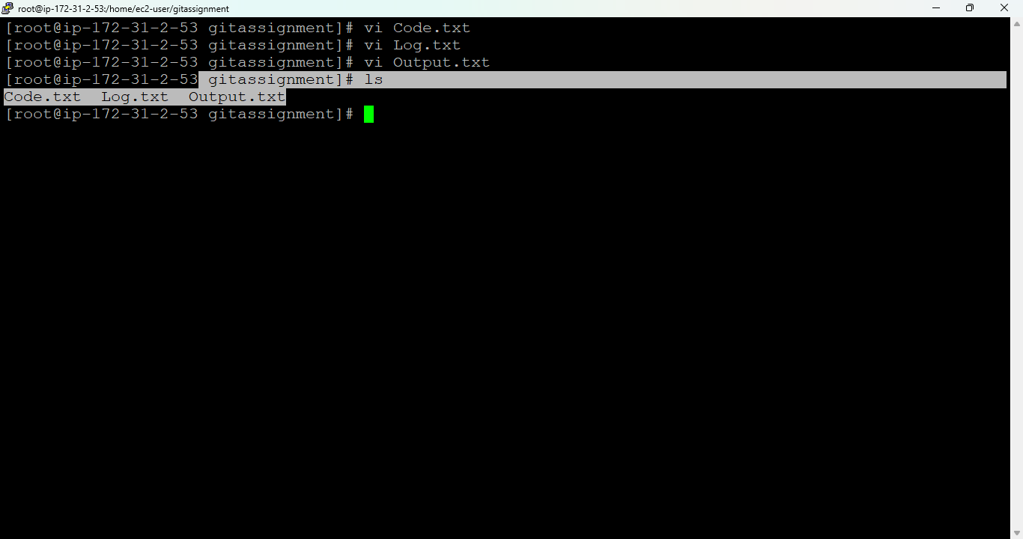

1. Stage the Code.txt and Output.txt files.

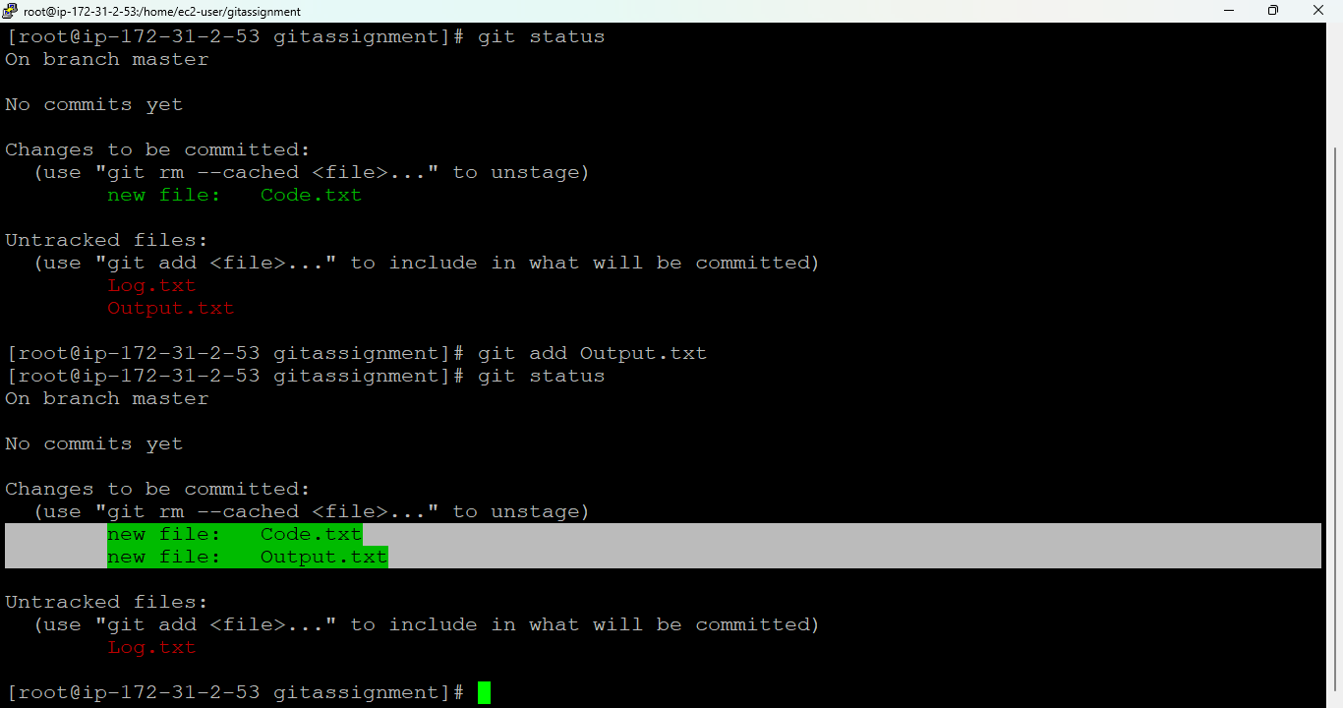

1. Committed the Code.txt and Output.txt files.

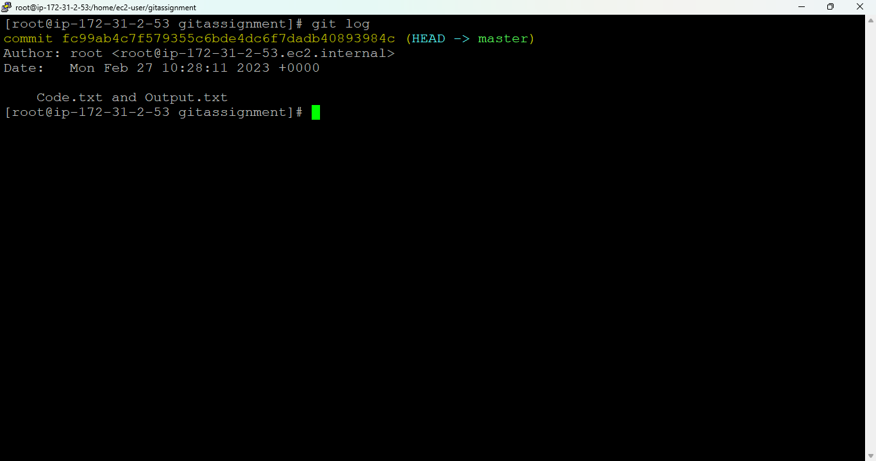

1. Push the committed files to github.



