**Module-2 Assignment-2**

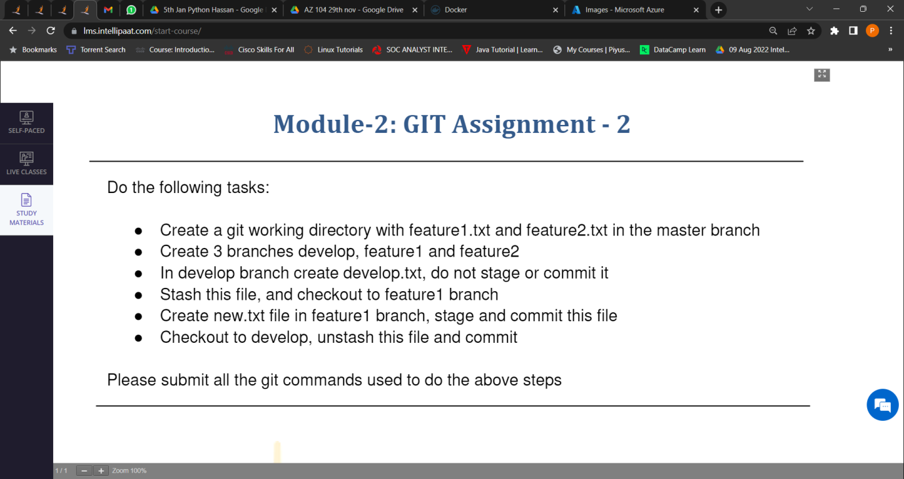

1. Created a git working directory with feature1.txt and feature2.txt in the master branch.

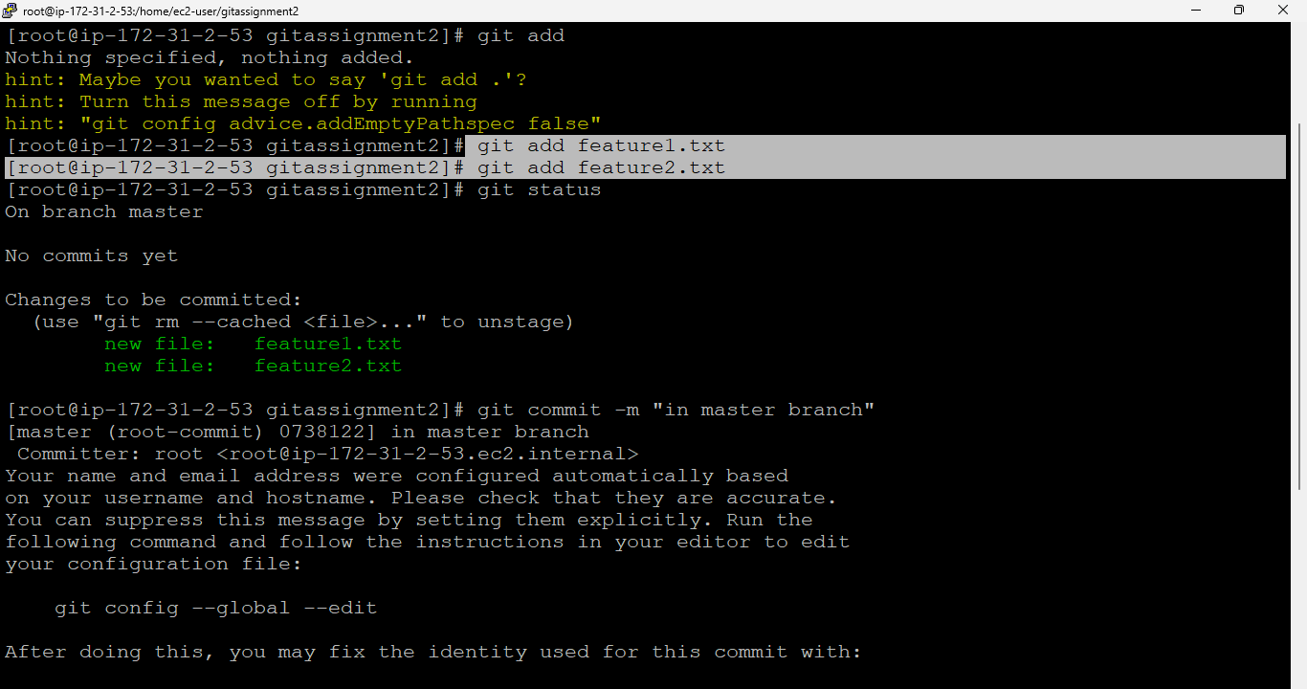

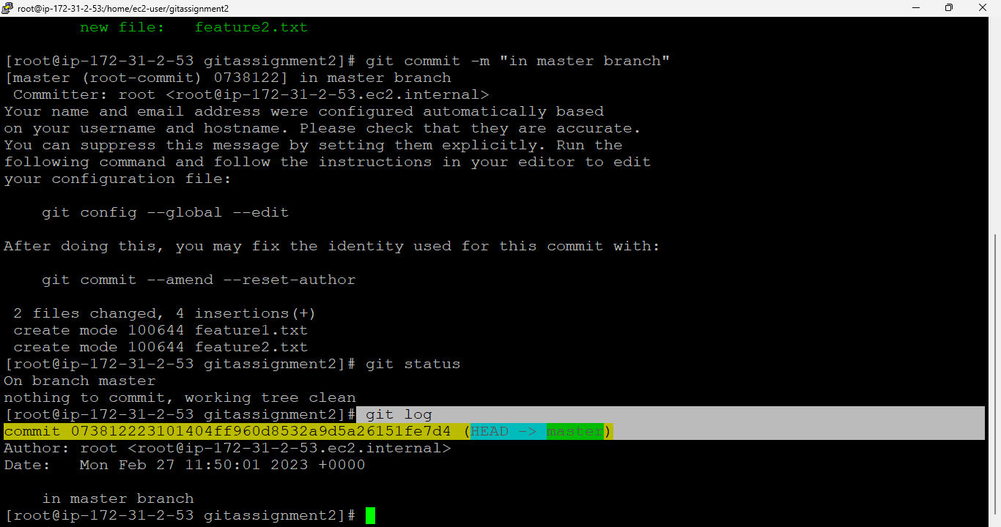

1. Created 3 branches develop, feature1,feature2.

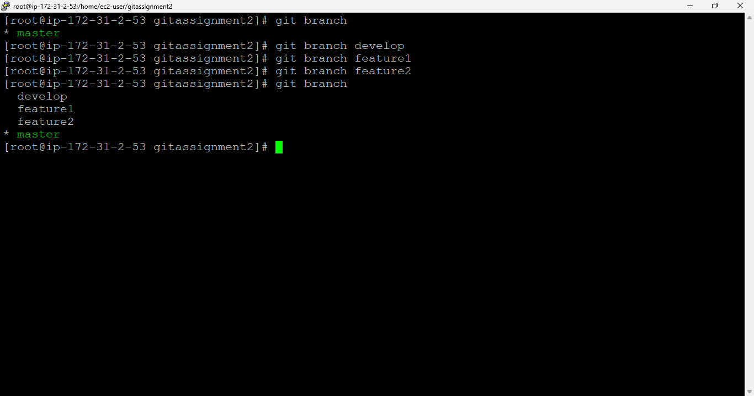

1. In develop branch created develop.txt and did not staged or commit.

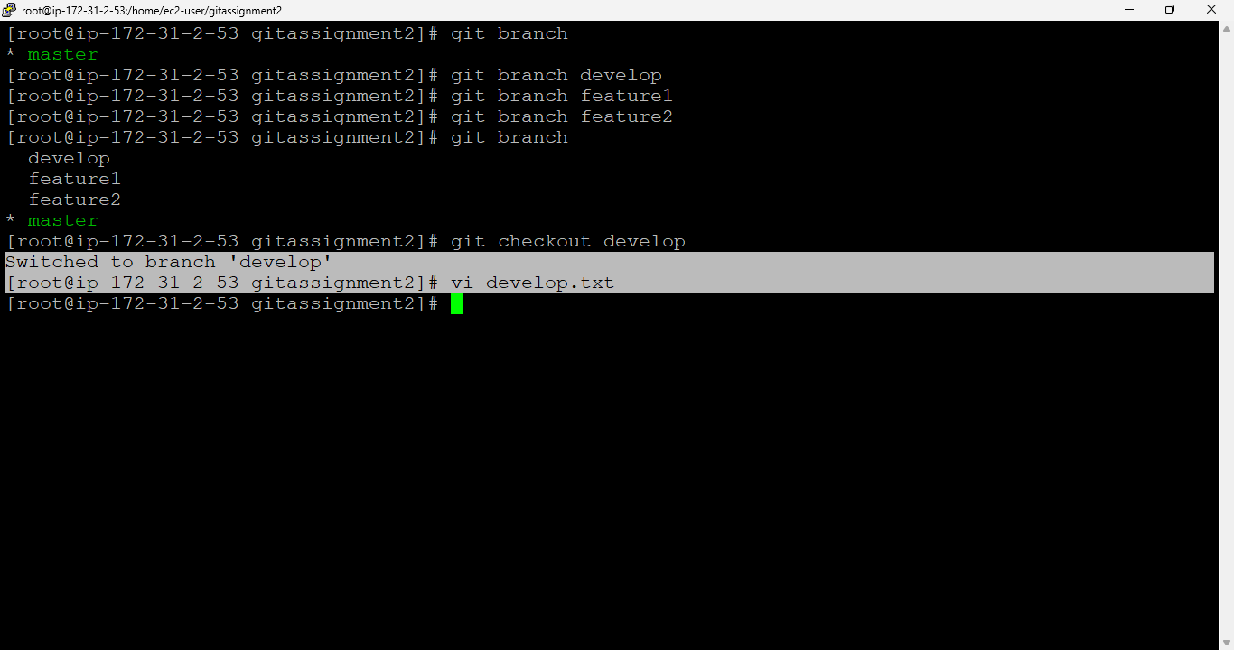

1. Stashed this file, and checkout to feature1 branch.

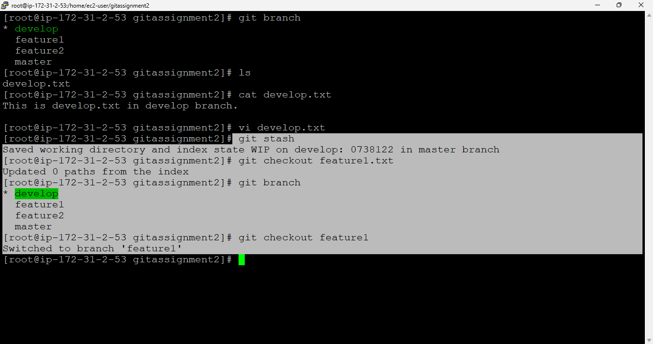

1. Created new.txt file in feature1 branch, staged and committed this file.

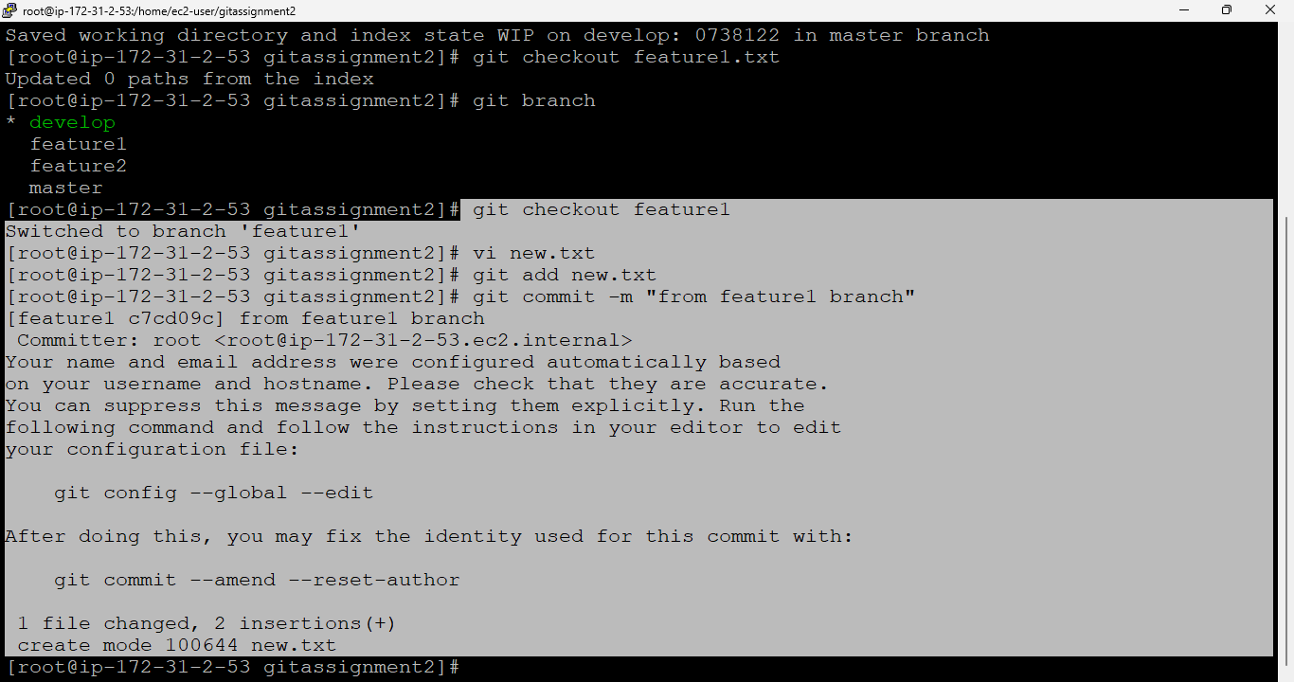

1. Checkout to develop, unstash this file and commit



