**Module-2 Assignment-3**

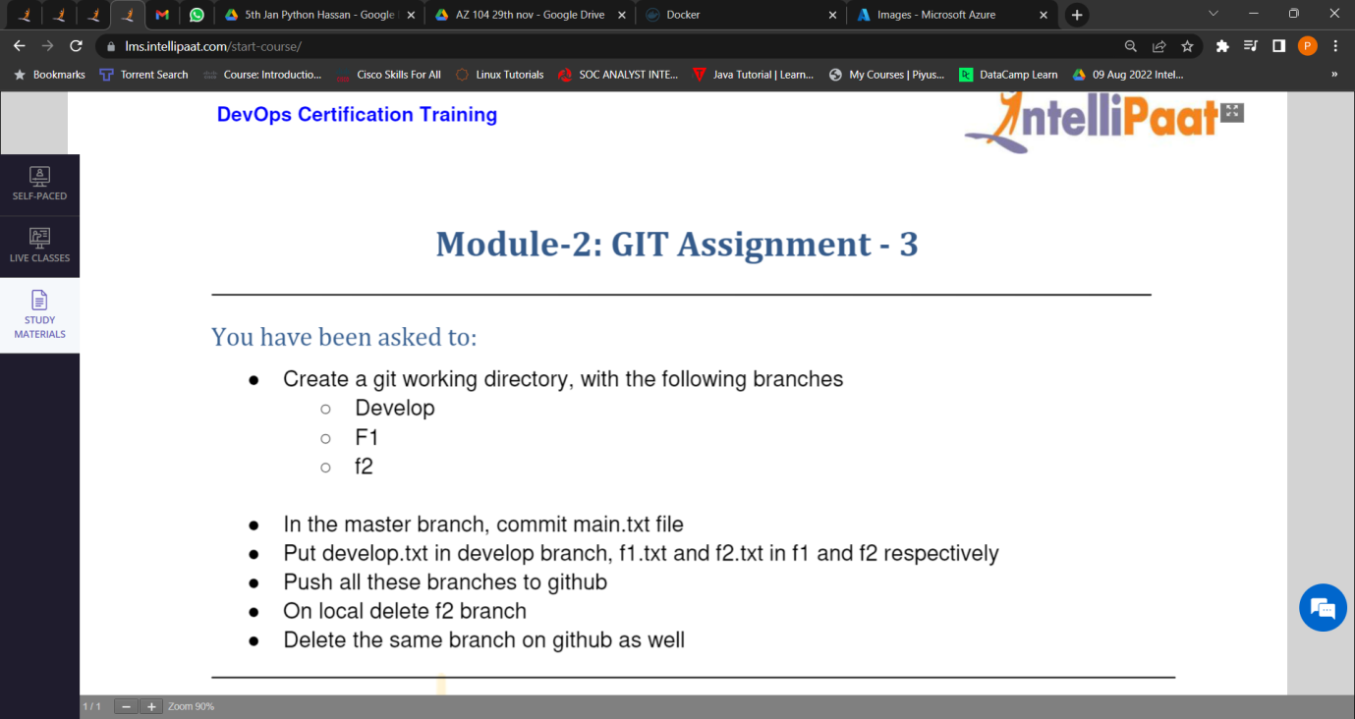

1. Created a git working directory, with the following branches – Develop, F1,f2.

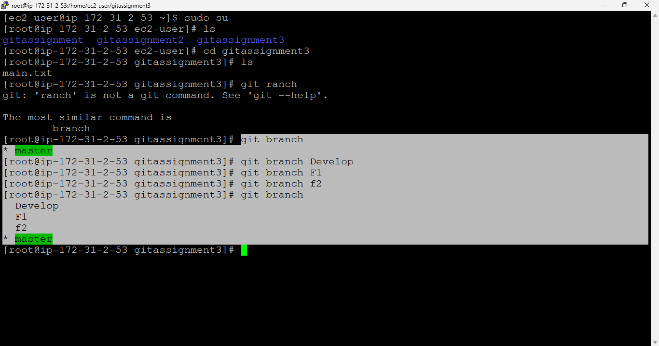

1. In the master branch committed main.txt file

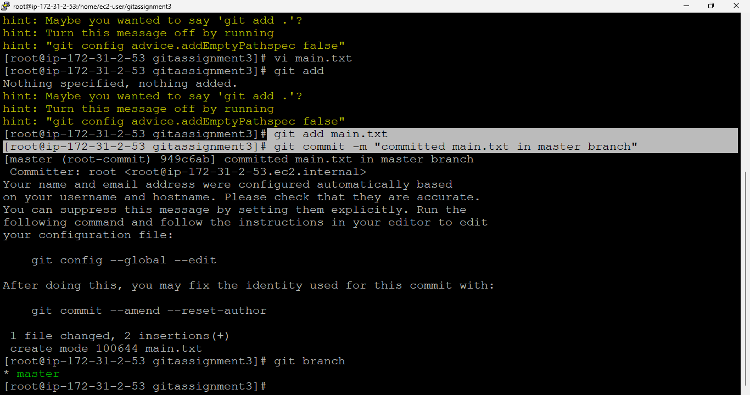

1. Put develop.txt in develop branch, f1.txt and f2.txt in f1 and f2 respectively.

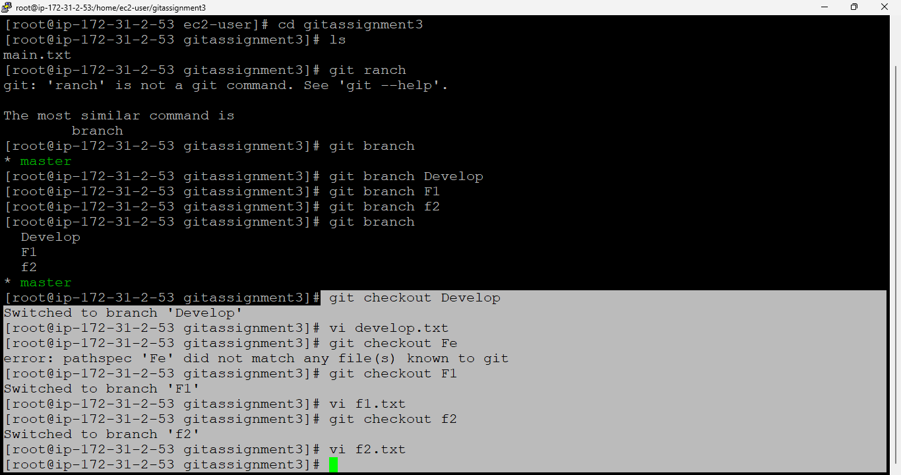

1. Pushed all these branches to github.

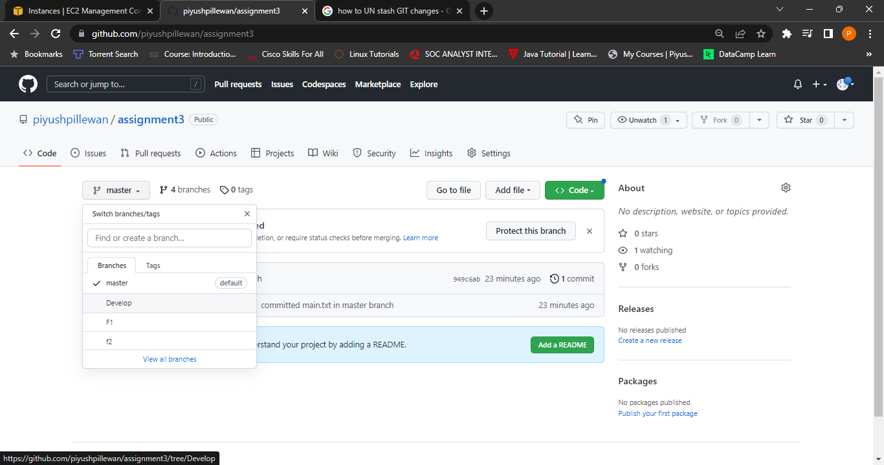

1. On local Deleted f2 branch.

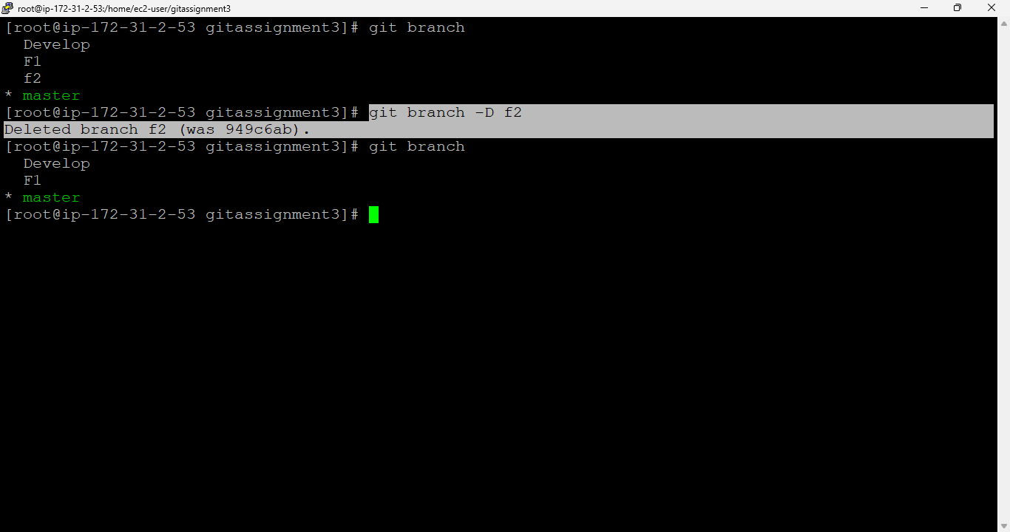

1. Deleted the same (f2) branch on github as well.



