**Module-2 Assignment-4**

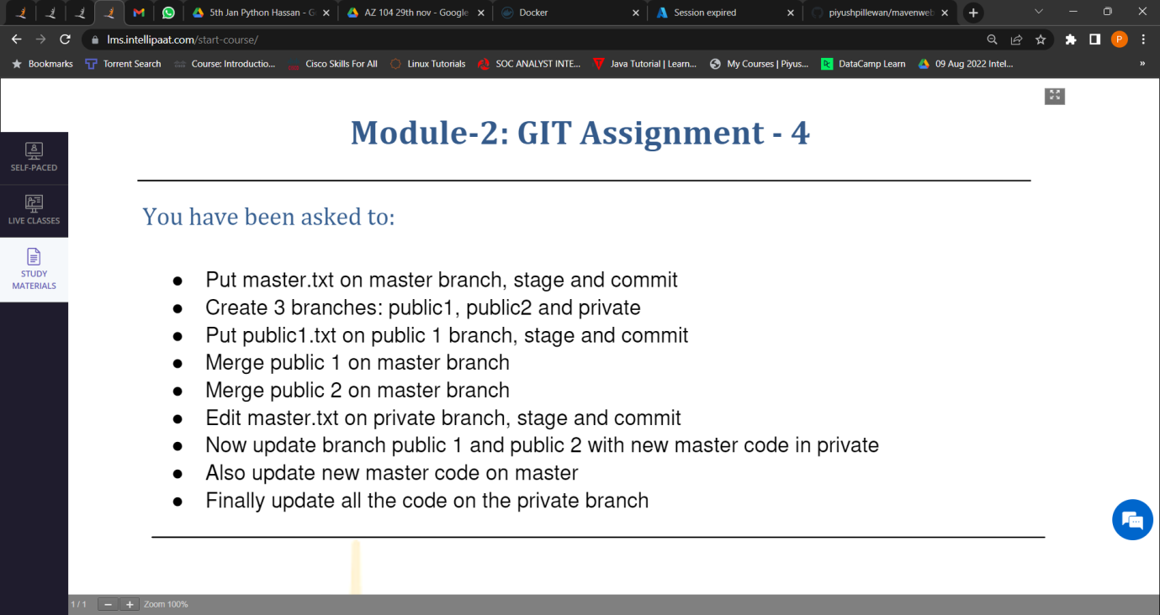

1. Put master.txt on master branch, stage and commit.

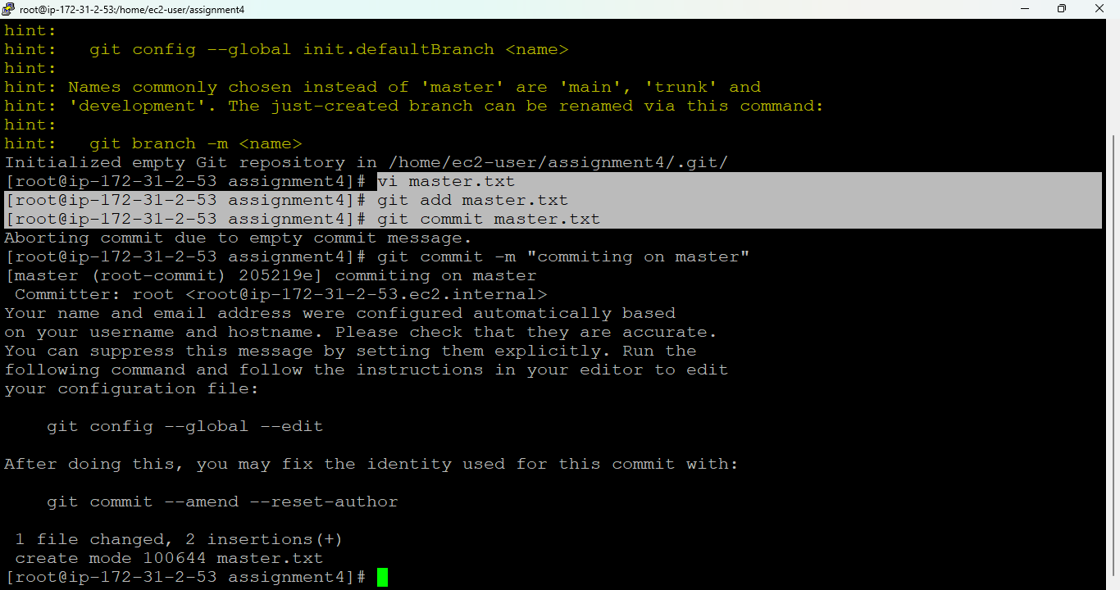

1. Create 3 branches: public1, public2 and private.

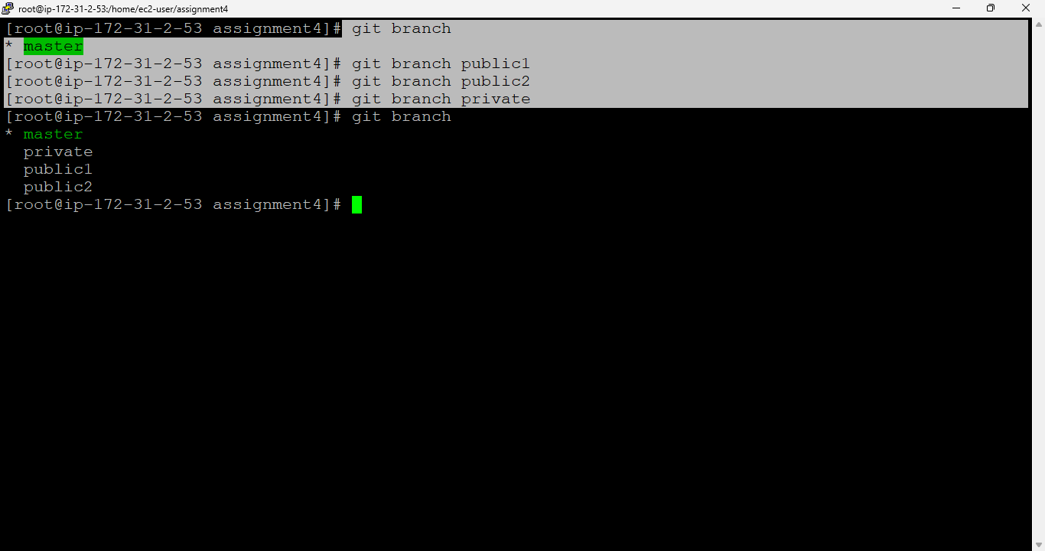

1. Put public1.txt on public 1 branch, stage and commit.

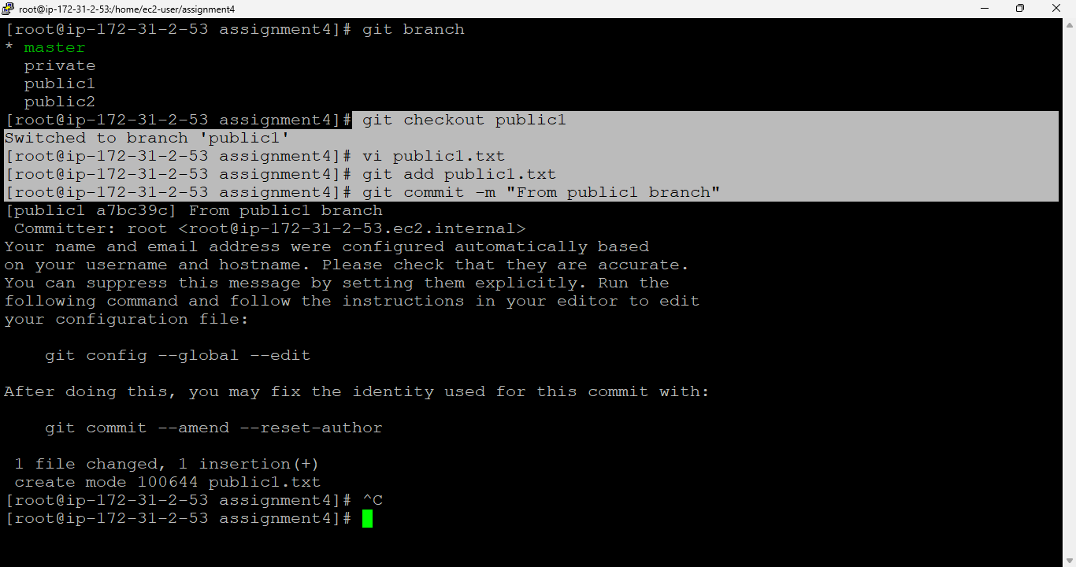

1. Merge public 1 on master branch.

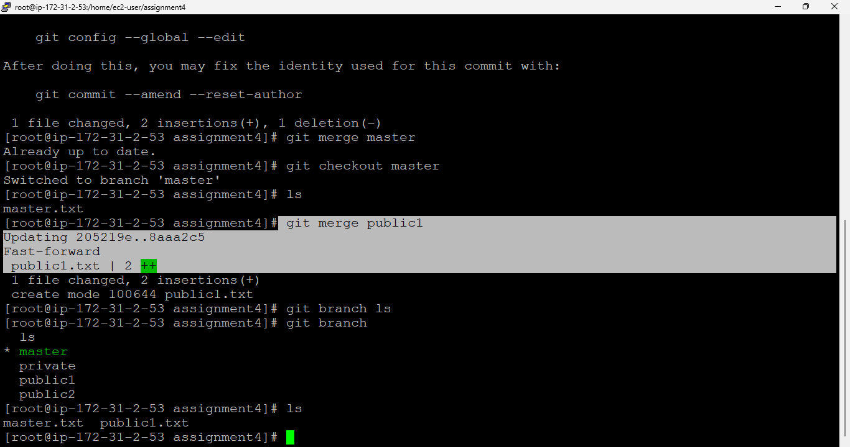

1. Merge public 2 on master branch.

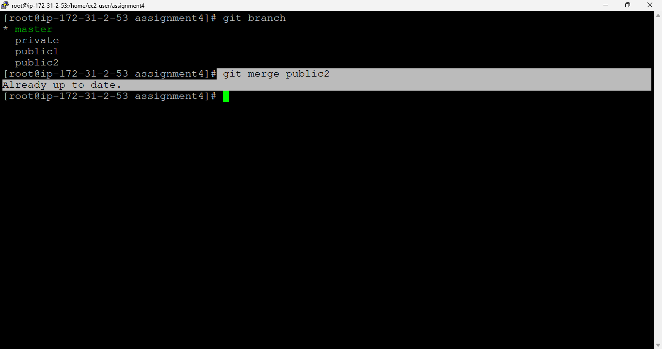

1. Edit master.txt on private branch, stage and commit.

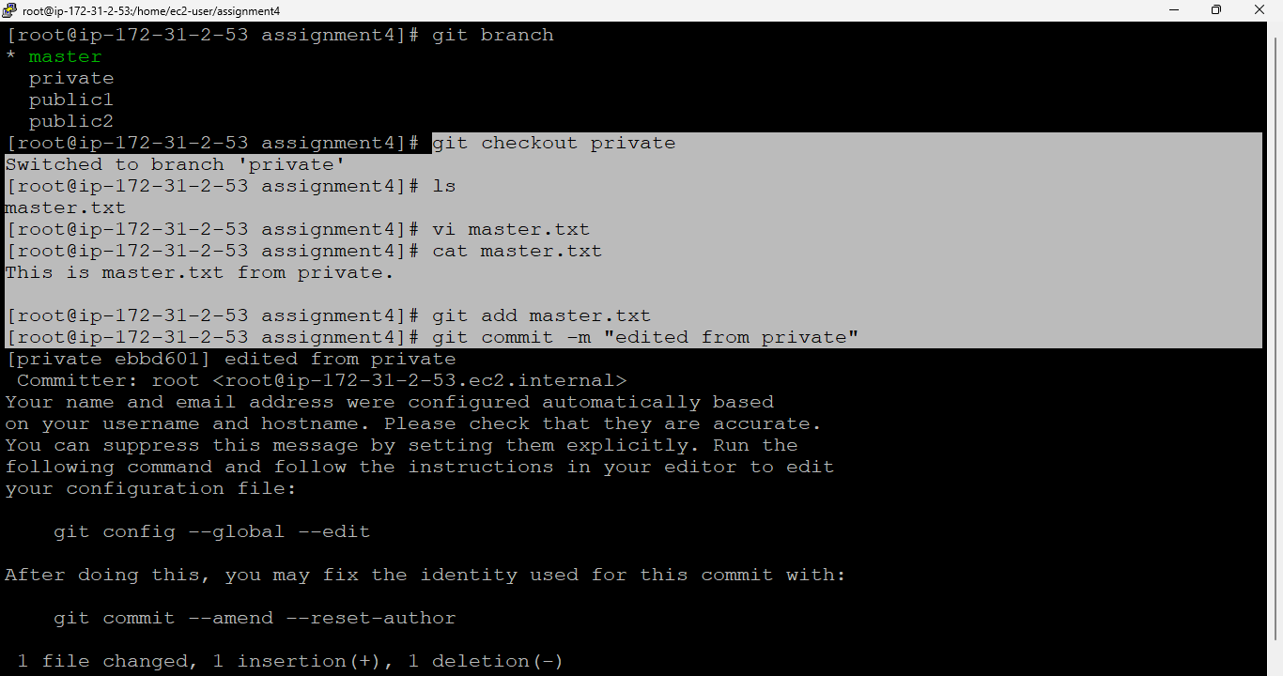

1. Now update branch public 1 and public 2 with new master code in private.

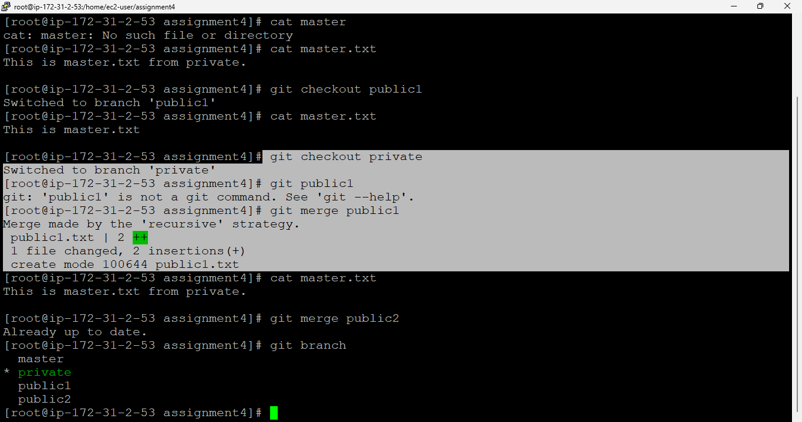

1. Also update new master code on master.

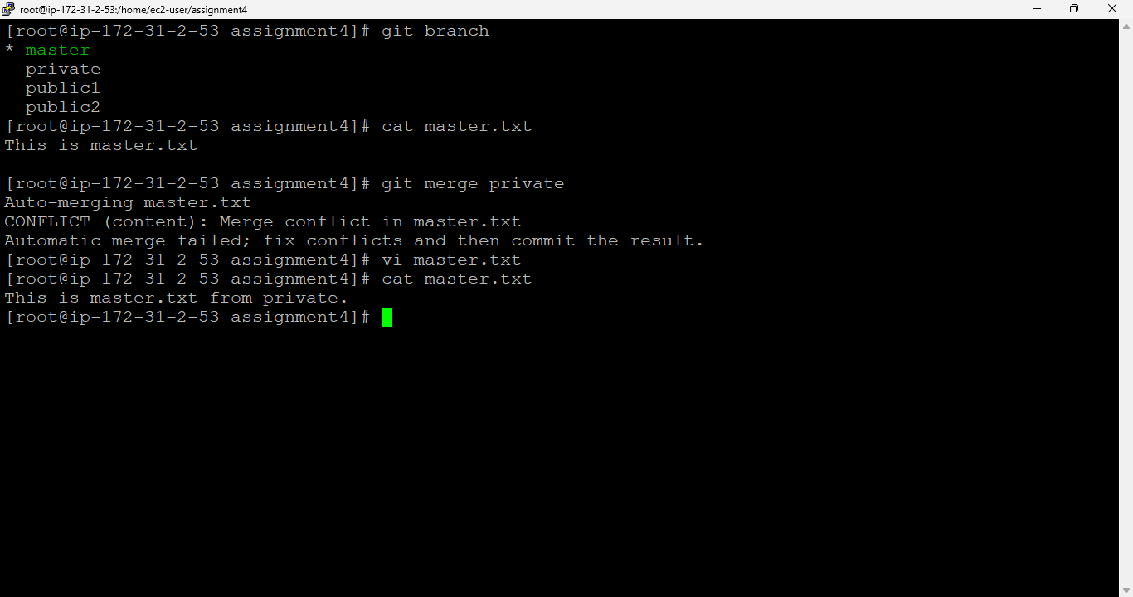

1. Finally update all the code on the private branch.



