**Module-2 Assignment-5**

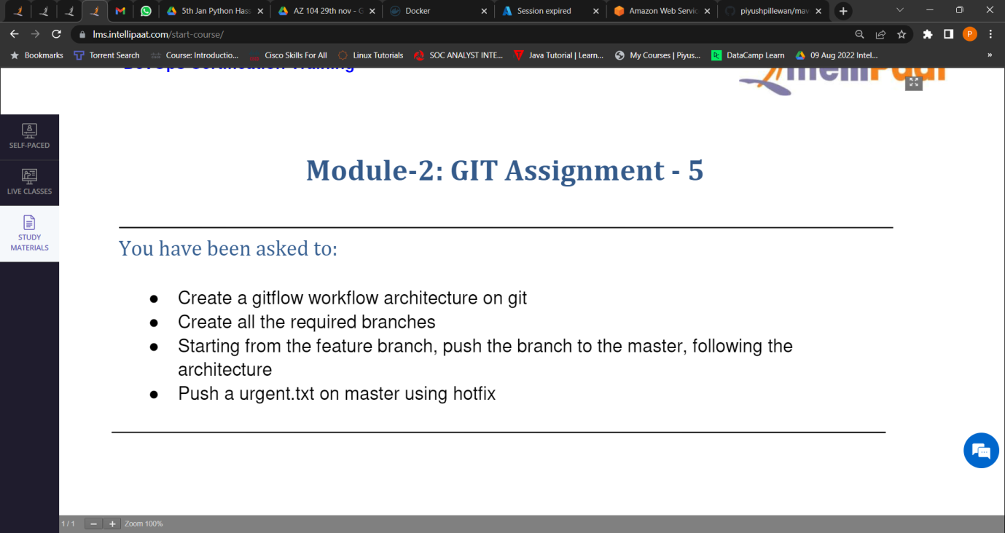

1. Create a git workflow architecture on git.

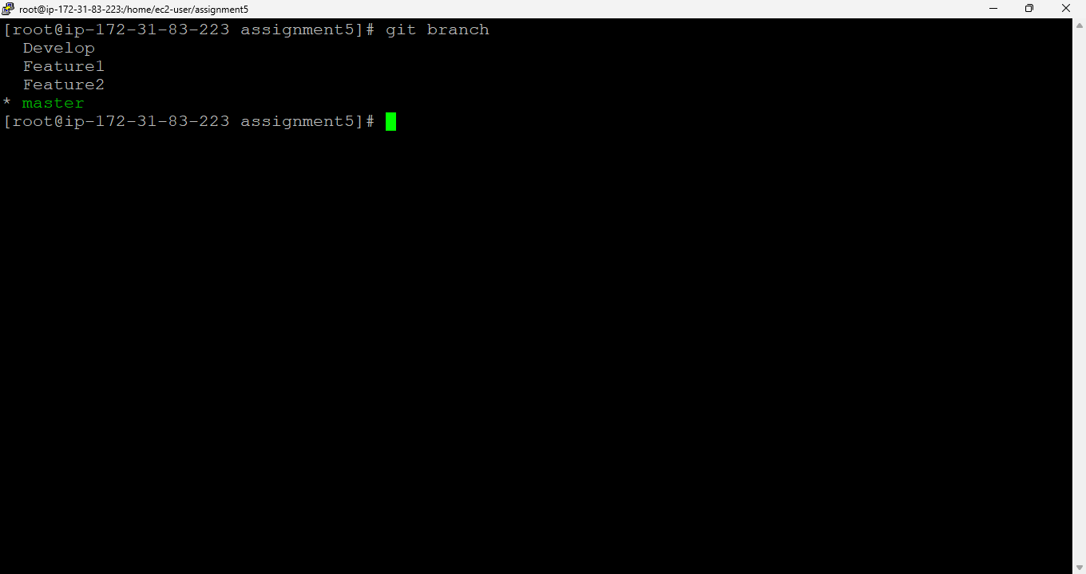

1. Created all the required branches.



1. Starting from the feature branch, push the branch to the master, following the architecture.

To push the file from feature to master branch we will need to follow the architecture.

For that we use the following commands.

1. Created a File in feature1 branch –

vi Hello.java

1. git add .
2. git commit -m "from Feature1 branch"
3. git checkout Develop
4. git merge Feature1
5. git checkout master
6. git merge Develop