**Module-5 Assignment-1**

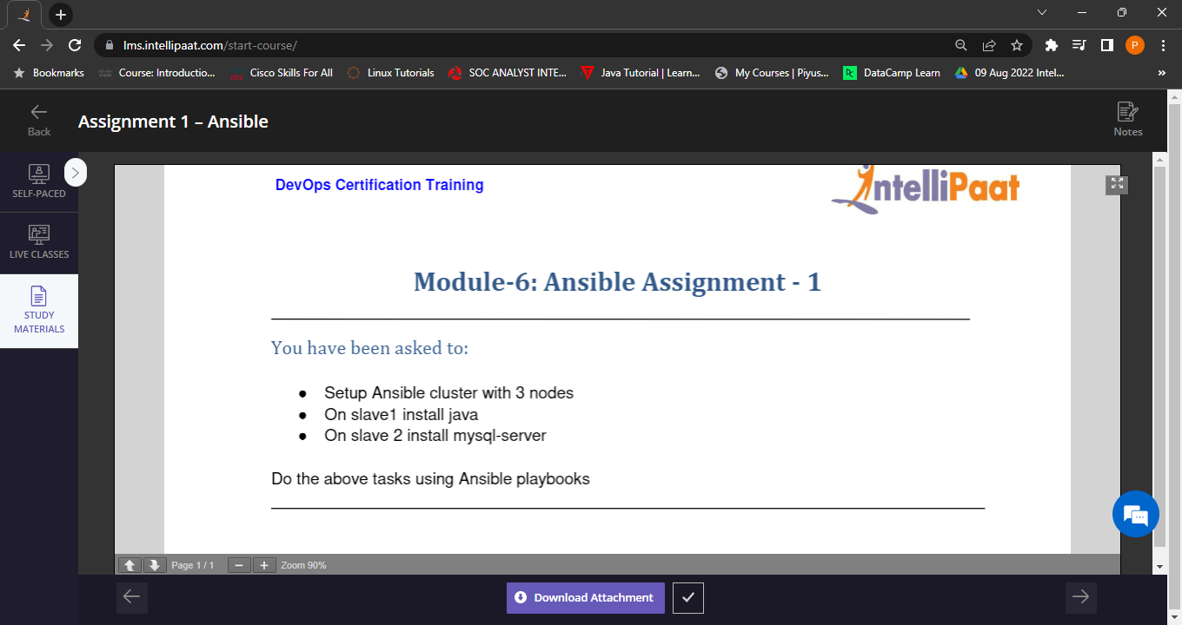

1. Setup Ansible cluster with 3 nodes

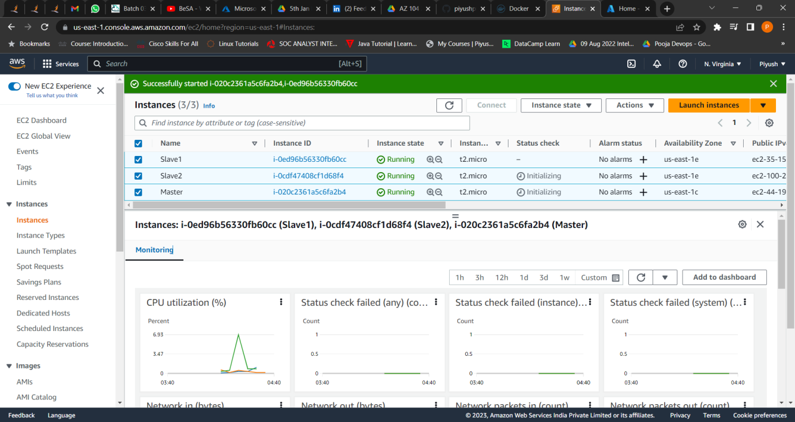

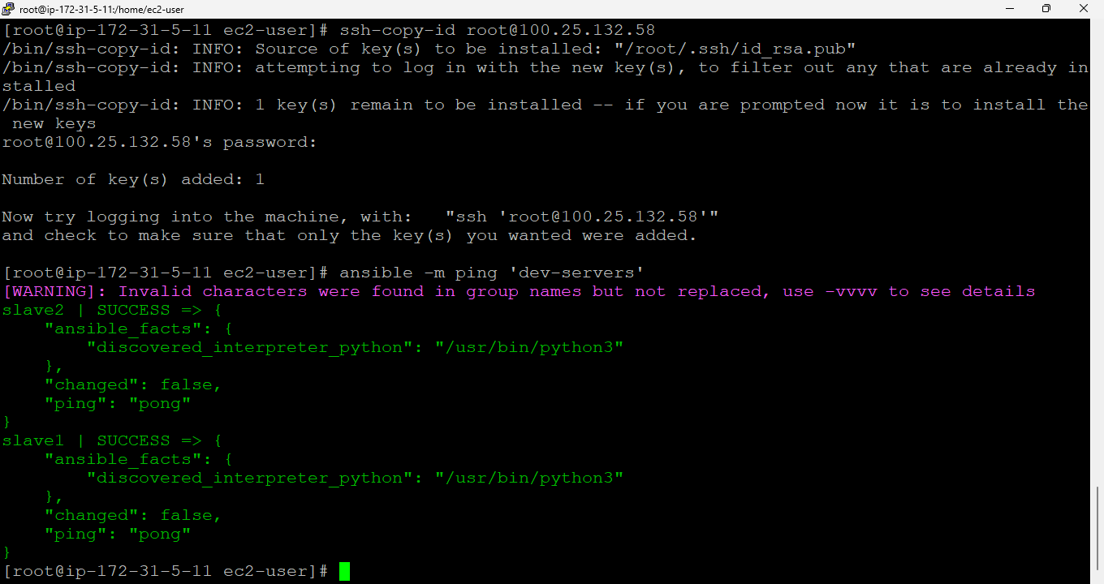

2. Slave1 🡪Installed java.

3. Slave2 🡪Installed mysql-server.

Using ansible Playbook



