**Module-5 Assignment-2**

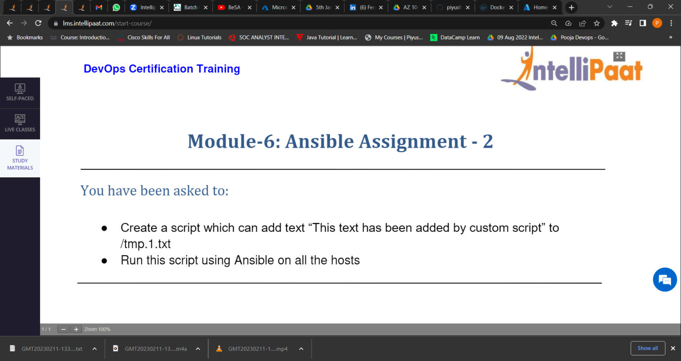

1.Created a script which can add text “This text has been added by custom script” to /tmp/1.txt.

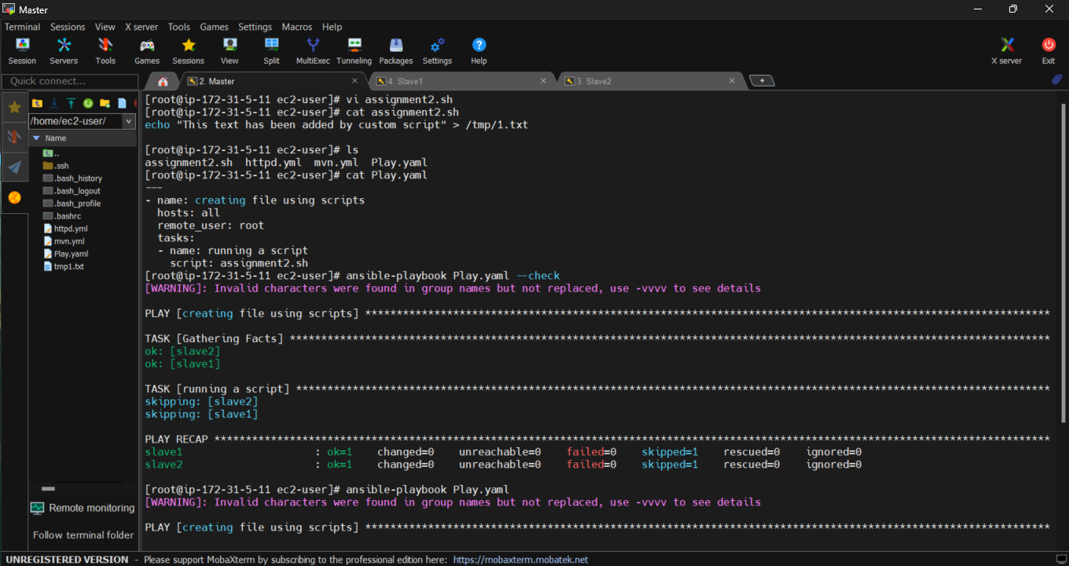

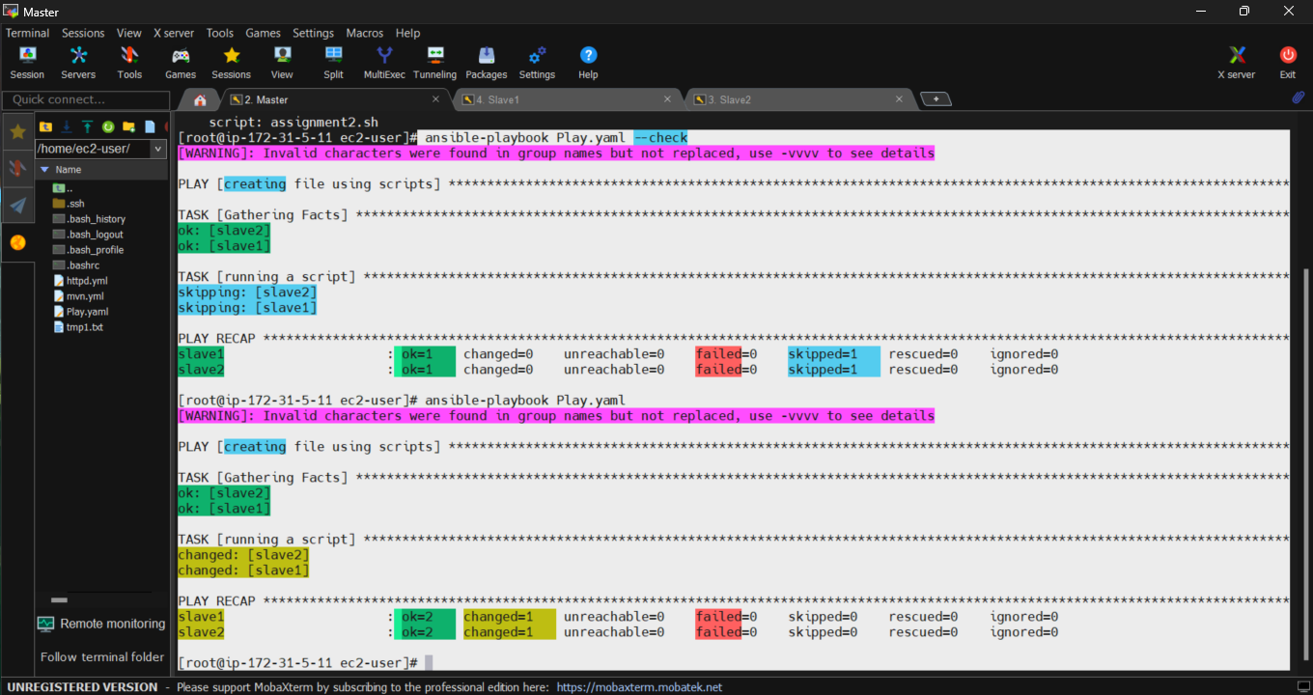

Slave 1:

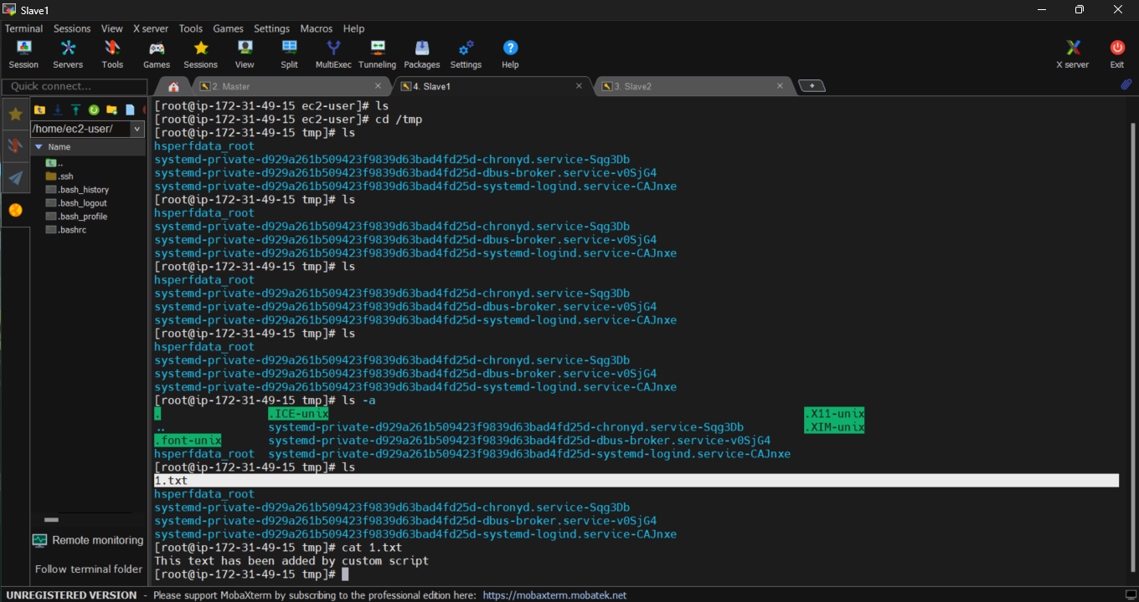

Slave 2:

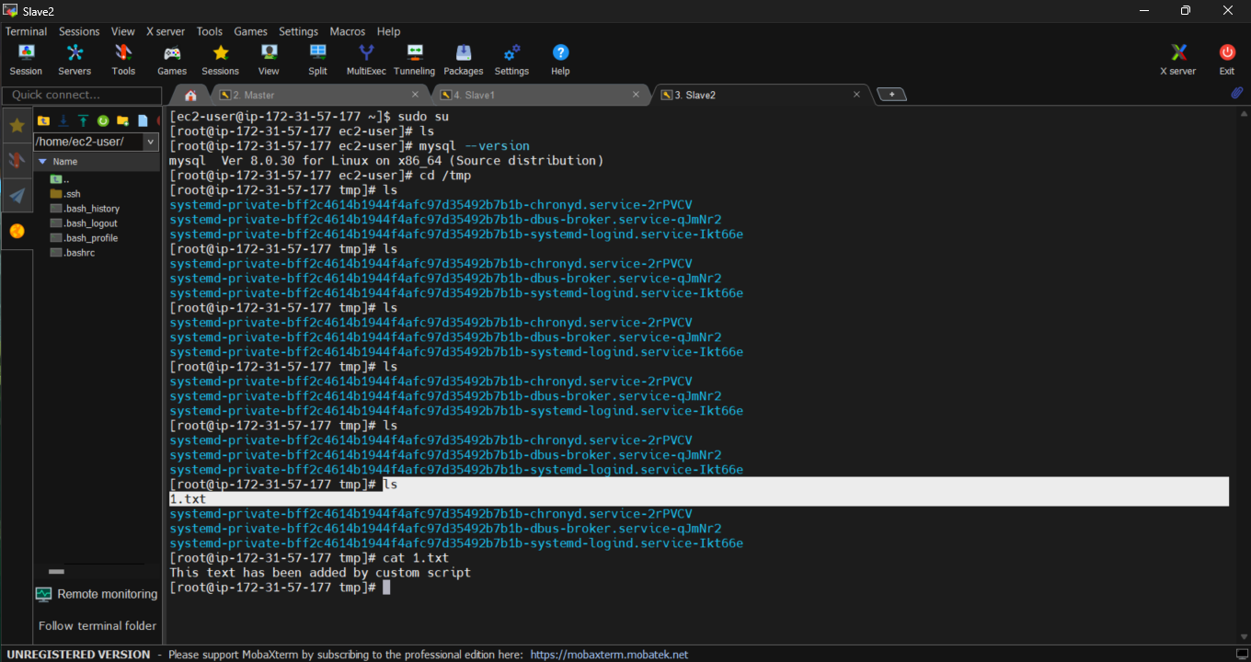

Ran the script using ansible Playbook.

*****************----------------------*******************