**Module-5 Assignment-3**

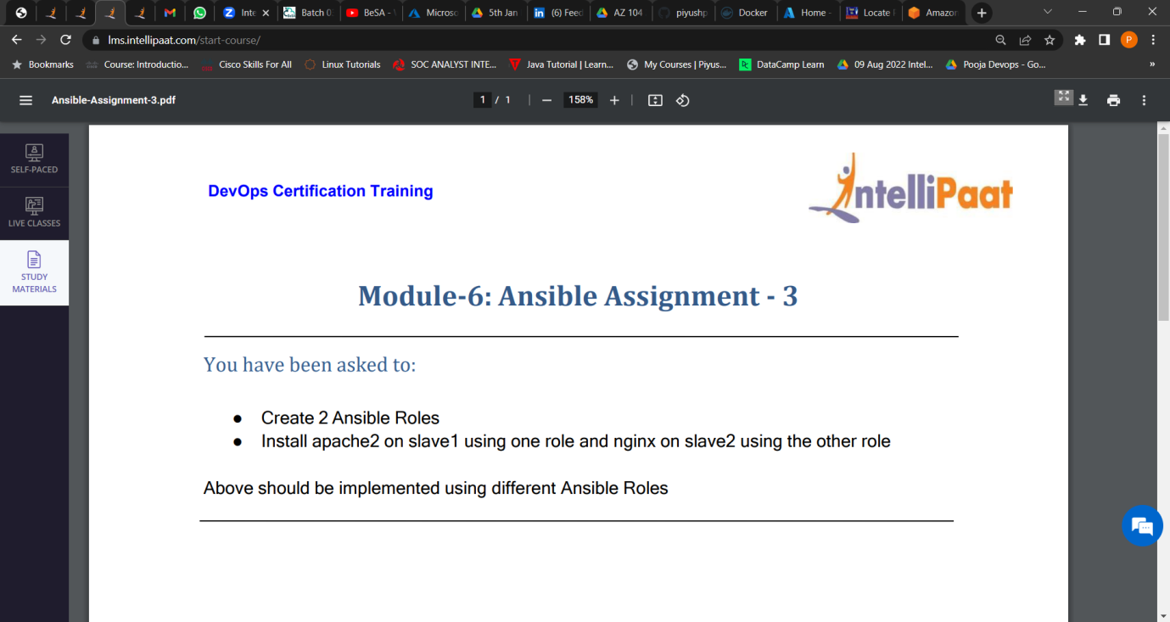

1. Created 2 Ansible Roles.

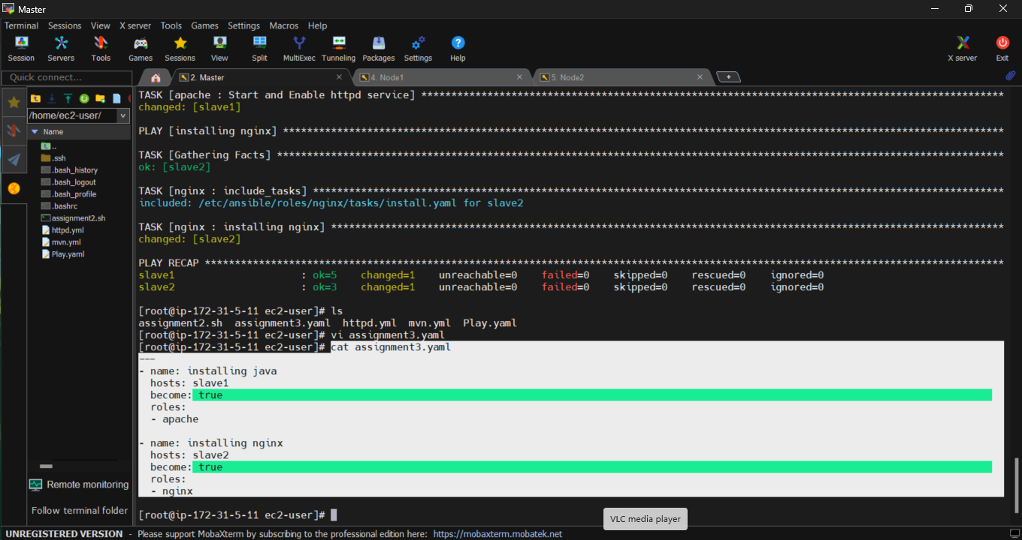

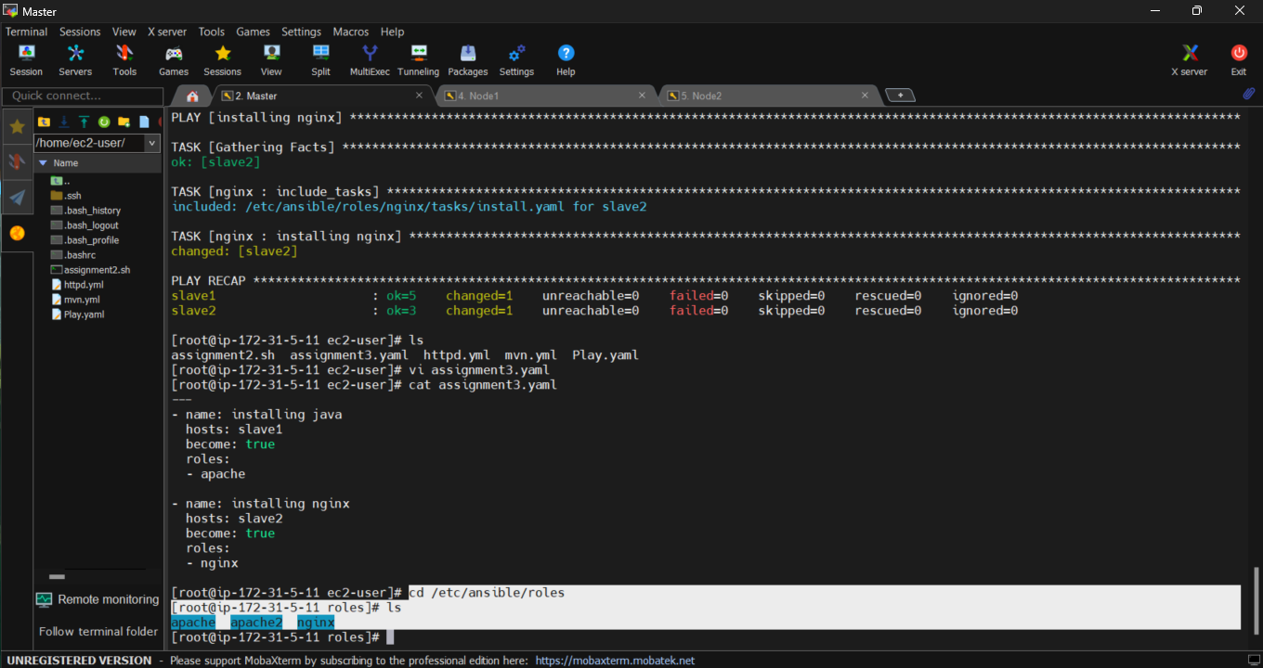

2. Install apache on slave1 and nginx on slave2 **Using role**



