**Module-5 Assignment-4**

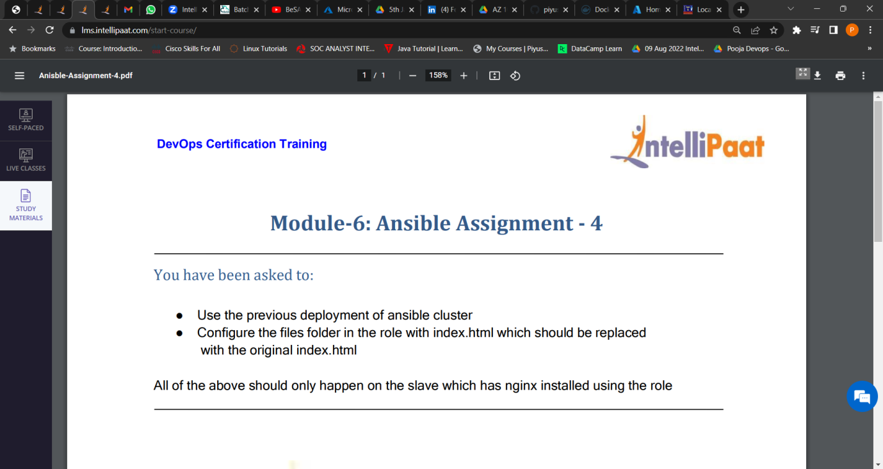

**1. Using the previous deployment of ansible cluster.**

**2. Configure the files folder in the role with index.html which should be replaced with the original index.html**

**On nginx only.**

* **For-Apache2**

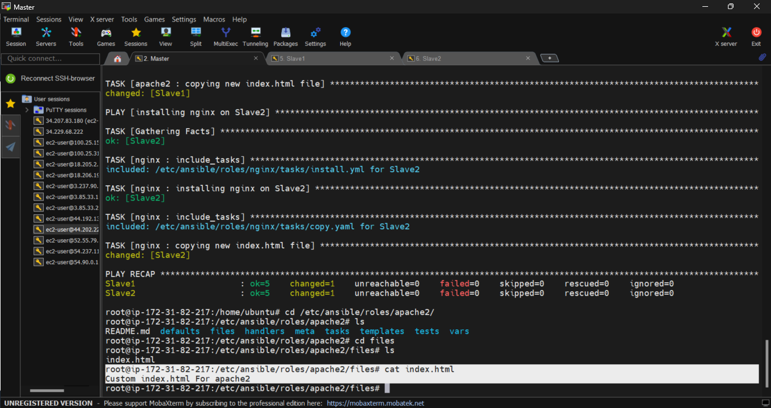

* **For-nginx**

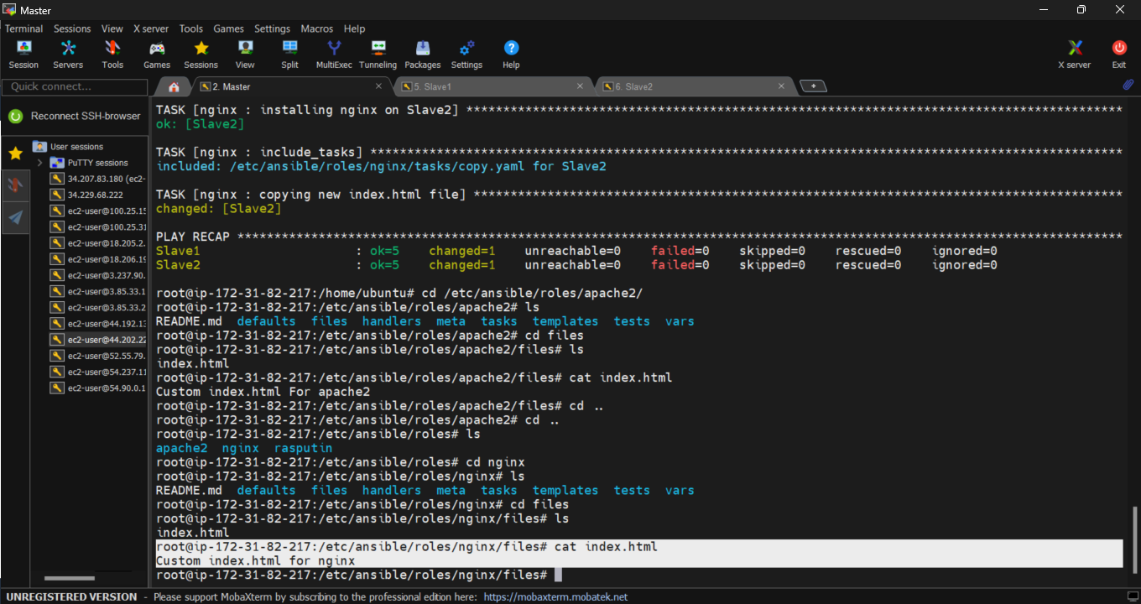

**Deploy:🡪**

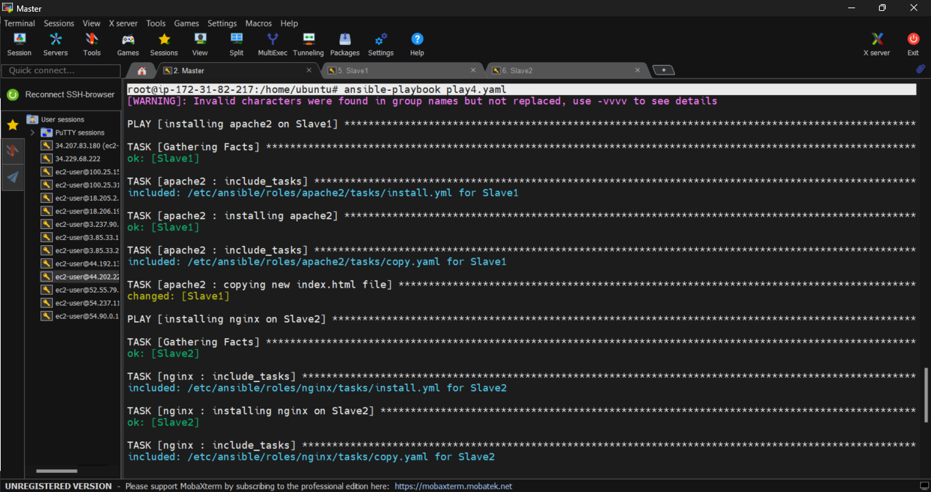

**Apache2:**

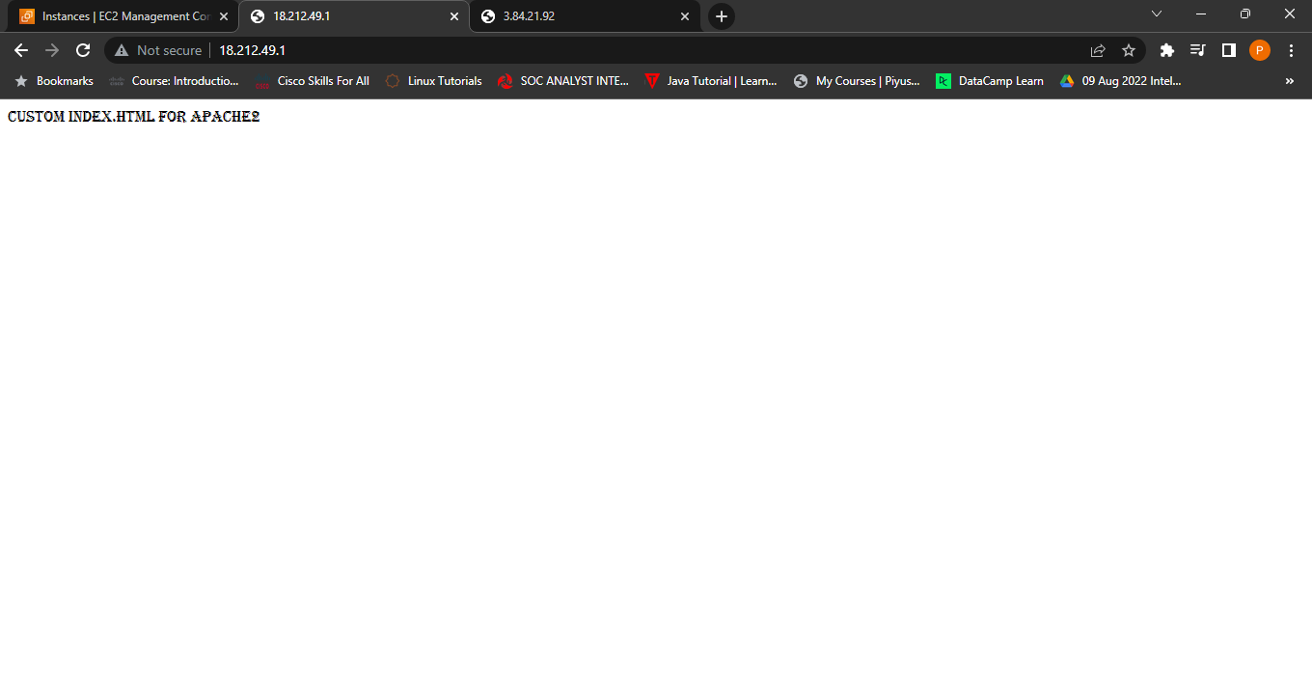

**Nginx:**

