**Module-5 Assignment-5**

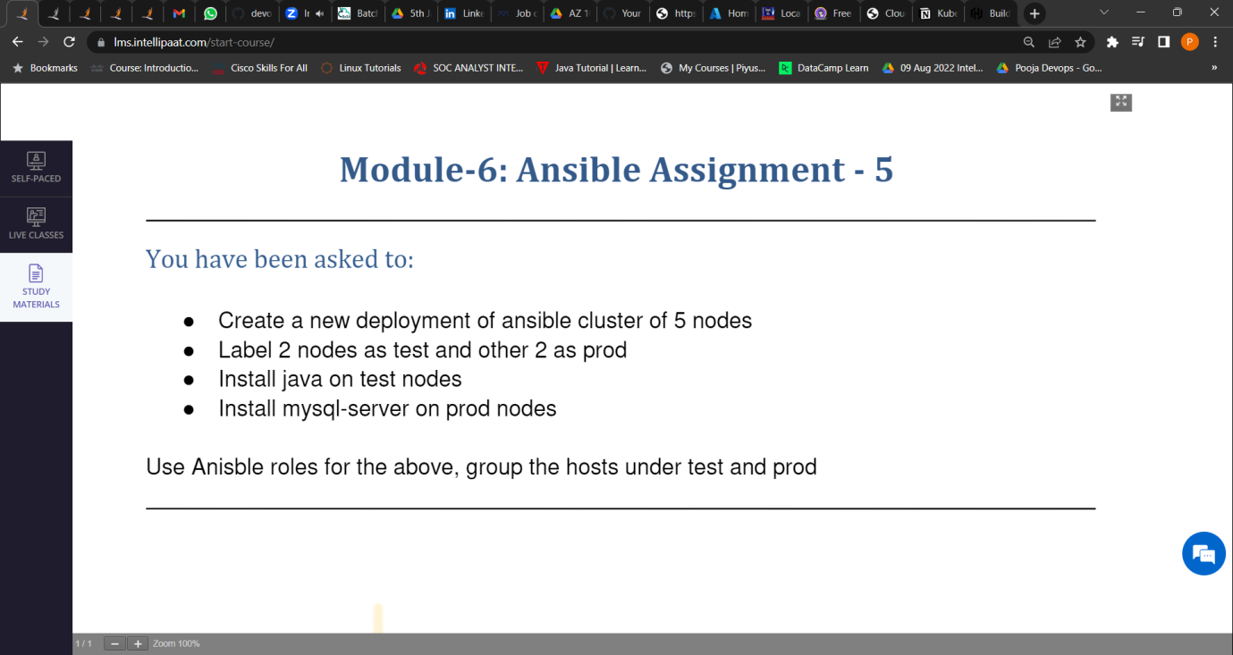

1. New deployment of Ansible cluster of 5 nodes.

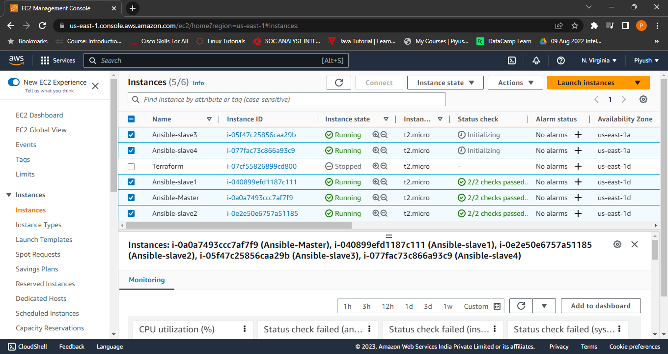

1. Labelled 2 nodes as test and 2 nodes as prod.

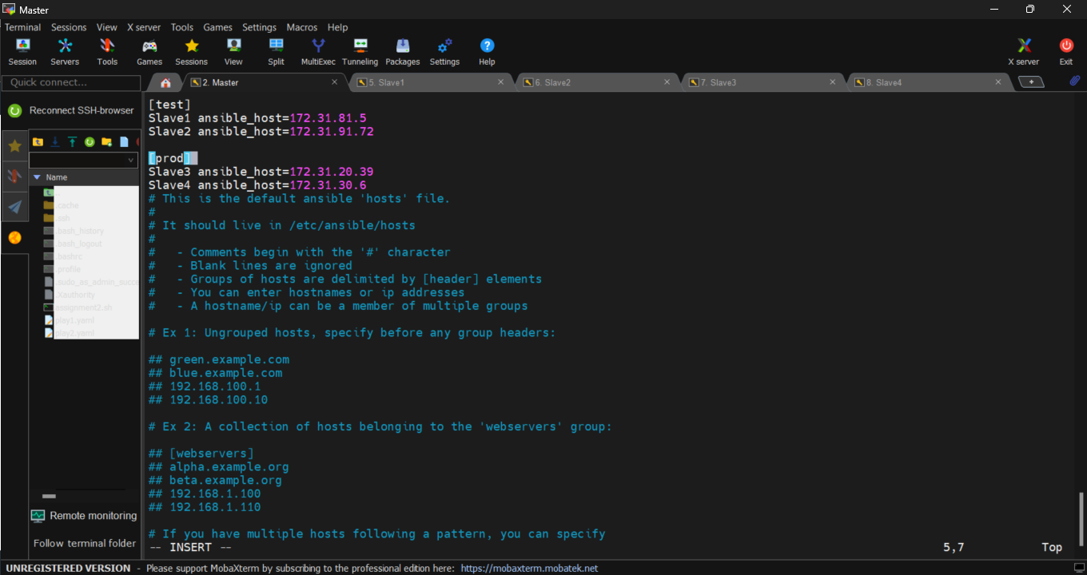

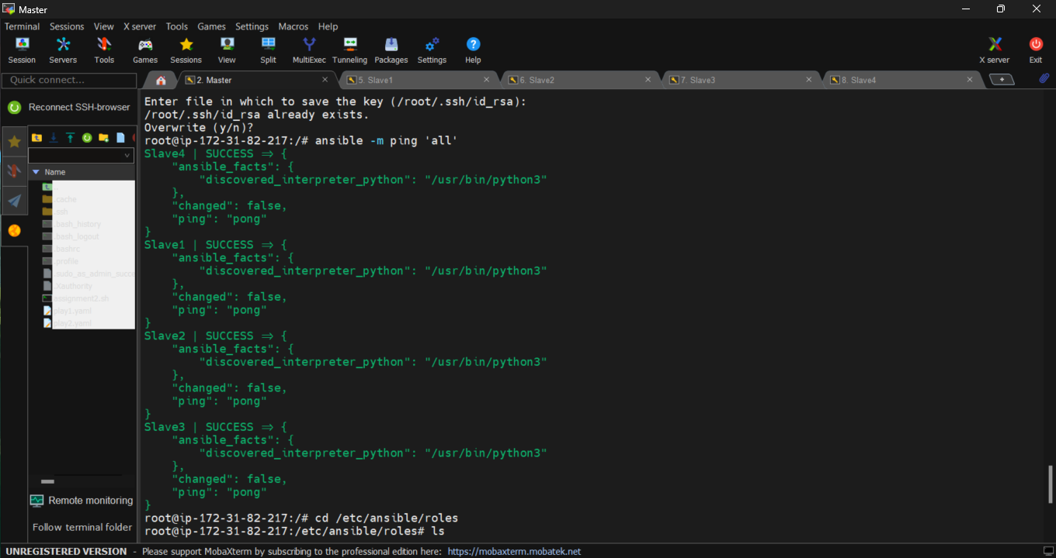

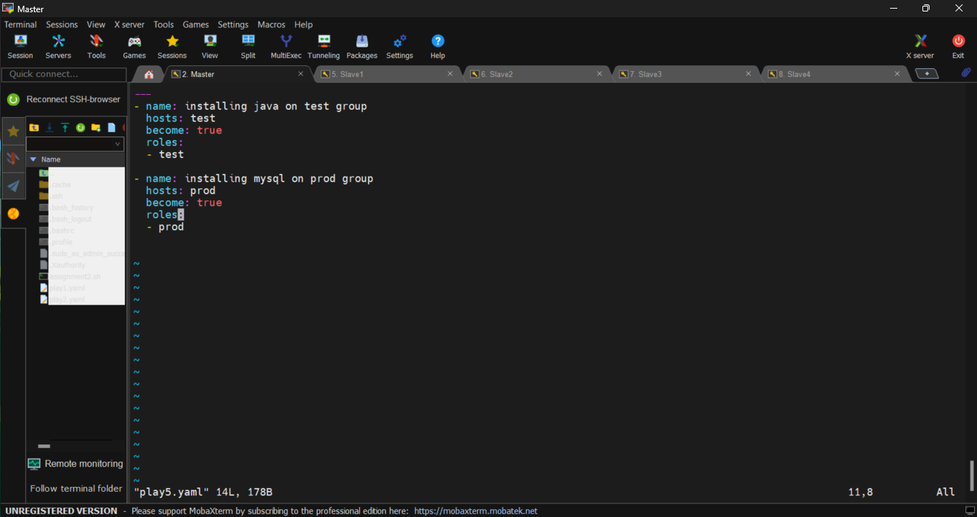

1. Install java on test Nodes

&&&&&&&&&&&&&

1. Install my-sql server on prod Nodes



