**Kubernetes Assignment – 1**

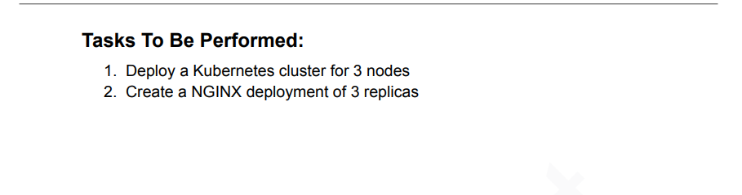

1. Deployed a Kubernetes cluster for 3 nodes.  
     
   🡪 with 1master and 2 nodes.

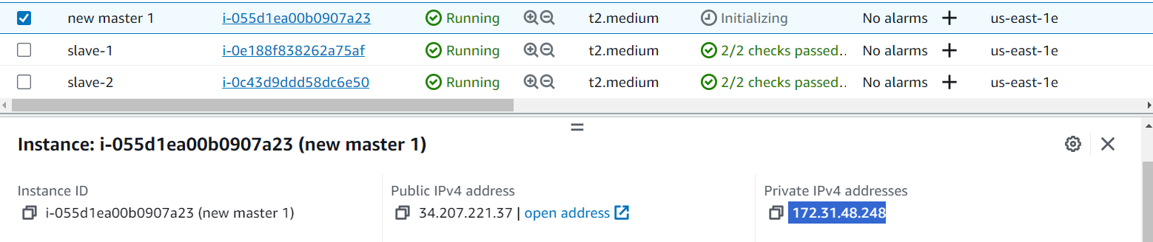

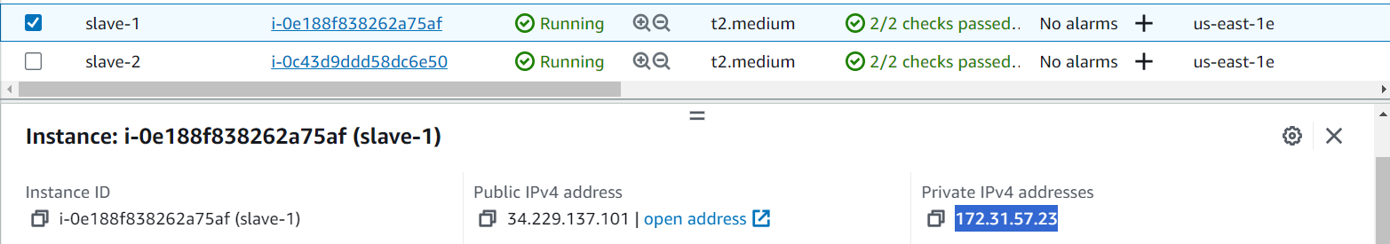  
  
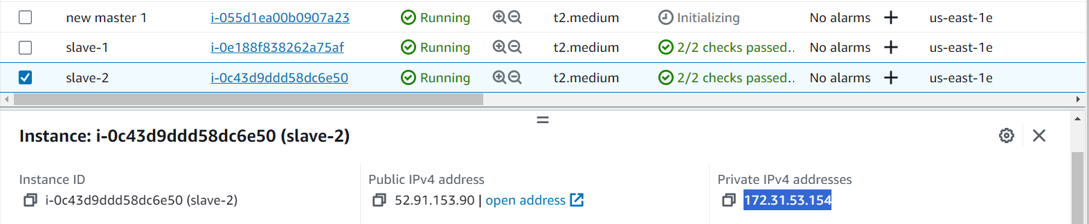  
  
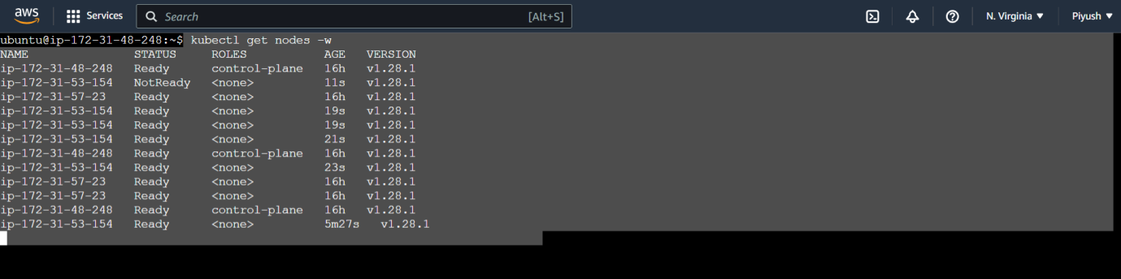

1. Create a NGINX deployment of 3 replicas.  
     
   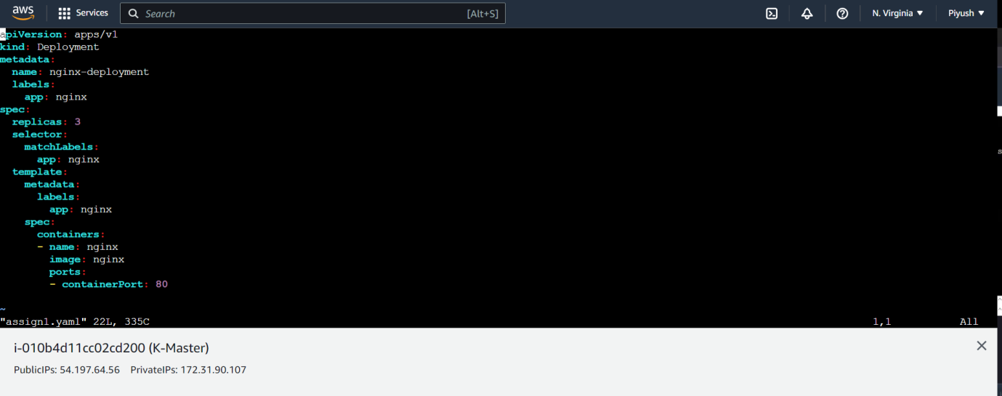

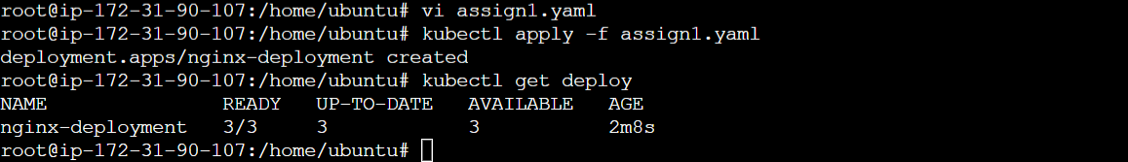  
  
Another way to create a deployment is by a command:-

**kubectl create deployment nginx-deployment-1 --image=nginx –replicas=3  
  
----------------------------------------------**********************-------------------------------------------**