**Kubernetes Assignment – 2**

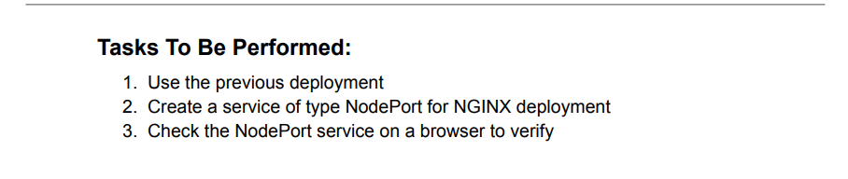  
1. Use the previous deployment.  
2. Create a service of type NodePort for NGINX deployment.  
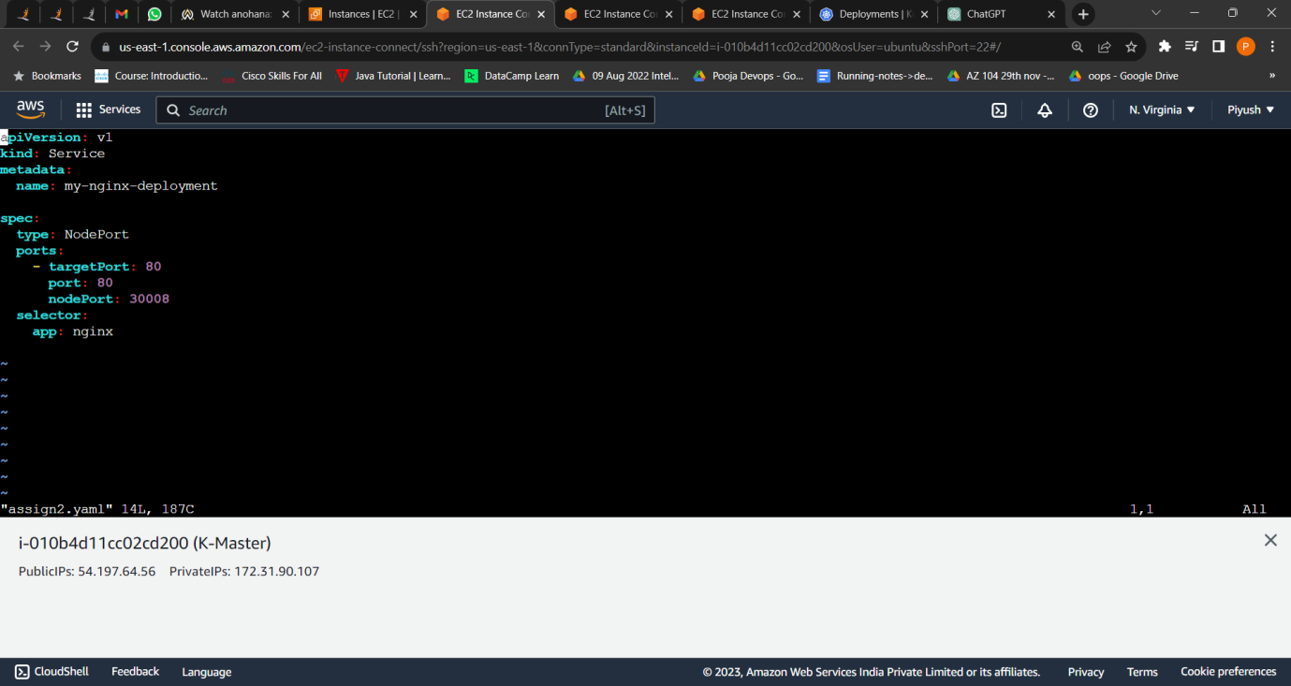  
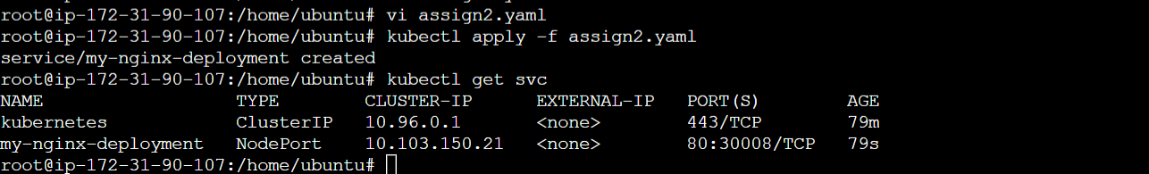  
  
  
3. Check the NodePort service on a browser to verify.

Slave1 :-  
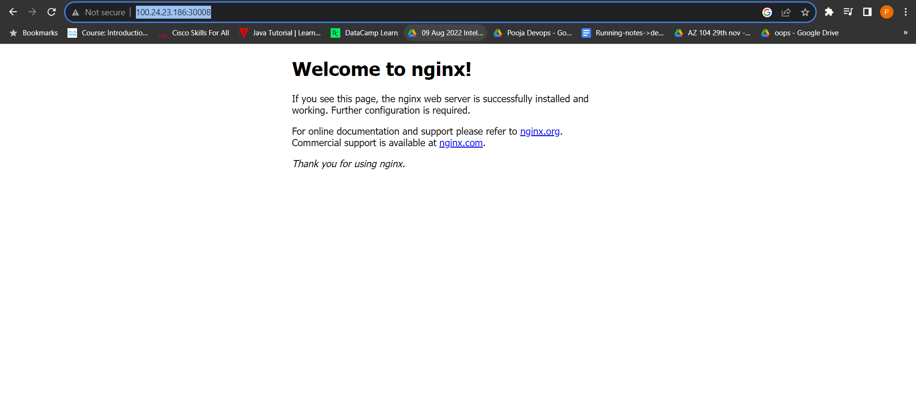 Slave2 :-  
  
  
 