**Kubernetes Assignment – 3**

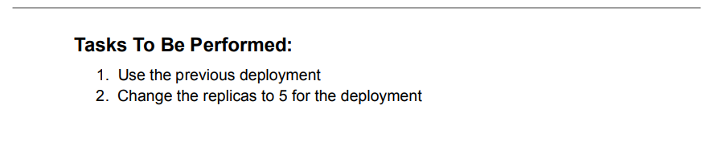

1. Using the previous deployment.
2. Change the replicas to 5 for the deployment







