**Kubernetes Assignment – 5**

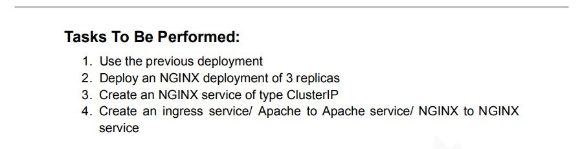

1. Used the previous deployment (used minikube)

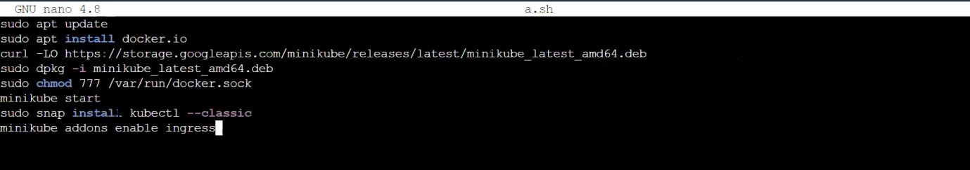

1. Deployed an NGINX deployment of 3 replicas

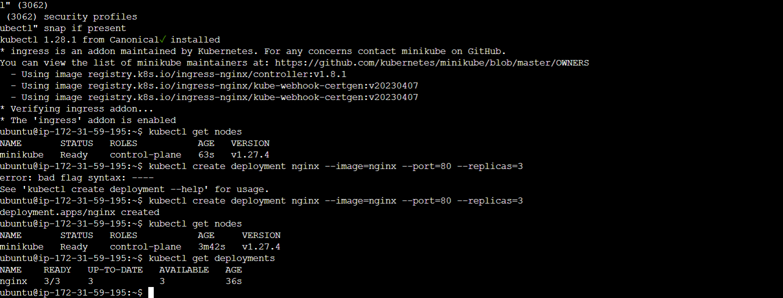

1. Created an NGINX service of type Cluster IP

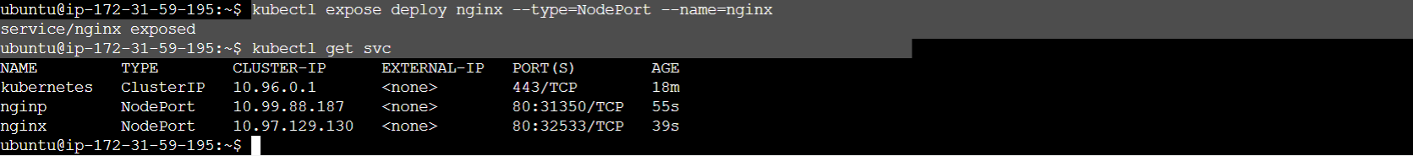  




1. Create an ingress service/ Apache to Apache service/ NGINX to NGINX service.





