**Terraform Assignment – 1**

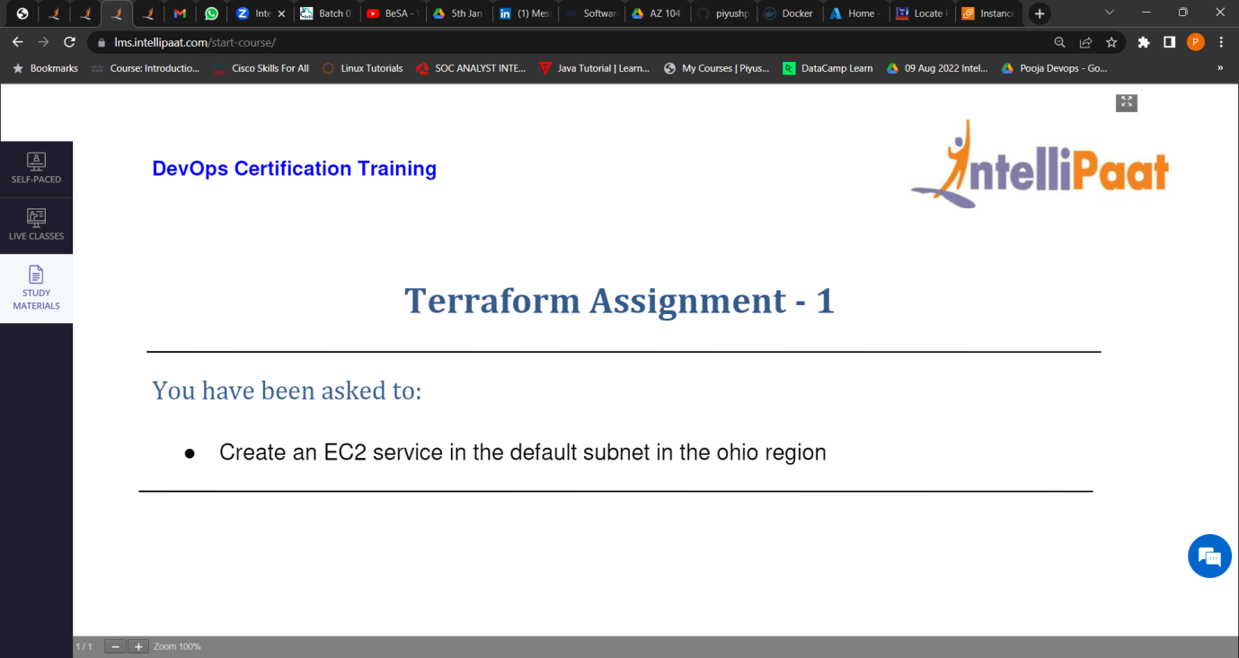

Create an Red-Hat instance first and install Terraform in it.

1. In Red hat instance install terraform
2. In AWS console
   * + 1. Go to IAM
       2. Create user
       3. Provide full admin access
       4. Copy-paste access id and secret key
       5. Save it.
3. In Red-Hat instance –

In the block of code provide access key and secret key

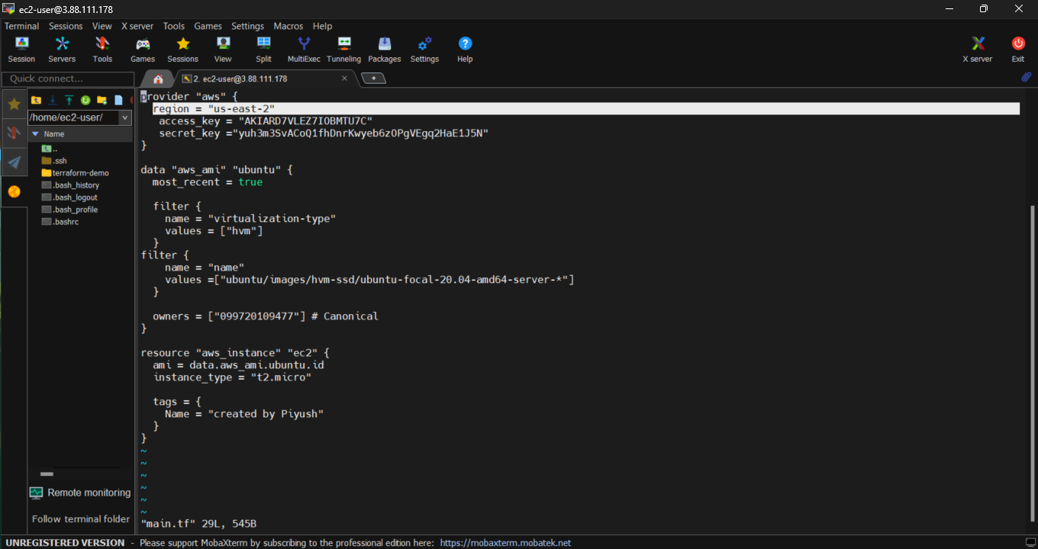

After this give the command

Terraform init

Terraform plan

Terraform apply

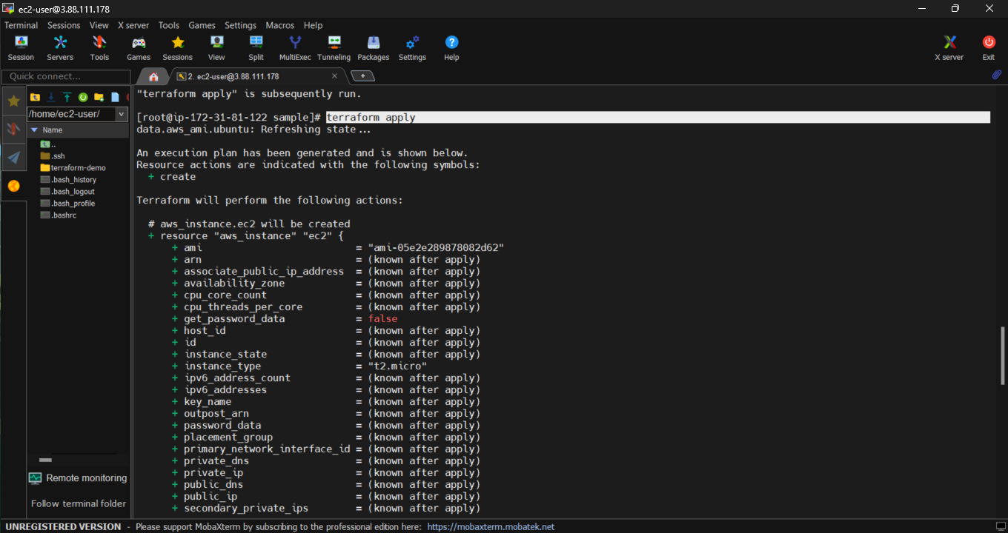

New instance is created via terraform in ohio region



