**Terraform Assignment – 3**

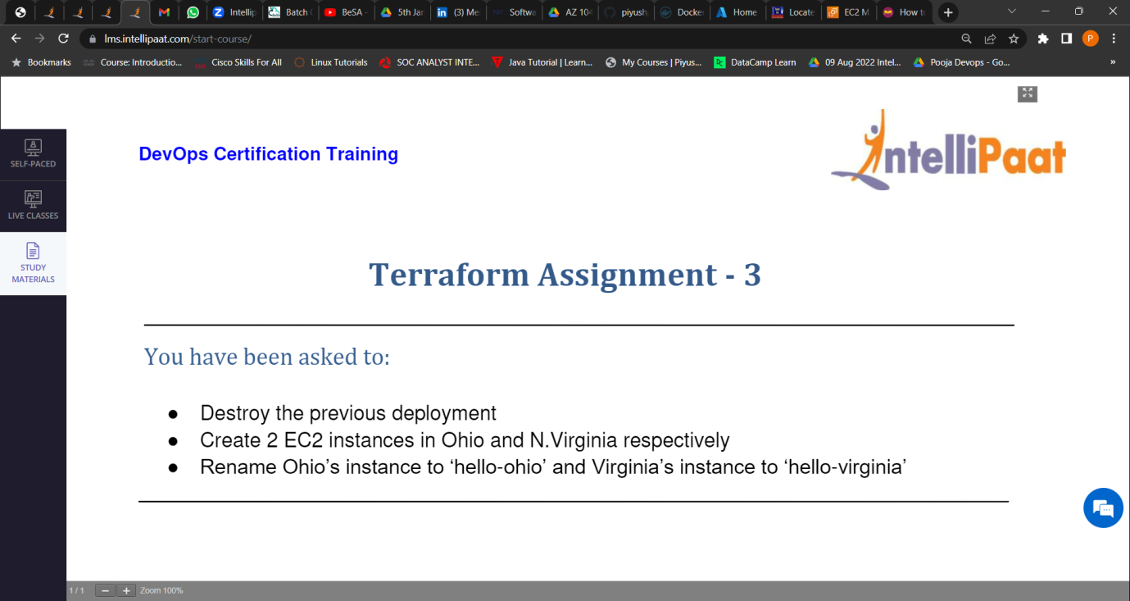

1. Destroy the previous deployment.

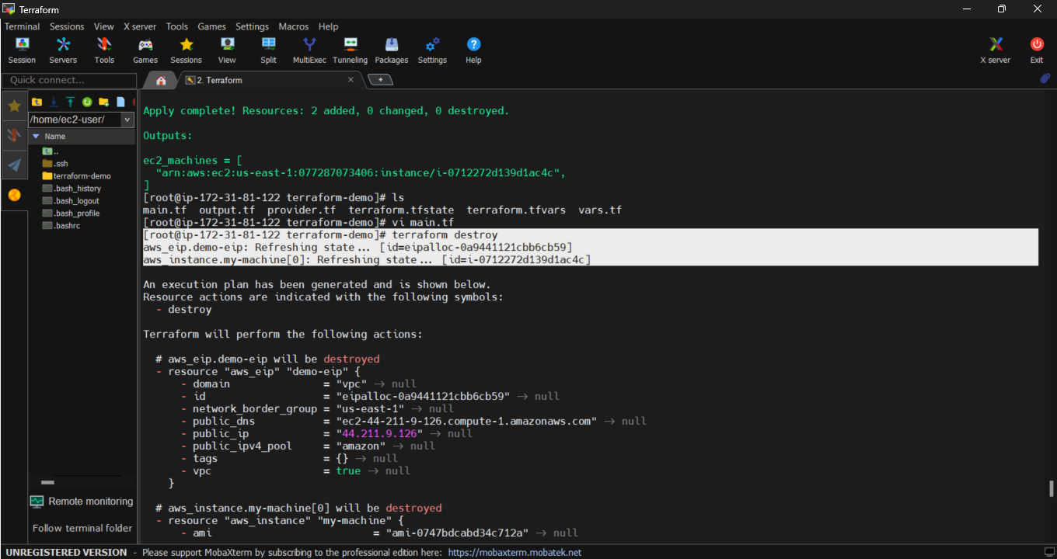

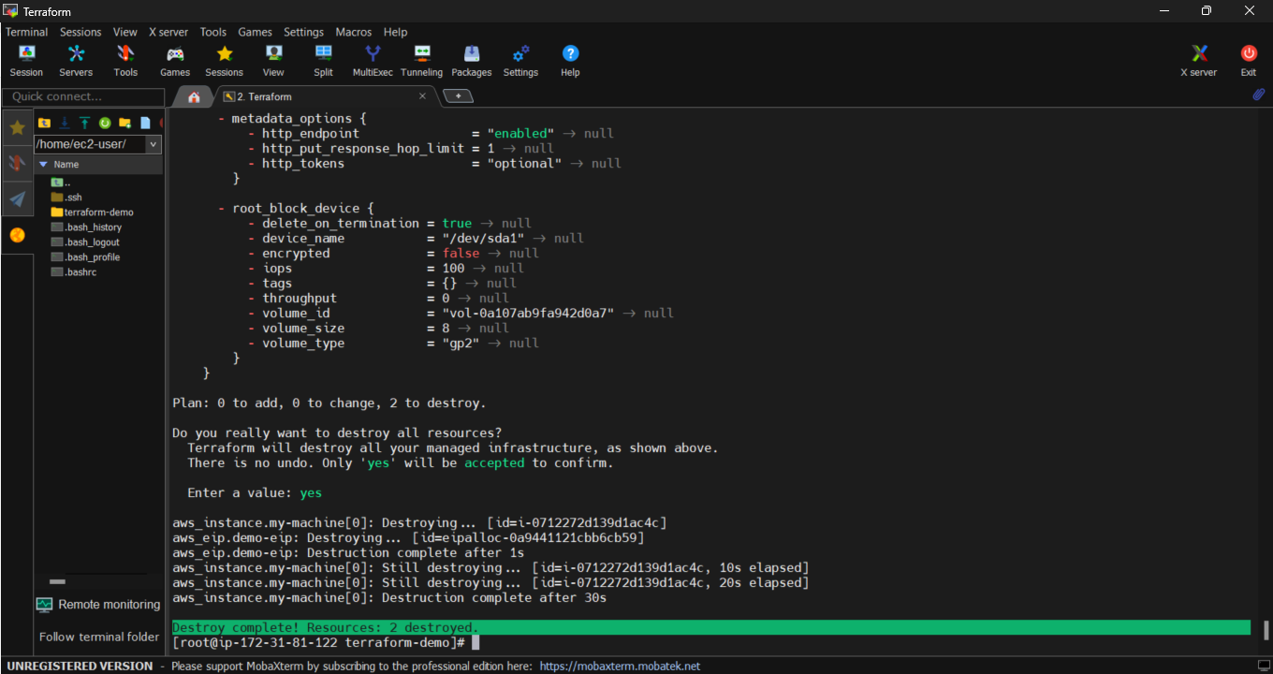

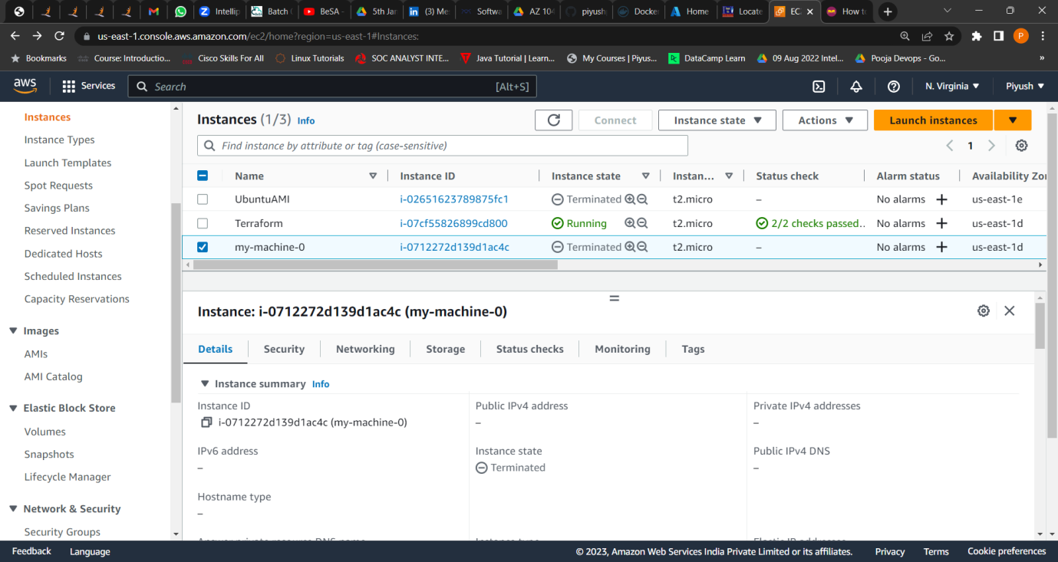

1. Created 2 ec2 instances in Ohio and north Virginia region respectively.



