**Terraform Assignment – 5**

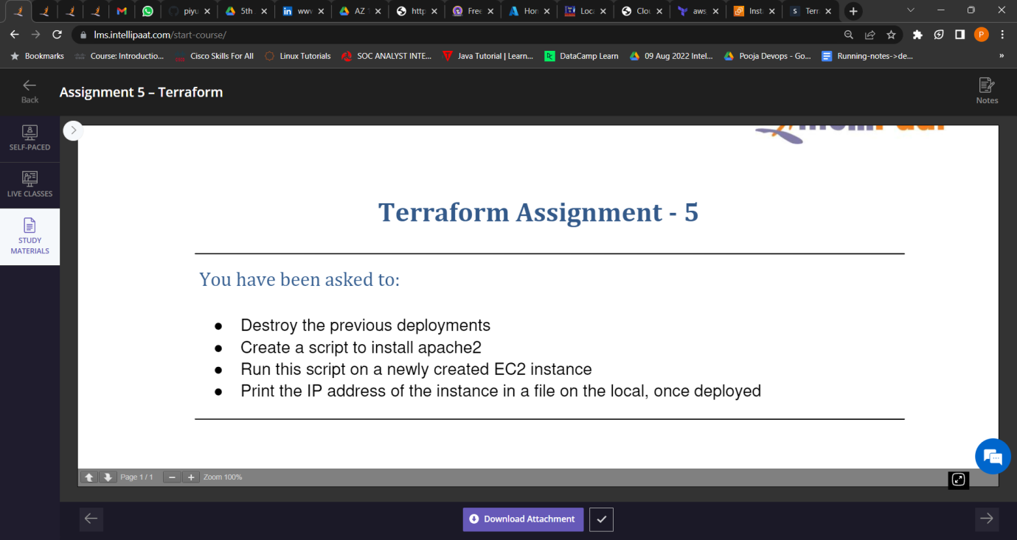

1. Destroyed the previous deployment.

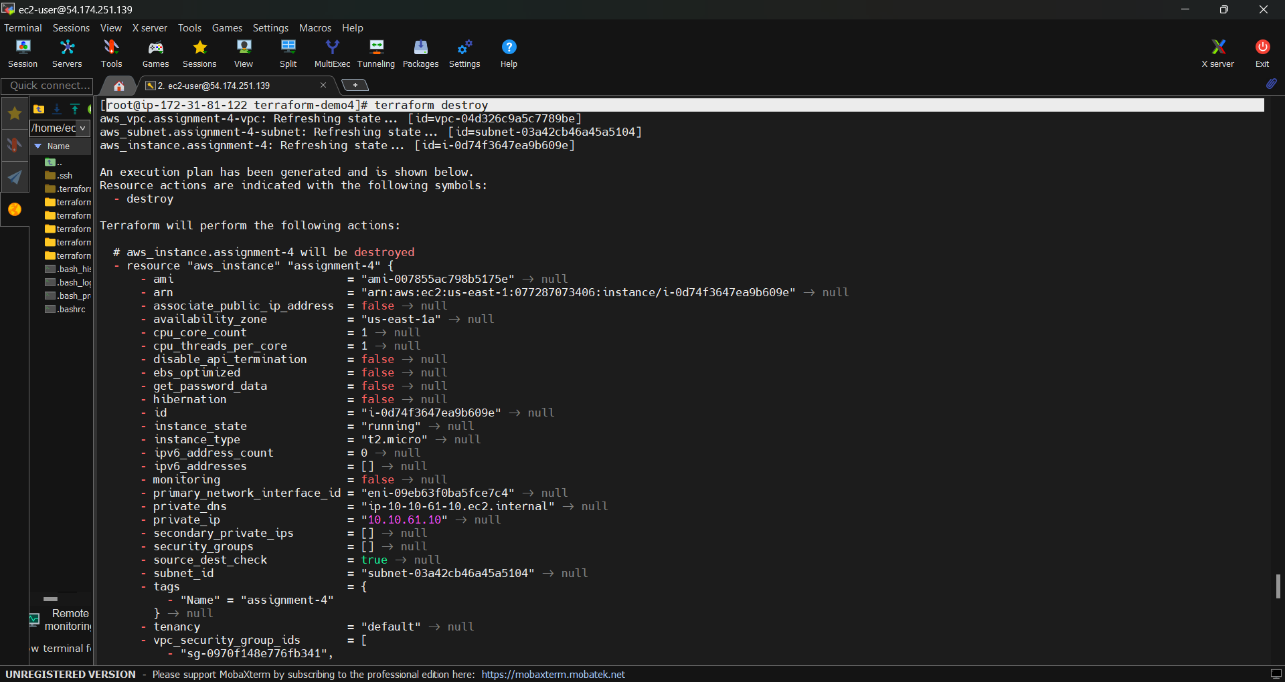

1. Created a script to install apache2.

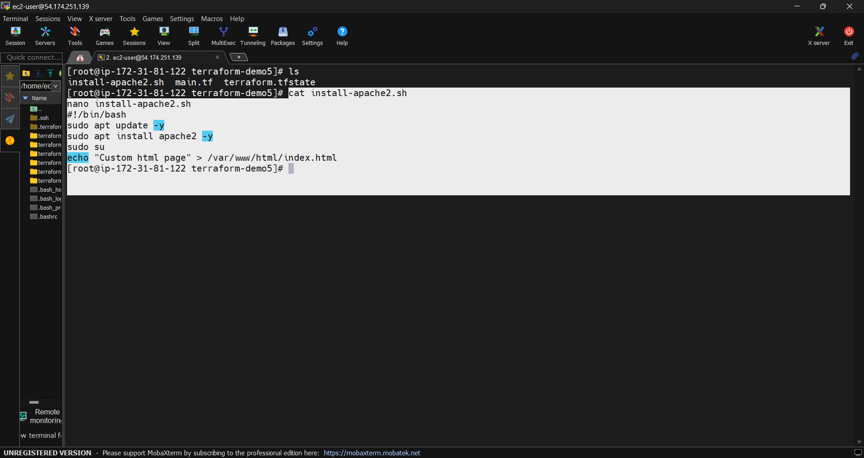

1. Run this script on a newly created EC2 instance.

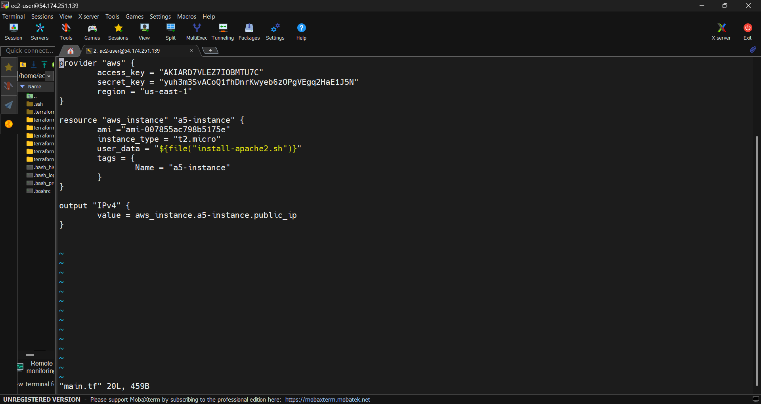

1. Print the ip address of the instance in a file on the local, once deployed.



