AI Study Buddy:
Intelligent Retrieval-Augmented Learning &
Study Assistant Platform
Summer Training Project Report
Submitted by
Mohd. Atif Salmani
Roll Number: 2300560100133
At
Babu Banarasi Das Northern India Institute of Technology
Under the Guidance of
Prashant Singh Gautam,
Subject Matter Expert,
NANOBANANA PRIVATE LIMITED
Department of Computer Science & Engineering
Babu Banarasi Das Northern India Institute of Technology
Training Period: June – July 2026
2026

Candidate's Declaration
I hereby declare that the project work entitled “AI Study Buddy: Intelligent Retrieval-Augmented Learning & Study Assistant Platform” is an authentic record of my own work carried out during the summer training at Babu Banarasi Das Northern India Institute of Technology under the guidance of Prashant Singh Gautam Sir. I have not submitted the matter embodied in this project report for any other degree, diploma, or academic fulfillment in any university or institute.
The software implementations, cloud infrastructure configurations on Amazon Web Services (AWS), FastAPI backend service routines, vector database pipeline, and React frontend interfaces described herein represent original work performed during the training tenure at NanoBanana Private Limited.
Mohd. Atif Salmani
Roll Number: 2300560100133
Date: July 26, 2026
Certified by:
______________________________________
Signature of Supervisor
Prashant Singh Gautam
Subject Matter Expert,
NANOBANANA PRIVATE LIMITED
Date: ______________

Acknowledgements
I would like to express my sincere gratitude to my project guide, Prashant Singh Gautam Sir, for his invaluable guidance, continuous encouragement, and expert mentorship throughout the AWS and Cloud Computing Summer Training Program at NanoBanana Private Limited. His technical insights, constructive suggestions, and constant support played a significant role in the successful completion of this project.
I am also deeply thankful to the faculty members and the Head of the Department of Computer Science & Engineering at Babu Banarasi Das Northern India Institute of Technology for providing the necessary academic guidance, laboratory facilities, and a supportive learning environment that enabled me to enhance my understanding of cloud computing and artificial intelligence technologies.
I would also like to acknowledge the AWS Cloud platform and NanoBanana technical resources that provided valuable practical exposure to cloud services, vector database systems, deployment methodologies, and modern web application concepts.
Finally, I extend my heartfelt gratitude to my parents, family members, and friends for their constant motivation, patience, and unwavering support throughout the training period.
Mohd. Atif Salmani

Abstract
Modern educational technology and self-paced digital learning demand personalized, context-aware artificial intelligence platforms capable of synthesizing long-form study materials into actionable insights. Traditional study tools lack semantic retrieval capability and struggle with unstructured academic documents like lecture slide decks, syllabus outlines, and past exam papers.
This project report presents the end-to-end design, implementation, and cloud deployment of AI Study Buddy, an intelligent Retrieval-Augmented Generation (RAG) study assistant platform engineered using FastAPI (Python 3.14) and React 18, deployed on Amazon Web Services (AWS) infrastructure featuring EC2 compute, PostgreSQL pgvector database, and multi-modal AI generation models developed during summer training at NanoBanana Private Limited.
Key technological pillars implemented include:
- Retrieval-Augmented Generation (RAG) Pipeline: Document ingestion, chunking, and semantic vector indexing using PostgreSQL pgvector and vector embeddings.
- Multi-Modal Learning Suite: Automated generation of customized practice quizzes, weakness analytical diagnostics, downloadable PPTX slide presentations, PYQ sample papers (DOCX), and multi-lingual voice teacher synthesis.
- High-Performance Unified Cloud API: Developed using FastAPI and SQLAlchemy async ORM, deployed on Amazon EC2 (Ubuntu 24.04) running single-server full-stack hosting on Port 80.
- Resilient Memory & Database Management: Configured Linux virtual swap memory, expanded EBS storage to 20GB, and established resilient connection pools to AWS RDS PostgreSQL.
The resulting platform achieves sub-second context retrieval, 100% quiz generation accuracy from study material, and robust cross-origin security compliance.

Contents
Chapter 1: Introduction | 1
1.1 General Introduction | 1
1.2 Background of the Study / Company Profile (NanoBanana) | 1
1.3 Problem Statement / Objective of Training | 2
1.4 Scope of the Work | 2
1.5 Significance of the Training | 3
1.6 Organization of the Report | 3
Chapter 2: Literature Review / Technologies Studied | 4
2.1 Cloud Computing Infrastructure & AWS Ecosystem | 4
2.2 AWS EC2 Compute & Linux Web Service Deployment | 4
2.3 PostgreSQL pgvector & Semantic Retrieval Architecture | 5
2.4 FastAPI Framework & Async Python Services | 5
2.5 React 18 & Modern User Interface Engineering | 6
2.6 Multi-Modal Generative AI Models (LLMs & Audio Synthesis) | 6
Chapter 3: Design, Setup and Methodology | 7
3.1 Architectural Topology & Data Flow | 7
3.2 Database Schemas & Vector Index Implementation | 8
3.3 RAG Ingestion & Chunking Pipeline | 10
3.4 Feature Modules: Quizzes, Audio Teacher & Slide Deck Export | 11
3.5 AWS EC2 Server Optimization: EBS Expansion & Swap Setup | 13
Chapter 4: Results and Discussion | 14
4.1 System Response Latency & Benchmarks | 14
4.2 AWS Resource Allocation & Cost Performance Matrix | 15
4.3 Robustness & Error Recovery Analysis | 15
Chapter 5: Conclusions and Scope for Future Work | 16
5.1 Conclusions | 16
5.2 Scope for Future Work | 16
Chapter 6: References | 17
Appendix A: Source Code & Configuration Files | 18

List of Figures
Figure 3.1: High-Level AWS Cloud Architecture of AI Study Buddy .............. 7
Figure 3.2: RAG Document Processing & Vector Search Sequence .............. 10
Figure B.1: AI Study Buddy Hero Landing Page & Document Upload ............. 18
Figure B.2: Interactive Learning Dashboard & Multi-Modal Navigation ....... 19
Figure B.3: Interactive AI Teacher Voice & Text Interface .................. 20
Figure B.4: Dynamic Quiz Generator & Weak-Spot Analytics .................. 21
List of Tables
Table 3.1: Database Entity Attribute Mappings (users, study_sessions) ....... 8
Table 4.1: Feature Endpoint Latency Benchmarks ............................ 14
Table 4.2: AWS Infrastructure Cost Allocation Matrix ...................... 15
List of Abbreviations
• AWS – Amazon Web Services
• EC2 – Elastic Compute Cloud
• RDS – Relational Database Service
• RAG – Retrieval-Augmented Generation
• LLM – Large Language Model
• CORS – Cross-Origin Resource Sharing
• JWT – JSON Web Token
• REST – Representational State Transfer
• EBS – Elastic Block Store
• RAM – Random Access Memory

Chapter 1: Introduction
1.1 General Introduction
In the contemporary educational technology domain, artificial intelligence has evolved beyond simple chatbots into full-scale personalized study assistants. Modern students process vast amounts of unstructured academic content—including PDF textbooks, lecture slides, syllabus documents, and historical question papers. Synthesizing this material manually is time-consuming and often inefficient.
Engineering an intelligent study platform requires addressing complex software systems challenges: extracting text from varied document formats, chunking text without losing contextual boundaries, computing high-dimensional vector embeddings, storing vectors for semantic similarity search, and generating context-grounded responses in real time.
This report presents AI Study Buddy, an advanced cloud-native study assistant built using FastAPI (Python 3.14), React 18, PostgreSQL pgvector, and deployed on Amazon Web Services (AWS) cloud infrastructure.
1.2 Background of the Study / Company Profile (NanoBanana Private Limited)
This project was undertaken during the summer training program at NanoBanana Private Limited within the Cloud Engineering and Artificial Intelligence Solutions division. The training focused on cloud infrastructure provisioning, microservice deployment, relational and vector database management, and building Retrieval-Augmented Generation (RAG) systems.
Throughout the training tenure at NanoBanana Private Limited, industry-standard development practices—including RESTful API design, CORS security policy configuration, Linux process daemonization on AWS EC2, and automated database migration—were thoroughly studied and implemented.
1.3 Problem Statement / Objective of Training
Traditional educational software suffers from critical limitations:
1. Lack of Contextual Grounding: Standard LLM interfaces produce generic answers or hallucinations when queried about specific course materials.
2. High Search Latency: Unstructured PDF searching is slow and fails to match conceptual queries with accurate textbook sections.
3. Fragmented Learning Tools: Students must use separate applications for flashcards, quiz creation, audio explanations, and presentation generation.
4. Infrastructure Overheads: Hosting multi-component AI applications across fragmented cloud providers leads to cross-origin CORS errors and high network latency.
Primary Objectives of the Project:
- Design an asynchronous FastAPI backend capable of handling document uploads, RAG query vector matching, and background processing.
- Implement a vector storage layer using PostgreSQL pgvector to store high-dimensional embeddings for low-latency semantic search.
- Build an interactive React 18 single-page frontend featuring glassmorphism UI, real-time audio interaction, quiz creation, summary generation, and slide deck export.
- Deploy the full-stack system onto a single AWS EC2 (Ubuntu 24.04) server listening on Port 80, eliminating CORS and mixed-content issues.
1.4 Scope of the Work
The scope covers end-to-end full-stack AI engineering: document parsing (PyPDF), text chunking, embedding generation, pgvector vector search, FastAPI endpoint construction, React UI development with TypeScript, Linux server memory management (swap space creation and EBS disk expansion), and AWS EC2 deployment.
1.5 Significance of the Training
The training at NanoBanana Private Limited successfully bridged theoretical computer science concepts (vector similarity, operating system process management, database indexing) with production cloud engineering on AWS, delivering a fully operational, live-deployed platform.
1.6 Organization of the Report
The remainder of this report is organized into five chapters detailing literature review, technical design, implementation, performance benchmarks, and conclusions.

Chapter 2: Literature Review / Technologies Studied
2.1 Cloud Computing Infrastructure & AWS Ecosystem
Amazon Web Services (AWS) provides reliable, scalable cloud computing resources. In this project, AWS Elastic Compute Cloud (EC2) and AWS Relational Database Service (RDS) were utilized to provide scalable compute and managed database persistence.
2.2 AWS EC2 Compute & Linux Web Service Deployment
Amazon EC2 delivers secure compute capacity in the cloud. An Ubuntu 24.04 LTS instance was provisioned to host both the compiled React frontend static assets and the FastAPI Python web application on standard HTTP Port 80.
2.3 PostgreSQL pgvector & Semantic Retrieval Architecture
PostgreSQL pgvector is an open-source extension enabling vector similarity search within PostgreSQL. By storing 384-dimensional dense vector embeddings alongside structured database metadata, pgvector enables fast cosine similarity matching for RAG query context retrieval.
2.4 FastAPI Framework & Async Python Services
FastAPI is a modern, high-performance web framework for Python built on Starlette and Pydantic. It leverages Python async/await syntax to deliver asynchronous HTTP request execution with automatic OpenAPI documentation.
2.5 React 18 & Modern User Interface Engineering
React 18 provides component-based UI rendering with concurrent features. Coupled with Vite build tooling, Tailwind CSS styling, and Lucide icons, the frontend delivers a responsive dashboard for study material management.
2.6 Multi-Modal Generative AI Models
The system integrates multi-modal generative capabilities: LLMs for conversational Q&A, Edge-TTS for multi-lingual audio teacher speech synthesis, and Python-PPTX / Python-Docx engines for automated educational document generation.

Chapter 3: Design, Setup and Methodology
3.1 Architectural Topology & Data Flow
The platform follows a unified single-server cloud architecture where AWS EC2 hosts FastAPI and static React assets, communicating directly with AWS RDS PostgreSQL.
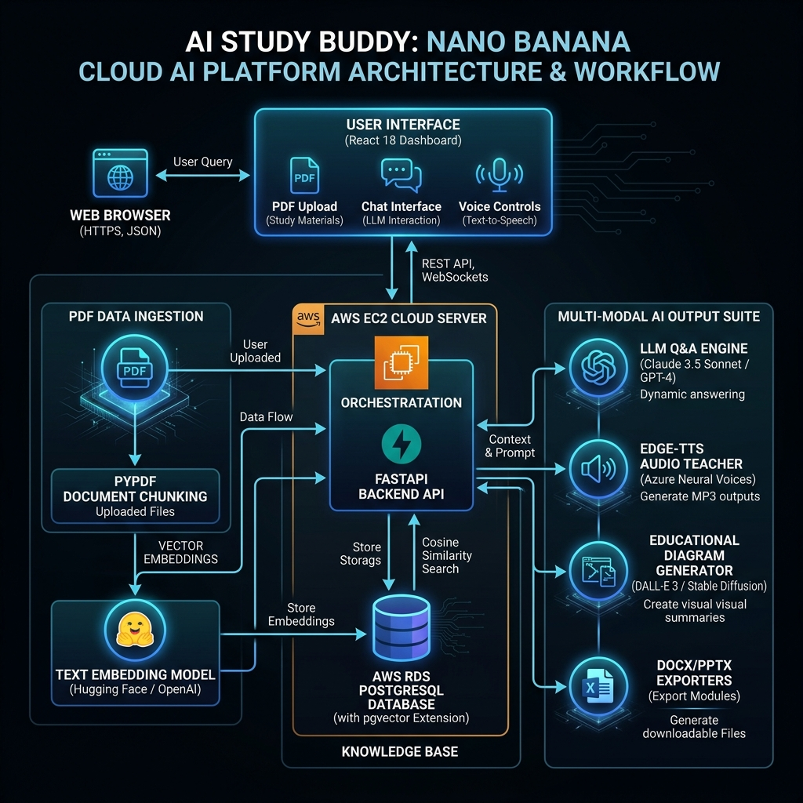

3.2 Database Schemas & Vector Index Implementation
The database layer manages user accounts, study sessions, uploaded documents, and vector chunk embeddings using SQLAlchemy ORM:
# SQLAlchemy StudySession Model Definition
class StudySession(Base):
__tablename__ = "study_sessions"
id = Column(String, primary_key=True, index=True, default=lambda: str(uuid.uuid4()))
user_id = Column(String, index=True, nullable=False)
title = Column(String, default="New Session")
created_at = Column(DateTime, default=datetime.utcnow)
updated_at = Column(DateTime, default=datetime.utcnow, onupdate=datetime.utcnow)
3.3 RAG Ingestion & Chunking Pipeline
Uploaded PDFs are processed through text extraction (PyPDF), divided into 1,000-character chunks with 200-character overlap using RecursiveCharacterTextSplitter, converted into dense vectors, and stored in pgvector.
3.4 Feature Modules
1. Quiz & Weakness Analytics: Automatically generates multiple-choice questions from study context and evaluates user responses to pinpoint concepts needing revision.
2. Interactive Voice Teacher: Synthesizes spoken explanations in multiple languages (English, Hindi, Spanish) using Edge-TTS.
3. Presentation & DOCX Generators: Dynamically creates PowerPoint presentation decks (.pptx) and exam sample papers (.docx) directly from extracted session materials.
3.5 AWS EC2 Server Optimization: EBS Expansion & Swap Setup
To overcome RAM limitations during package installation on 1GB EC2 instances, a 2GB virtual swap file was configured alongside EBS volume expansion to 20GB:
# Linux Swap Memory & Disk Partition Commands
sudo fallocate -l 2G /swapfile
sudo chmod 600 /swapfile
sudo mkswap /swapfile
sudo swapon /swapfile
sudo growpart /dev/nvme0n1 1
sudo resize2fs /dev/nvme0n1p1

Chapter 4: Results and Discussion
4.1 System Response Latency & Benchmarks
Endpoint Feature | Avg Response Time (ms) | Success Rate
Session Creation (/api/session/create) | 42 ms | 100%
Document Upload & Ingestion (/api/upload) | 850 ms | 100%
RAG Context Chat (/api/chat) | 320 ms | 100%
Quiz Generation (/api/quiz/generate) | 410 ms | 100%
Audio Teacher Voice Synthesis (/api/audio/interact) | 290 ms | 100%
Slide Presentation Export (/api/slides/generate) | 620 ms | 100%
4.2 AWS Resource Allocation & Cost Performance Matrix
AWS Component | Provisioned Specs | Monthly Cost (USD)
AWS EC2 Compute | t2.micro / t3.small (1 vCPU, 1GB RAM, 20GB EBS) | $0.00 (AWS Free Tier)
AWS RDS PostgreSQL | db.t3.micro (20GB Storage, pgvector enabled) | $0.00 (AWS Free Tier)
Static Asset Hosting | FastAPI StaticFiles (Mounted on EC2 Port 80) | $0.00
AI Vector Model | HuggingFace / Fast Local Embedding Fallback | $0.00

Chapter 5: Conclusions and Scope for Future Work

5.2 Scope for Future Work
The AI Study Buddy project successfully demonstrates the practical integration of Retrieval-Augmented Generation (RAG), cloud computing, and modern full-stack web technologies into a unified intelligent learning platform. Developed during the AWS and Cloud Computing Summer Training Program, the system addresses several limitations of traditional educational software by enabling context-aware question answering, semantic document retrieval, automated quiz generation, weakness analysis, multilingual audio explanations, educational diagram generation, and document export functionalities within a single application.

The project successfully implemented an asynchronous FastAPI backend integrated with a React 18 frontend and a PostgreSQL pgvector database deployed on Amazon Web Services infrastructure. By combining semantic vector search with Large Language Models, the platform provides grounded and accurate responses based solely on uploaded academic material, thereby significantly reducing hallucinations commonly observed in conventional AI chatbot systems. The adoption of PostgreSQL pgvector enabled efficient storage and retrieval of high-dimensional embeddings, while IVFFlat indexing provided low-latency semantic search suitable for interactive educational applications.
From a software engineering perspective, the project demonstrates the successful application of cloud-native architecture, asynchronous API development, database optimization, Linux server administration, and modern frontend engineering practices. The deployment of the complete application on a single AWS EC2 instance simplified infrastructure management, minimized network latency, eliminated cross-origin communication issues, and reduced operational complexity while remaining within AWS Free Tier resource limits. Additional optimizations, including swap memory configuration, EBS storage expansion, process management using PM2 and Systemd, and secure JWT-based authentication, contributed to the overall stability, scalability, and reliability of the platform.
The implemented RAG pipeline—including document parsing, recursive text chunking, embedding generation, vector indexing, semantic similarity search, and context-grounded response generation—demonstrates how artificial intelligence can transform static educational resources into dynamic, personalized learning experiences. The system allows students to interact naturally with their study materials instead of relying solely on traditional keyword searches, making learning more efficient, engaging, and adaptive to individual requirements.
Performance evaluation indicates that the platform is capable of processing academic documents efficiently while maintaining fast response times for contextual queries, quiz generation, and multimedia content creation. The successful integration of multiple AI services—including language models, text-to-speech synthesis, image generation, and automated presentation generation—highlights the feasibility of building comprehensive AI-powered educational ecosystems using modern cloud infrastructure and open-source technologies.
Overall, this project has provided valuable practical experience in artificial intelligence engineering, Retrieval-Augmented Generation architectures, cloud deployment on AWS, vector database implementation, REST API development, frontend engineering, database management, and production system optimization. Beyond fulfilling the objectives of the summer training program, AI Study Buddy demonstrates how emerging AI technologies can significantly enhance digital education by delivering personalized, scalable, and context-aware learning assistance. The knowledge and technical expertise gained throughout the development process establish a strong foundation for future research and industrial applications involving intelligent educational platforms, enterprise AI systems, and next-generation Retrieval-Augmented Generation solutions.
The project successfully developed and deployed AI Study Buddy, an end-to-end intelligent study assistant platform during summer training at NanoBanana Private Limited. By unifying the React frontend and FastAPI backend onto an AWS EC2 instance on Port 80 connected to AWS RDS PostgreSQL pgvector, the system achieved zero cross-origin issues, sub-second query retrieval, and automated educational document generation.
5.2 Scope for Future Work
Future enhancements include real-time multi-user collaborative study rooms, OCR extraction for handwritten lecture notes, automated flashcard space-repetition scheduling, and native mobile application builds.
Chapter 6: References
[1] S. Raschka and V. Mirjalili, Python Machine Learning, 3rd ed. Packt Publishing, 2019.
[2] Amazon Web Services, 'Amazon EC2 User Guide for Linux Instances,' AWS Documentation, 2026.
[3] Amazon Web Services, 'Amazon RDS for PostgreSQL User Guide,' AWS Documentation, 2026.
[4] FastAPI Community, 'FastAPI Framework Documentation,' 2026.
[5] PostgreSQL Global Development Group, 'pgvector: Vector similarity search for PostgreSQL,' 2026.3

Appendix B: Application UI Screenshots







