BU.330.740 Large Scale Computing on the Cloud

**Lab 2 Extension. Twitter Sentiment Analysis using Hive on AWS**

Learning Goal: use Hive to implement Twitter sentiment analysis, and deploy it on AWS

Required Skills: understand basics of sentiment analysis using dictionary, and Hive basics

1. Download the zip file of inputs and scripts, unzip and store the three files in your local folder.
2. **EMR**: choose the cluster you have set up and then **Clone** and choose **DO NOT** **include the steps**.
3. While waiting for the cluster to be provisioned, go to **AWS Management Console**->**S3,** create a bucket. Create 2 folders in your bucket**,** 1 for input files and 1 for your Hive script. Under the input folder, create a sub-folder named **tweets** for tweets file and another sub-folder named **dictionary** for dictionary file.

Upload tweets.csv into **tweets** folder; dictionary.csv into **dictionary** folder; and tweetSent.q into your scripts folder.

Please note that if you do not use **tweets** and **dictionary** as the folder names, you need to modify the script file, tweetSent.q, accordingly.

1. Wait till the cluster is ready, add a step of type **Hive program**. Name your Hive program. Point Script to tweetSent.q on your S3; Input to the input folder on your S3; and Output to a folder on your S3 instance. **Note that this output folder should not pre-exist**. Add this step and then wait for your program to complete. After it’s completed, you can check and download results from your S3 bucket -> your output folder.

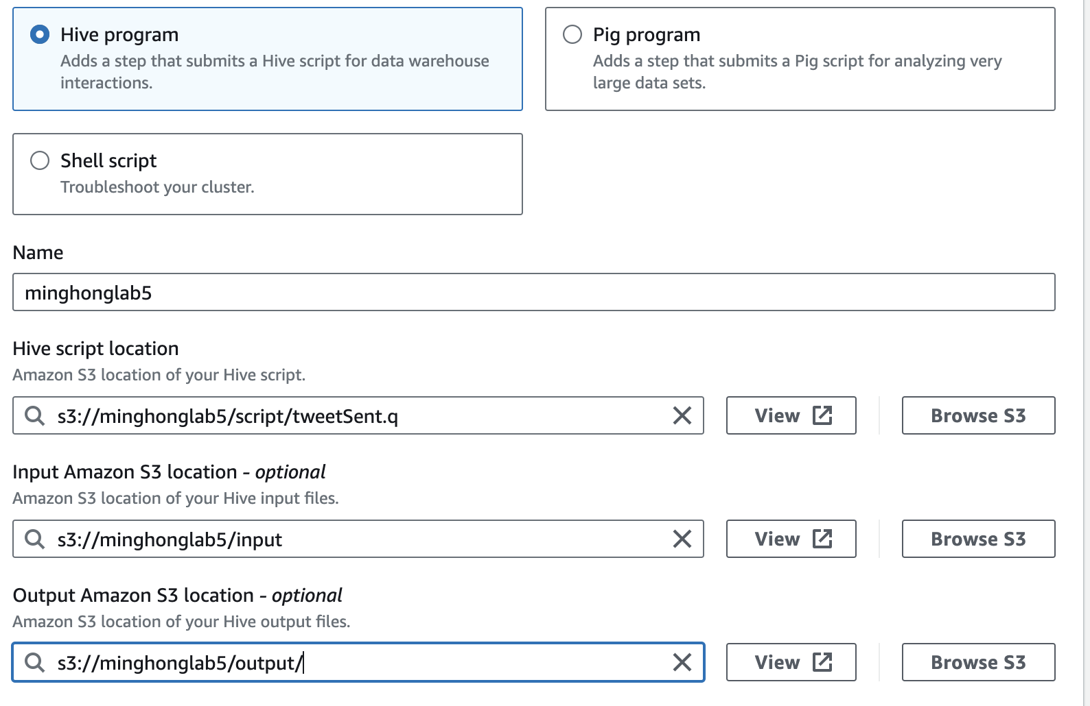

1. Last but not least, **DO NOT FORGET TO terminate the cluster.**

Reference:

<https://www.kaggle.com/crowdflower/twitter-airline-sentiment>