# Homework 4: AWS Rekognition Custom Label Project

## 1. Image Task Description

For this assignment, I collected an image dataset focused on various apple varieties. The dataset contains images of different apple types such as Apple 6, Apple Braeburn 1, Apple Crimson Snow 1, Apple Golden 1, Apple Golden 2….etc. Each class contains approximately contains 30 to 33 images for test and 130-140 images for training ensuring a balanced dataset. The total dataset consisted of 141 unique labels with a total of 18,831 images for training and 4,788 images for testing. The images were pre-processed to ensure uniformity in size and clarity, which helps in improving the model's accuracy during training.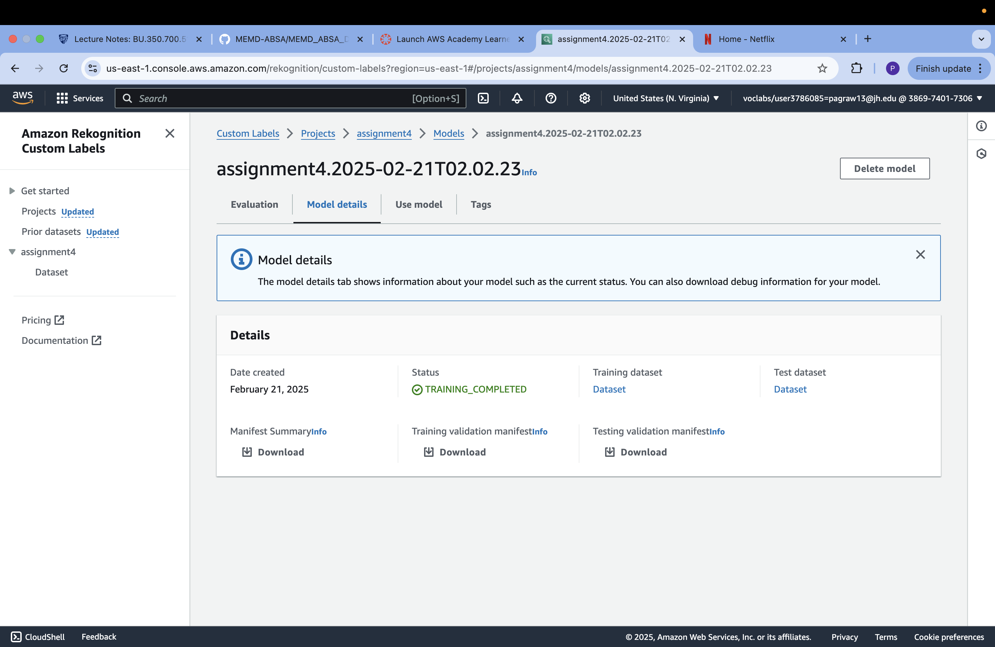

## 2. Model Performance

The model was trained using AWS Rekognition Custom Labels and achieved outstanding results. The training was completed successfully within 7.571 hours. The overall evaluation metrics of the model are as follows:  
- F1 Score: 1.000  
- Average Precision: 1.000  
- Overall Recall: 1.000

The confusion matrix and misclassification analysis revealed no false positives or false negatives, indicating that the model performed flawlessly on the test dataset.

## 3. Dataset and Submission

The dataset used for this project consists of labeled apple images and is available here: https://www.kaggle.com/api/v1/datasets/download/moltean/fruits