In this exercise you will enhance the Help.java app that was developed in an earlier exercise. Enhancements will include syntax help for the for, while, and do-while constructs, and the program will allow the user to make multiple choices in a single run.

A sample run of the program is illustrated below:

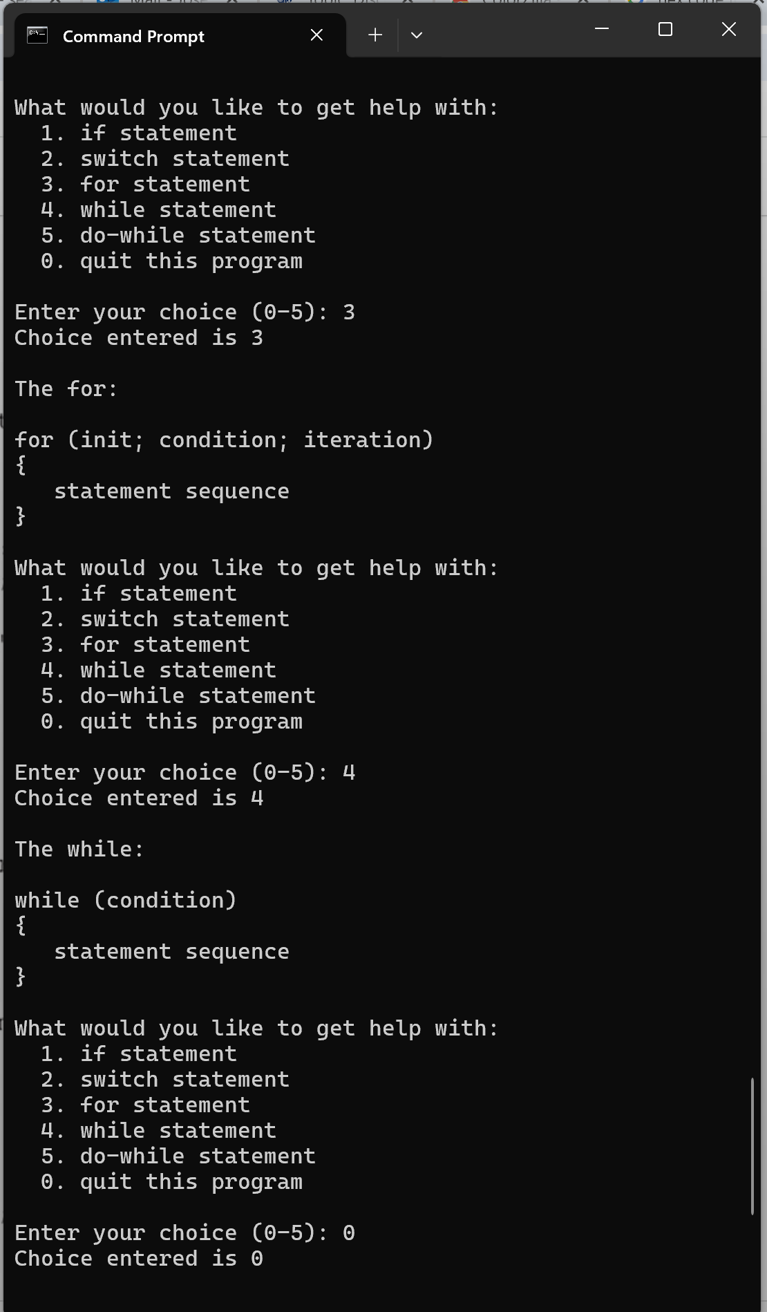

1. Start by making a copy of the Help.java program from the earlier exercise and name it Help2.java.
2. The code for the remaining construct syntax can be found in the MoreSyntax.java file on the Canvas site. You can copy and paste it into the Help2.java source file.
3. You must use a do-while construct to allow the user to make repeated selections. You must also change the user prompts to accommodate the additional construct choices.
4. Compile and run the completed program and test it to be sure it only accepts valid integer input.