LABORATORY REPORT
Application Development Lab
(CS33002)

B.Tech Program in ECSc

Submitted By

Name:-Piyush Patra
Roll No: 2230264



Kalinga Institute of Industrial Technology
(Deemed to be University)
Bhubaneswar, India

Spring 2024-2025

Table of Content

Exp No. | Title | Date of  Experiment | Date of  Submission | Remarks
1. | To design and develop a professional resume using HTML and CSS.
2.
3.
4.
5.
6.
7.
8.
9. | Open Ended 1
10. | Open Ended 2

Experiment Number | 1
Experiment Title | To design and develop a professional resume using HTML and CSS.
Date of Experiment | 7/01/2025
Date of Submission | 13/01/20251

Objective:- To design and develop a professional resume using HTML and CSS.

Procedure:-
1. Open a new project folder and create an `index.html` file for the structure of your resume.
2. Write HTML code for sections: Header (Name, Photo, Contact), Skills, Projects, Work,Experience, and Education.
3. Add hyperlinks to LinkedIn, GitHub, and other online portfolios.
4. Use CSS to apply design elements for proper alignment, spacing, and colors.
5. Make the layout responsive using Flexbox or Grid.
6. Integrate images and video links as required.
7. Test the design across devices.

Code:-
HTML:
<!DOCTYPE html>
<html lang="en">
<head>
<meta charset="UTF-8">
<meta name="viewport" content="width=device-width, initial-scale=1.0">
<title>Piyush Patra - Resume</title>
<link rel="stylesheet" href="styles.css">
<script src="https://unpkg.com/lucide@latest"></script>
<style>

.typewriter {
font-family: monospace;
white-space: nowrap;
overflow: hidden;
display: inline-block;
border-right: 2px solid rgba(0, 0, 0, 0.75);
}

.cursor {
border-color: white;
}
</style>
</head>
<body>
<div class="container">
<div class="resume-card">
<!-- Header Section -->
<div class="header">
<div class="header-content">
<img src="photo.jpg" alt="Profile" class="profile-img">
<div class="header-text">
<h1>Piyush Patra</h1>
<p id="typewriter-text" class="typewriter"></p>
</div>
</div>
</div>

<!-- Contact Info -->
<div class="contact-info">
<a href="mailto:piyushpatra14@gmail.com" class="contact-item">
<i data-lucide="mail"></i>
piyushpatra14@gmail.com
</a>
<a href="tel:+917853068387" class="contact-item">
<i data-lucide="phone"></i>
+91 7853068387
</a>
<span class="contact-item">
<i data-lucide="map-pin"></i>
Bhubaneswar, India
</span>
<a href="https://github.com/Piyush-patra" class="contact-item" target="_blank">
<i data-lucide="github"></i>
github.com/Piyush-patra
</a>
<a href="https://www.linkedin.com/in/piyush-patra-814322308/" class="contact-item" target="_blank">
<i data-lucide="linkedin"></i>
linkedin.com/in/piyush-patra
</a>
</div>

<!-- Main Content -->
<div class="main-content">
<!-- Skills -->
<section class="section">
<h2>Technical Skills</h2>
<div class="skills-grid">
<div class="skill-category">
<h3>Programming Languages</h3>
<div class="skills">
<span class="skill-tag">Java</span>
<span class="skill-tag">Python</span>
<span class="skill-tag">C</span>
</div>
</div>
<div class="skill-category">
<h3>Web Development</h3>
<div class="skills">
<span class="skill-tag">HTML</span>
<span class="skill-tag">CSS</span>
<span class="skill-tag">JavaScript</span>
</div>
</div>
<div class="skill-category">
<h3>Database</h3>
<div class="skills">
<span class="skill-tag">SQL</span>
<span class="skill-tag">MySQL</span>
</div>
</div>
<div class="skill-category">
<h3>Computer Science</h3>
<div class="skills">
<span class="skill-tag">DSA</span>
<span class="skill-tag">OS</span>
<span class="skill-tag">OOPS</span>
<span class="skill-tag">DBMS</span>
</div>
</div>
<div class="skill-category">
<h3>Tools</h3>
<div class="skills">
<span class="skill-tag">GitHub</span>
<span class="skill-tag">VS Code</span>
<span class="skill-tag">Jupyter</span>
<span class="skill-tag">Arduino IDE</span>
</div>
</div>
<div class="skill-category">
<h3>Soft Skills</h3>
<div class="skills">
<span class="skill-tag">Leadership</span>
<span class="skill-tag">Teamwork</span>
<span class="skill-tag">Event Management</span>
</div>
</div>
</div>
</section>

<!-- Experience -->
<section class="section">
<h2>Work Experience</h2>
<div class="experience">
<div class="job">
<div class="job-header">
<h3>Machine Learning Researcher</h3>
<span class="date">August 2024 - Present</span>
</div>
<div class="company">
<span class="company-name">KIIT-Technology Business Incubator</span>
<span class="separator">•</span>
<span>Bhubaneswar, Odisha</span>
</div>
<ul>
<li>Developing a predictive model for early detection of Parkinson's seizures using unsupervised machine learning</li>
<li>Using prototype data collection device for real-time physiological data capture</li>
<li>Conducted in-depth exploratory data analysis for robust feature extraction</li>
</ul>
</div>
</div>
</section>

<!-- Projects -->
<section class="section">
<h2>Projects</h2>

<!-- Project 1 -->
<div class="project">
<div class="project-header">
<h3>Obstacle avoiding rover</h3>
</div>
<div class="project-content">
<!-- Placeholder for Project Image -->
<img src="project1.jpg" alt="Rover" class="project-image">
<!-- Project Description -->
<p>A rover that can avoid obstacles in front it using ultrasonic sensor and rotate itself accordingly.</p>
</div>
</div>

<!-- Project 2 -->
<div class="project">
<div class="project-header">
<h3>Automated car parking system</h3>
</div>
<div class="project-content">
<!-- Placeholder for Project Image -->
<img src="project2.jpg" alt="car parking system" class="project-image">
<!-- Project Description -->
<p>An automated car parking system using arduino that keeps count of the garage and whenever there is space it allows new vehicle to enter otherwise it doesnt allow any vehicle to enter.</p>
</div>
</div>
</section>

<!-- Certifications -->
<section class="section">
<h2>Certifications</h2>
<div class="certifications">
<div class="certification">
<div class="certification-header">
<h3>Flask (Cursa)</h3>
<span class="date">December 2024</span>
</div>
<p>Issued by Cursa</p>
<a href="https://cursa.app/en/my-certificate/certdbeec4d0c90c4744297208e675d1d636" target="_blank" class="cert-link">
<i data-lucide="award"></i>
View Certificate
</a>
</div>
<div class="certification">
<div class="certification-header">
<h3>Web Development (Udemy)</h3>
<span class="date">July 2024</span>
</div>
<p>Issued by Udemy</p>
<a href="https://www.udemy.com/certificate/UC-f3f1e888-4a28-4d88-b519-3b83a5978ffd/" target="_blank" class="cert-link">
<i data-lucide="award"></i>
View Certificate
</a>
</div>
</div>
</section>

<!-- Education -->
<section class="section">
<h2>Education</h2>
<div class="education">
<div class="degree">
<div class="degree-header">
<h3>Bachelor of Technology (Electronics and Computer Science)</h3>
<span class="date">September 2022 - Present</span>
</div>
<div class="school">
Kalinga Institute of Industrial Technology
<span class="separator">•</span>
<span>Bhubaneswar, Odisha</span>
</div>
</div>

<div class="degree">
<div class="degree-header">
<h3>Class 12th</h3>
<span class="date">April 2019 - March 2021</span>
</div>
<div class="school">
Kendriya Vidyalaya No.2
<span class="separator">•</span>
<span>Bhubaneswar, Odisha</span>
</div>
</div>
</div>
</section>
</div>
</div>
</div>
<script>
lucide.createIcons();

const text = "Full Stack Web Developer";
const typewriterElement = document.getElementById("typewriter-text");
let index = 0;

function typeWriter() {
if (index < text.length) {
typewriterElement.textContent += text.charAt(index);
index++;
setTimeout(typeWriter, 150);
} else {
setInterval(() => {
typewriterElement.classList.toggle("cursor");
}, 500);
}
}

// Start the typewriter animation
typeWriter();
</script>
</body>
</html>

css:
* {
margin: 0;
padding: 0;
box-sizing: border-box;
}

body {
font-family: system-ui, -apple-system, sans-serif;
background-color: #415a77;
color: rgb(20, 19, 19);
line-height: 1.5;
}

.container {
min-height: 100vh;
padding: 3rem 1rem;
}

.resume-card {
max-width: 64rem;
margin: 0 auto;
background-color: white;
border-radius: 0.5rem;
box-shadow: 0 6px 12px rgba(0, 0, 0, 0.1), 0 4px 8px rgba(0, 0, 0, 0.06);
overflow: hidden;
}

.header {
height: 16rem;
background: linear-gradient(to right, #000000, #000000);
background-color: #000000f8;
position: relative;
}

.header-content {
position: absolute;
bottom: 0;
left: 0;
right: 0;
padding: 2rem 1.5rem;
display: flex;
align-items: flex-end;
gap: 1rem;
}

.profile-img {
width: 8rem;
height: 8rem;
border-radius: 0.5rem;
border: 4px solid rgb(114, 9, 183);
box-shadow: 0 4px 6px -1px rgba(0, 0, 0, 0.1);
object-fit: cover;
}

.header-text {
margin-left: 1rem;
padding-bottom: 1rem;
}

.header-text h1 {
font-size: 2rem;
font-weight: bold;
color: rgb(114, 9, 183);
}

.header-text p {
font-size: 1.125rem;
color: rgb(219, 234, 254);
}

.contact-info {
margin-top: 4rem;
padding: 1rem 1.5rem;
display: flex;
flex-wrap: wrap;
gap: 1rem;
font-size: 0.875rem;
}

.contact-item {
display: flex;
align-items: center;
gap: 0.25rem;
color: rgb(75, 85, 99);
text-decoration: none;
}

.contact-item:hover {
color: #2563eb;
}

.contact-item i {
width: 1rem;
height: 1rem;
}

.main-content {
padding: 2rem 1.5rem;
}

.section {
margin-bottom: 2.5rem;
}

.section h2 {
font-size: 1.25rem;
font-weight: bold;
color: rgb(31, 41, 55);
margin-bottom: 1rem;
padding-bottom: 0.5rem;
border-bottom: 2px solid rgb(229, 231, 235);
}

.skills-grid {
display: grid;
grid-template-columns: repeat(auto-fit, minmax(250px, 1fr));
gap: 1.5rem;
}

.skill-category {
margin-bottom: 1rem;
}

.skill-category h3 {
font-size: 1rem;
font-weight: 600;
color: rgb(55, 65, 81);
margin-bottom: 0.5rem;
}

.skills {
display: flex;
flex-wrap: wrap;
gap: 0.5rem;
}

.skill-tag {
padding: 0.25rem 0.75rem;
background-color: rgb(0, 2, 4);
color: #4361ee;
border-radius: 9999px;
font-size: 0.875rem;
}

.experience {
display: flex;
flex-direction: column;
gap: 1.5rem;
}

.job-header {
display: flex;
justify-content: space-between;
align-items: center;
margin-bottom: 0.5rem;
}

.job-header h3 {
font-size: 1.125rem;
font-weight: 600;
color: rgb(31, 41, 55);
}

.date {
font-size: 0.875rem;
color: rgb(107, 114, 128);
}

.company {
display: flex;
align-items: center;
margin-bottom: 0.5rem;
color: rgb(75, 85, 99);
}

.company-name {
font-weight: 500;
}

.separator {
margin: 0 0.5rem;
}

ul {
list-style-type: disc;
list-style-position: inside;
color: rgb(75, 85, 99);
}

li {
margin-bottom: 0.25rem;
}

.project {
background-color: rgb(249, 250, 251);
padding: 1.5rem;
border-radius: 0.5rem;
margin-bottom: 1.5rem;
box-shadow: 0 4px 6px rgba(0, 0, 0, 0.1);
text-align: center;
}

.project-header h3 {
font-size: 1.25rem;
font-weight: 600;
color: rgb(31, 41, 55);
margin-bottom: 1rem;
}

.project-content img {
display: block;
margin: 0 auto;
max-width: 100%;
height: auto;
border-radius: 0.25rem;
margin-bottom: 1rem;
}

/* Reduce the size of the first project's image */
.project:nth-of-type(1) .project-content img {
max-width: 50%;
margin-bottom: 1rem;
}

.project-content p {
font-size: 0.9375rem;
color: rgb(75, 85, 99);
line-height: 1.5;
margin-bottom: 1rem;
}

.project-links {
margin-top: 1rem;
}

.project-link {
display: inline-flex;
align-items: center;
gap: 0.25rem;
color: rgb(37, 99, 235);
text-decoration: none;
font-size: 0.875rem;
transition: color 0.2s ease, text-decoration 0.2s ease;
}

.project-link:hover {
text-decoration: underline;
color: rgb(29, 78, 216);
}

.certifications {
display: flex;
flex-direction: column;
gap: 1rem;
}

.certification {
background-color: rgb(249, 250, 251);
padding: 1rem;
border-radius: 0.5rem;
}

.certification-header h3 {
font-size: 1rem;
font-weight: 600;
color: rgb(31, 41, 55);
}

.cert-link {
color: rgb(37, 99, 235);
text-decoration: none;
font-size: 0.875rem;
}

.cert-link:hover {
text-decoration: underline;
}

.separator {
margin: 0 0.5rem;
}

@media (max-width: 480px) {
.profile-img {
width: 6rem;
height: 6rem;
}

.header-text h1 {
font-size: 1.5rem;
}

.header-text p {
font-size: 1rem;
}

.contact-info {
flex-direction: column;
align-items: center;
}

.skills-grid {
grid-template-columns: repeat(auto-fill, minmax(200px, 1fr));
}

.skill-tag {
font-size: 0.75rem;
padding: 0.25rem 0.5rem;
}
}
Results/Output:- 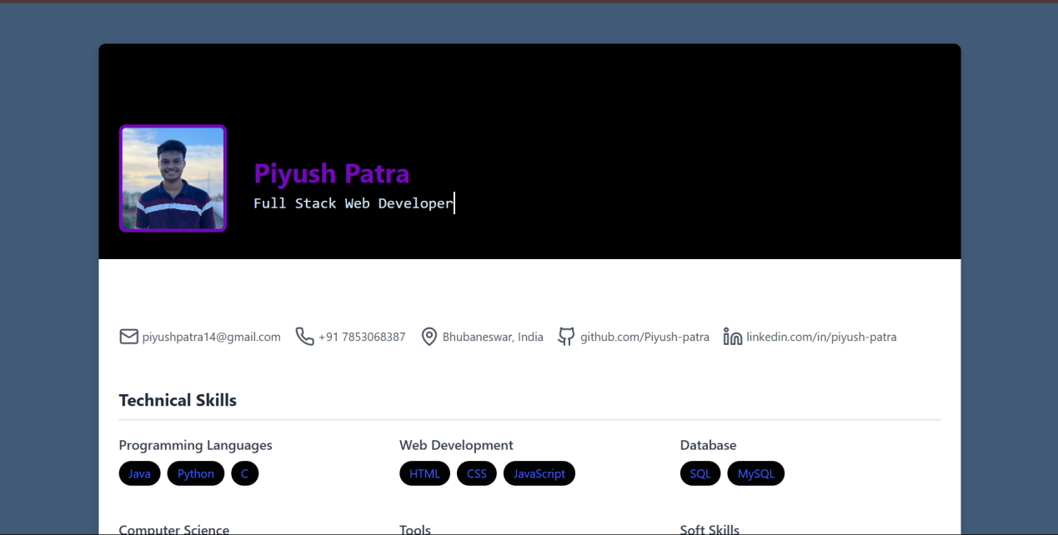
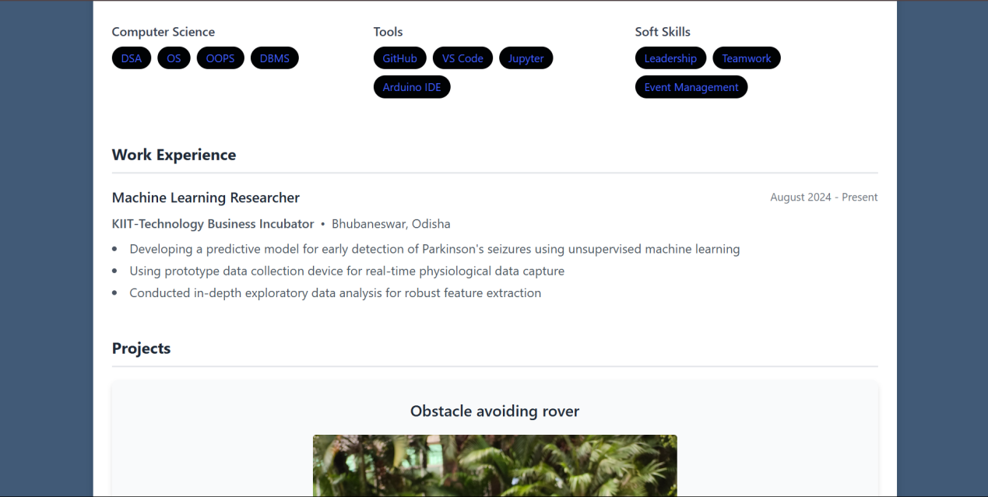
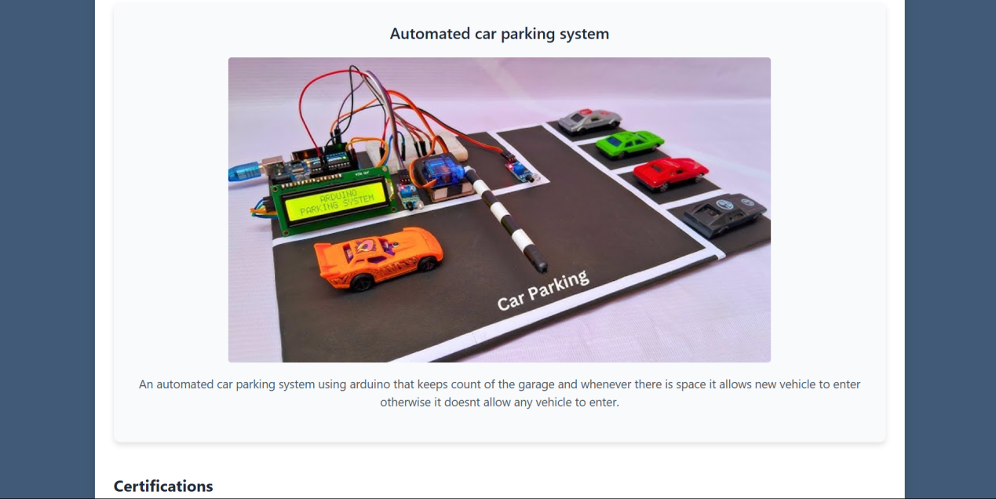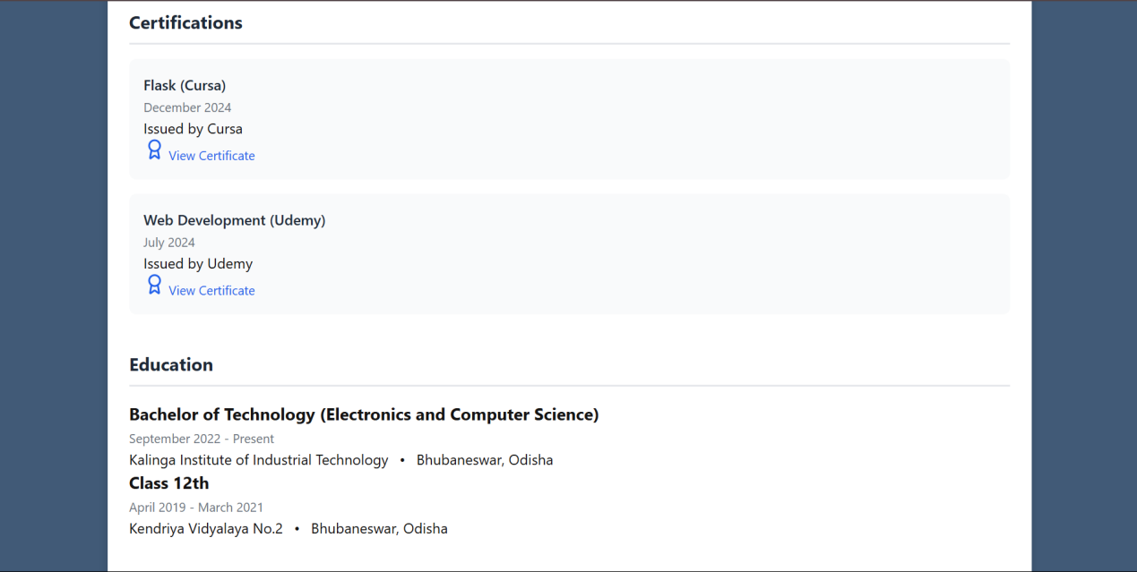

Remarks:-
From this experiment i learned how to apply html and css to build my personal resume.

Signature of the Student  Piyush Patra  ____________________ | Signature of the Lab Coordinator  Bhargav Appasani  _________________________________

