GENAI_HANDS_ON 1
ARYAN SAPROO
PES2UG23CS099

Repository : https://github.com/Piyush-sahoo/GenAI-Hands-on.git

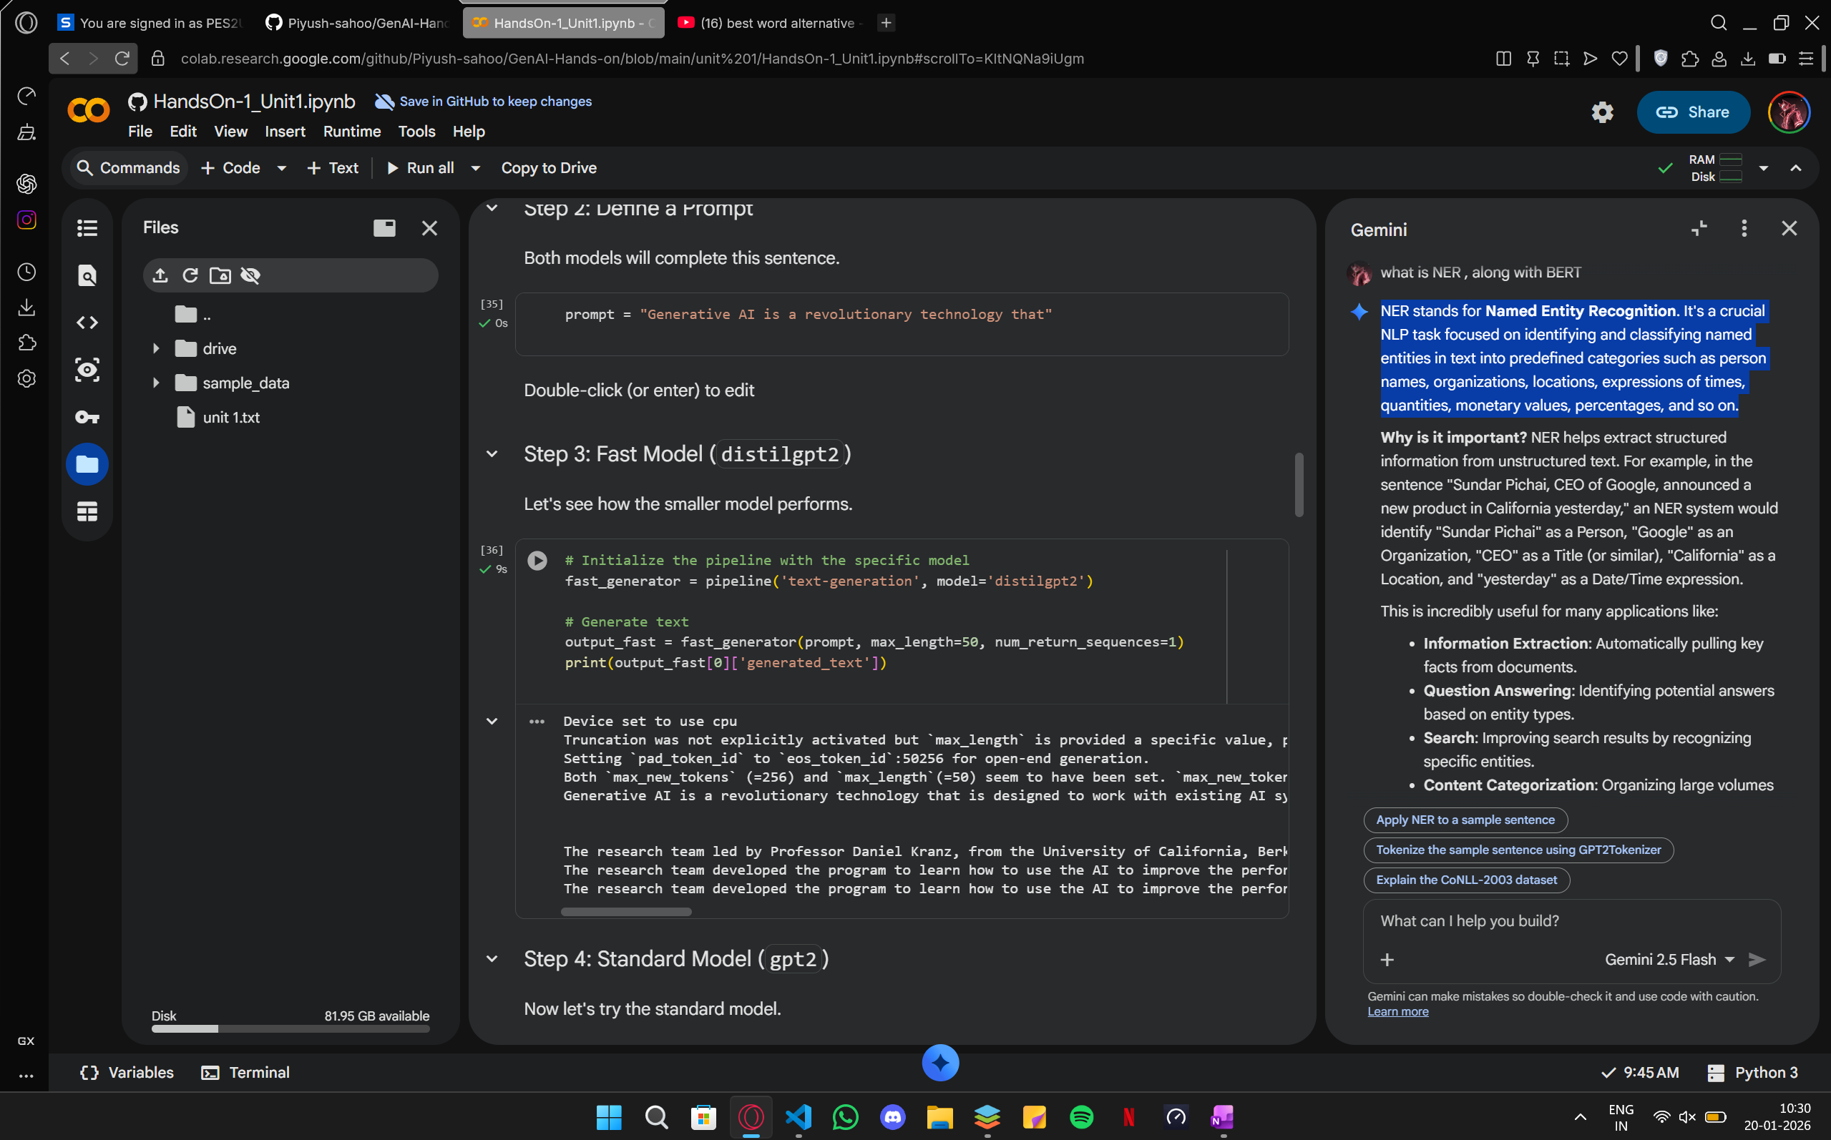

Seed(200) : Generative AI is a revolutionary technology that has been developing for decades.

Seed(42) : Generative AI is a revolutionary technology that is designed to work with existing….

1)Temperature - measure of how predictable the text generator is . Limit of constraints on the creativity of the model.

2)Tokenization - breaks text into pieces (tokens) assigns each token a unique ID.
- Every model has its own tokenizer

3)POS stands for Parts Of Speech tagging. It's an NLP fundamental that helps us understand the grammatical role of each word in a sentence.

- NNS: Stands for Noun, plural. It indicates that the word is a noun and is in its plural form (e.g., "Transformers", "cars", "books").
- NNP: Stands for Proper Noun, singular. It refers to a singular proper noun, like a specific name of a person, place, or organization (e.g., "NLP", "Hugging Face", "Google").
- VBD: Stands for Verb, past tense. It means the word is a verb in its past tense form (e.g., "revolutionized", "walked", "sang").

Other available POS :

- NN: Noun, singular or mass (e.g., "cat", "tree", "water")
- NPS: Proper noun, plural (e.g., "Americans", "Computers")
- VB: Verb, base form (e.g., "eat", "run", "go")
- VBG: Verb, gerund or present participle (e.g., "eating", "running", "going")
- VBN: Verb, past participle (e.g., "eaten", "run", "gone")
- VBP: Verb, non-3rd person singular present (e.g., "I eat", "they run")
- VBZ: Verb, 3rd person singular present (e.g., "he eats", "she runs")
- JJ: Adjective (e.g., "big", "happy", "new")
- JJR: Adjective, comparative (e.g., "bigger", "happier")
- JJS: Adjective, superlative (e.g., "biggest", "happiest")
- RB: Adverb (e.g., "quickly", "very", "never")
- RBR: Adverb, comparative (e.g., "faster", "sooner")
- RBS: Adverb, superlative (e.g., "fastest", "soonest")
- DT: Determiner (e.g., "the", "a", "this")
- PRP: Personal pronoun (e.g., "I", "he", "she", "it")
- IN: Preposition or subordinating conjunction (e.g., "in", "on", "of", "for")
- CC: Coordinating conjunction (e.g., "and", "but", "or")
- CD: Cardinal number (e.g., "one", "two", "three")
- MD: Modal (e.g., "can", "will", "may")
- EX: Existential 'there' (e.g., "there is")
- TO: To (as in "to go")
- UH: Interjection (e.g., "oh", "uh", "wow")
- WP: Wh-pronoun (e.g., "who", "what")
- WDT: Wh-determiner (e.g., "which", "what")
- WRB: Wh-adverb (e.g., "where", "when", "how")

4)NER stands for NAME ENTITY RECOGNIZATION. It's a crucial NLP task focused on identifying and classifying named entities in text into predefined categories such as person names, organizations, locations, expressions of times, quantities, monetary values, percentages, and so on.

