GEN AI HANDS ON

NAME: ARJUN RAJESH
SRN: PES2UG23CS089
SEM: 6

Seed 42

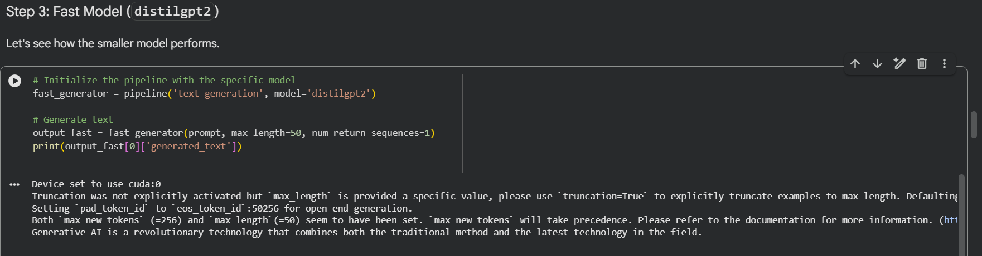

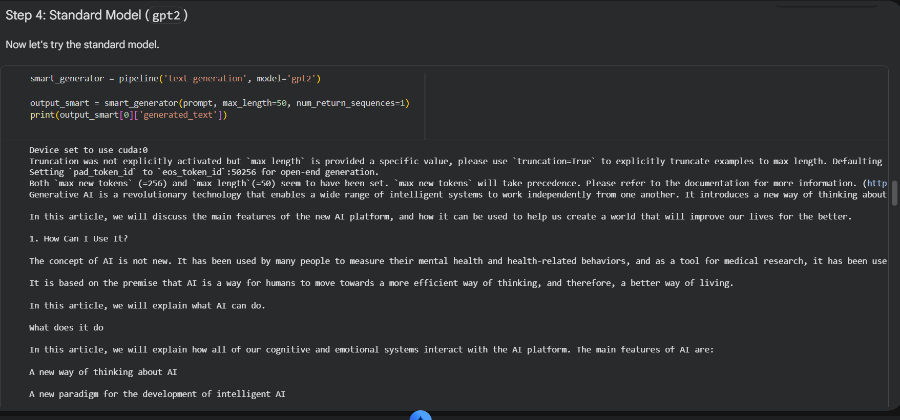

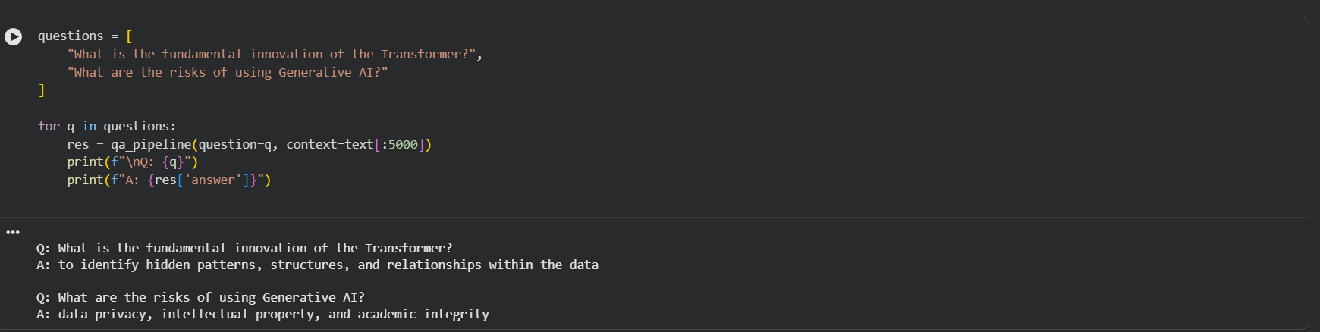

Seed 87

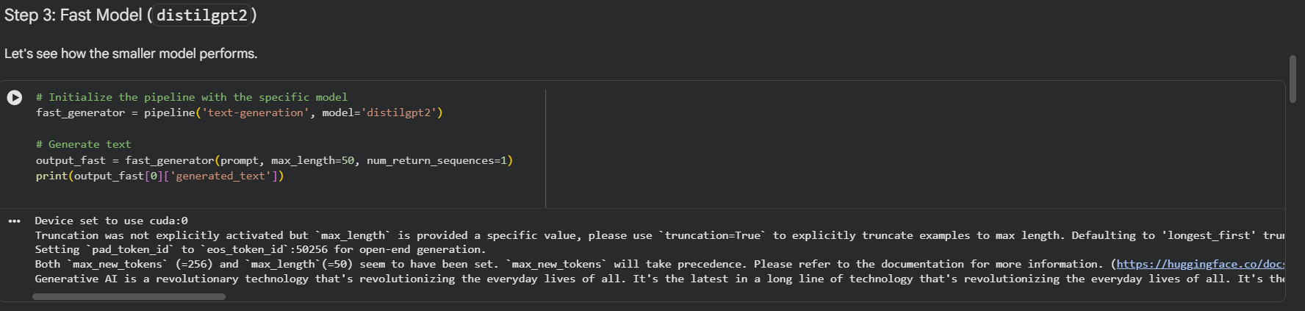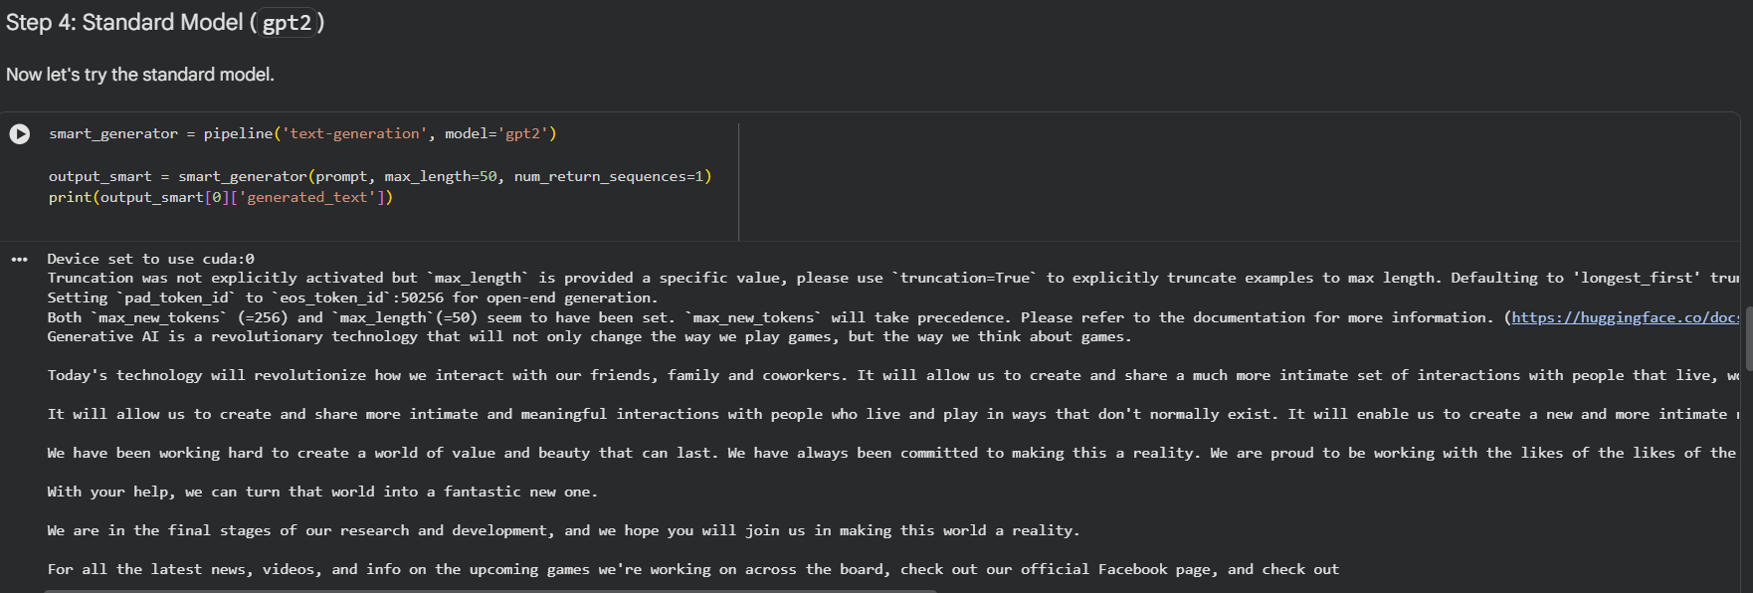

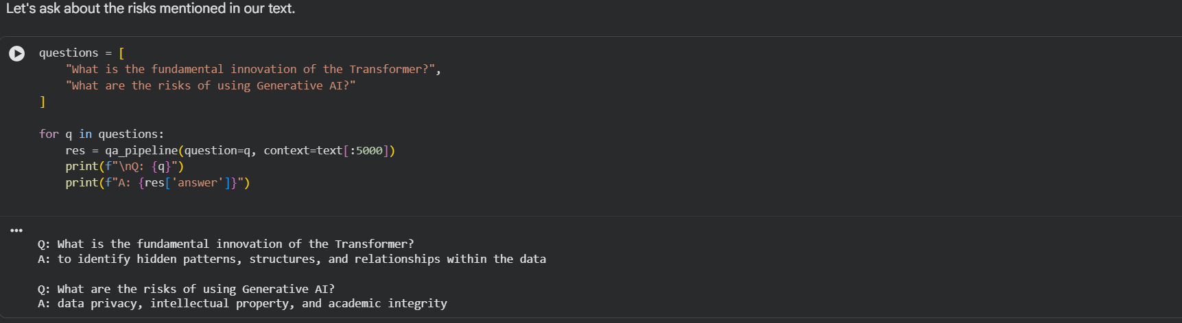

The models complete the sentence differently when the seed values are different. But the answers to the questions remain the same even if the seed value is different.

Distilgpt takes lesser time to compute compared to gpt2 and the output of the distilgpt is lesser than gpt2.

Distillgpt is the preferred option when gpu/memory is low and low latency is required.

The sample sentence is tokenized and then converted into token ids so that the model can understand.

The sample sentence words are tagged as nouns, verbs, adjectives etc.(POS) with nltk.
NNS : Noun Plural
VBD : Verb Past
NNP : Proper Noun

NER helps in categorizing named entities as person, organization, place etc. A specific BERT model is fine-tuned for the NER task.

distilbart-cnn-12-6 architecture was compared to bart-large-cnn in summarization.
The distilbart-cnn-12-6 was faster in summarizing but the summarized text was longer showing lesser efficiency while the bart-large-cnn took longer time to summarize the text but it was smaller showing more efficiency.

