**RESULT**

Here we will be sequentially presenting the outputs obtained in our project.

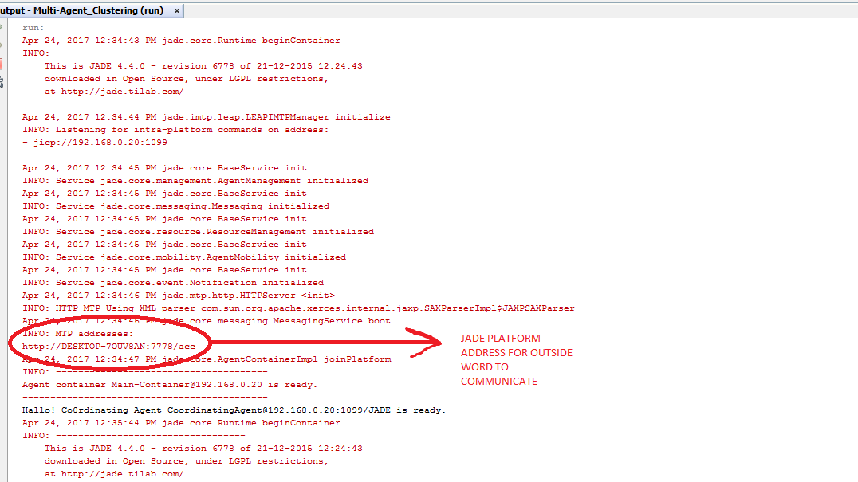

*Figure.1. Coordination-Agent Setup in main Container of platform.*

As we can see in Figure 1 jade setup was been installed as Coordinating Agent is been launched in the Main container. Jade generally installs MTP package in the main container of the platform as highlighted in the Figure.1. So any other Agent present on different platform can communicate using a combination of Unique MTP address and specific agent name to communicate with agents on that platform.

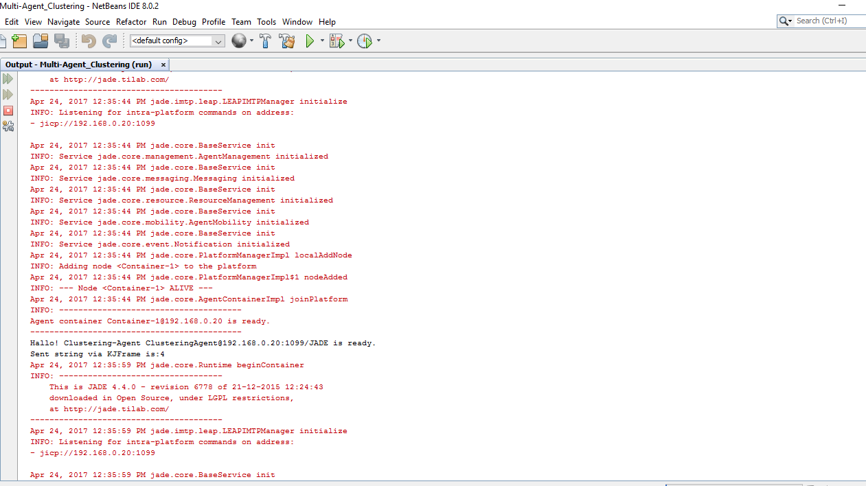

*Figure.2. Clustering Agent Setup and sending K value.*

Figure 2. shows how a clustering agent is been setup in jade which along with coordinating agent acts as an listener agent waiting for value of K to be reported via User-Agent. As we can see in console kJFrame invokes user Agent on receiving value of K which is user input value for K.

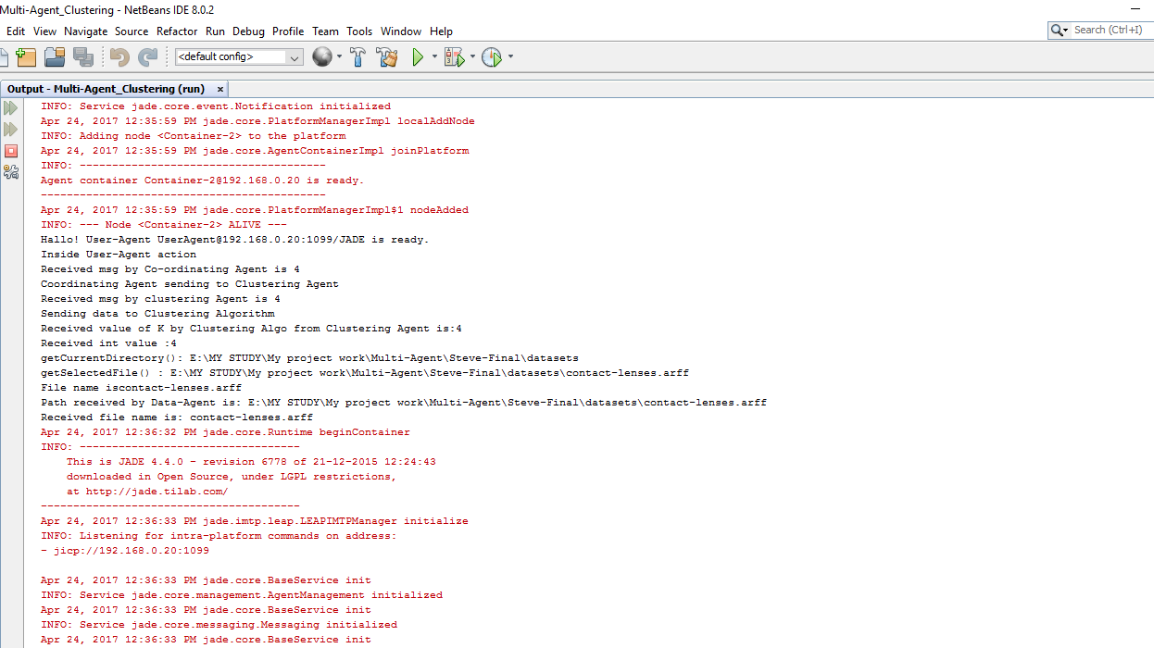*Figure.3. ACL Message Sending*

Figure 3 Shows how User agent sends K value via an ACL message to Coordinating Agent which further forwards it to Clustering Agent, thus inter-Agent communication is been implemented. This communication is been implemented successfully on single platform as well as multi-platform in our project.

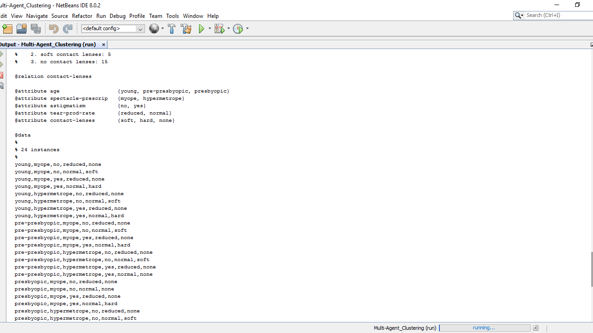

*Figure.4. Dataset sending via Byte sequencing through Data Agent*

Sending Dataset file is not been permitted via Jades ACL message sending service. Thus our Data Agent takes the dataset and then sends it to Coordinating Agent via byte sequence thus the whole data file is been received at other end of system in terms of bytes and is been regenerated as a duplicate copy of original file without using original file at remote location to perform clustering.

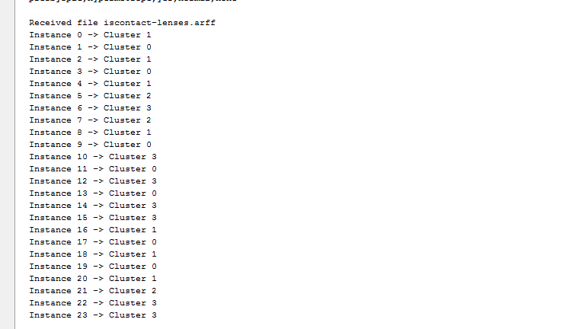

*Figure.5. Clustering Performed.*

Once dataset is been received by Clustering agent along with number of cluster value earlier. Clustering Agent calls for backend code of Clustering Algorithm which performs the above analysis. Figure.5. Clearly shows how 4 cluster’s are been shown in terms of cluster 0,1,2 and 3.