

G H Patel College of Engineering & Technology
(A Constituent College of CVM University)
Vallabh Vidyanagar - 388120, Anand

COMPUTER ENGINEERING DEPARTMENT

Project Report
on
Laptop Price Predictor
Submitted By

Chunara Piyush - 12202040501050
Raninga Ravi – 12202040501053

AIML (202046702)
A.Y. 2024-25 EVEN TERM

Laptop Price Predictor

1. Introduction
The Laptop Price Predictor project is designed to estimate laptop prices based on various attributes. It involves data preprocessing, exploratory data analysis (EDA), feature engineering, and evaluation of several regression models.

2. Dataset Overview
The dataset `laptop_data.csv` includes the following columns:
- Company: Laptop manufacturer (e.g., Apple, HP).
- TypeName: Laptop type (e.g., Ultrabook, Notebook).
- Inches: Screen size.
- ScreenResolution: Display resolution and panel type.
- Cpu: Processor details.
- Ram: Memory size (initially in GB).
- Memory: Storage configuration (HDD, SSD, etc.).
- Gpu: Graphics unit.
- OpSys: Operating system.
- Weight: Laptop weight.
- Price: Target variable.
Dataset Characteristics:
- Shape: 1303 rows × 12 columns.
- No missing or duplicate values.

3. Data Preprocessing
Steps and Code:
# Removing units from Ram and Weight
df['Ram'] = df['Ram'].str.replace('GB', '').astype('int32')
df['Weight'] = df['Weight'].str.replace('kg', '').astype('float32')
- Dropped `Unnamed: 0` column as redundant.
- Converted `Ram` and `Weight` to numeric types.
- Handled complex strings in Memory using mapping for SSD, HDD, Flash, etc.

4. Exploratory Data Analysis (EDA)
Visual Insights:
- Price Distribution: Right-skewed; most laptops are under 100k.
- Popular Brands: HP, Dell, Lenovo dominate.
- Screen Sizes: Predominantly 13-15 inches.
Plot Example:
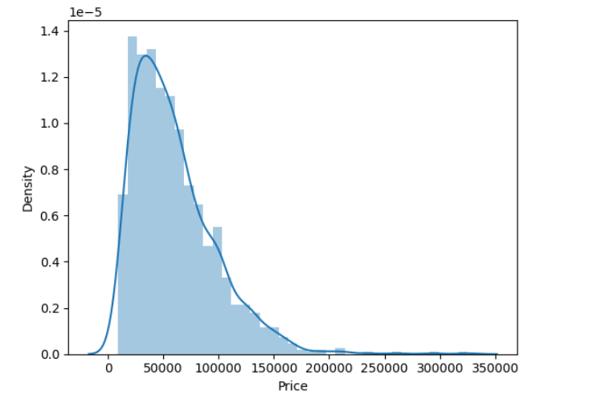
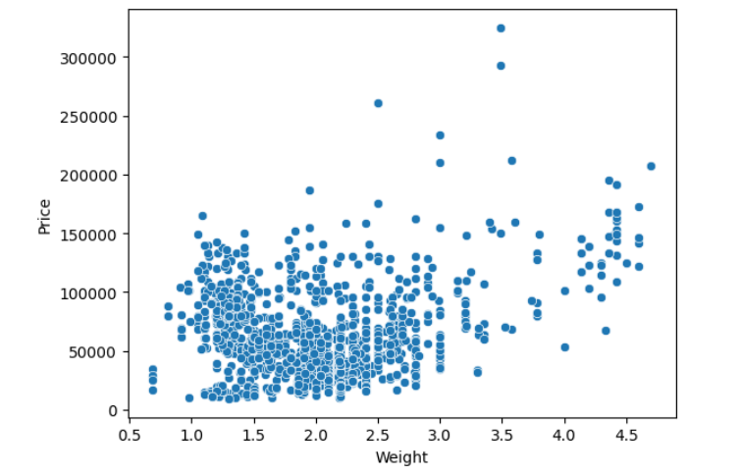
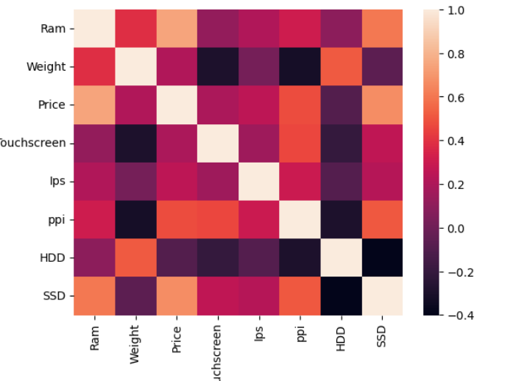

5. Feature Engineering
Feature Transformation:
- Created new binary features for storage types from `Memory`.
- Extracted CPU brand from `Cpu`.
- Extracted resolution and touch capability from `ScreenResolution`.
Encoding Categorical Variables:
categorical_columns = [0,1,7,10,11]
step1 = ColumnTransformer(transformers=[
('col_tnf', OneHotEncoder(sparse_output=False, drop='first'), categorical_columns)
], remainder='passthrough')

6. Model Training and Evaluation
from sklearn.model_selection import train_test_split
X_train, X_test, y_train, y_test = train_test_split(X, y, test_size=0.15, random_state=2)
Models Evaluated:
Model | R² Score | MAE
Linear Regression | 0.8073 | 0.2102
Ridge Regression | 0.8127 | 0.2093
Lasso Regression | 0.8072 | 0.2111
K-Nearest Neighbors | 0.8031 | 0.1926
Decision Tree | 0.8505 | 0.1779
Support Vector Machine | 0.8083 | 0.2024
Random Forest | 0.8873 | 0.1586
Extra Trees | 0.8754 | 0.1598
AdaBoost | 0.7916 | 0.2279
Gradient Boosting | 0.8802 | 0.1599
XGBoost | 0.8771 | 0.1626
Voting Regressor | 0.8902 | 0.1568
Stacking Regressor | 0.8781 | 0.1663

7. Ensemble Techniques
Voting Regressor:
from sklearn.ensemble import VotingRegressor
vr = VotingRegressor([('rf', rf), ('gbdt', gbdt), ('xgb', xgb), ('et', et)], weights=[5,1,1,1])
Stacking Regressor:
from sklearn.ensemble import StackingRegressor
sr = StackingRegressor(estimators=estimators, final_estimator=Ridge(alpha=100))

8. Challenges
- High cardinality in `Cpu` and `Gpu` columns.
- Complex feature extraction from `ScreenResolution` and `Memory`.
- Outliers: Premium laptops skew the price range.
- Model tuning: Finding the optimal ensemble weights and parameters.

9. Conclusion
The best-performing model was the Voting Regressor, achieving:
- R² Score: 0.8779
- MAE: 0.1669
This model can be deployed for real-world predictions after converting it into a web application or an API service.

10. Tools and Libraries
- Python
- Pandas, NumPy – Data manipulation
- Matplotlib, Seaborn – Visualization
- Scikit-learn, XGBoost – Machine learning
- Pipelines – For clean, reusable model architecture
- Flask – for web interface for users

